## Databases, Tables and Views

### Databases, Tables and Views

In the next few lessons, we are going to be learning about Spark Data Objects such as databases, tables and views to get a better understanding. We need to first understand the role of high metastore in all of this. As we've seen, our data is stored in our data as files of varying types such as CSV, JSON and Parquet. In order for Spark to treat this data as tables and columns, we need to register this data in a metastore. Metastore is nothing but a storage for storing the metadata about the data files, for example, things like the location of the file, the format of the data, column names, etc. Spark uses the metadata provided by the Apache Hive Project for this, which is called high Metastore. Hive metadata is the most commonly used metastore in the data lake space. When it comes to choosing the storage for Hive Metastore, we have a choice, we can either choose the default databricks manage metastore or the external storage option of your own. So you've got a choice between Azure SQL, MySQL, MariaDB and a few others.

|  |  |
| --- | --- |
| Once we registered our tables in the Hive Metastore, we can then use Spark SQL to access these tables like we would in a relational database. Just to summarize, the data is usually stored in an object storage, which is ADLS, in our case, Hive metastore still keeps the information about the file, such as the location, name of the file, table column, etc.. When you run a Spark SQL command, Spark uses the metastore to apply the schema and access the files accordingly, as if we are accessing any relational table. Now let's look at how database organizes databases, tables and views. |  |

A databricks workspace can have a number of databases. They're also referred to as schemas within a database, they can have a number of tables and view. Tables are basically structures given to the data stored in an object storage. As we said ADLS, is our object storage. There are two types of tables in Spark. The first one is called the managed table and the other one is called external or unmanaged table. In the case of managed table, Spark maintains both the metadata in hive metastore and also the data files associated with a table, which is stored in ADLS in our case. In the case of external tables, Spark only manages the metadata and we manage the data files. What I mean by that is for external tables, we specify the location of the data files and Spark doesn't decide it for itself. Also, the main properties that dropping the table for an external table does not delete the files, whereas in the case of managed table, it delete the files as well as drop the table.

|  |  |
| --- | --- |
| Hope that explains the difference between managed and external tables. But if you haven't understood it properly, that's OK.  In the forthcoming demos, I'll make the things a bit more clearer for you. Views can be built on the tables with a selection of data. For example, you could apply a filter to a table or you could select just a certain number of columns and then create a view with that information. |  |

### Databases

Now that we understand the database objects that we can create within database, let's start creating some of those. So I'm going to create a new notebook and the demo folder and I'm going to call that one as six dot sexual objects. And this time I'm going to pick the default language, as SQL, because we are mostly going to be working on SQL rather than Python, and we'll attach to a cluster and click create.

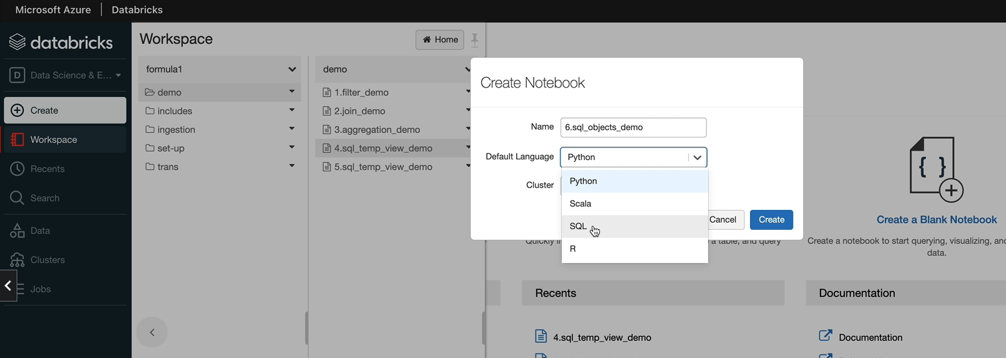

So in this lesson, these are the things we're going to do.

%md

##### Lesson Objectives

1. Spark SQL documentation

1. Create Database demo

1. Data tab in the UI

1. SHOW command

1. DESCRIBE command

1. Find the current database

So we're going to start looking at the SQL documentation. This is slightly in a different place to the API documentation that we've seen previously. I'm going to show you how to create a new database, will create one called Demo, and then I'll show you the data tab, which you can see here. And then we look at the show and describe command, which will let you examine the metadata within the Hive Metastore. And also I'll show you how to find out the current database so that actually you know which database you are working on. So let's start with the spark sql documentation. And if you come over to the Spark documentation homepage, under programming guides, you'll see siecle data frames and data sets. And here, if you click on SQL reference, then you're going to get all of these SQL documentation.

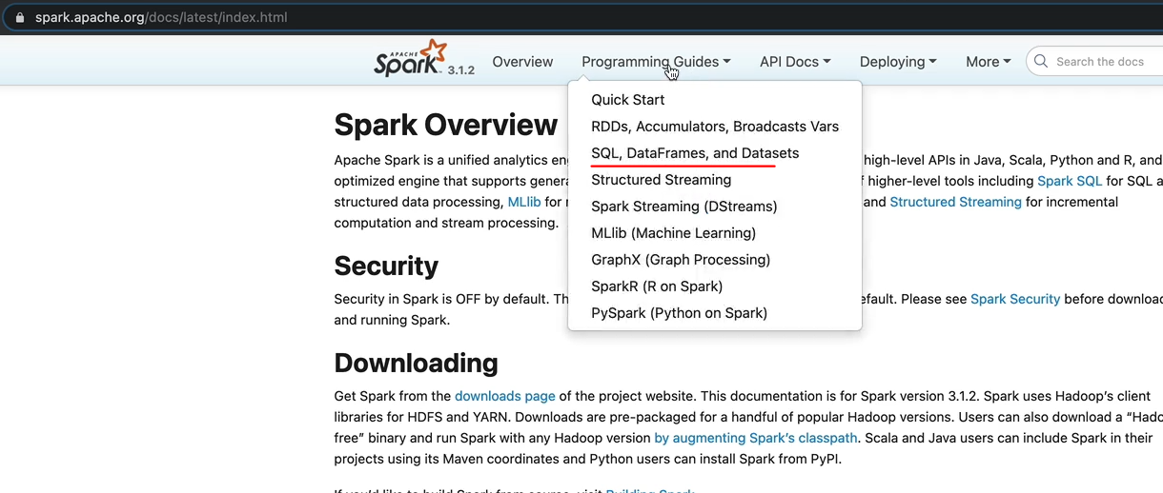

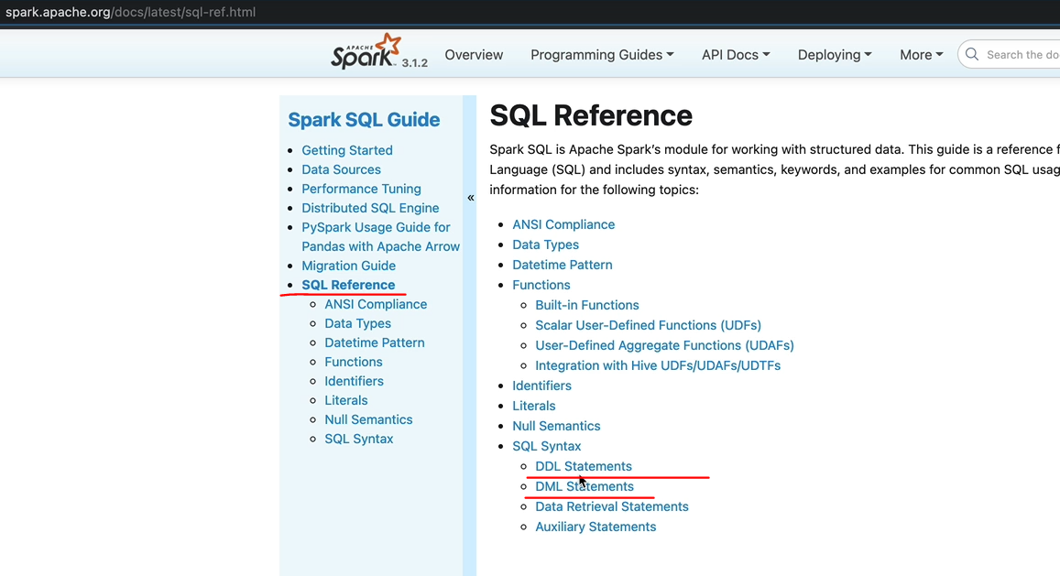

So things like DDL statements are here. The DML statements are here. So let's click on the DDL statements. We're going to create a database first. So if you're going to create a database, then you'll see the options here so you can create a database. As we said, database and the schema are synonymous. So it is exactly the same thing in the context here. So you can create database and you can specify if not exists. So that means if it already exists, it's not going to create that database. And you give the database name and you can give a command and the database directory and they can set some properties as well. So I'd encourage you to go through this, but let's switch over to our notebook and start creating the database. So let's create the database first.

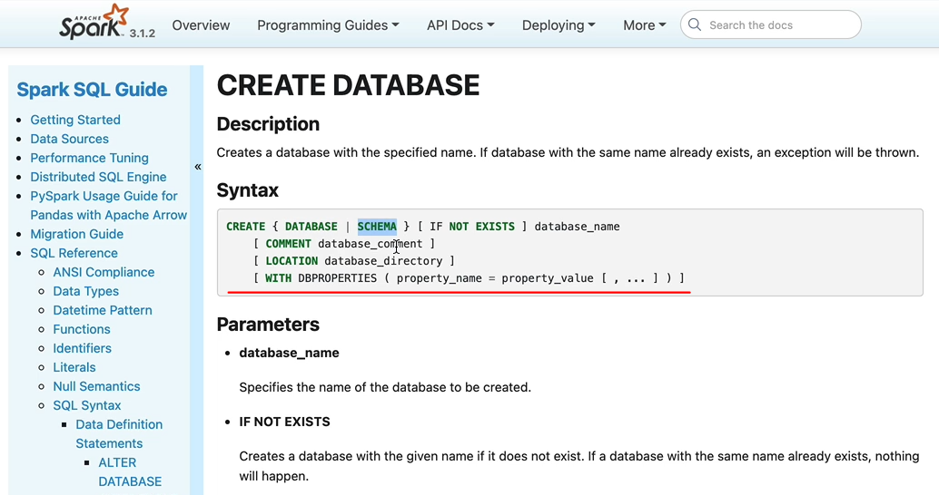

As we said, we're going to create the database demo. So you may have noticed we didn't use the magic command %SQL, because we are in a SQL notebook, so it is simply create database Demo should create the database for us. So that database now exists, but one thing we saw previously in the documentation is, if not exist, class. So if I run this command, it's going to fail, saying actually the database already exists. So if you are going to have these kind of dismal statements in your notebook, which are running on a daily basis, you want to put, if not exist so that it doesn't fail, if it if the database already exists.

CREATE DATABASE demo;

CREATE DATABASE IF NOT EXISTS demo;

SHOW databases;

So now when I it it hasn't done anything because the database already exists, otherwise it would just create one for us. The next thing we want to look at is the data tab. So let's go to the data tab. That's this one here. In order to look at what's in here, you need to have a cluster running. So in our case, we have the database called cluster that I created is running. So that's why it's listing all the metastore metadata here. So here we got two databases, we've got the default database that's always there. You don't create it that's been created for you.

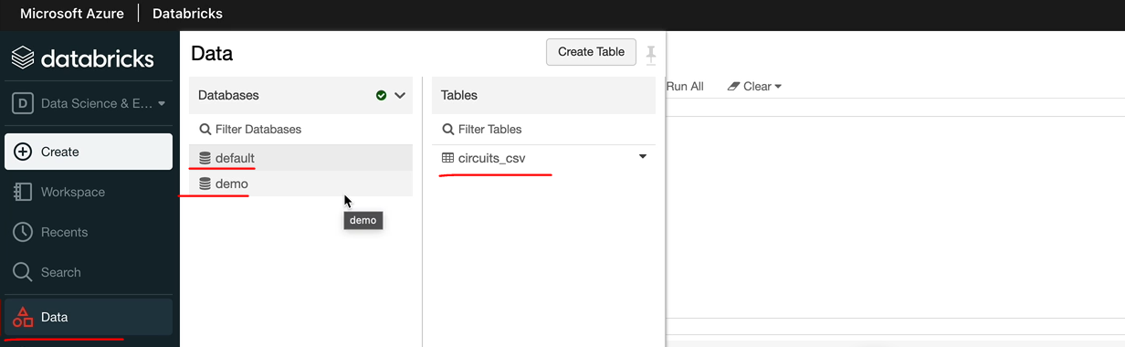

And when we did the initial demo, one of the demos, we imported some data and created the table using the UI, that's why we got the circuits and the CSV file. And we've created the new database here called Demo, and that doesn't have any tables, as we expected, because we haven't created any tables here. So if I switch back to default, you can see the table. And if you click on that one ( clicked on circuits_csv in image above ), it will give you some of the metadata here.

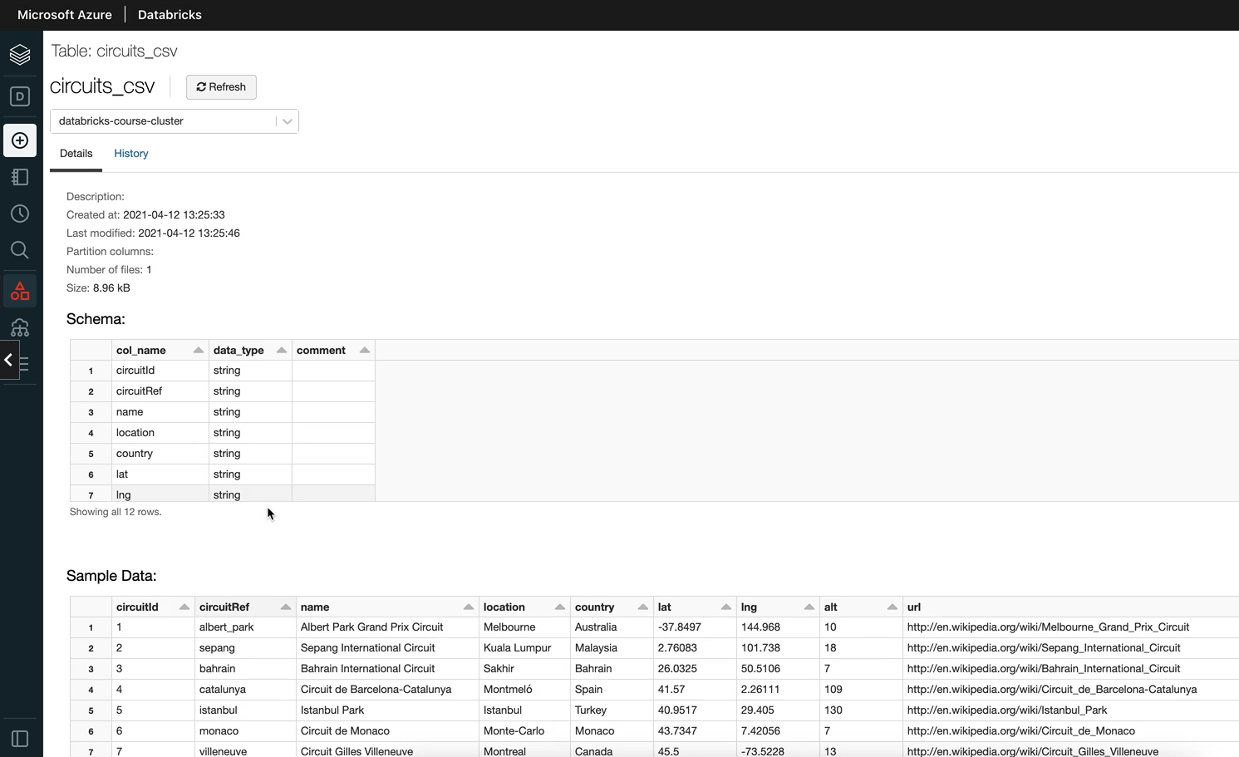

So things like you've got the schema and then it's going to give you some tables as well. So that's what you can see in the data tab. And also, we got a bit of history, so it'll tell us actually when we did it, whether we copied any data into it.

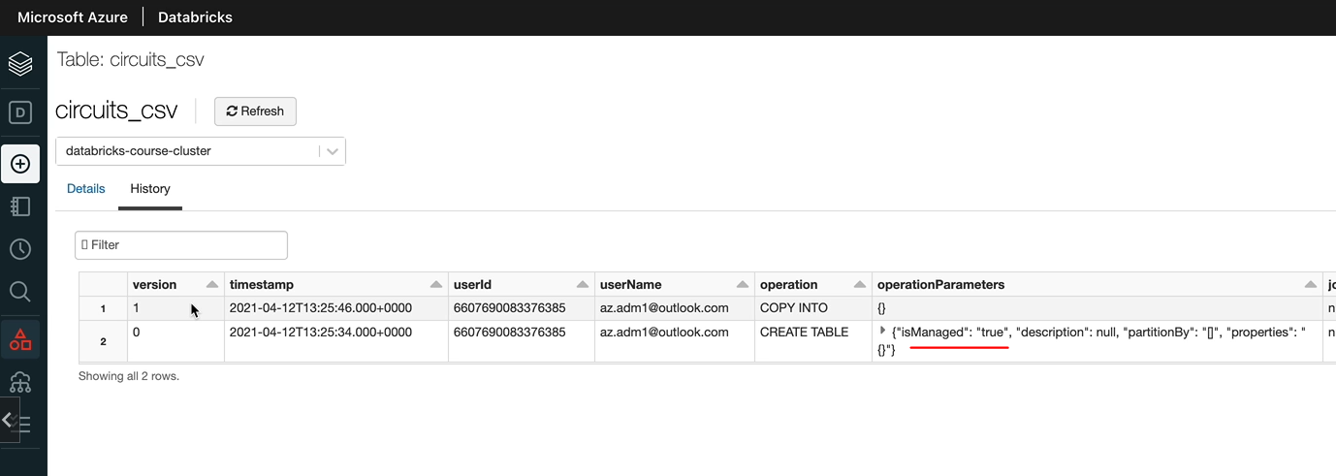

So we created this table and that's a managed table, as you can see, is managed, dissected through while we created the table. We also copied some data into that. So that's where it's got data as well. So you've got the history tracks the full history of what's going on. And they keep all of that information. And you can come and have a look here as well. So let's switch back to our notebook. You saw using the UI how to look at the databases, but you can do the same thing from the notebook itself and this comes quite handy a lot of times. So you want to know these things. So show databases would list all the databases available.

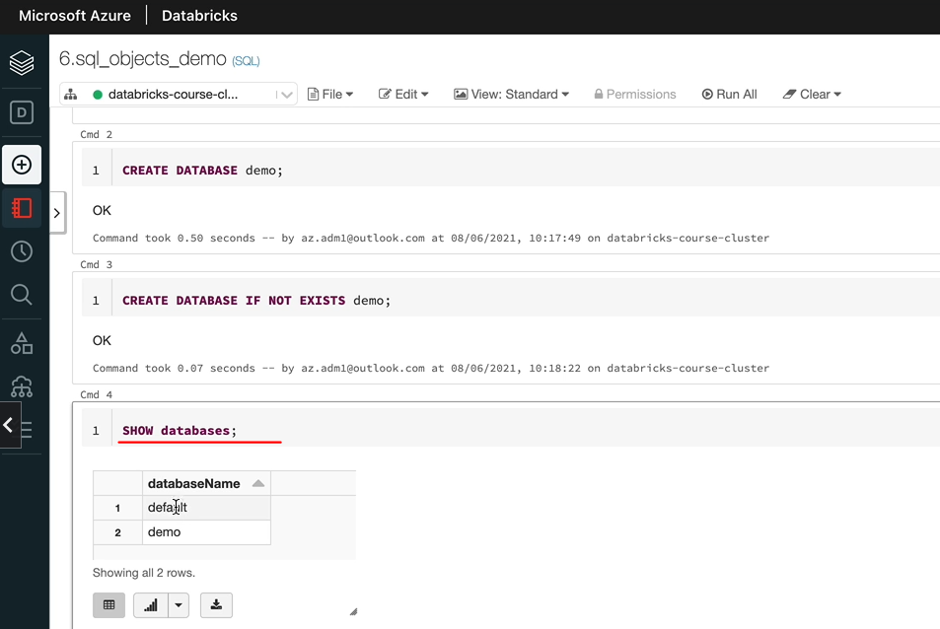

So you can see we got the default and the demo. Let's now look at the describe command. Describe command lets you describe an object. In our case, we only have databases here. So let's do the database so that you can go the abbreviated way DESC or you can do the full DESCRIBE word in there and you need to specify what you're describing. Is there a database or a table? So in our case, it is a database. So I'm going to say demo. OK, so as you can see, it's described the database demo we got the database name, we got the location where the database is going to write the files to and the one that in this case is route.

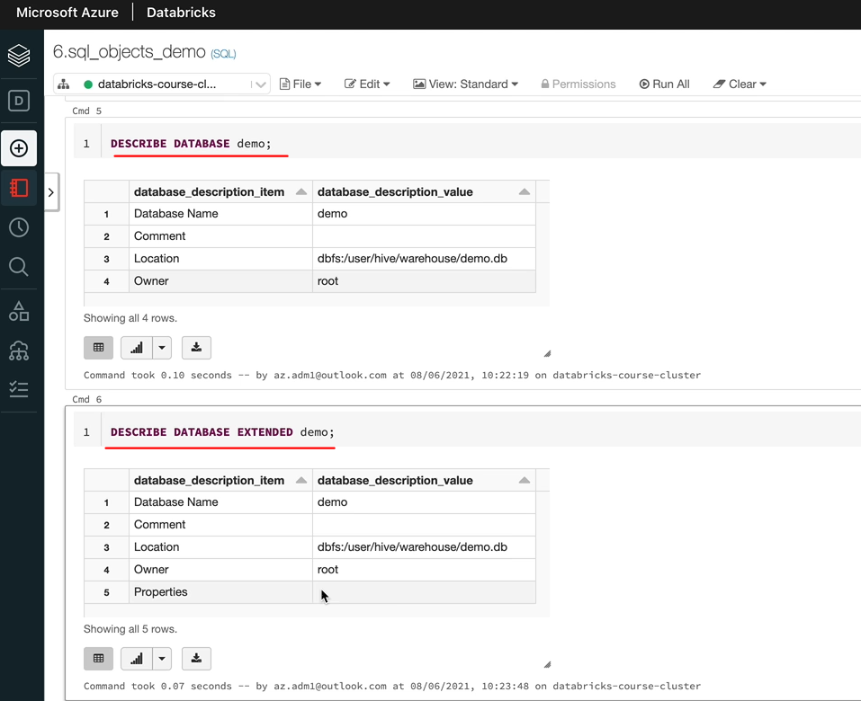

SHOW databases;

DESCRIBE DATABASE demo;

DESCRIBE DATABASE EXTENDED demo;

SELECT CURRENT_DATABASE();

SHOW TABLES;

And if you specified any comments that will be here as well, every described command, you can add an optional keyword called extended here, and that will give you more information. So it is quite simple. In the case of database, it's going to give you any property. So as you saw, we can give a list of properties to that one. And if we specified any of those, you're going to see them here. But in our case, we got nothing for the database. But when you look at a table, there will be a lot more information as well. So the extended keyword, you can use it on a database. That's as we've done here. You can use it on a table as well or a view or whatever, really. So the next thing I want to show you is the current database. So how do we specify which database we're working on? Because when you create a table without a qualifying database name, it'll create that table in the current database so you can run select on this current database. That will tell you what is our current database, current database normally is default, and I'll show you how to switch that. So if I did a show tables here, it's going to last me all the tables in the current database, which is our default database, because default is the current database. But say we wanted to see the tables in our demo database. We got two choices. One is you can specify here the name of the database and I can say Demo and that's going to give me all the tables under the database demo. In this case, there are no tables or the other option is we can change the current database. So if I did use and then put the database name, which is Demo, it's going to switch that.

SHOW TABLES IN demo;

USE demo;

SELECT CURRENT_DATABASE();

SHOW TABLES;

So if I run that statement again, select current database, I would see that my current databases demo and when I do show tables. It's going to list no tables because there are no tables, so that's been changed. But if I did show tables in default, it's going to show us that one table we already have.

### Managed Tables

In this lesson, we're going to look at Managed Tables in Spark. So first, we are going to create a managed table using Python, and then we'll look at how to create a managed table using SQL and also will drop one of the tables so that we can see the effect of dropping the managed table. Because the difference between managed table and external table is that when you drop a managed table, you drop the data as well. In the case of external table, the data remains as it is just the metadata gets dropped. And then finally we look at describing a table as well. So let's get started. I just ran this one. So that is just to get the variables for all the parts being available.

%md

#### Managed Tables

##### Learning Objectives

1. Create managed table using Python

1. Create managed table using SQL

1. Effect of dropping a managed table

1. Describe table

%run "../includes/configuration"

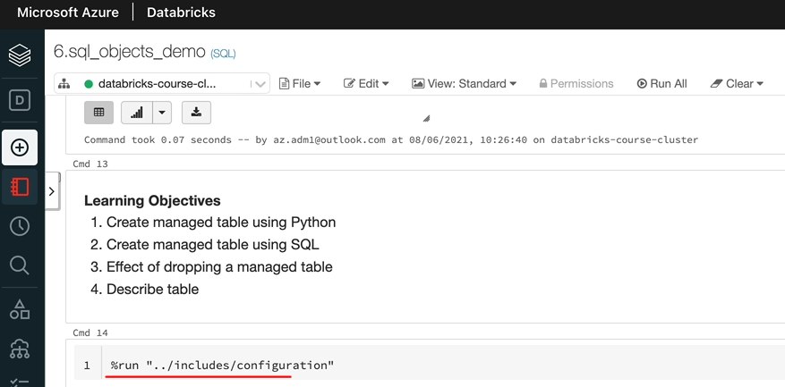

So the first thing we want to do is to create a managed table using Python because we are in a cycle not we need to use the magic command to switch to Python. And then what I'm going to do is I'm going to use the race_results file that we created. And read that into a data frame and save that as a table, so the data frame that we create would be served as a table and then we'll start to see that in SQL. So let's do that. Let's start by clear in the data frame first. OK, the data frame now has the data. The next thing we want to do is write that data into a table so you do similar to what we did. So we're going to use the API to write the data. So that will be race results, data frame .write. And then we need to specify the format of the data in the table. We'll still use the parquet data parquet format. And here is the difference, what we're going to do is we're going to use this method called saveAsTable and then we need to give the name of the table. So when we give the name of the table, we want to qualify that with the database name. So that be a demo dot I'm going to call this one as a race results underscore then just to say this was created by the python.

%python

race_results_df = spark.read.parquet(f"{presentation_folder_path}/race_results")

%python

race_results_df.write.format("parquet").saveAsTable("demo.race_results_python")

USE demo;

SHOW TABLES;

So let me execute that one. OK, so what I have missed here is the magic command. So let me do that. And that table is now created, so a couple of options for us to have a look at that so we can go to the data tab. And then on the demo tab, we can see we got the race_results_python table.

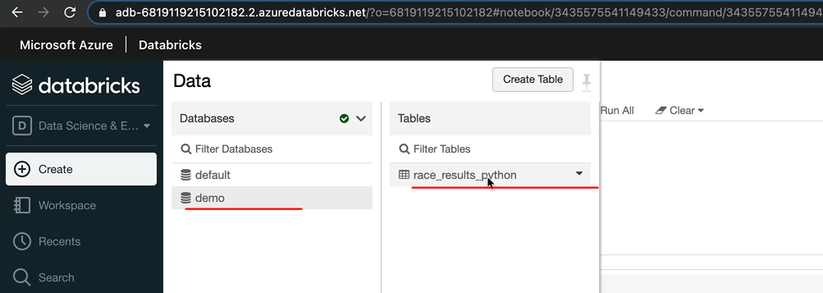

And if you go there, you've got the schema and you've got a sample data as well. So that's that looks as we expected.

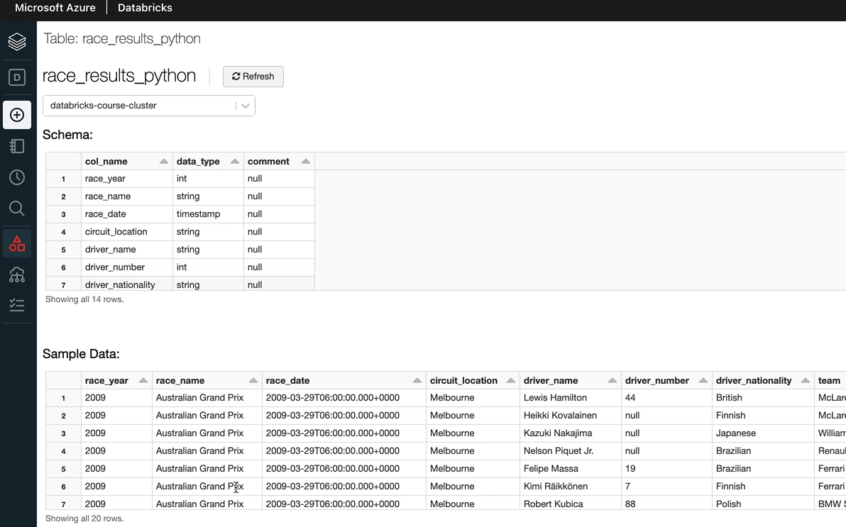

Or you could just do the show tables. So that's going to give us the tables from the default database, so as we did before, we can use the demo database or you can even say show tables in demo. So I've done the use demo and then show us tables and we got the table here and now we can describe the table as well. So let's do that now. So DESCRIBE would give you the date column names, data types and things like that. But describe extended is quite useful. And that's going to give you a lot more information.

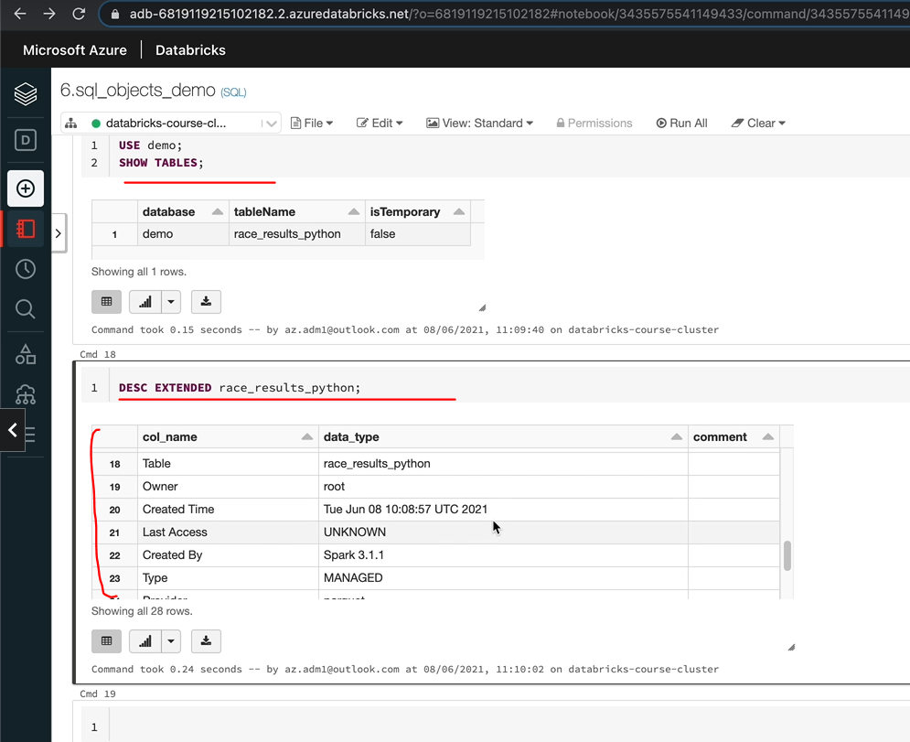

DESC EXTENDED race_results_python;

So if we scroll down that he can see here, we got the detailed table information, which has got information about who's created it, what time it was created and last access created by Spark in this case and type. That's the key one. So we created a managed table. We didn't specify that we want to create a manager table. But the way you do that is you do the service table without a part. I'll show you how to create an external table in a minute. And as you can see here, the location of the table is on the DBFS user. Hive has Demo.db and then you've got the table name, obviously DBFS location here but when you create the database, you can give a different location as we saw that in the documentation.

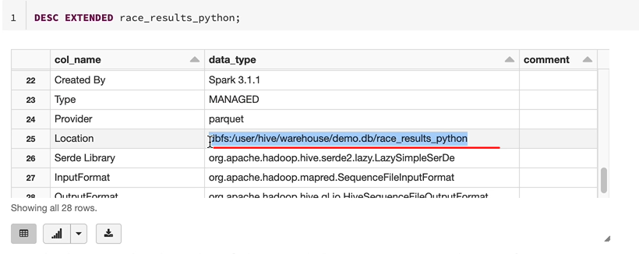

If you use the different directory, then it will put the table under that directory as well.

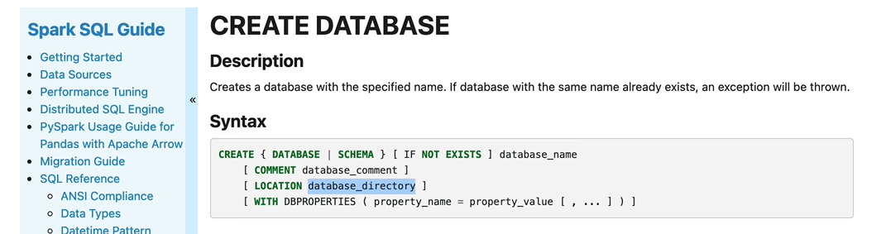

Let's now try and select some data from the table. It will be exactly the same as what you did from the views. I normally tend to qualify all my tables with the database name so that we know which database we are reading the data from. But as I said before, you can use the use to search the current database and then not qualify your table names. But this is my preference that I would encourage doing this, that because a lot of times you might be joining up tables from different databases and querying the data from there.

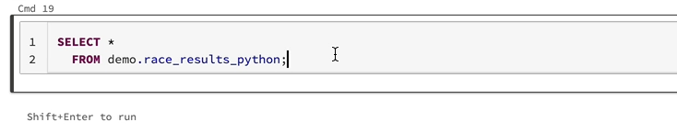

One, it makes it obvious to know which database you are getting the data from and to when you have multiple tables. Current database one lets you set one of the databases. You still have to qualify the others. So this is this is my recommendation, but it'll be up to you. So let me do run this country. So as you can see, we got the results. So what I'm gonna do is I'm going to filter the data for 2020. OK, so that's how you run your second statements on a table, the next thing we want to do is we want to create the manager table using SQL.

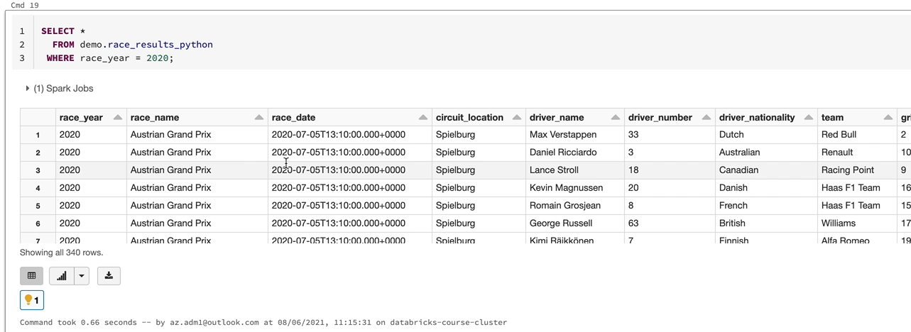

So there are ways you can do so. You can, for example, create a managed table and then insert data into that table. Or if you're familiar with the relational databases, you can use CTAS or create table as statements. So we're going to use the create table as statement, lets copy this. And all you have to do is create table and instead of race_results_python, I'm going to call this one a race_results_sql and use race_results_sql as that select statement. So what's going to happen is I'm going to get this results, which is restricted to one year 2020, and select that data and put it into a new table called race_results_sql. We don't specify the location. The location is taken from the database itself and it will be managed tables. So let's run this statement.

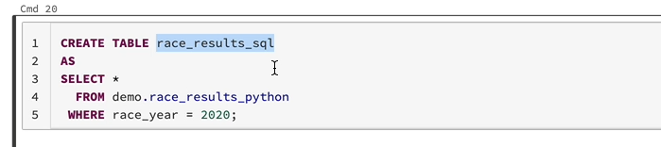

I should have specified the database, but I think we searched the database to demo. So that means it's created there. So let's do select from current database. And that demonstrates it doesn't make any difference, but I would have normally qualified that with a database name.

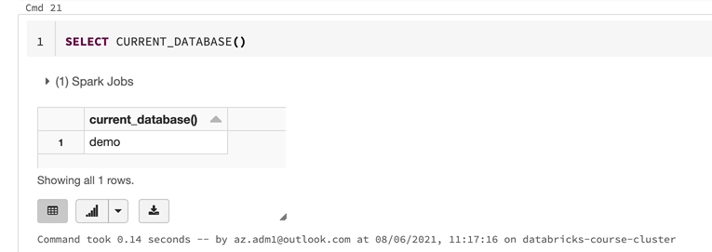

So let's describe this table now. Let's scroll down to the bottom and see whether that's a managed table, and as you can see, that's a managed table and the location is again, dbgs:/user/hive/warehouse/demo.db/race_results_sql.

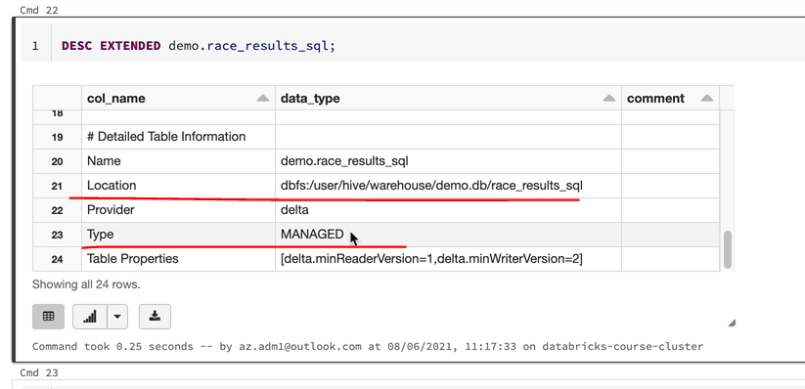

I'll show you how and where to see these files. I'm going to just duplicate this tab so we can clear we can open up another one. And if I go to the main page and if I go to explore data under the user hive warehouse and Demo dbfs, the one that we created and the demo DB got the two files are two folders, the race results equal and the Python one.

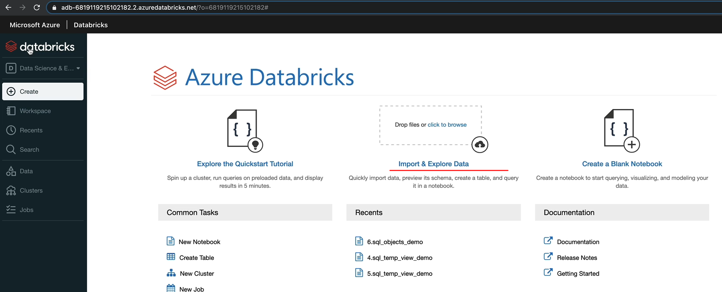

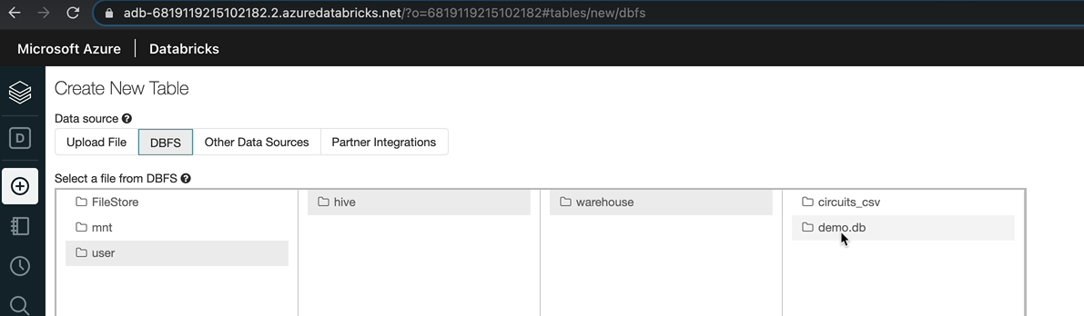

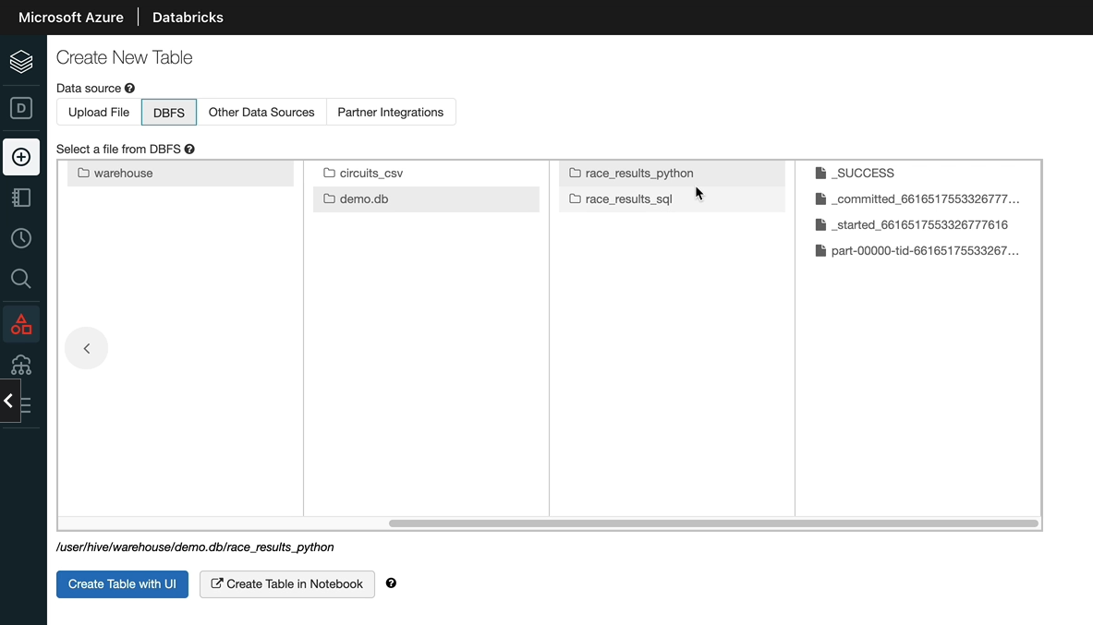

So what we're going to do is we're going to drop this to drop one of the tables and then I'll show you what the effect. So let's drop the second table, so in order to do that, you run the prop table command and demo that race results underscore. So that table's now dropped. So let's do a show tables in demo database, so we should only. See, one of the tables, which is the python one and the second table now dropped.

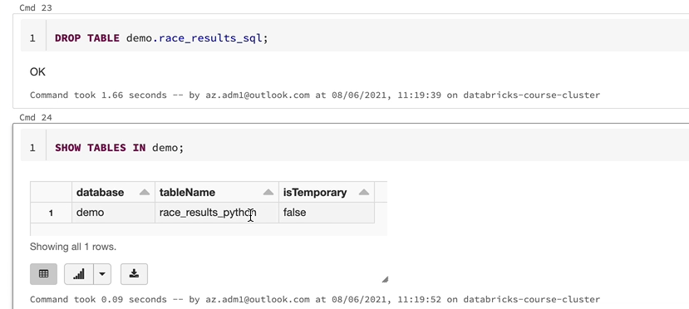

So what that means is that information has been wiped out from the high metastore. It doesn't know about that table anymore. But the important thing is we want to look at whether that data exist in our file system. So let me just do a refresh. Of the UI and then come to use a high warehouse demo DB and as you can see, we only have Python now. We don't have that SQL table that we created because it's a managed table. When you drop the table, it drops both data as well as metadata, so that is the main thing you need to bear in mind when you come to differentiate between a managed and an external table.

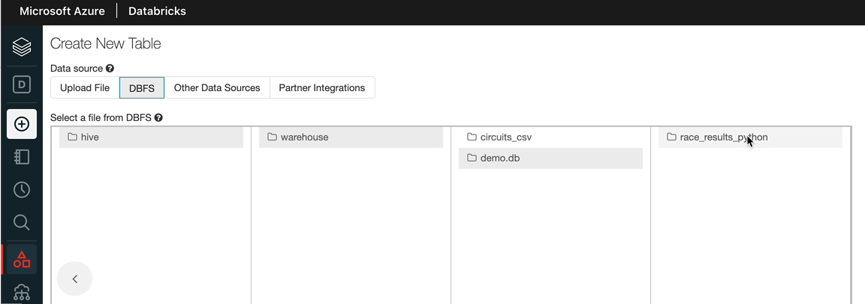

Hope you've got an understanding about what a managed table is. Now, in the next lesson, we'll talk about external tables and I'll also reinforce the concepts around managed tables. So you know exactly what the difference is between the two.

### External Tables

In this lesson, we're going to create an external table using Python like we did before, as well as using SQL. And also I'll show you the effect of dropping an external table. So we'll use the same dataframe that we used for our managed table, which is the race_results_df and this is the statement we had to create our managed table. The only difference between this and to create an external table is to specify an option that will include the path for the files to be written. So other options will specify the path. I'm going to specify the path as there where we want the data to be written to. So let's write the data to our presentation, follow the path. So that'll be the presentation for the path. And under that, we don't want to override the race and discard results file. And I'm going to call this one race_results_extr for external and then we can say pi for Python and we'll do the same thing here. So that will be easy. And so let me go over.

%md

#### External Tables

##### Learning Objectives

1. Create external table using Python

1. Create external table using SQL

1. Effect of dropping an external table

%python

race_results_df.write

.format("parquet")

.option("path", f"{presentation_folder_path}/race_results_ext_py")

.saveAsTable("demo.race_results_ext_py")

So we got exactly the same as what we did before. But we are going to specify the part where the data to be returned to and that we still think our presentation for the part and the name of the fall that there would be race results. And that's the same name I've used for the table as well. So let's run this. So that's completed. Let's describe this table and see what the differences between what we had for the manager table and this one. So if I scroll down, we should be able to see the detailed information so as you can see, the type of the table now is external and the location is our mount because we use the presentation layer for us.

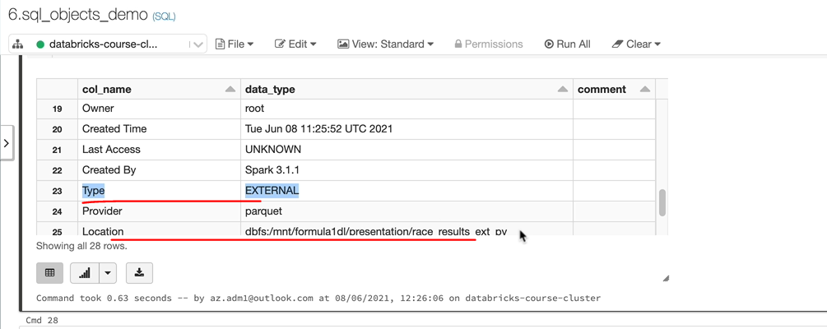

So that is the dbfs:/mnt/formula1dl/race_results_ext_py. So let's go into our storage explorer and have a look at that folder path as well, just to be sure that it's there. And that's under the presentation folder in my Formula One diesel storage account. I'm going to just do a quick refresh. And as you can see, I've got race_results_ext_py there, which is a parquet file. So let's go back to the notebook now. Let's now look at creating the external table using sequel statements.

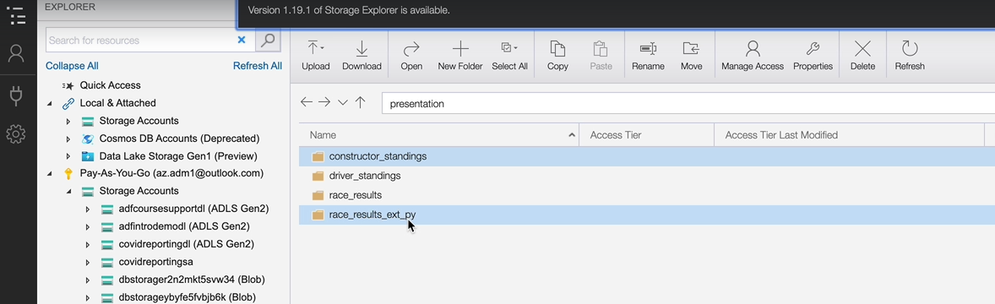

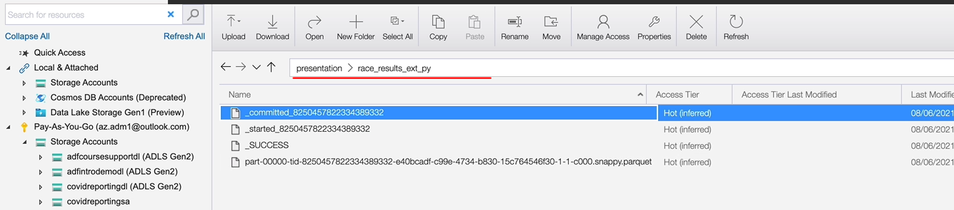

In case of the managed table we use to create table a statement to do that, which you can do exactly the same thing. But I want to show you how to create a table and then insert data into that. So in this case, we are going to create an external table, but it'll be the same thing you would do for management as well. I want to show you both techniques. So in order to do that, you would use the create table statement and I'm going to call my table as the same name except for py we will use sql. And then we need to specify the schema for the table. I've already prepared that one just to save a bit of time. So I'll quickly copy and paste that. And that's got racer, name, date and everything, as we know, and we need to specify the format of the file in our case, I want to create the table with the format of the file file so it'll be parquet. And the one difference between managed table and this one is we need to specify the location. If we're creating a managed table, we would stop at this. But for our external table, we need to specify the location. So I want to put the data into our presentation layer again so that is /mnt/formula1dl/presentation/race_results_ext_sql I tend to normally use the folder name as the table name. So let me run that one. So what that's done is just created the table. There is no data in the table. So if I did a show tables in their demo.db that will show me all the tables and that should show me this table as well, which is the school. But if I switch to my storage account and look for the sql folder, it won't be there. So we got the race_results_ext_py.

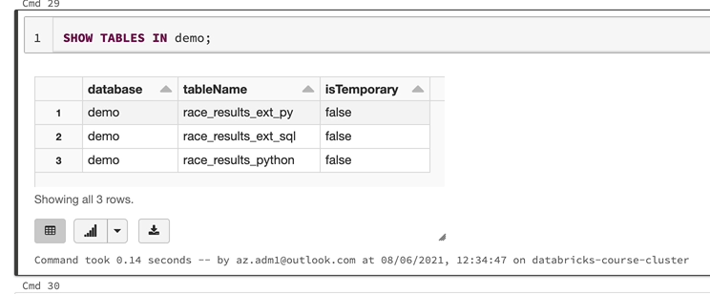

We need to insert data into this. But I want to show you quickly where the documentation is for these things. Last time when we came here and the sequel, we came into the definition statements. But you've got data manipulation. So as part of data manipulation, you've got the insert and the load statements within it. Use the insert statement to do that. So what you do is you do insert into a table and then you specify the values.

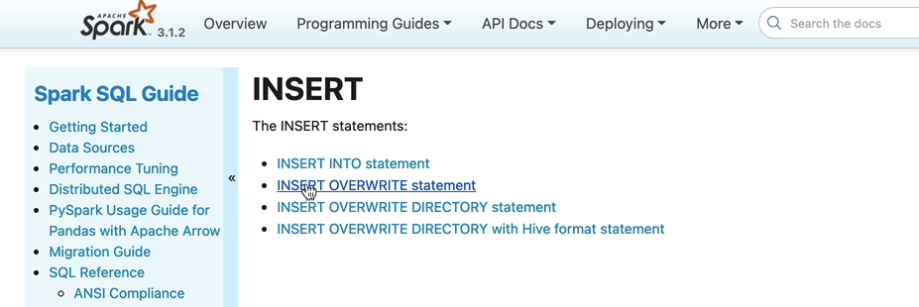

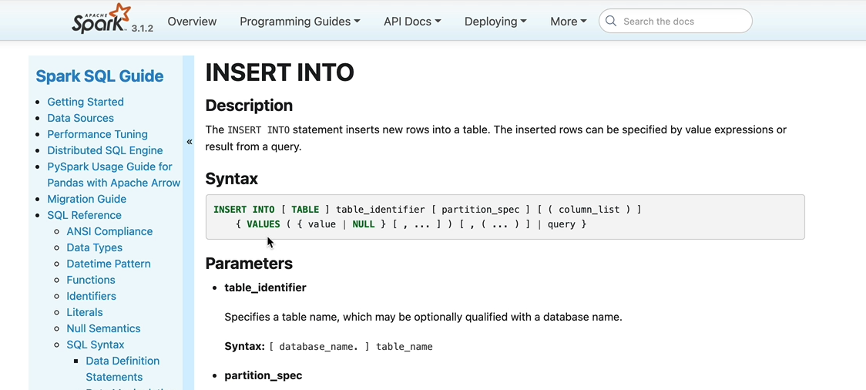

So there are a few ways of doing that. The first way is you use the insert into table using the values, but you can only pass in like one record at a time, which you don't want to be doing, or you specify more than one, but you have to put them like this.

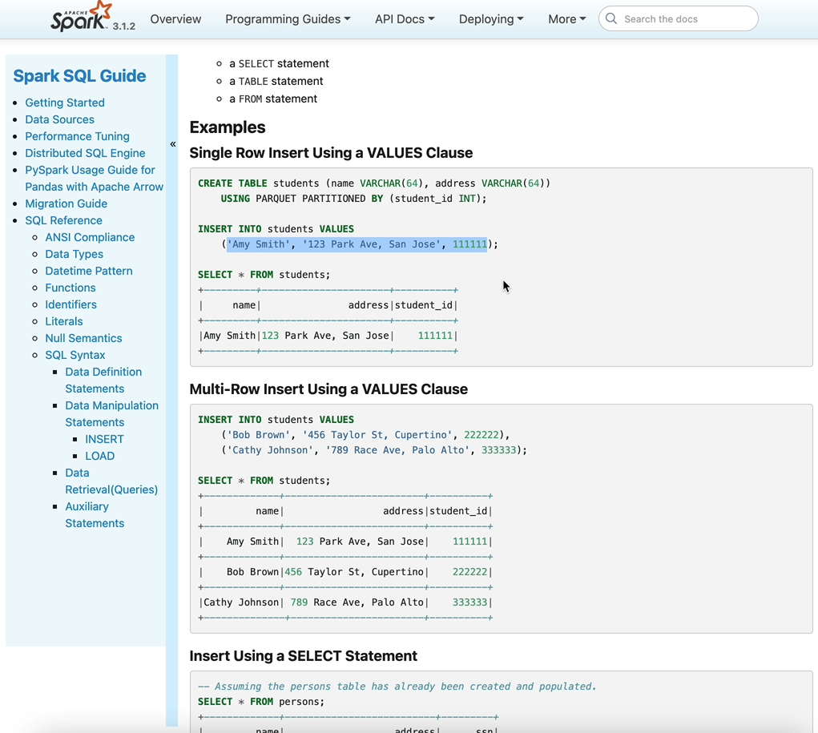

We don't want to do that. We want to select from a table and then insert into this table so that you can use this, select a insert using select statement that you do like this insert into the target table, which is the new one we've created. If we had a partition, we can specify a partition. In this case, we don't have a partition and then you can put your select statement there. So let me switch back and write that statement.

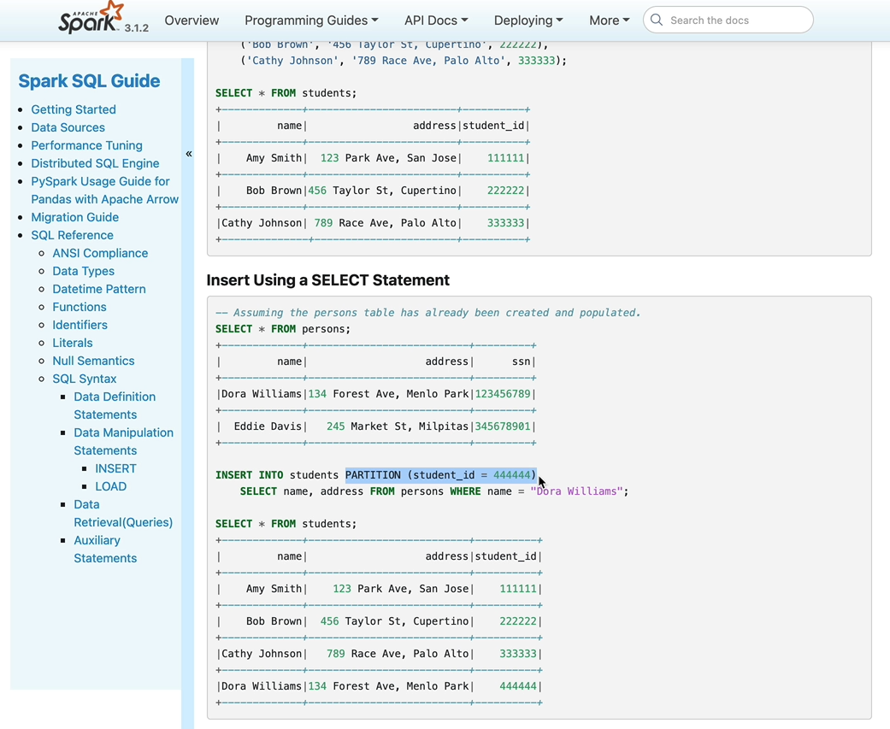

So in our case, we are going to be inserting into the new table that we created, which is the second table. And let's select the data from the other table that we played already in in a real project. He would probably select it from your raw table and then insert it into, for example, you are process layer or your presentation layer. But in our case, let's just take this one.

INSERT INTO demo.race_results_ext_sql

SELECT * FROM demo.race_results_ext_py WHERE race_year = 2020;

This is just for Demo. And like we did before, let's just pick one of the ratios so that we are not writing a lot of data. If you run this one, what's going to happen is we are going to select the data from this table, which we've already created and filtered down to one by 2020, and then insert into this table, which is the new external table we created just high up here. So that's now completed. And if I just do select from this table, let me do a select count(*) from this table. I would see the three hundred and forty records has to be expected

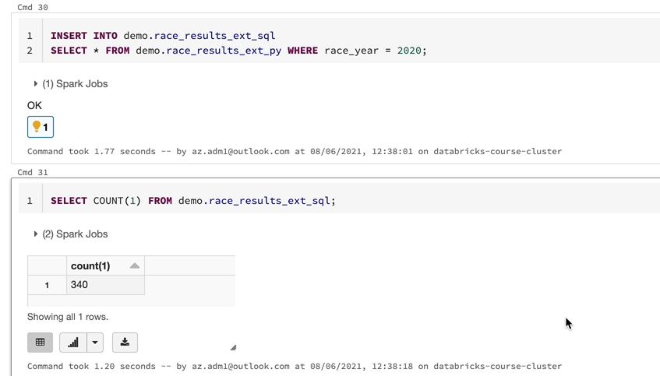

but the important thing we want to do is to go over to the storage explorer and see the folder. So the folder should appear here so she can see the folder here.

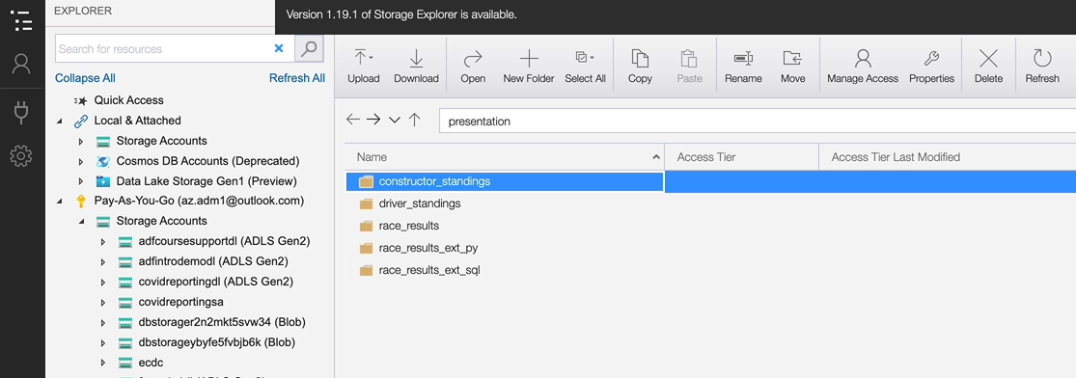

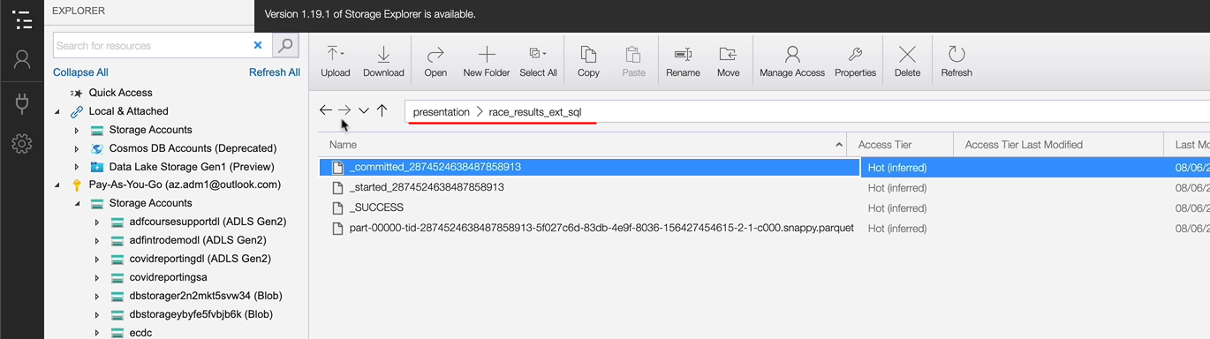

So when you create an external table, it's just a table that's being created, which is the metadata has been created in the Hive Metastore, or you could call it that. You've registered an external table. But when you insert data into that table, that's when the data gets written into your object storage. In our case, which is ADLS, if you are in AWS that, that'll be S3 for example.

So the last thing we want to do is to see what happens when you drop an external table. So let's drop this table. Before we do that, I'm going to do show tables in our demo database just to list all the tables there,

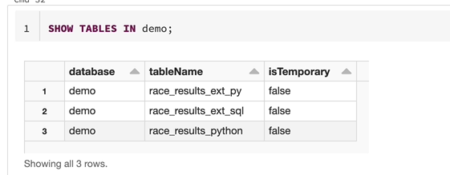

and then now we're going to drop this table and we expect to see that table being removed from the register. If I just rerun this one one more time. And that table has now disappeared

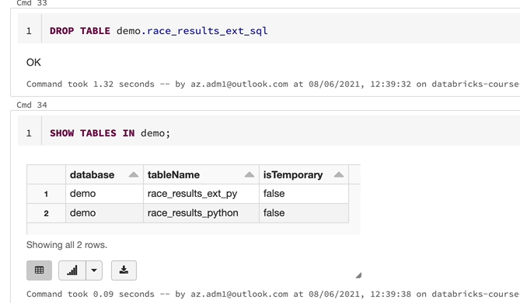

but. The data here would stay as it is, so it's not going to change, it's exactly stay as it is.

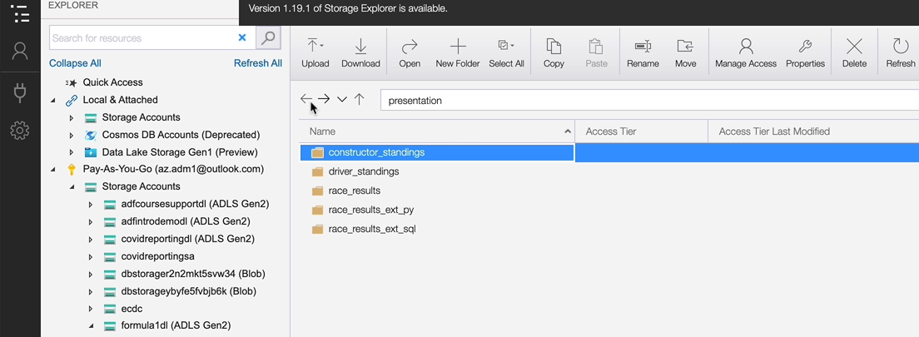

So that's the difference between external table. In the case of external table, you are controlling the data. So if you wanted to remove this data, you will have to run commands to remove data from the file system. Separately, dropping the table itself won't have an effect.

The beauty of this is I could simply come here and then run this statement now, which is create table on this location. I don't even have to insert the data because the data is already there.

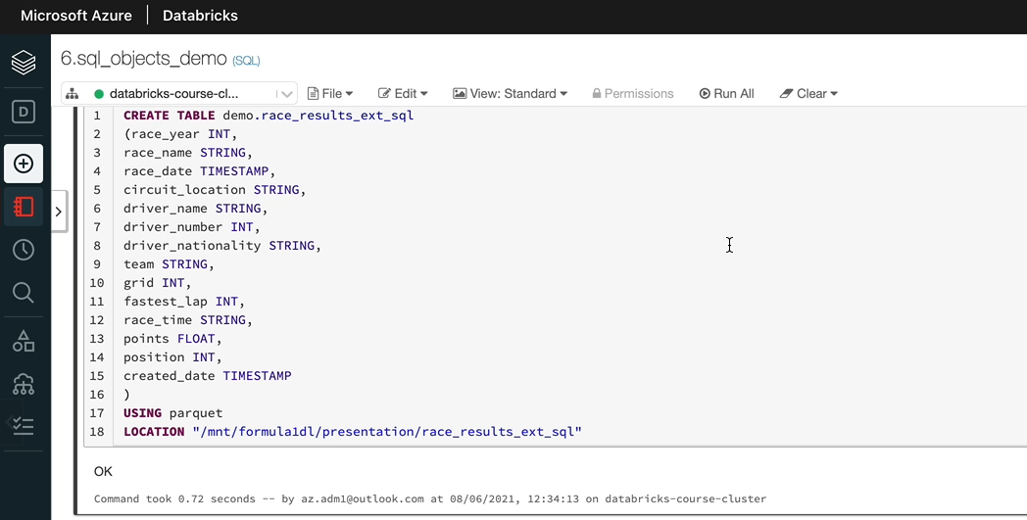

So if I just run the select, I can't tell one more time it'll give me all the data. So that is three hundred and forty records.

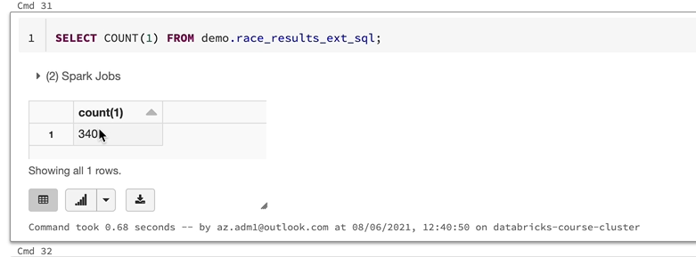

So that's how it works, because it is our presentation layer be played with. I'm going to remove these two folders so that it's clean. I should have really created a separate container called Demo and then worked on that one for the demo purposes.

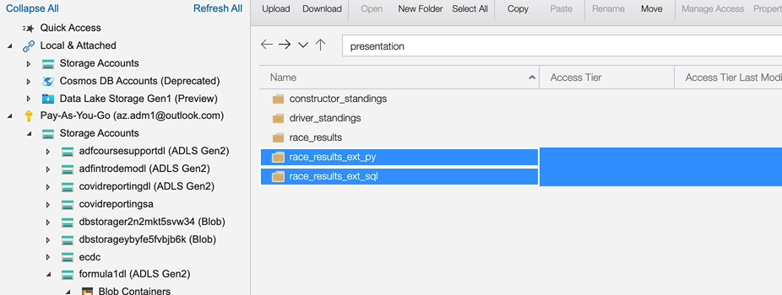

But it's okay, we can just remove it and tidy up from our project space. So let's click s. So those two folders have been deleted and the table could stay as it is because it's just on a demo database. So just to recap, the difference between external and manage tables is that, in the case of manager table Spark, manages are Spark maintains both metadata as well as data, but in the case of external tables, Sparke only maintains the metadata and the externally maintained the data itself.

### Views

In this lesson, we are going to look at views that you can create on tables. If you're coming from a relational database background, that will be familiar. But the difference between a table and a view is that tables are supported by data and they store data. In our case, the tables, the managed, as well as the external tables that we created, have underlying data stored in our Azure Blob storage or the as Azure data lake storage. But a view is simply a visual representation of that data. So in in this case, we'll be creating views on top of the tables. So when you execute a view it doesn't have any data in itself. It's going to query the data from the tables and then give you the results back. So that's the main difference between a table and view. If you remember from a couple of lessons back where we created temporary views on data frames, the concepts are pretty much the same, except that here we are going to use the SQL syntax to create views on top of tables themselves rather than data frames. But we have the concept of temp view and the global temp view, and they work exactly the same way. So temp view, for example, is only accessible within this spark session. It's not available outside of the spark session. And the global temple is available within this spark application. So that means any notebook that's attached to the cluster can access that global temp view. So if you're unclear about any of this, please go back and watch those videos. But we'll just quickly create those temporary views here and I'll show you how that's done using the SQL syntax.

%md

#### Views on tables

##### Learning Objectives

1. Create Temp View

1. Create Global Temp View

1. Create Permanent View

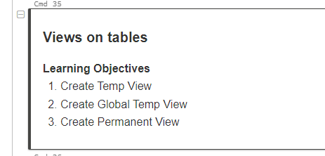

So the way you do that is create temp view and it'll be you can call it a name. So I'm going to call my v_ race_results as so, that is like a create table as statement, so it is clear to us and then you specify the table from which we want to select the data. So I'm going to get the data from our managed table, because that's the only one which is got data. The moment we drop the data from the other two external tables, let's do that. And if you wanted to apply a filter, you can do that. You can do any kind of transformations you want to do. So I'll just simply apply a filter just to show you how that's done. And when I run this one, it's going to create the temporary view.

SELECT CURRENT_DATABASE();

CREATE OR REPLACE TEMP VIEW v_race_results

AS

SELECT *

FROM demo.race_results_python

WHERE race_year = 2018;

OK, so that's because I haven't qualified it with the database name. I restarted the cluster. I am on the default database. So it's it's better I show you why that's happened. So if you do select and then if you do the current database, that will give us the current database. And that is the default.

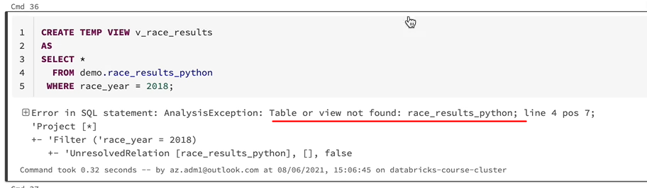

So it's looking for that table under the default database and now that I've qualified it with Demmer, it's going to find that table. Or I could have used the use statement use demo to switch to the current database as a demo. But I'm going this way now. It should create the value for us. So let's run that statement and we should have the view.

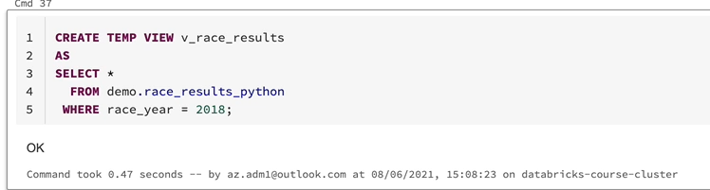

So if I do start from The View, I should be able to see the data. So that's brilliant. That work will be limited to Rasiah 2018. That's why we're seeing the 2018 data.

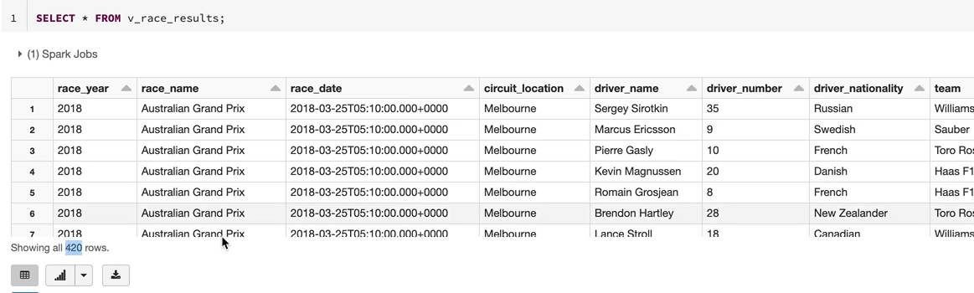

The next view we wanted to create is the global temporary view. But before that, let me tell you, if we rerun this statement again, it's going to fail because the view already exists. So in order to get around this, you can use the create or replay statement. So that means if the view already exists, it won't try and recreate it. Otherwise it will just create the view for us. So this notebook will become re-runnable by doing this. Let's now create the global temporary view. So I'm going to copy that statement and put it here. And the difference here, again, is the only keyword global here. So it's going to be createOrReplaceGlobalTempView. And I'm going to call this view as gv_race_results. And let's pick data from, say, 2012.

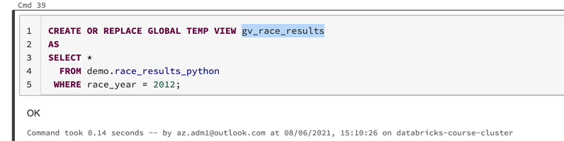

And again, in order to select data from this table, you have to use the global_temp database and then use the table names. So that'll give us the data. I'll show you why we needed to use the global temp. We explained that previously.

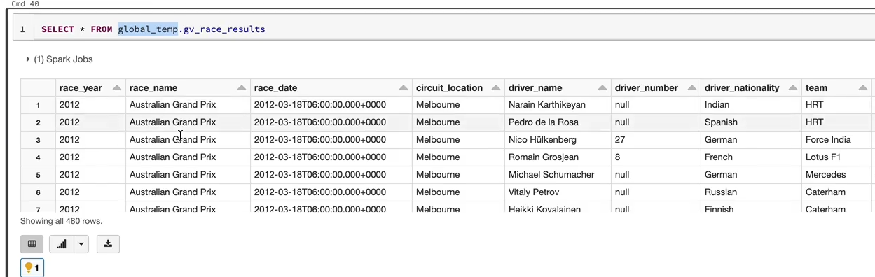

But let me quickly show you, because that database is the one which is going to have to be. So I'm going to do show tables here and it's not going to have that view. But if I just qualify that with show tables in global temp, you should be able to see that view, which is gv_race_results.

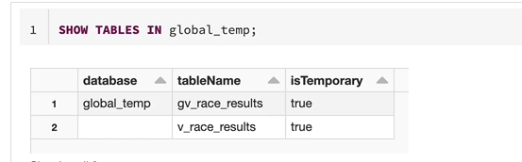

That's why we need to use global temp view.gv_ race_results to get the data. Again, similar to what we said previously, this global temporary view is not only available in this position, which is this not book, it can be accessed from under the notebook, which is attached to this cluster. So that's the difference between the temporary view and the global temporary view. So the last thing we want to do is to create a permanent view. So this view would be registered on the high register and it is permanent. So even if you detach from the databricks cluster or terminate the cluster and restart or from another cluster, you will still be able to use it. So let's do that, so in order to do that, we just simply remove the global and the temp here. And I'm going to call this one as pv_race_results for a permanent view, and I'm going to get data from, say, 2000. And if I do, I show tables, I would see that view in the default database, as you can see here, default database has got that view now.

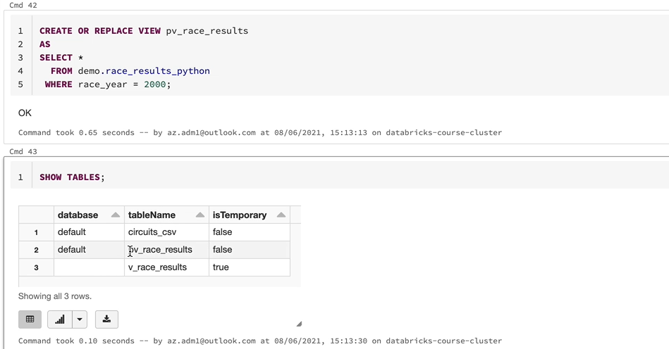

So if we simply go over to the data tab, you would be able to see that view under the default database. But we wouldn't want to put anything under the default database.

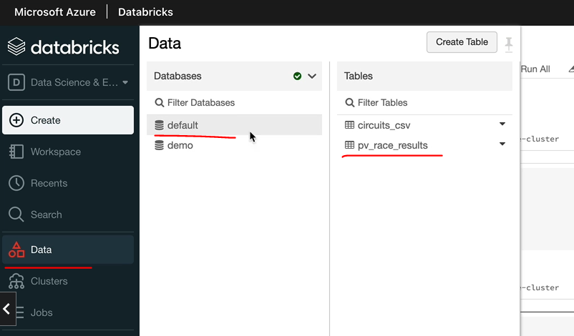

So it's normally advisable to put it into a named database, which is which is created by us. So let's put it into the demo database. And now that will be created under the DEMO database. We still have the other view that we can drop, but if I do show tables in Demo, you're going to see that view as well. So we have the view here called pv_race_results.

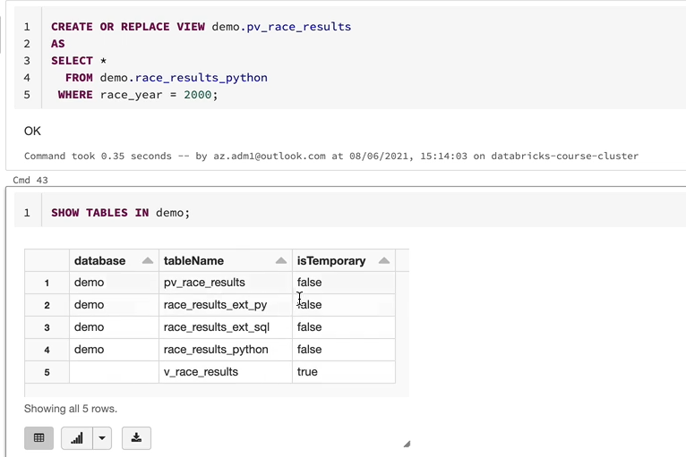

And I'll just quickly detach and reattach to the cluster, and you will still be able to see that view, so if I go over to data and the demo, you're going to see that view, it will be there.

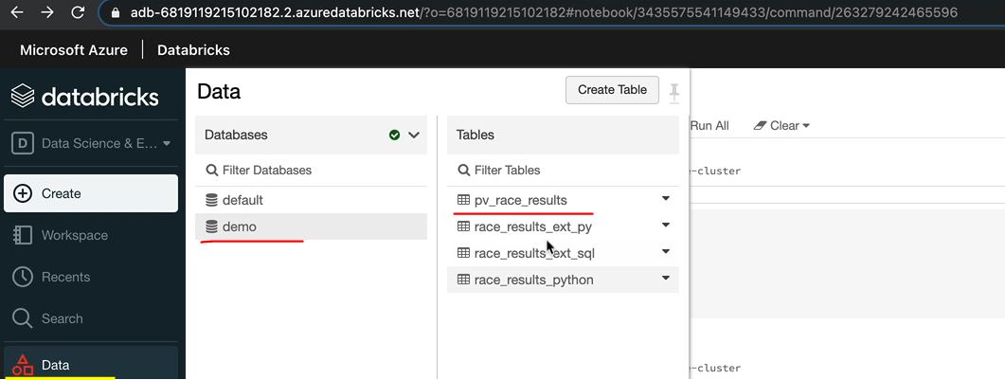

And also, if I just ran the select statement on this view, you're going to be able to see that data as well. So that is pretty much permanent. And you can come and access that view any time you want to. So that's how the permanent views work. You might be wondering when to use which view. So, as we said before, if you want to create a bill and use it within the notebook and then you think it's not going to be useful anywhere else, you would create a temporary view so that is only available within the spark session, which is the current notebook, but if you want to create a set of views and then use it in the other notebooks within the same application, and then once you've done that batch process or a job, you don't need those views anymore because we produce the outputs and return to, for example, tables. Then you go for a global tempoary review.

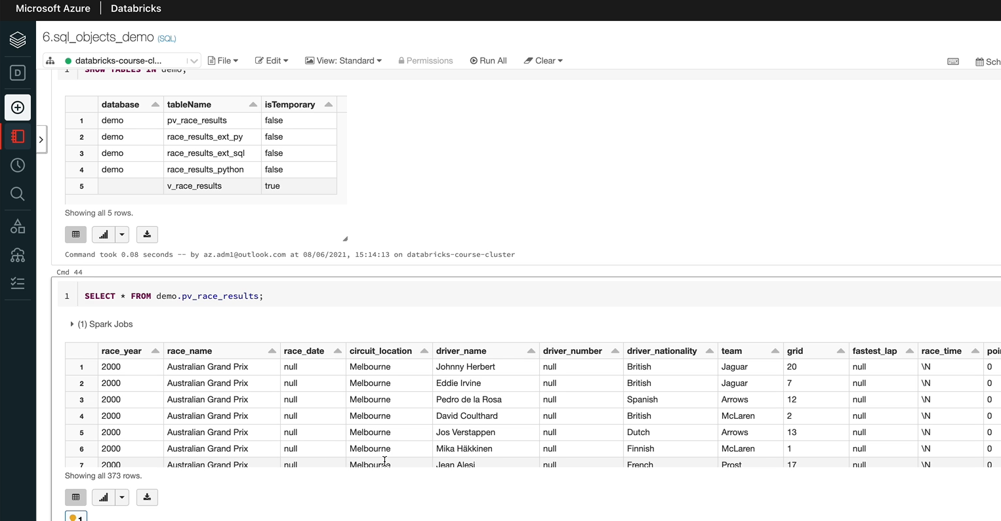

But if you want to have views which you want to be able to come back and access, then you want to create permanent views. A typical scenario where you might want to have a permanent view is you have a table with a lot of data which is being populated by pipelines, and then you have some dashboards accessing these tables. But the data needs to be summarised for the dashboard so you can create some views and the views, the results of the views could be used in the dashboard so that they could be permanent views. So that's about the views on SQL tables.

### Formula 1 project SQL Requirement

Now that we understand the difference between managed and external tables, let's have a think about whether to use managed or external tables for our project as we know that raw data is manually imported in our solution. Even if we had an automated solution that's unlikely to this spark or databricks, the most likely solution would be to use Azure Data Factory copy activity to pull the data from the Ergast API.

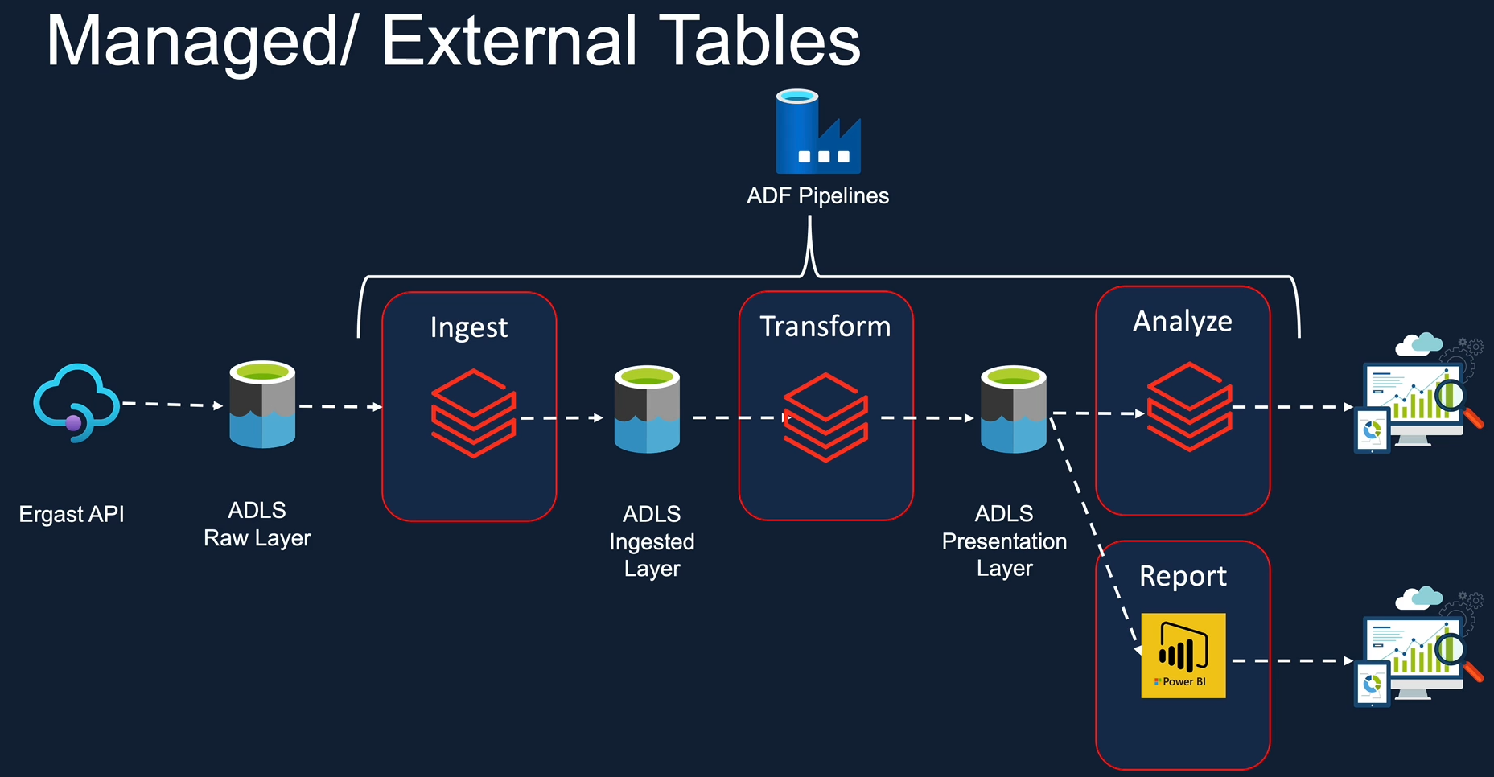

Because Spark is not managing the data for this layer, the most appropriate solution is to use external tables. On the other hand, the data in ingested and presentation layer are managed by spark for our project, we're not using any of the solutions to create or update data in these layers. So the most appropriate solution is to use managed tables. Having said that, I've seen many industry projects using external tables for all three layers.

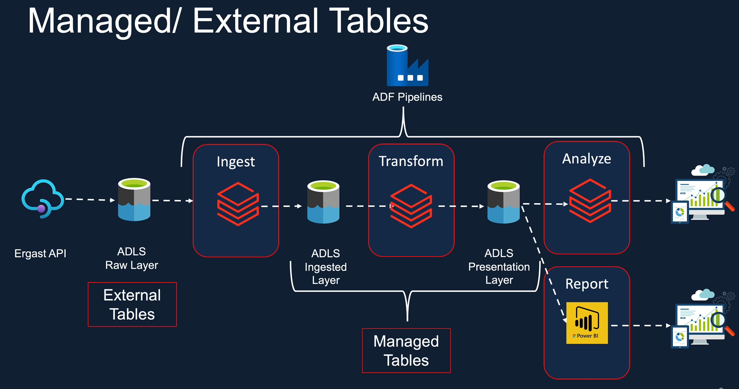

So please don't be surprised to see that the solution I propose here is based on the criteria that we discussed in the previous lessons for using external and tables. In the next few lessons will create the external tables for our role here and change the pisspot notebooks, which we already have for our intuition and the presentation layers to create the managed tables while the data is being loaded.

### Create Table – CSV Source

As we discussed, we want to create external tables for our raw data. So in order to do that, let's create a new notebook. But we don't have a folder for raw at the moment, so let's create a folder first. So I am creating a new notebook called that create raw tables, and that's a SQL notebook and let's create and I also want to create a new database so that we can keep all the tables in a separate database, our schema, whatever we want to call it, and it's easier to find them. So let's do that first. I'm going to do create a database f1_raw. So the database is now created. We can let the data and that's the database with no tables at the moment. As we discussed previously, very similar to the tables. You can also do create a database, if not exist. So this becomes a re-runnable script or a notebook. So the next thing we want to do is to create the tables. So let's start with the circuits table. If you remember, the circuits file is a CSV file and we've examined the data already when we did the ingestion for the circuits file, so let's pick that script up. That will give us all the information we need in order to create these raw external tables. So I'm going to open this in a new tab. So this is the CSV file that’s under the raw folder path circuits.csv, and that file had the structure here as we've defined, and it's got the header as True.

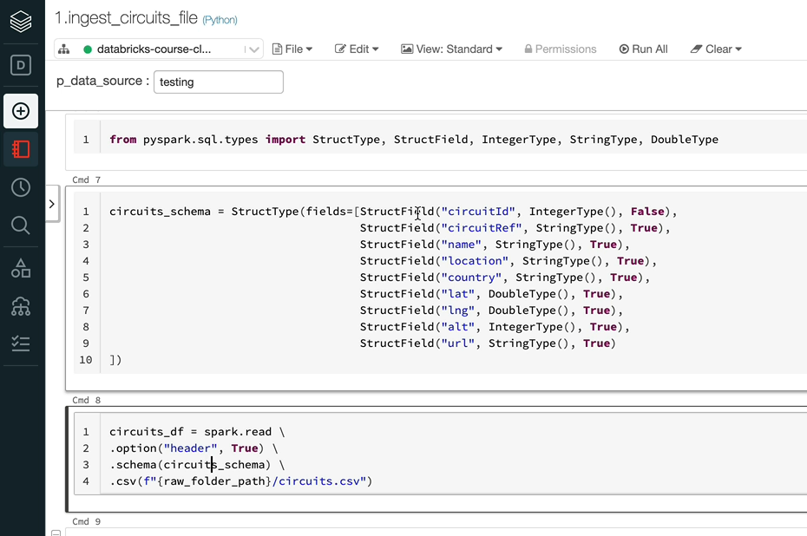

And that's the schema that we've defined. So it's quite simple file, so we're going to use this information to create our create table statement. The only difference will be that instead of using these kind of struct types and Struct fields, we will be using the DDL style of schema. So let's do that.

I've already prepared the schema for us just to speed up the time, and the next thing we want to do is we want to give the format of the file. In this case, we as we said, it's a CSV file. So let's use using csv. And the next thing is we want to specify the path that a couple of ways of doing it. You can use the location option to do it. But I'm going to use path here and you specify the path here. We have got that under the raw mount for us.

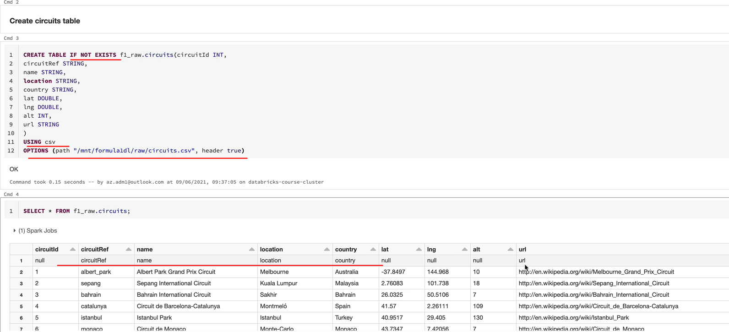

So that's created the table and let me just do a select from the table here. And the data looks OK, except for the first record, because we've got the header being printed as the first record, so in order to fix that, let's specify the header as true. This is still not going to work and I'll show you why. So as you can see, we got the header record being printed as the first record. That's because we have got the statement here as creative. If not exists, our table already existed without the header option being specified. So. It didn't recreate the table with the new options we've specified here, so to fix that, we need to drop the table, but we will make the drop statement in the same way as we did the create statement so that it is re-runnable. So we are going to say drop table if it exists and we specify the table name.

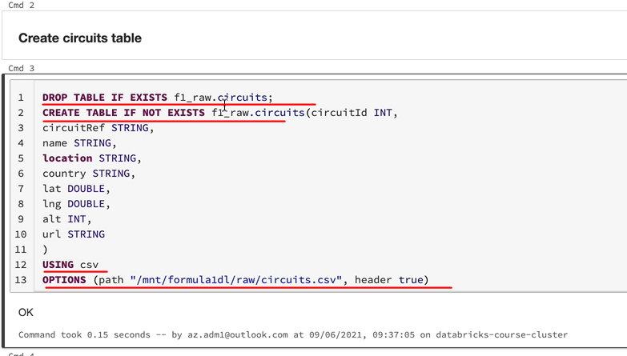

What that does is if the table already exists, then it will drop. Otherwise it won't. So when you come to run the notebook, first time there won't be a table, but it'll do nothing and just carry on because the table doesn't exist. Otherwise it'll drop it and then it just carries on. So now if I ran it, it should fix the problem. So the head has now been removed and the data is, as we expect to see.

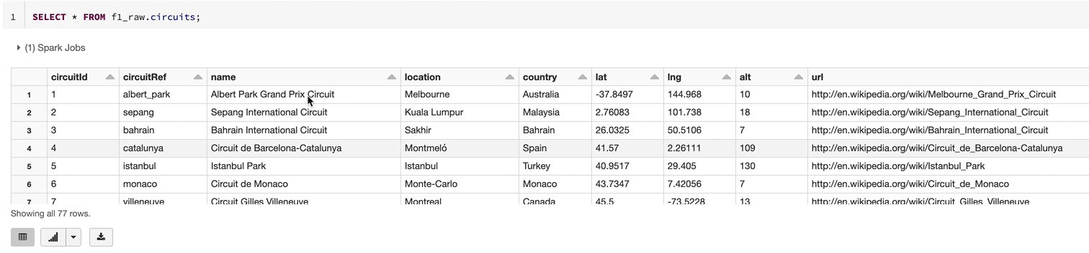

So we need to do the next one, which is the irresistable. So let me switch to my other tab and then open up the races ingestion file that'll tell us actually how the data looked.

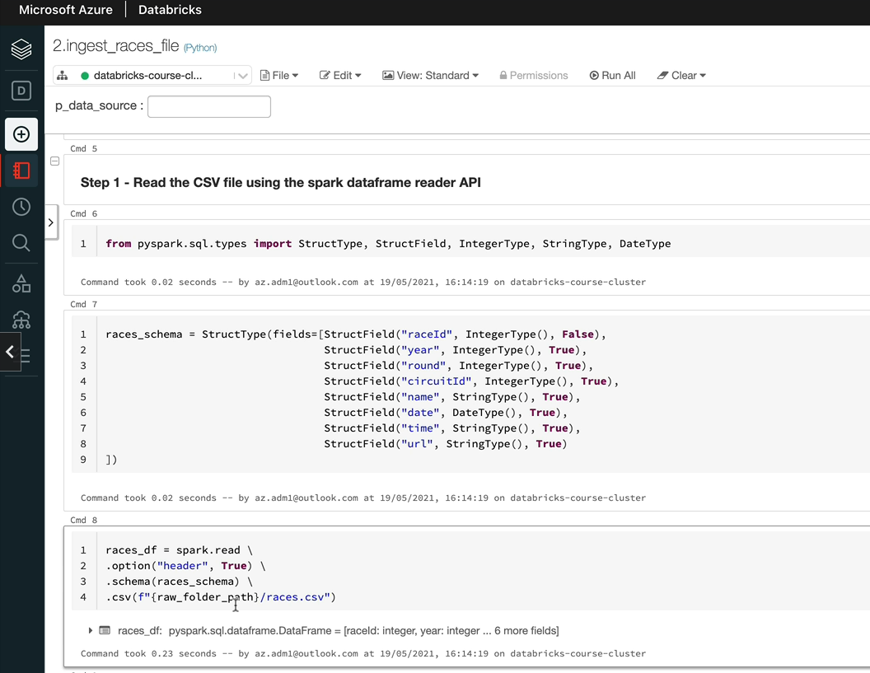

And thus we can see again, it's very similar. So we got this schema and the header as True, there is no difference between the circuits file and the races file. So let's do that here. So that's worked and let's have a look at the data as well, just to make sure that's as expected. Yep, that worked fine. So as you can see, it's a CSV file and the header is true and this schema as we've seen in our ingestion.

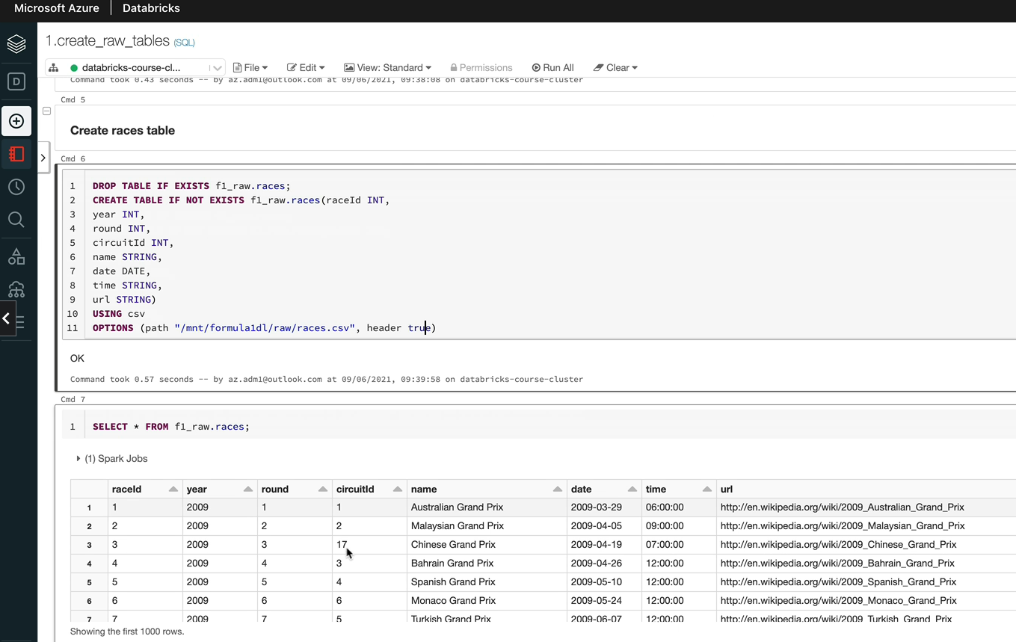

So that's all the CSV files we had in the next lesson. And we look at handling the JSON files.

### Create Table – JSON Source

In this lesson, we are going to look at creating external tables for the adjacent files, so as we know, we got a few JSON files, we got the constructors, drivers, racists and pit stops, and there are varying combinations. So some of them a single line files, some have a simple structure, some have a complex structure, and others have got multiline JSON as well. So we'll deal with each one of those. We'll start with the constructor's file first. And that is a single line, JSON, with a simple structure. Let's open up the ingestion notebook so we can look at it properly. So as we can see here, this is basically got the schema here and use the detail structure as well, which is great. So we can directly use this in our code for clear in the table. And that's got a single line, JSON. So that means we don't have to do anything special either. So let's switch over to the clear tables notebook. And I've already put the structure here, so we got the table. If not exists, constructors is the table we are going to create and that's the schema. And what you do is you need to specify the format as JSON, like we did for the others, and then we need to specify the path. So that's all we need to do and it should work.

%md

#### Create tables for JSON files

%md

##### Create constructors table

* Single Line JSON

* Simple structure

DROP TABLE IF EXISTS f1_raw.constructors;

CREATE TABLE IF NOT EXISTS f1_raw.constructors(

constructorId INT,

constructorRef STRING,

name STRING,

nationality STRING,

url STRING)

USING json

OPTIONS(path "/mnt/formula1dl/raw/constructors.json")

Let me just quickly run the statement just to make sure that the data is as expected. That looks brilliant, it's as simple as clear the table like this for the adjacent file.

SELECT * FROM f1_raw.constructors;

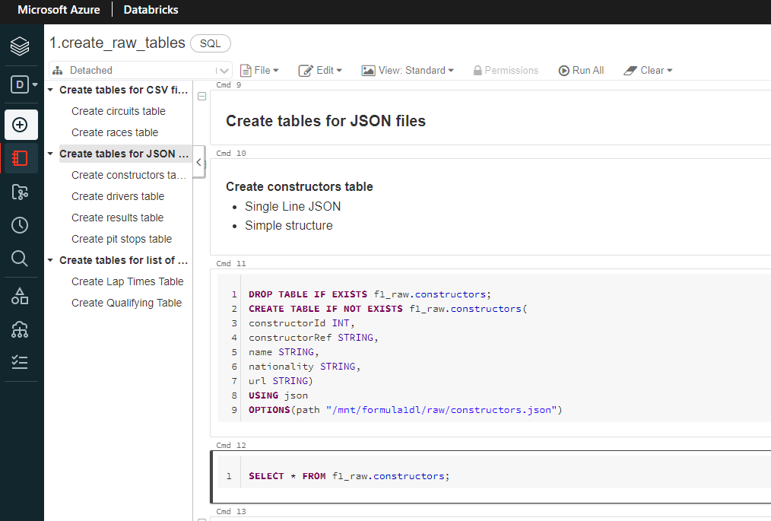

So the next one we've got is the drivers table and that's again, a single line, JSON, but it's got a complex structure. So let's again open it up and see what we mean by that. And this is the schema and the name here is actually a complex structure, so we got a name schema that contains before name and the surname. So we need to specify that in our DDL and I'll show you how to do that. And everything else looks exactly the same because it's a single line and we don't need any other options either. So let's switch over to our notebook. So up to the column name everything is as we normally do, because that's a String type and the name is not one of these base data types. So we need to use the Struct type for that one.

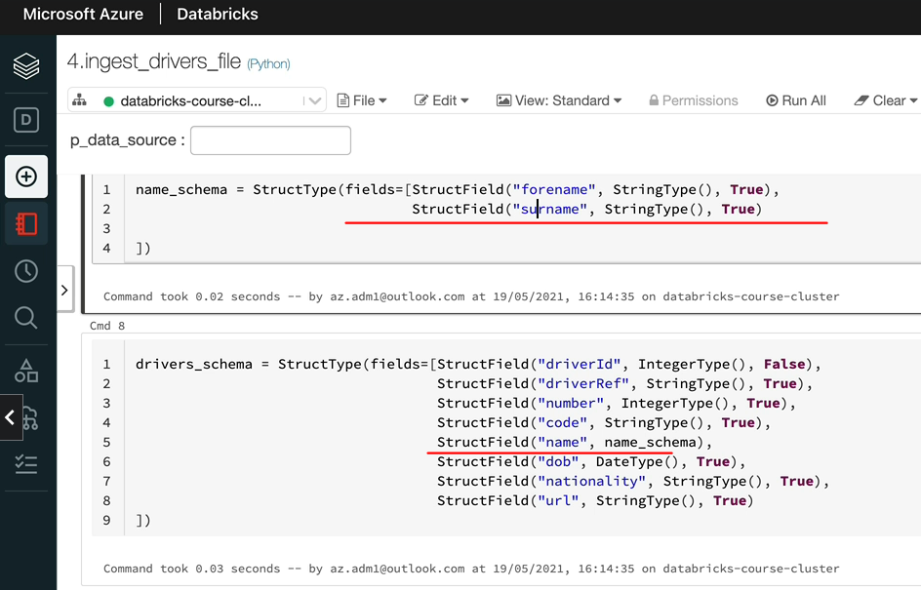

And then you specify within the Struct what are the fields you've got. So as we know, we have the forename and that's a String as well as we have the surname, and that's a String, too, so we need to specify those. So after this, everything else is exactly the same as the other one. So I'm going to copy and paste from my prepared statement here. So we got the dob, nationality, url, and then the format is JSON, and this is the path where we got the file, so let's execute that. And that's worked. OK, let's quickly do a Select to make sure we can see the data.

DROP TABLE IF EXISTS f1_raw.drivers;

CREATE TABLE IF NOT EXISTS f1_raw.drivers(

driverId INT,

driverRef STRING,

number INT,

code STRING,

name STRUCT<forename: STRING, surname: STRING>,

dob DATE,

nationality STRING,

url STRING)

USING json

OPTIONS (path "/mnt/formula1dl/raw/drivers.json")

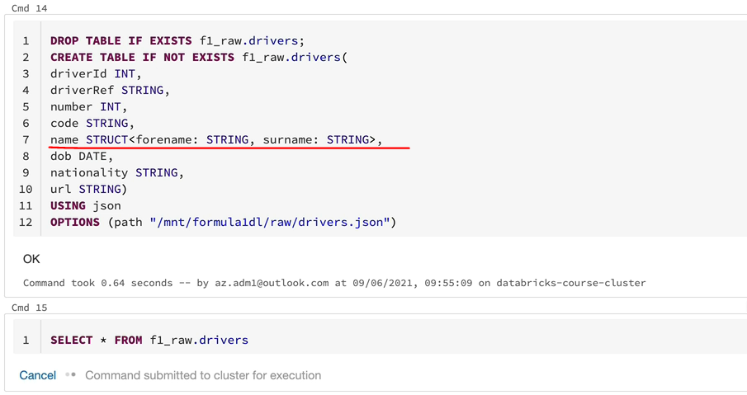

And as you can see, everything looks OK, and the name column is an object with the forename and surname rather than a simple data type of string.

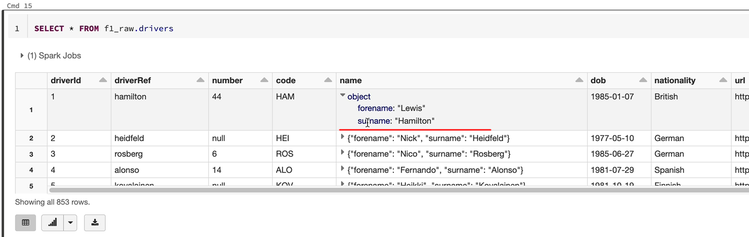

So the next one we want to do is the results table. And it's a single line, JSON, with a simple structure, as we did for the constructors file, because that's the single single line, JSON, as well. So let's switch to the Ingestion script and as I said, it's got a simple schema as defined here, and there is nothing special. So there are no other options we need to specify. It's a single line JSON. So let's get back to the notebook here to create the raw tables. And I'm going to put the pre prepared statement here and I'll walk you through what I've got here. We got a drop in the table, as we did for the other ones, and then we're going to create the table with the schema. And then the format we want to specify is JSON. And the one thing I'm missing here is the path. So I just quickly specify that. OK, let's get that one, and that should be OK. Let's quickly check the results anyway.

DROP TABLE IF EXISTS f1_raw.results;

CREATE TABLE IF NOT EXISTS f1_raw.results(

resultId INT,

raceId INT,

driverId INT,

constructorId INT,

number INT,grid INT,

position INT,

positionText STRING,

positionOrder INT,

points INT,

laps INT,

time STRING,

milliseconds INT,

fastestLap INT,

rank INT,

fastestLapTime STRING,

fastestLapSpeed FLOAT,

statusId STRING)

USING json

OPTIONS(path "/mnt/formula1dl/raw/results.json")

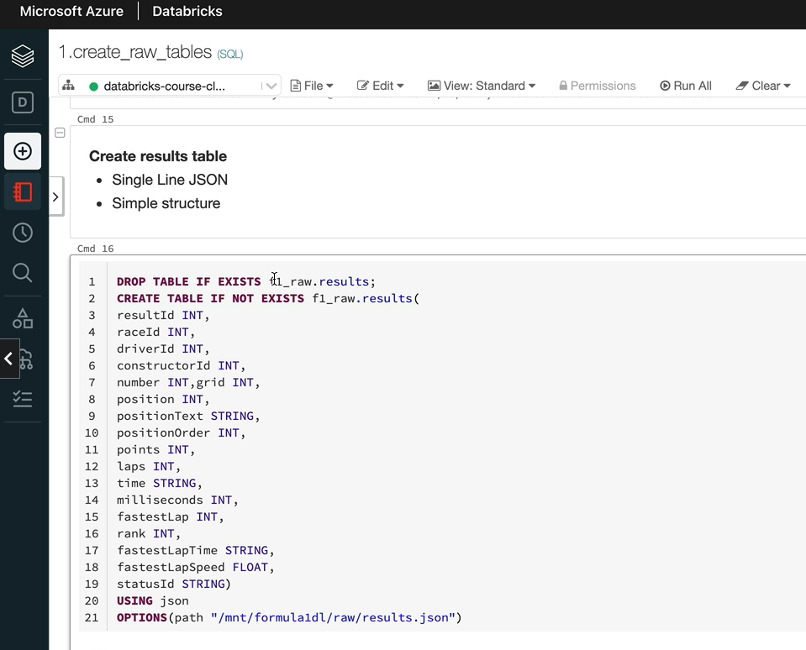

And as you can see, everything looks OK

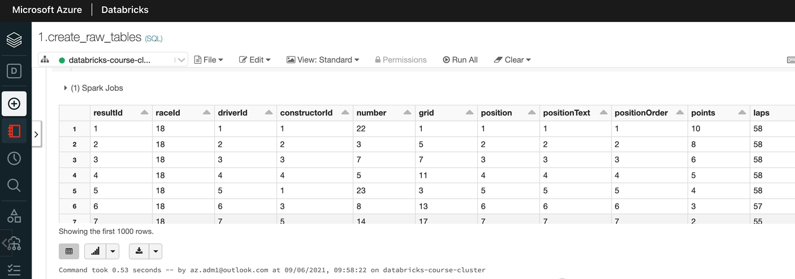

So the last one of the JSON files is the pit stops file. So let's have a look at that. As we specified here, it's a multiline Jason with a simple structure. But let's quickly look at the injection script anyway and. As you can see, we got a simple schema here, but we have the option multiline, which we need to specify when we create the table and everything else looks as we've seen for the others.

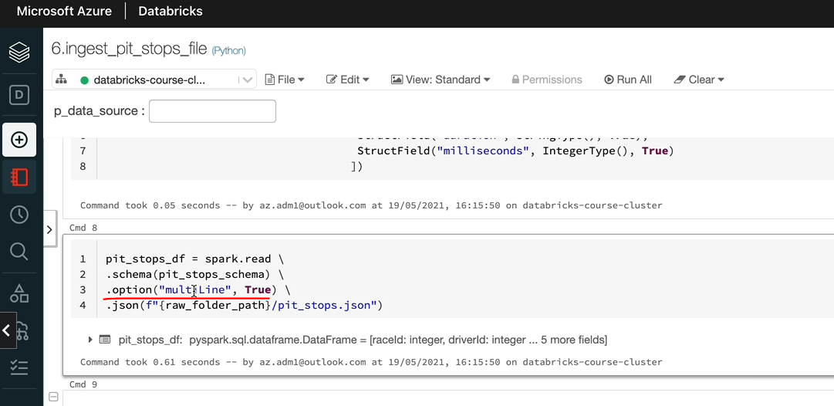

So let's switch back to the notebook. So similar to the other tables, everything else looks the same. So we got the table with the schema and then you've got the format as JSON. But within the options, the path is the path is very similar. We just have to specify the path. But we also need to specify that it is a multiline, Jason, so in order to do that, you do the multi-line see the case. It's Camel case. And we specify that that's true. So that should pick up the multiline JSON.

%md

##### Create pit stops table

* Multi Line JSON

* Simple structure

DROP TABLE IF EXISTS f1_raw.pit_stops;

CREATE TABLE IF NOT EXISTS f1_raw.pit_stops(

driverId INT,

duration STRING,

lap INT,

milliseconds INT,

raceId INT,

stop INT,

time STRING)

USING json

OPTIONS(path "/mnt/formula1dl/raw/pit_stops.json", multiLine true)

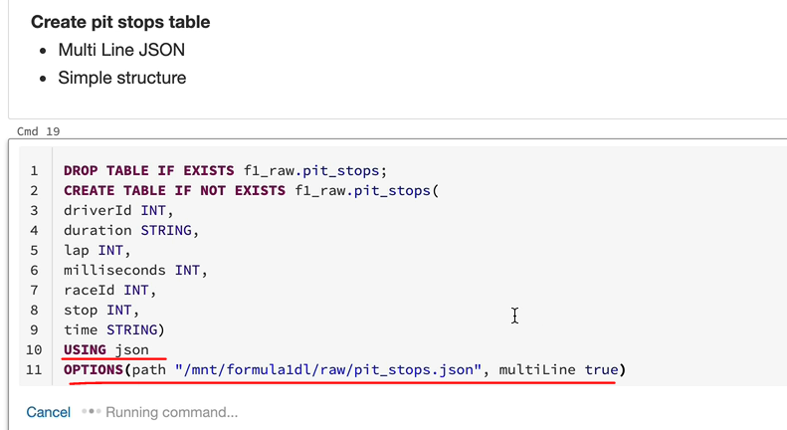

And let's just do a act to ensure that we can see the data and we haven't done anything wrong. So, yeah, you can see the data, so that's how it works.

SELECT * FROM f1_raw.pit_stops;

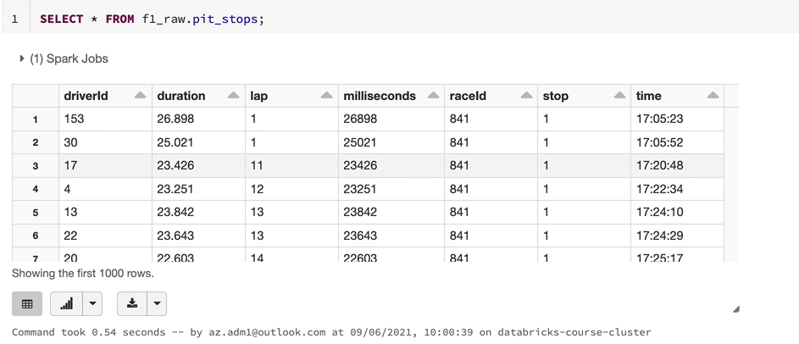

The only difference here is multiline as true. So any options we specified in our spot don't read API or the data from the API, as we call it. We can use them within options here as well. So everything we did there, in addition, we can use it on a table here as well. I hope now you've got a good understanding about how to create External tables for JSON File.

### Create Table – Multi Files Source

In this lesson, we're going to be looking at creating tables for a list of files and what we mean by that, actually we have some of the files which are split into multiple files. I'll quickly show you what they are. You've seen them before, but just to just to make sure you understand what we're talking about. So we have the lap times and the qualifying

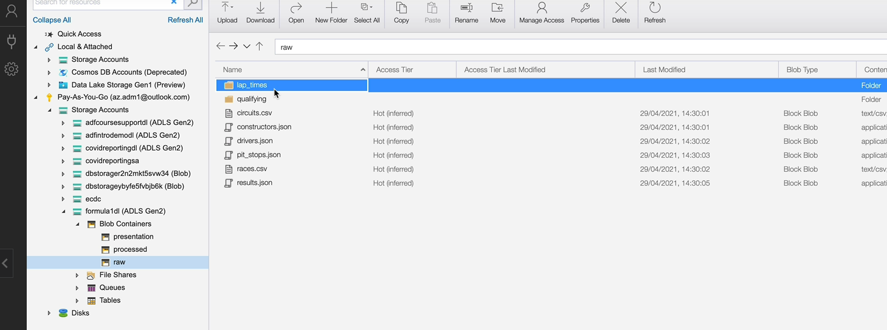

but under the lap times, we've got five different CSV files and under qualifying we've got two different JSON files.

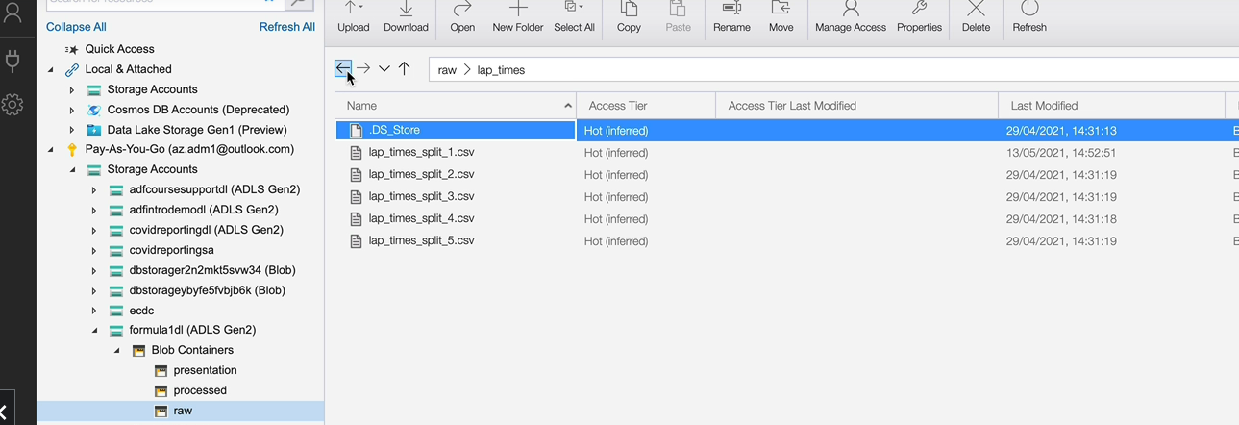

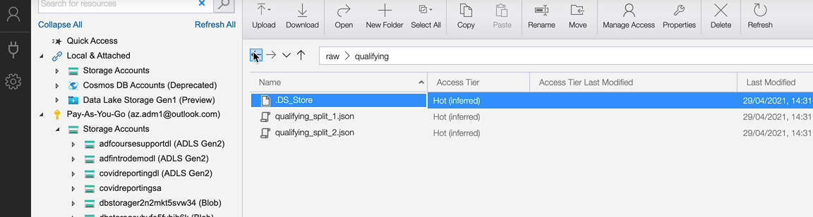

So what we want to do is we want to create a table on top of the lap times folder and also create a table on top of the qualifying folder. So let's switch back to her notebook and let's start with looking at the injection for the lap times first. Even though it's multiple files, we don't do anything special about them, apart from the fact that within the folder path we specified the folder, which is lab_times, rather than the individual files. So that's what we need to do. Everything else looks the same because the schema is simple as well. So let's switch back to our notebook to create the tables. And again, all of this looks very similar to the others. You've got the table being created here and the columns listed here and the data types. And then we specify the format of the file, which is CSV. And now we need to specify the folder path, which is slightly different. It'll be /mnt/formula1dl/raw/lap_times. And then we stop at lap times. We don't go to the individual files, so let's give that one and it should pick up the files from the folder and then give us all of the data.

%md

#### Create tables for list of files

%md

##### Create Lap Times Table

* CSV file

* Multiple files

DROP TABLE IF EXISTS f1_raw.lap_times;

CREATE TABLE IF NOT EXISTS f1_raw.lap_times(

raceId INT,

driverId INT,

lap INT,

position INT,

time STRING,

milliseconds INT

)

USING csv

OPTIONS (path "/mnt/formula1dl/raw/lap_times")

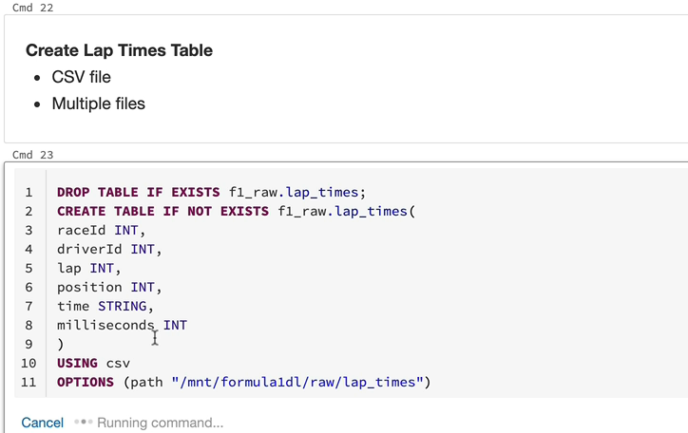

And if I just select from the table, I should see all of the data. As you can see, we got four hundred and ninety thousand attackers. We got five files and each one had roughly about one hundred thousand records. And that adds up. And let's do a select start as well, just to make sure that the columns look OK. And that's all perfectly fine as well.

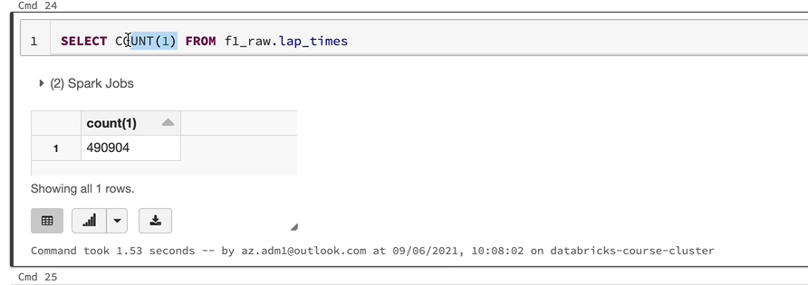

So the last one we've got is the qualifying final, this is slightly different. We got JSON files, it's multi-line JSON philes as opposed to a single line JSON file. And there are multiple files within that as well. So as we saw in our storage explorer that he had to files within the folder.

%md

##### Create Qualifying Table

* JSON file

* MultiLine JSON

* Multiple files

So let's switch to the ingestions script just to be sure as to what we're doing. So we specified the scheme as a scheme, as a simple scheme, that's fine for the fall apart as well as we did for the lap times, we will have to specify the folder. And we also have another option, which is multiline. So that's the combination we need to do.

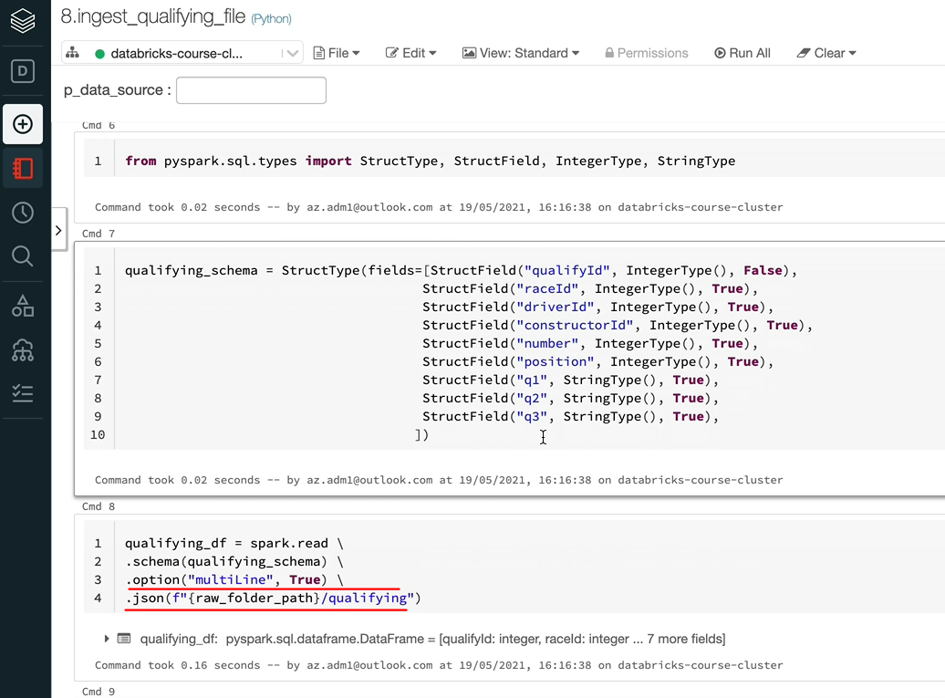

As we said, everything up to here is pretty standard. So we create the table with the columns and the data types and the format adjacent. So now we need to specify the options and that's where there are differences. So path as we know, we need to specify the path to the folder as opposed to the files. Let's do that. So we stop at the folder here rather than the files, and then we need to specify that it is a multiline JSON. So, again, remember to get the right casing here, which is Camel case, and it should now clear the table. So that's done. Let's cut the table to make sure we got the right data there as well. So that would be selected from this table. And we got the data as we expected. So that's brilliant. So that's how you deal with folders, which contains more than one file.

DROP TABLE IF EXISTS f1_raw.qualifying;

CREATE TABLE IF NOT EXISTS f1_raw.qualifying(

constructorId INT,

driverId INT,

number INT,

position INT,

q1 STRING,

q2 STRING,

q3 STRING,

qualifyId INT,

raceId INT)

USING json

OPTIONS (path "/mnt/formula1dl/raw/qualifying", multiLine true)

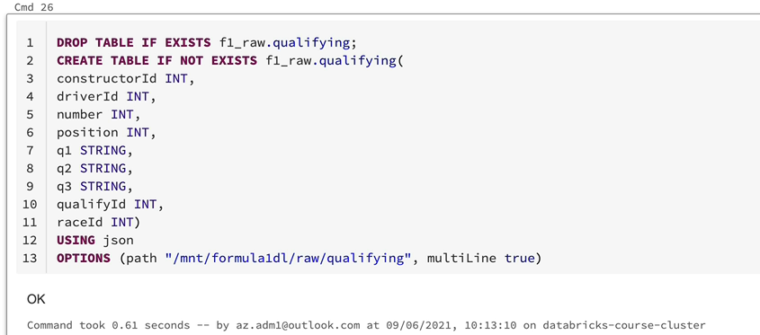

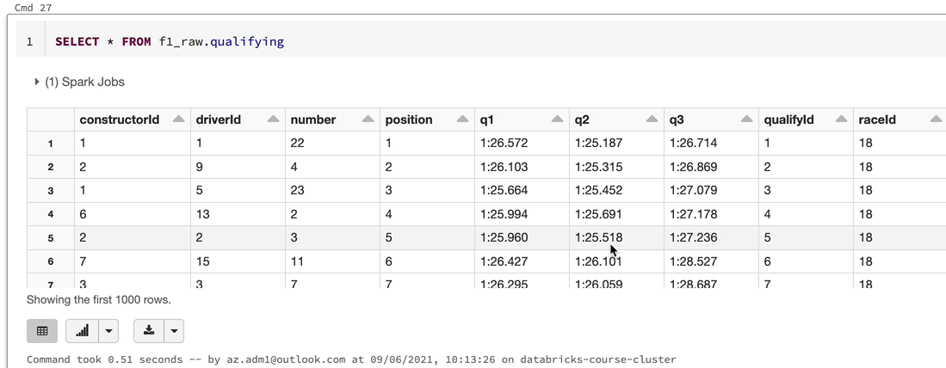

So I hope with all 8 tables being created, you've got a good understanding about how to create external tables, but I just want to quickly show you the describe of one of these tables. So let's just do describe extended on this table and we should see them as external tables as we saw them previously.

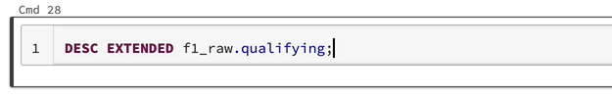

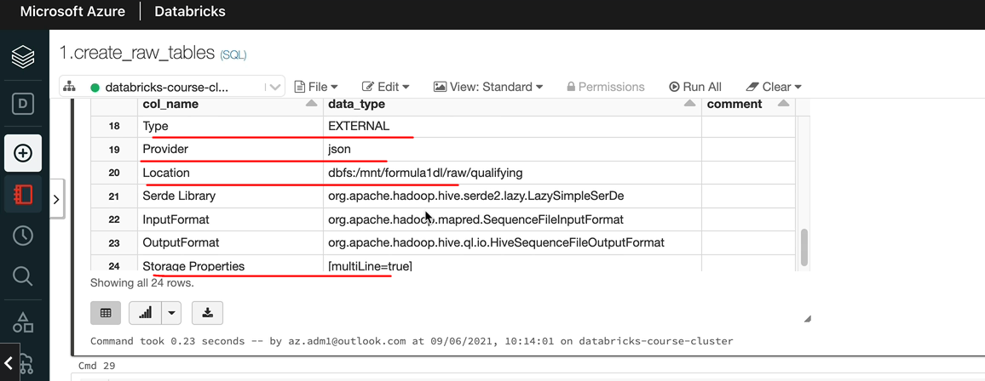

Let's have a quick look at that. And as you can see, that the type is external. And also, the table should be listed under the data tab, so come up with the data and then under Airfoil and our database, we got all of those eight tables as well. That looks neat.

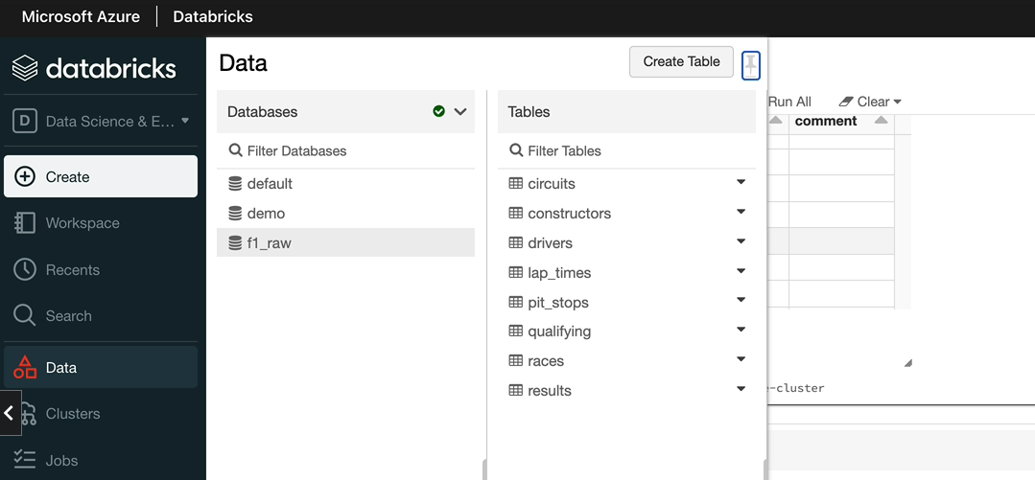

So when we come to create the other databases, we will have separate databases for each of the areas as well.

### Create Table – Parquet Source ( Processed Data )

In this lesson, we're going to look at creating tables for our data in the process to layer so they are the ones being ingested. So let's have a quick look in the storage explorer. And these are the folders for which we want to have our tables as well so our analyst can query the data using SQL as well as we can process the data using Spark. So let's get started.

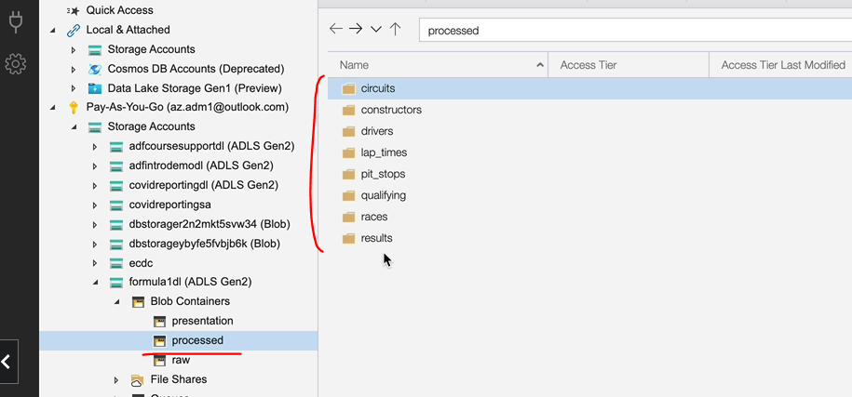

The first thing we want to do is we want to create a database because we have got a f1 raw database, but we don't have a f1 process database. So let's create a notebook within our ingestion so that we can create the database.

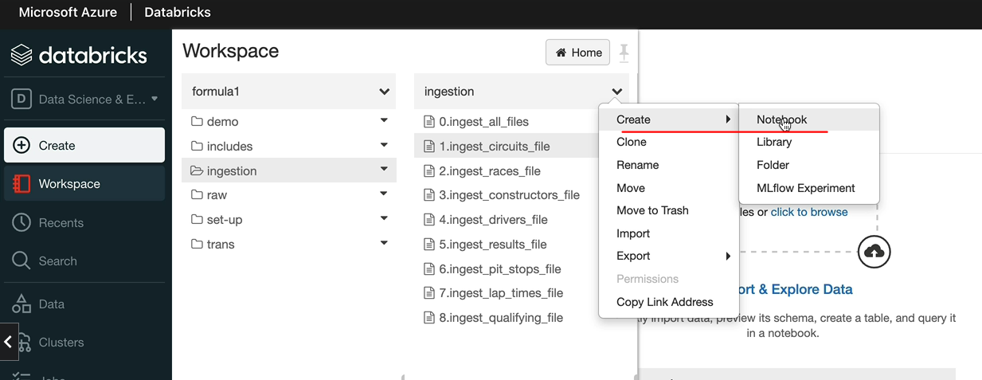

And I'm going to call this one as create processed database. And let's create the database, create a database, if not exists. And that is going to be a f1_processed, that's what we said, but we also want to specify the location here because we are going to create managed tables, not the external tables. And so that means we don't want to specify the location. We want the location to be picked up from the database itself. So that will be /mnt/formula1dl/processed. So what will happen is any table you create on the database, which is a managed table, would be created under this mount. If you don't specify the location, the data will be created under the database default location. We don't want that. We want the data to be created in our storage account that we've specifically created to keep the data. I'll show you where the default location is, because when we created the database for RAW, we didn't specify the location. So that would have the default location. So we're going to look at that.

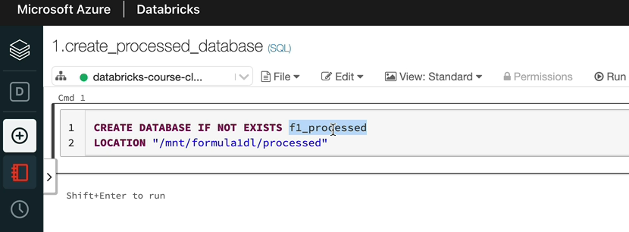

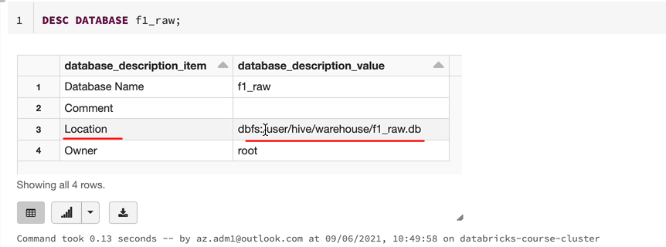

As you can see, that would be under dbfs:/user/hive/warehouse/f1_raw.db in the storage account that that's created by databricks rather than us. So we wanted to go into the Formula One, the storage account. So let's create this database with the location here and then we can look at the describe as well just to make sure the location is as we expected. So that is the /mnt/formula1dl/processed.

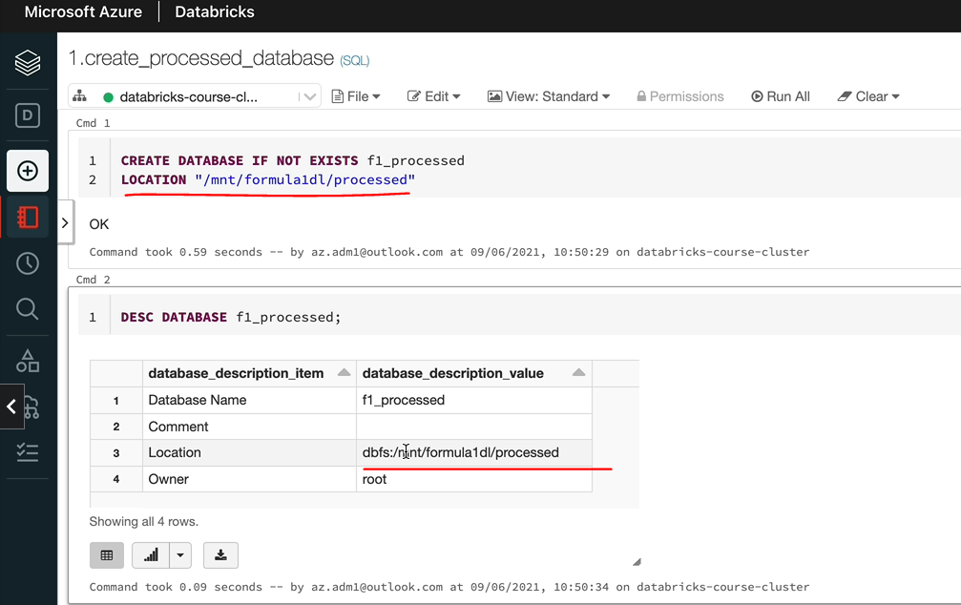

So now we need to create the tables. So we've got two choices. As we said in our demos, we can either use the SQL syntax like we did for the external tables or we can use the Python pyspark syntax. So I'm going to do the pyspark syntax for this one, which will be using the .saveTable method on the data frame itself. So let's go to our ingestion scripts. So let's pick this circuits.csv file. And if I scroll down at the moment we use the data frame right. To write the data into a parquet file. So we need to turn this into using the service table method. So let's do that in order to do it. We've got to make a few small changes. That will be the data frame name.right. The .mode is still overwrite because we want to overwrite the data and now you specify the format and within the format you specify the name file format, which will be Parquet in this case. And then we need to use saveTable method. And when we do the saveAsTable method, we specify the name of the table, so that will be the database name, which is f1 and processed and then this is the circuit file, so it will be circuits. So what will happen is it's going to create a table called circuit and register that under the f1 and called processed database. And also it's going to write the data to the folder path that we've specified in our database. So let's execute this notebook and see whether that works as we expect. I'm going to run this notebook.

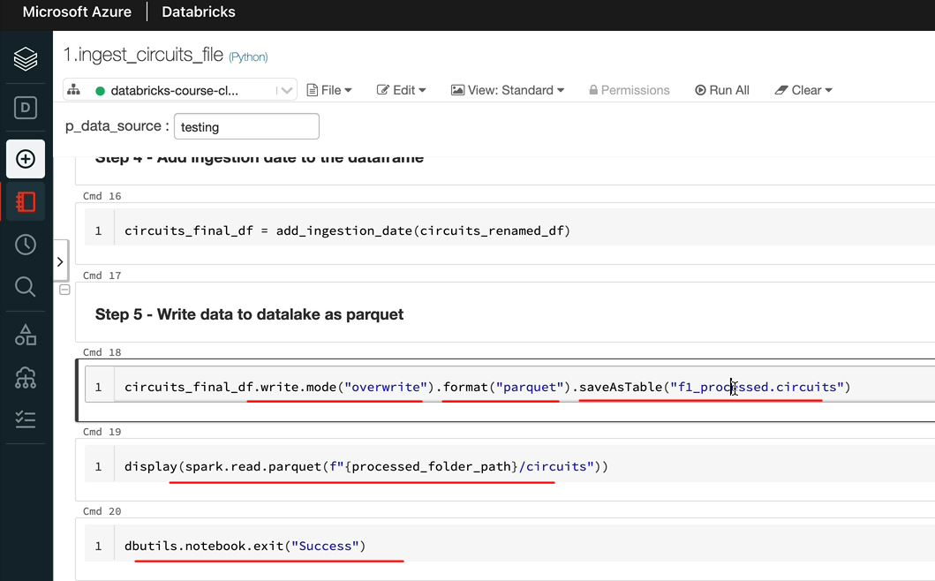

We've got this exception because we've already written the data into the folder, but the high metastable still doesn't know about this at all, really.

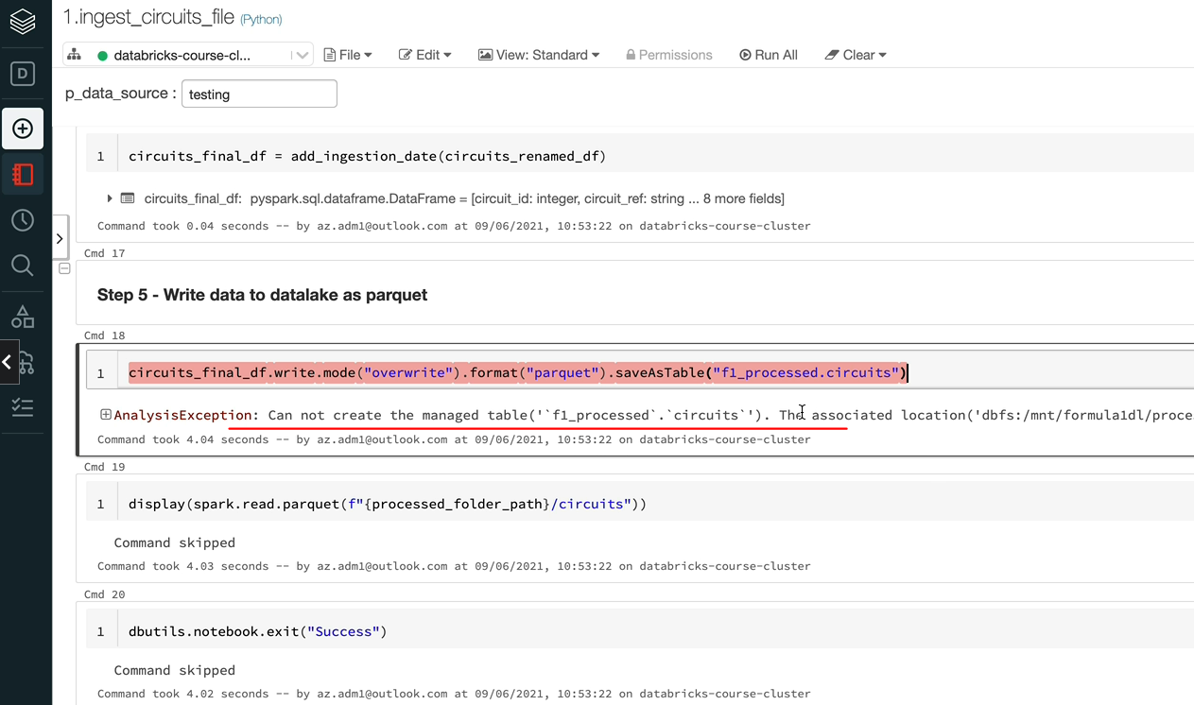

So the best thing to do is to delete the folder here. And I'm going to just do that.

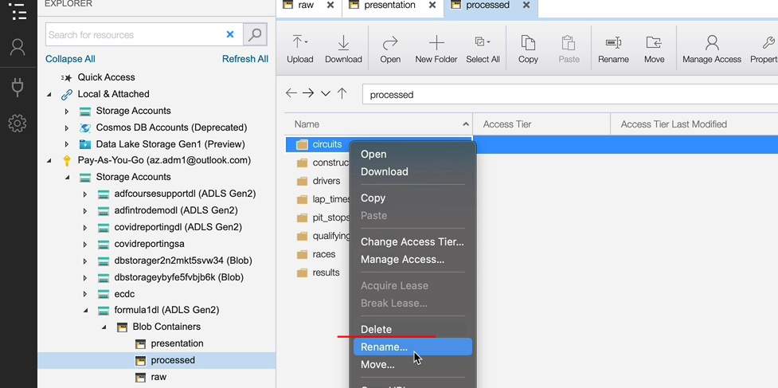

And then if we come back and run this, it should go through OK? And if I go over to the. Storage explorer, and then if I do refresh, we got all the data here, but from here onwards, any kind of clearance should go through OK as well. So I'm going to have an all again. And it should be OK.

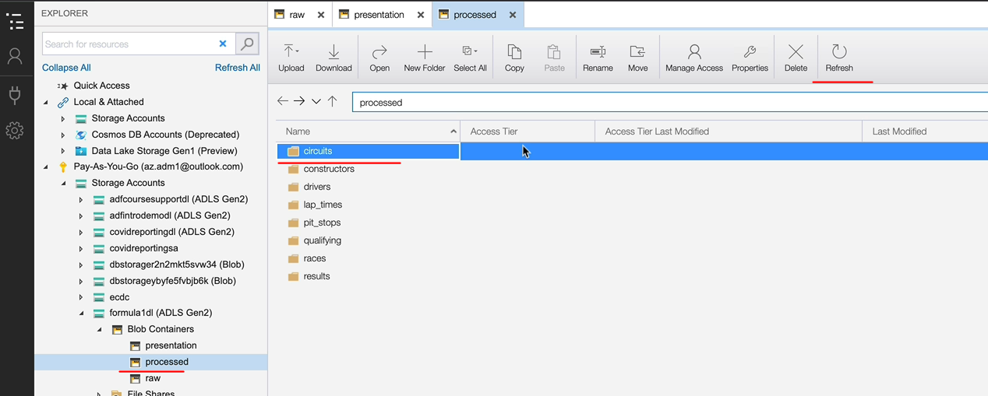

So you might be wondering how this rerun still worked because we have the data in the containers. That's OK. That's because we've created the table via Southpark now and it's a managed table. And how metastable knows that there is some data and we need to overwrite and that's done that. So the issue was just because we initially created the data without using the service table method, but now we use in the saveAsTable method. So once you've done this, it'll be fine.

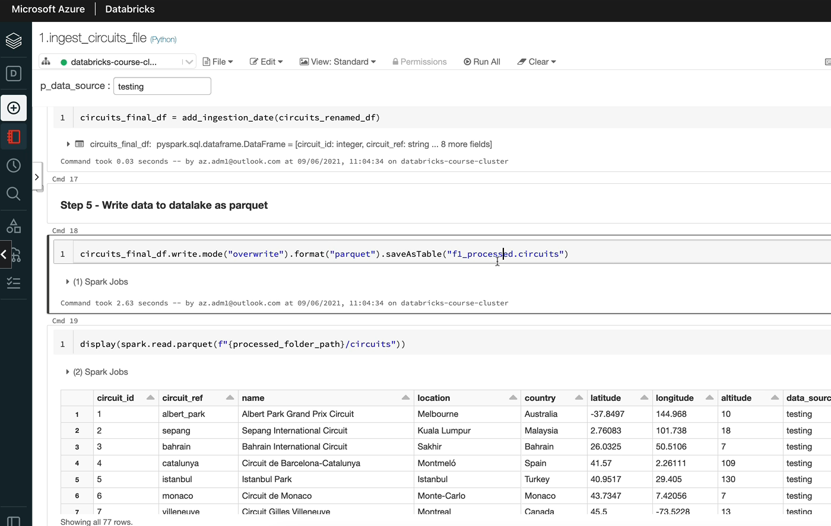

So what I'm going to do is I'm going to quickly delete all the other folders as well. So all the other seven can go. And we need to make those changes to those notebooks and then we'll rerun them and everything should be OK.

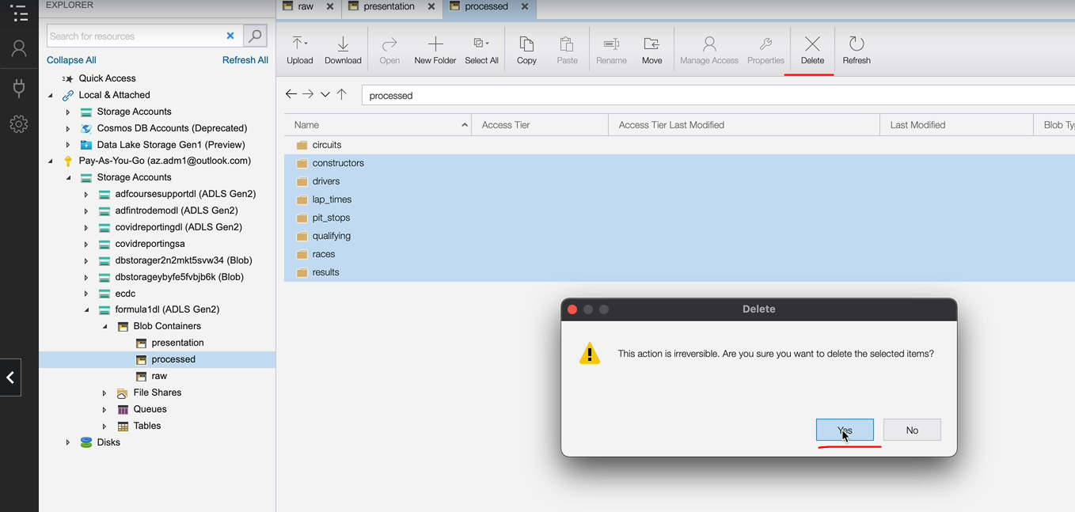

And as you can see, as a test be querying the folder path and the data is what we expected. And let's also query the table.

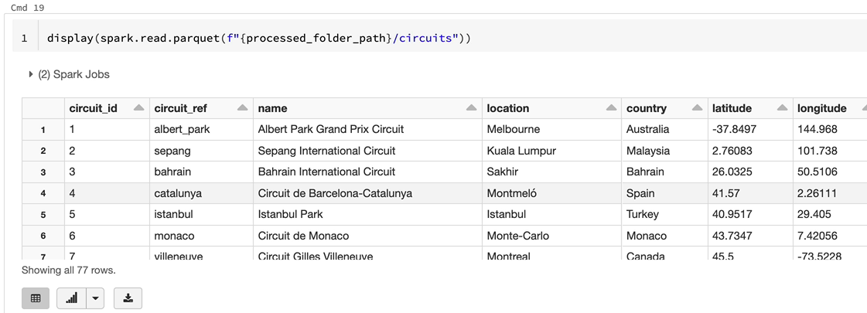

So that will be %sql because we are in a Python notebook and let's do a select from the table. So that's given us exactly the same data as well.

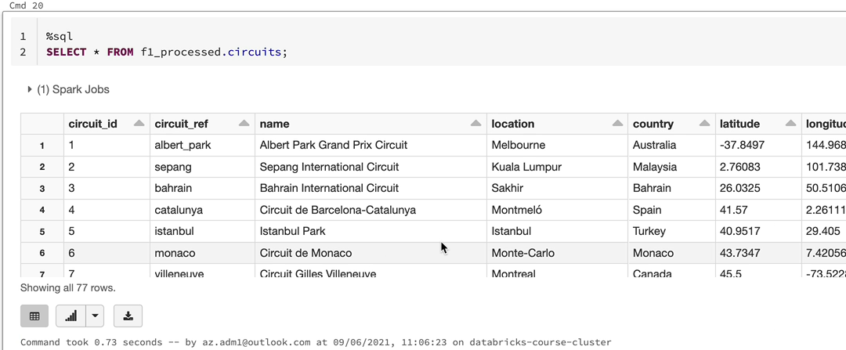

So now we've got two options to query the data. You can use the folder path and get the parquet files and process that. And normally, if you're doing data frames and pyspark code, you could be using that option. So you can use this spark.read.parquet to get the data. But if there is an analyst working on this data, they would normally prefer to get the data using the SQL statements. So we've got the best of both worlds here. So now that we've done this one, let's make the same changes to the other notebooks as well.

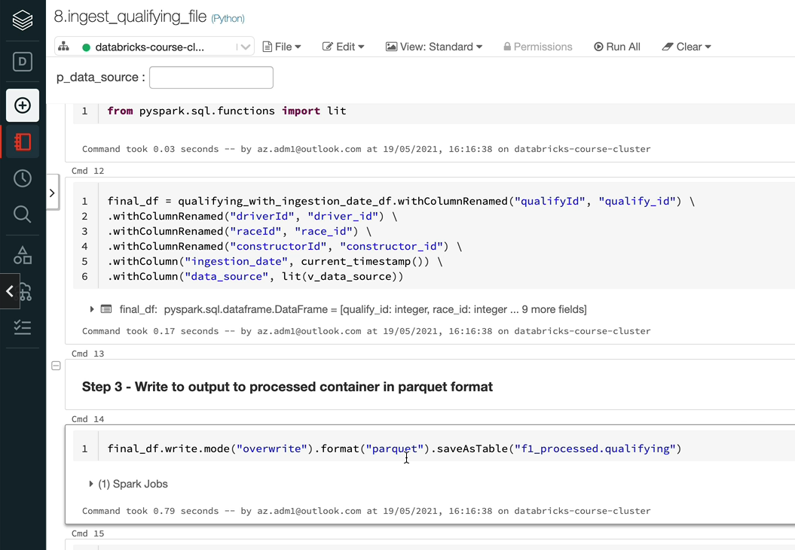

OK, and then the changes to all of the eight files here to use the service table to save our data into a table as well as right as a pocket file into the containers. So we have got the workflow notebook to ingest all files so we can run that one. But before that, I want to just quickly rename this one, because I've used the same numbering for that.

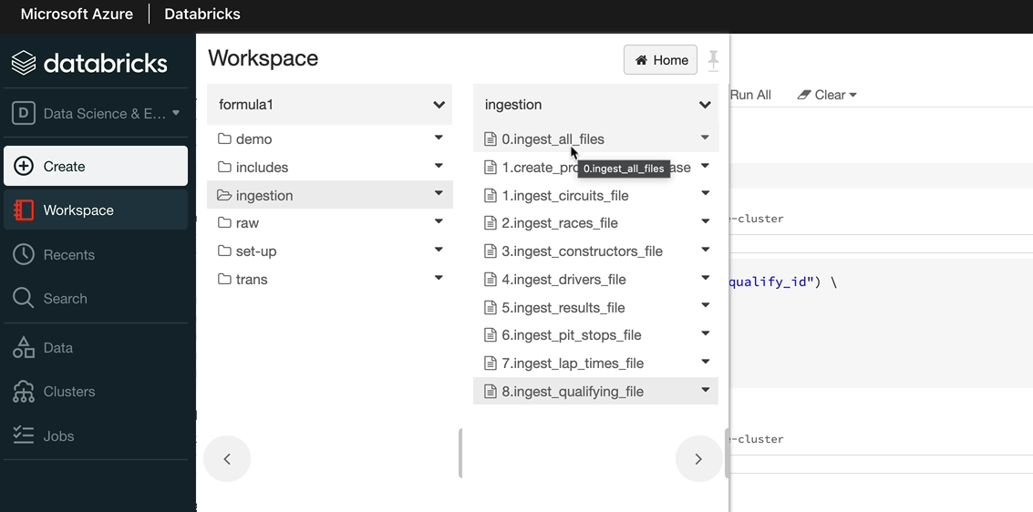

I'm going to put number nine on that one. And let me open up the ingestible files, as we know, actually, this one would run all of the ingestions and then just load the data for us. So I'm going to just quickly run that.

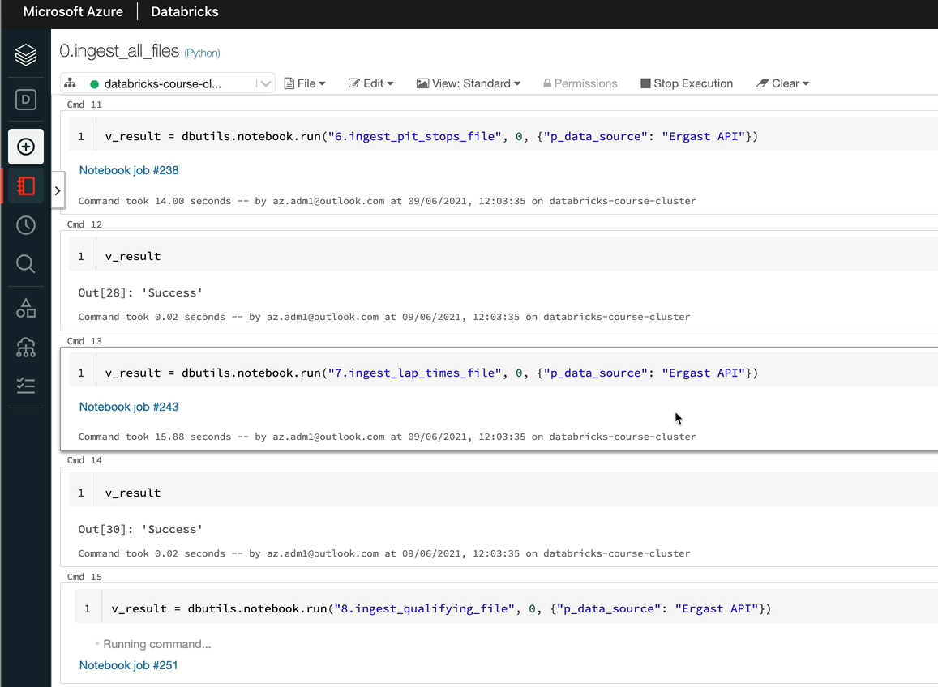

OK, that's now completed. Let's have a look at a storage explorer to see whether the data has appeared for all of them. So let me refresh this. And as you can see, we got all the eight folders appeared.

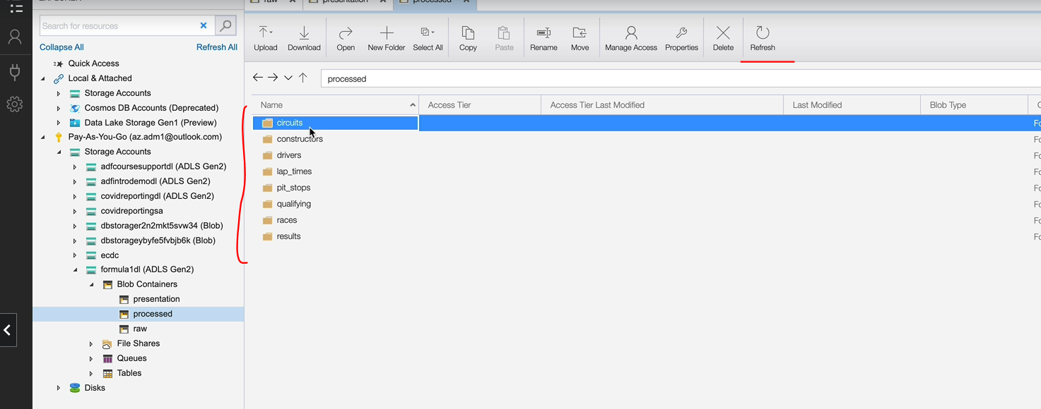

And let's also do a final check to make sure that our tables are created under the f1 processed database as well. So we go to data and f1 process to see all the tables as well. So which is brilliant. So this is how we create manage tables using Pyspark.

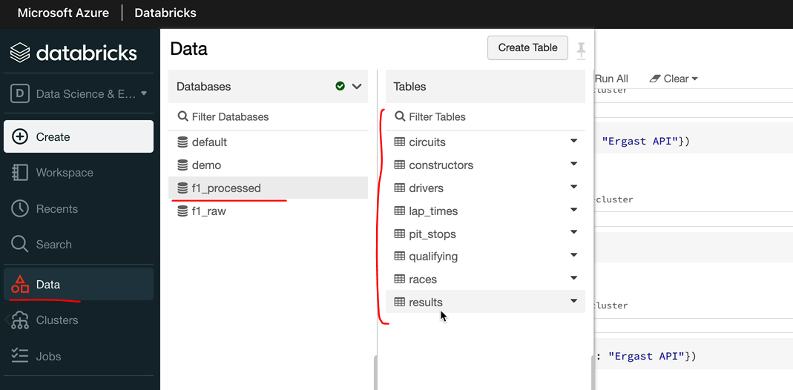

### Create Table – Parquet Source ( Presentation Data – Assignment )

Now that we've created managed SQL tables for all our data in the processed container that, let's move on to the presentation container. So as we know, we got three sets of files here and we would like to create tables for those as well, so that if there is an analyst who wants to analyze the data, it'll be easier for them to query using SQL.

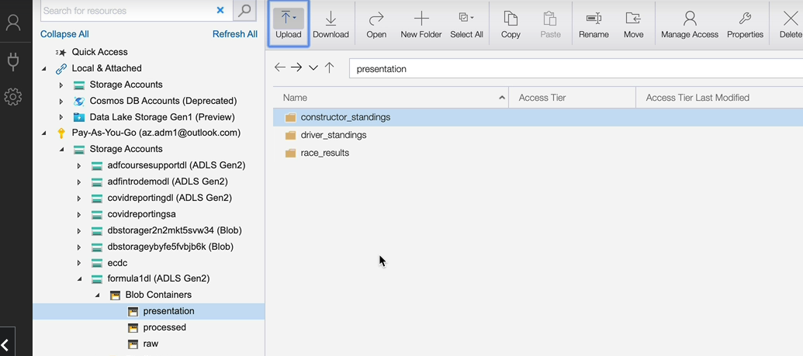

So let's switch to our databricks workspace. And as you know, these are the three notebooks which creates those three sets of files. And these are the ones we need to change.

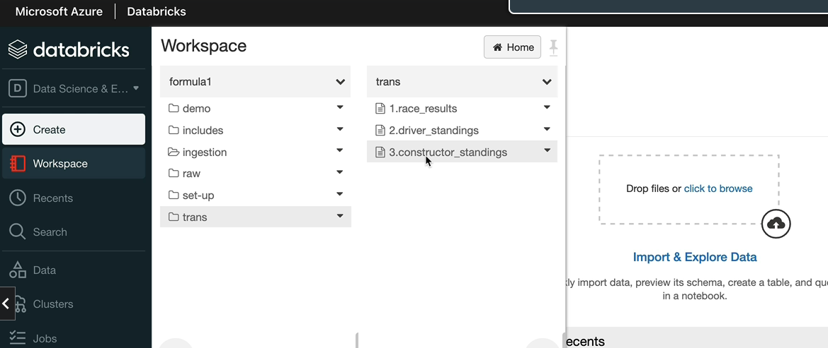

They'll need a similar change to the ingestion scripts in order to create the managed tables on these files.

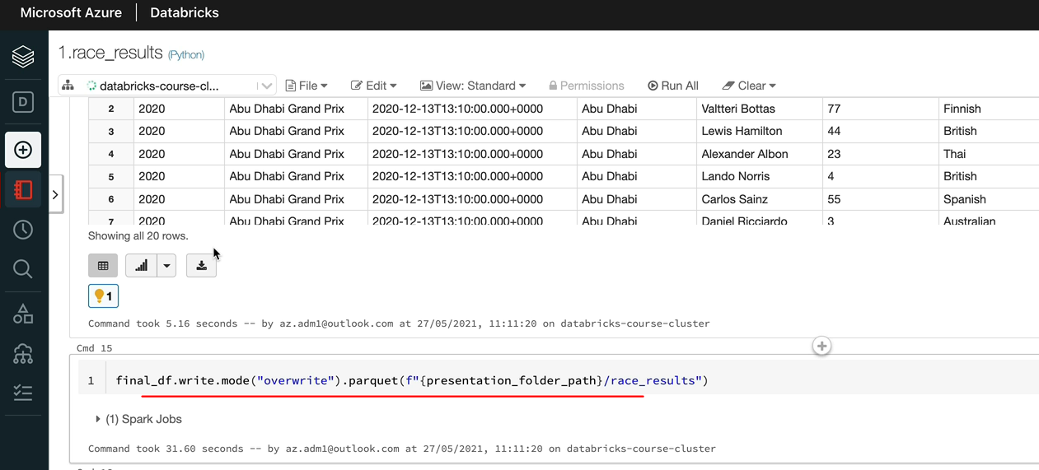

And also, as we did before, we will have to create a new database called for an underscore presentation. And that should have a location of the presentation folder part, which is the amante formula1dl presentation.

Now, I'll show you what I have done, so I've created the database and this new script, our new notebook and the database name as f1_presentation, and that's pointing to our presentation container in our storage account.

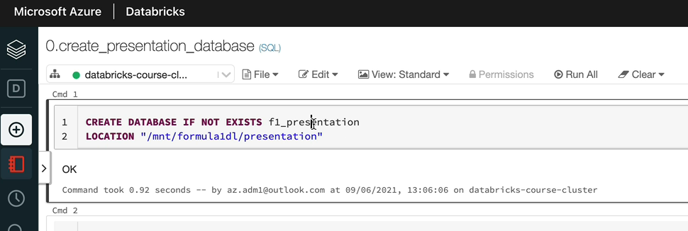

And also, I've changed all three scripts to use the data frame right command to have the format as park. And also we're using the service table method with the name of the table being passed in as well. So let's run this. If I run this, as we know, it's going to fail because it's a managed table and I'm supposed to manage it. I supposed to manage it, that as we've already written the data without the knowledge of to Hive Metastore. So we will have to delete these folders, which I'm going to do now. And then we can run these notebooks.

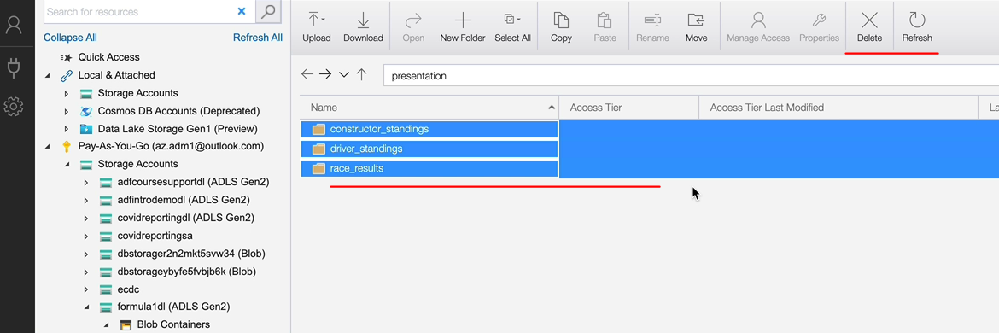

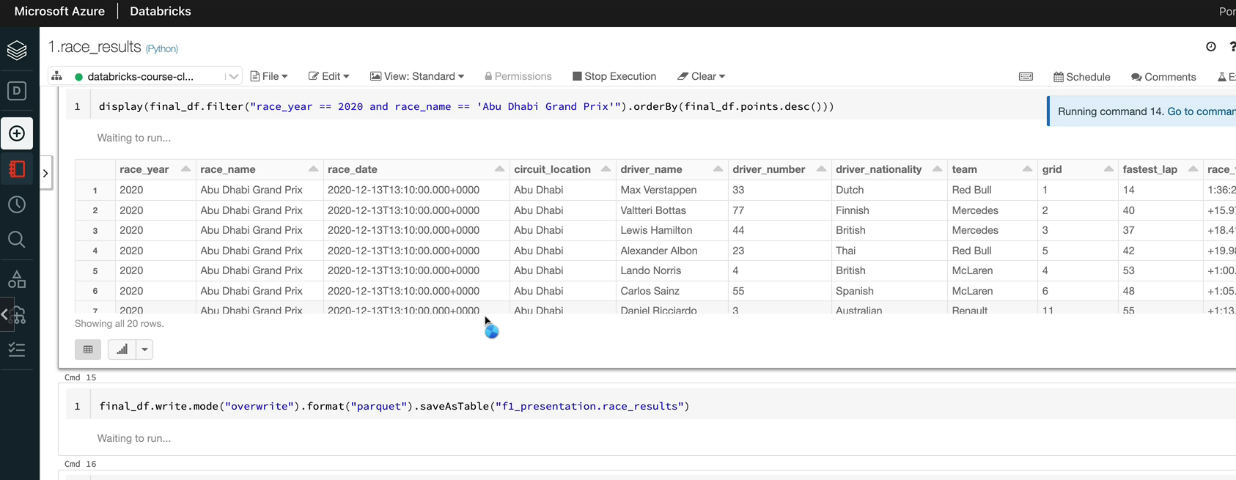

And once this is completed, we can run the drivers standings and the constructors standings because they both run of this output. OK, that's completed.

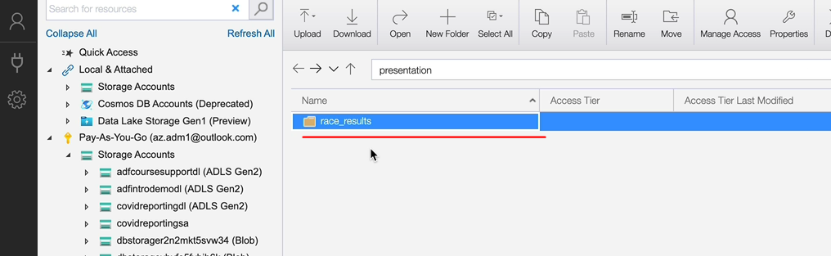

Let's have a look at the data, we should have the results, which is there, and also we should have the table for the race results as well, which is good.

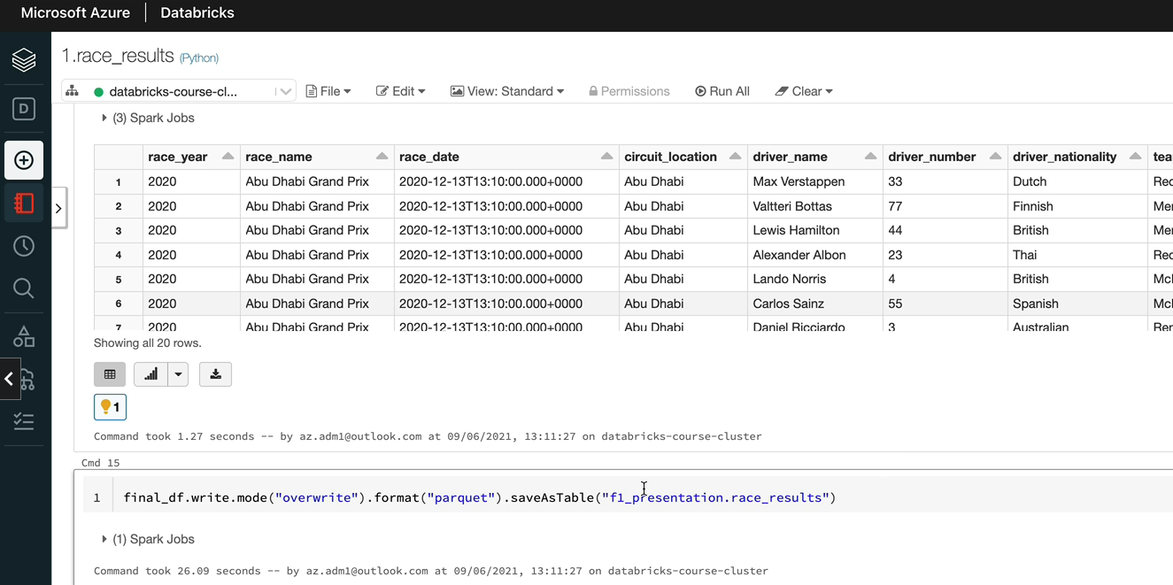

So we can now run the driver standings and the constructors standings. I'm going to do them alongside each other because they're just dependent on the race results and they should be able to run alongside each other. So the constructor is finished and the driver standing has finished as well.

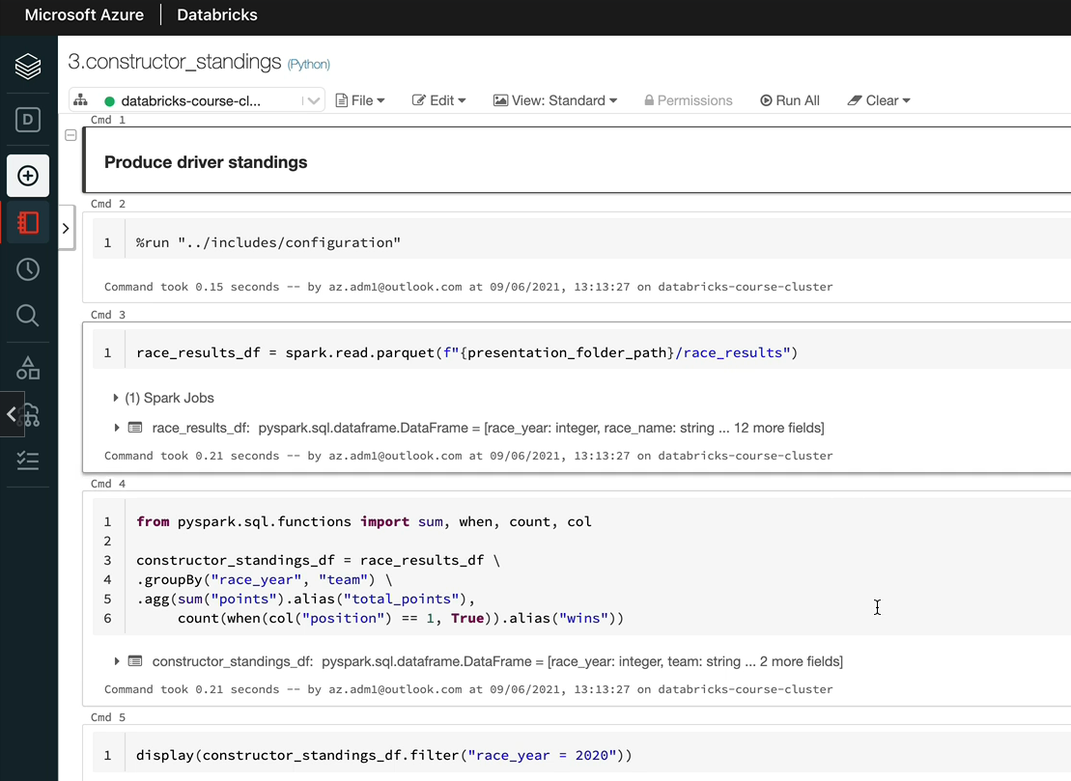

So let's have a look at the database. So we should have the three tables and also we should have the three sets of folders here as well.

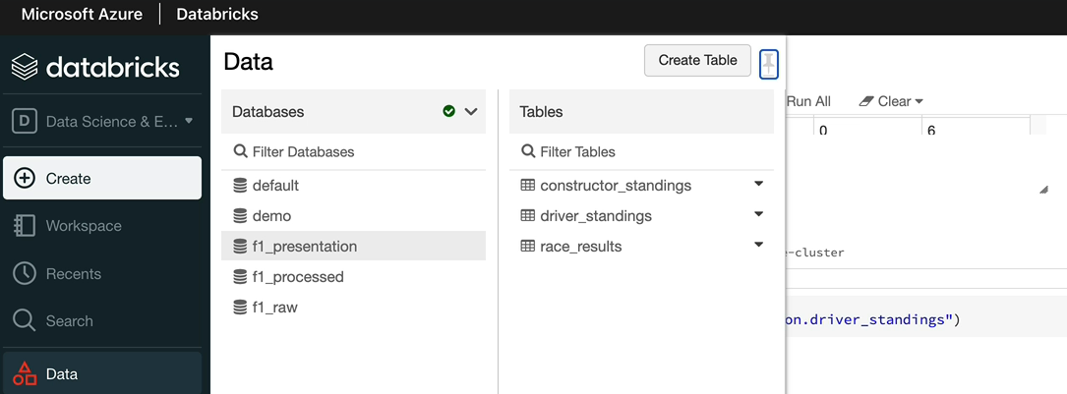

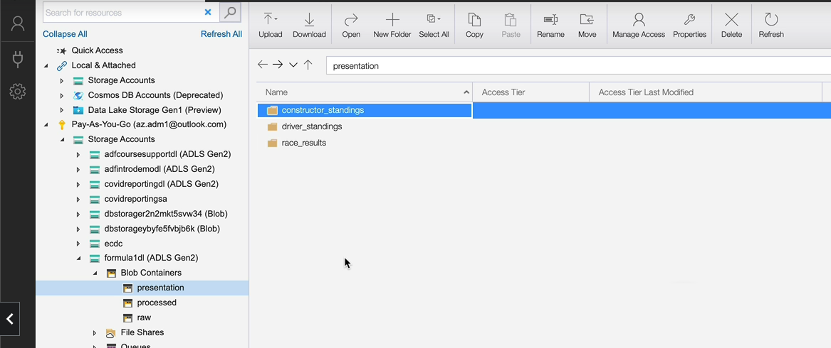

So now for all our presentation data, we've also got the second table as well as the pocket files in our storage account.

## Spark SQL – Filters, Joins, Aggregations

Now that we've created Sparke tables for all of our data, it'll be the right time to learn about how to use a SQL to read and transform the data. In this section will take a similar approach to the way we learned about dataframes. First, we look at how to read or select data from Spark SQL tables, apply filters order the data being selected, etc.. This will be an introductory lesson, so please feel free to skip that. If you're proficient with SQL, we will then look at simple functions that you can apply on the data being selected. For example, concatenating two fields to create one. Well, then look at doing aggregations by grouping data, we will then learn about performing functions such as rank, lead, lag, etc. on a window of data which are called window functions. Finally, we learn about different types of joins available and look at some examples of joining the data in Spark SQL by the end of this section. I hope you will have gained a good understanding about how to read and manipulate the data in Spark SQL to gain insights.

### SQL DML Basics

So what I have already done is I have created this notebook under our demo folder that we have in our project, and that is the default language of SQL. So let's assume that you are a data analyst and you've got no no knowledge about the data available within this project. So you would look to see what's available. So the first thing you would do is normally you list all your databases. So that is the show database command, which is going to give you all the databases, so we got the raw data here, we got the ingested or the processed data here, and we got the fully processed data or the transform data within our presentation layer ready for presentation.

SHOW DATABASES;

So let's assume that we want to look at all the data that's been ingested. So in order to do that, you need to list all the tables in your app on processed database name. So we talked about this before, we have the concept of current database in South Park and the current database generally is the default database. So in order to switch the current database to something else, you can use the command use.

SELECT CURRENT_DATABASE()

USE f1_processed;

So now I want to switch to f1_processed, then that is the command. You would use that to see the tables in your f1_processed database, which is your current database. You do show tables and then the list to all the tables.

SHOW TABLES;

So as an analyst, you now you find out that actually you have access to these data and you can do what you want to do. Let's assume that I want to look at the drivers data. In order to do that, we can run the select command. We have done some of these before, but I'm going to just quickly talk it through. So in order to select data from drivers, you can do select start to list all the columns. So select from the table. So you could qualify that with the database name or you can just put drivers because we have set the current database assessment and processed. As I said before, my preference is normally to put the database name, dot the table name when I'm writing any scripts for the project because it's obvious where the data is coming from. So let's do this, let's talk from drivers, this is just a demo, so I skip the database name there. And these are the columns available and also this is the data. So if he didn't want to do a select from the table, you can also describe the table to see the list of columns.

SELECT *

FROM drivers;

DESC drivers;

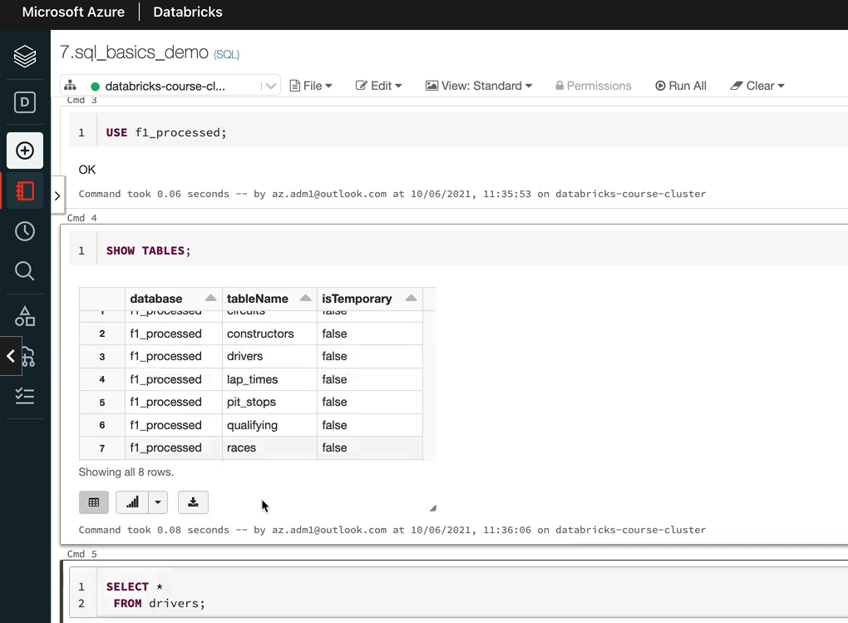

So if you do just describe bribers, it's going to give you the list of column names and the data types. And if the columns were given any comments, then you can see those as well, actually. So this is quite useful in order to see data types and things like that. So let's say we have now got the data collected here in the case of data breaks, it limits the number of records to 2000, but some of the other tools don't do that.

So one of the things you want to know is when you're just looking at the data, you don't want to be listing everything. So you can say, I want to limit the number of records being shown to 10, for example, then just give you the ten records. This is quite handy to do if you're using another idea to carry the data, but within data breaks, it automatically limits that 2000 records being displayed. So it's not a problem. Otherwise you'll just run out of memory and things like that.

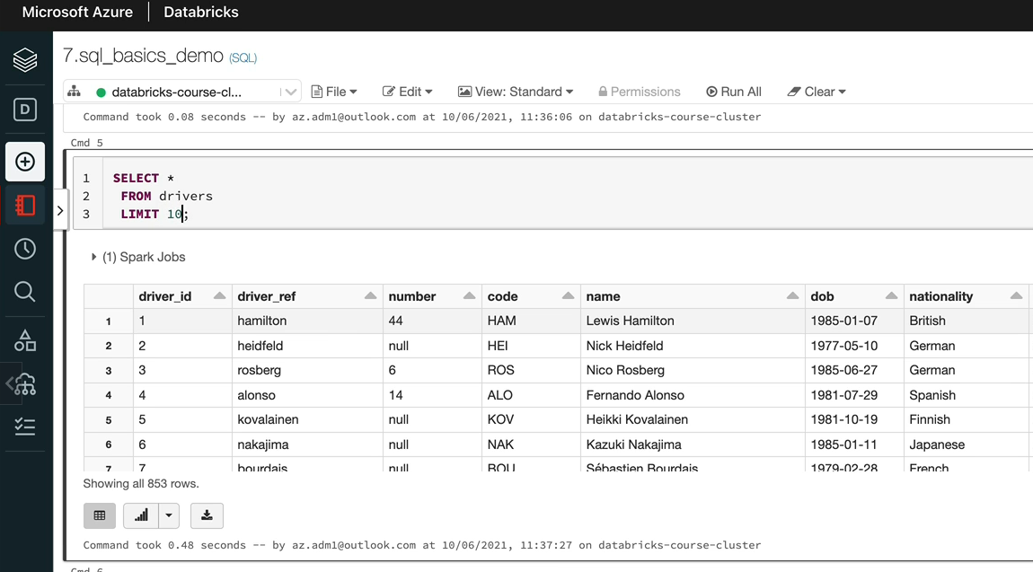

So let's say actually we want to do something more to this. So we want to find all the drivers whose nationality is British, for example. So you would come in here and then you would have to write a where clause. This is exactly same as the filters we used in sport data frames, you would say nationality equals and then within a single card or a debit card, you say British. And that should list all the drivers whose nationality is British, so the sport has had more British drivers. It's got one hundred and sixty five records here. You can add further, filters, to this data. For example, if you wanted to see the drivers who were born after the year 1990, you can say and data, but greater than or equal to, say, 1990 zero one zero one, which is 1st of January 1990. That will pull up the drivers who were born after the January 1990. So you can see them here, I think London and Paris being the English one here.

SELECT *

FROM drivers

WHERE nationality = 'British'

AND dob >= '1990-01-01';

So we have used select tower here. But instead, if you want to select a few column names, you can do that as well. So, for example, you wanted to get the name and address, the date of birth there. You would just do that. And they just get the name and the date of birth, and if you wanted to rename a column when you're selecting, you can say as, for example, this is the date of birth and they'll rename the column for you. And similar to date, flams, you can order the output that's coming out, for example, if you wanted to order by the date, but you would just say, oh, the boy, I just do that. And you say date of birth, so by default, you're going to have the data ordered by ascending. So you've got the smallest number on the top and biggest number at the bottom.

SELECT name, dob AS date_of_birth

FROM drivers

WHERE nationality = 'British'

AND dob >= '1990-01-01';

SELECT name, dob

FROM drivers

WHERE nationality = 'British'

AND dob >= '1990-01-01'

ORDER BY dob DESC;

But if you want to see the drivers in the order of the one being the youngest, he would do the descending. And that gives you a London address on the top and then George Russell and things like that, actually, so so that's how the art works. If you wanted to order by multiple columns, you just list the columns in the order by and the order as well. So whether it's ascending or descending. So let's do that. So if I did select staff from drivers, then it would list all the drivers. But if, for example, you wanted to order by the nationality. And also, you wanted to order by their date, but deciding like we did before, you would just do that. So in here, nationality is assumed to be a sad thing. But if you want it to be explicit, you can just do ASC as well. So let's run this command.

SELECT *

FROM drivers

ORDER BY nationality ASC,

dob DESC;

SELECT name, nationality,dob

FROM drivers

WHERE (nationality = 'British'

AND dob >= '1990-01-01')

OR nationality = 'Indian'

ORDER BY dob DESC;

As you can see, the American drivers on the top based on their data but descending, so and when you go down, you'll see the others as well. So there is there are plenty of American drivers and they've got Australian and Argentinean drivers as well. One more thing I want to teach you before we finish this lesson, so in the last example, we used the and condition in your back plus. But you can use our conditions as well as well as you can, you can add many nested conditions as well. So let's say we want to get all the drivers via the nationalities, British and the date of birth greater than 1990 or. Indian drivers, but immaterial of what their data, but they simply want to get them as well, in that case, you would put these in brackets. So that means this is like one condition evaluate to true or false, and then you add your condition so you can just do it here. And then I'm going to say. And nationality is equal to Indian. So that should bring back all the British drivers who were born on or after 1st of January 1990 and any Indian drivers as well. So let's put the nationality as well so it'll make a bit more sense when we look at the data. So we got all the British drivers here and then you've got the two Indian drivers, but they were not born after 1990, but we still wanted to see them as well in this list.

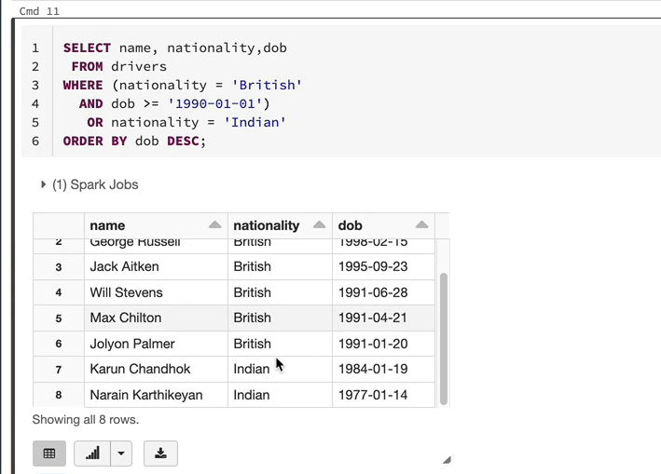

So that's how you can add all conditions as well into your work. Plus, you can go as complex as you like to be, but this is how it works.

### SQL Simple Functions

In this lesson, we're going to look at SQL functions. As you can see, I've created a new notebook, SQL Functions Demo with the default language of school, and I also run the statement here, use a f1_processed to set the current database as a f1_processed.

**USE** f1_processed;

Before we start using functions, I would like to quickly show you the documentation because there are a lot of functions available and barely cover a handful of those. So if you come to the documentation of the pyspark documentation under the documentation, you've got SQL built in functions.

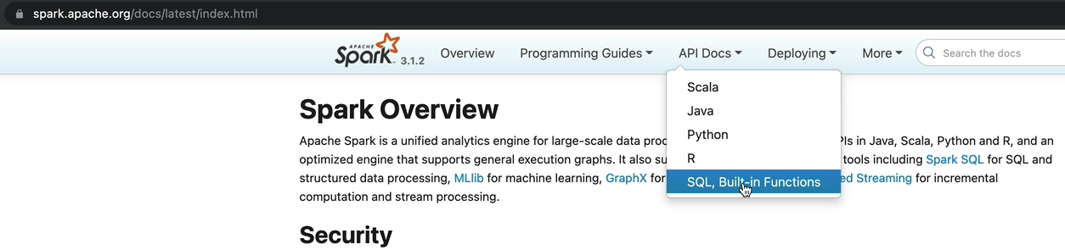

And as you can see, there are plenty of functions available that will make your life a lot easier when you come to do any kind of calculations or any kind of manipulations of the data.

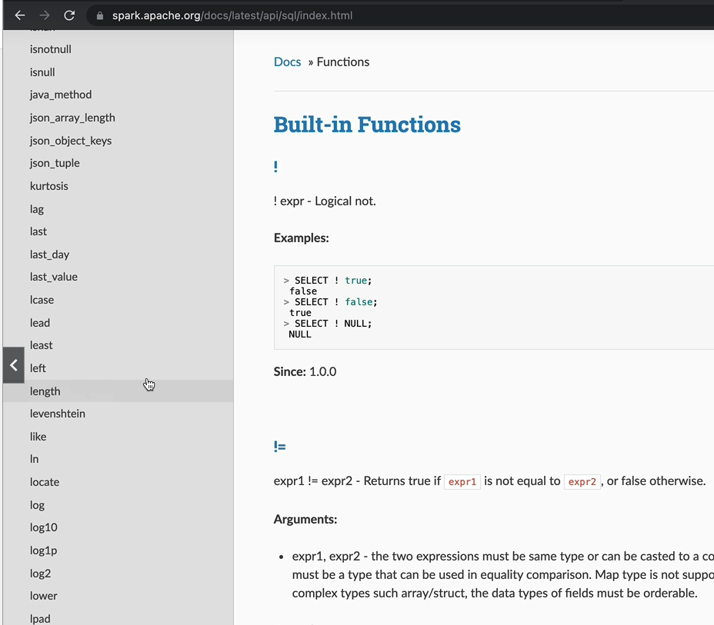

But we will use a few of those. As you can see, most functions will have a brief description of what they are and an example. So the description should help you when you come to use it. But if not, I would encourage you to just write your own statements and test it. And then you can learn from that as well, because some of them have got a very cryptic description for those, and that might not be enough for you to understand it fully.

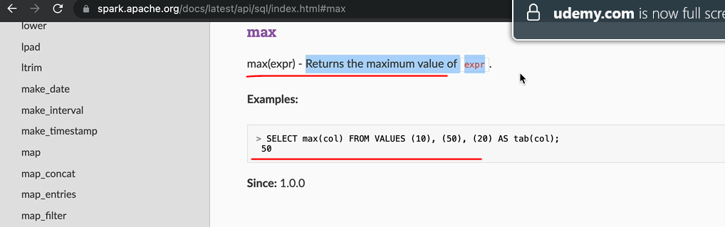

So let's switch back to our notebook. Similar to the data frames, you've got the scalar functions and aggregate functions as well as you've got the window function. So let's start with a simple scalar function.

So I'm going to do a select * from drivers table. That's the one we've been seeing so far. And let's say we want to concatenate to fields, the driver reference and the code and we want to have a hyphen in between those two and we'll call that as something different. In order to do that, we can use a function called concat. Concat takes a number of arguments and then just to concatenate all of those together for you. So in our case, we want to send in the field driver reference and then we want to have literal value of hyphen, and then we want to send in the other field code and then the concatenated value to be output. So let's say we want to call this one as a new driver reference and now the output should have that new driver references.

**SELECT** *, CONCAT(driver_ref, '-', code) **AS** new_driver_ref **FROM** drivers

Right, so that he can say we got Hamilton with Hampster code, we got the new driver references, Hamilton hyphen. But the interesting thing with this is it's kind of work on each record, so it's not going to increase the number of records we had eight hundred and fifty three years before and we still have the eight hundred and fifty three records.

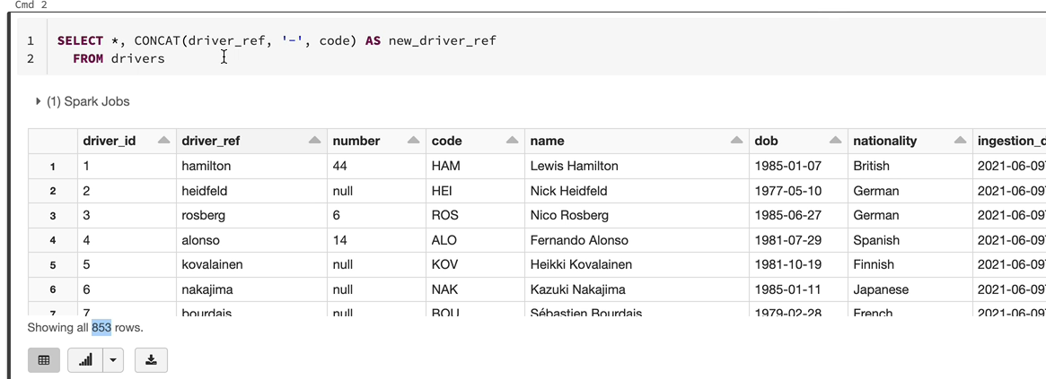

Let's say we want to do something slightly different, which is to spit out the names into surnames and for names, so in order to do that, you can use a function called split. So this function split will take in a string that is our name, and then you can say I want to split it based on this character. So it's kind of split name based on the character space. So that give you two words, Lewis and Hamilton. In this example, we say, so let's run the first. So as you can see, you've got an output, which is an array, and that's got the first element as Lewis and the second element as Hamilton, so each one has been split out like that. And if you want to take only the first two and name them as separate fields, you can do square brackets and then access the first array element, which is zero, and then call that one for name and then you can do the same thing and call the next one as the surname is. Right. So that'll be index one. And then this is going to be called surname. And now we'll see the full name and the surname being played out as well. Again, we've got the eight hundred and fifty three records. Nothing has changed. So it's working on that individual record and then adding the new fields as you go along.

**SELECT** *, SPLIT(name, ' ')[0] forename, SPLIT(name, ' ')[1] surname

**FROM** drivers

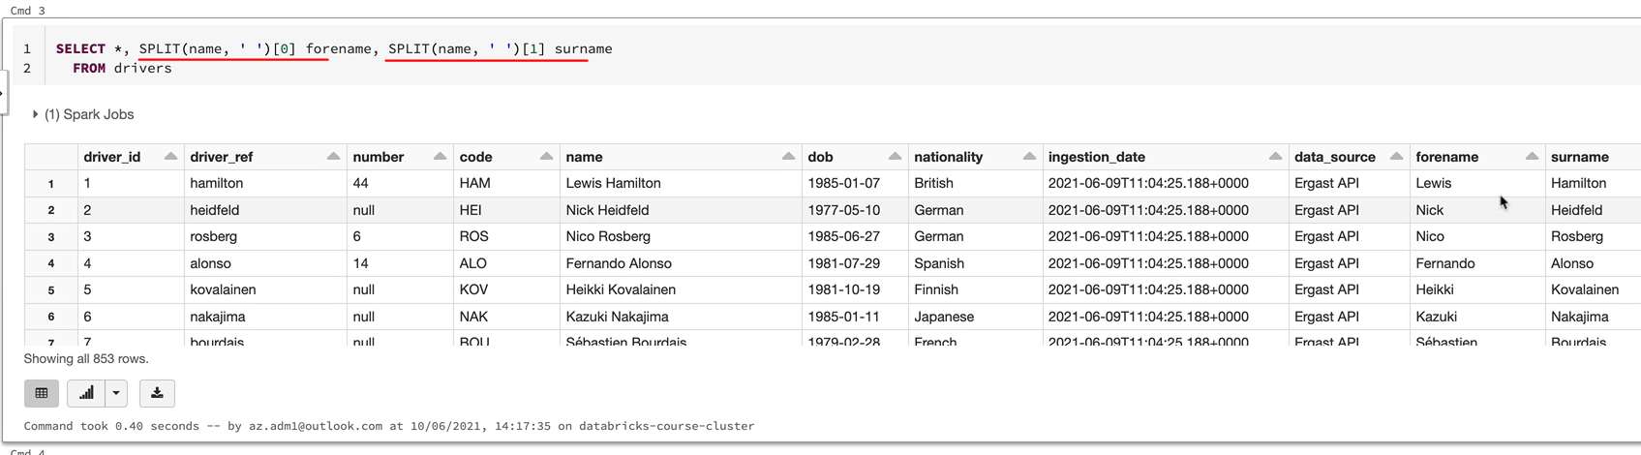

**SELECT** *, **current_timestamp**

**FROM** drivers

And there are a lot of functions spark offers, which will help you work with dates and timestamps. If you remember, we use the current timestamp to populate the injection date when the date frames. So the same exact function is available here and that will be current timestamp. So you do select *, current timestamp, you're going to get the current timestamp from the system. So we're working on the 10th of June 2021. So that's why you're seeing this value as 10th of June 2021.

**SELECT** *, date_format(dob, 'dd-MM-yyyy') **FROM** drivers

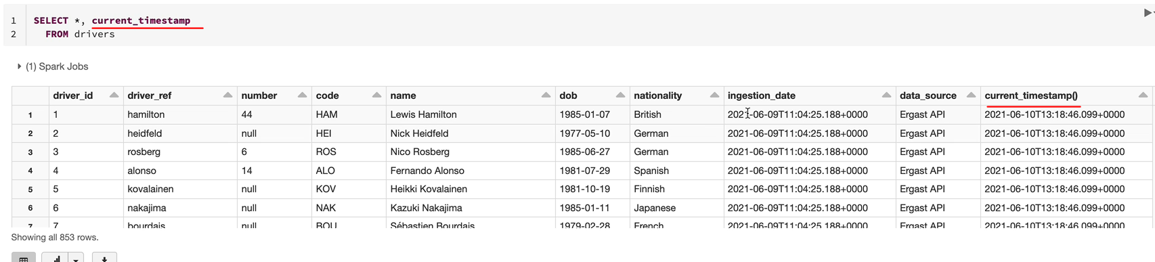

**SELECT** *, date_add(dob, 1) **FROM** drivers

You can aliased that and then the field will be different. And next, for example, you want to change the date format of the date of birth from y y y y MDD to DMM. Why? Why you can use a function called date format. So that would be a date format here. And then you would put the date of birth field and then you specify which format you want. So I'm going to go for the hyphen M. Hyphen y y y y.

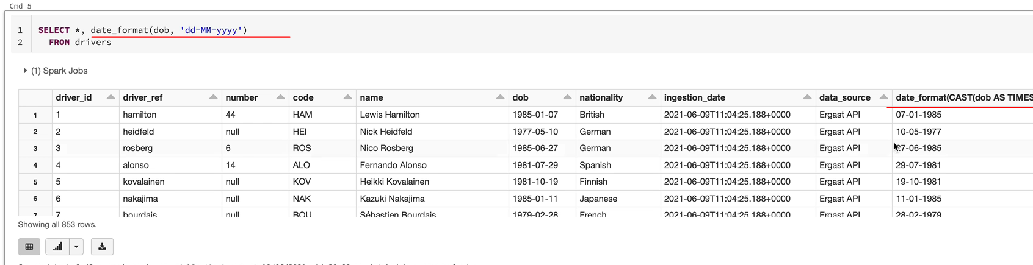

And now we should get the data, but in a different format, so as you can see, seven one 1985 with Hamilton St. Bernard rather than the 1985 017, and this is not a valid scenario. But if you wanted to add day to everybody state data, but you can use the function called data add and then you just specify the number of days. So that'll be say number one is data, but it's going to be moved up by a day. So that's what's happened. But if you come over to the documentation and then look for the date, you're going to find a lot of them. So you've got the current date, current time stamp zones, date, date, date, format, and plenty of functions here, which you can use when you come to manipulate the data.

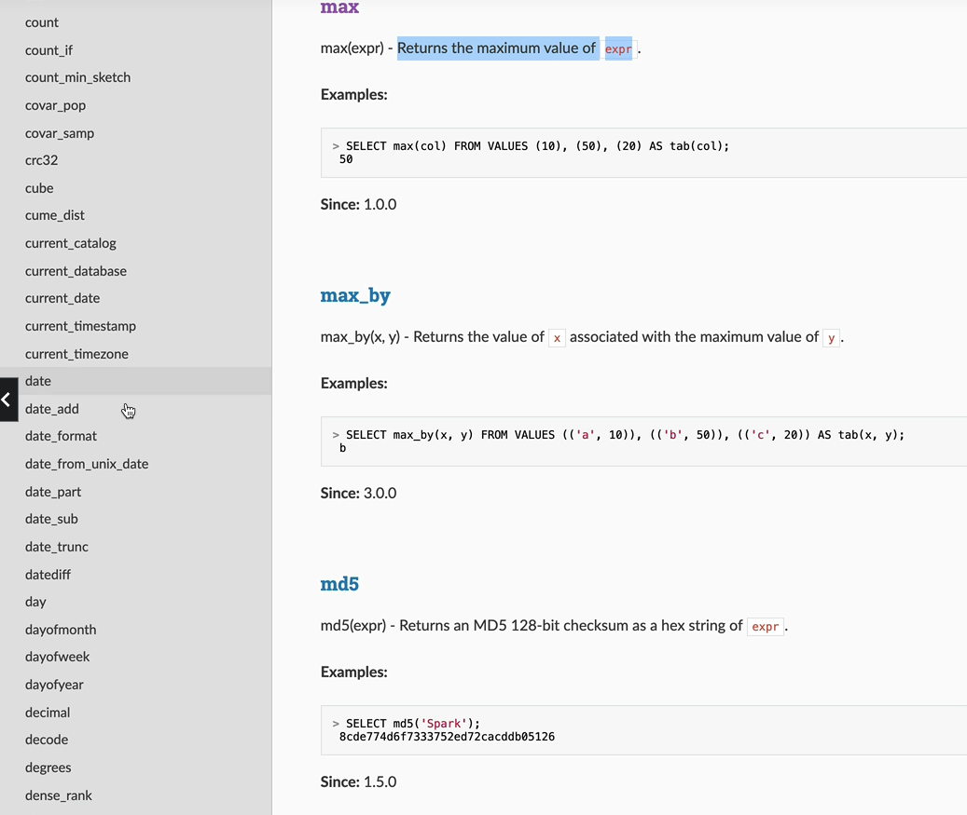

### SQL Aggregates, Window Functions

**SELECT** nationality, name, dob, RANK() **OVER**(**PARTITION** **BY** nationality **ORDER** **BY** dob **DESC**) **AS** age_rank

**FROM** drivers

**ORDER** **BY** nationality, age_rank

Let's now look at some aggregate functions. We've seen some of these before, so we did that count. So that was select count(*) from table with chosen drivers. And that gave us 850 records. And similarly, if you wanted to look at the max date, the birth of a driver, for example, you could just say, max(), there will be and then that's going to give you the youngest driver there with the date birth of 2000-5-11. Let's see who that driver is. You could just do a select. So that's the new Japanese driver on the grid, Uki Senada, so you can use a number of aggregate functions like this.

**SELECT** COUNT(*) **FROM** drivers;

**SELECT** MAX(dob) **FROM** drivers;

**SELECT** * **FROM** drivers **WHERE** dob = '2000-05-11'

For example, if you wanted to see the number of British drivers in Formula One, you could just say select Canstar from drivers where nationality equals British. And that would give you the number of British drivers, that's one hundred and sixty five.

**SELECT** COUNT(*) **FROM** drivers **WHERE** nationality = 'British' ;

But having said that, this is not what you would normally want to do, you would want to have the list of drivers against each nationality. So that's where we have the group by statement that comes in. We've seen how gloopy works within date frames, and it's exactly the same manner. It works within sequel as well. What you do is you just say, I want the nationality. And the count by nationality, so in order to say I won the count by a nationality, you have to use the group by statement. So so what this is going to give you is the nationality and the count of drivers per nationality as well. So let's execute that one.

**SELECT** nationality, COUNT(*)

**FROM** drivers

**GROUP** **BY** nationality

**ORDER** **BY** nationality;

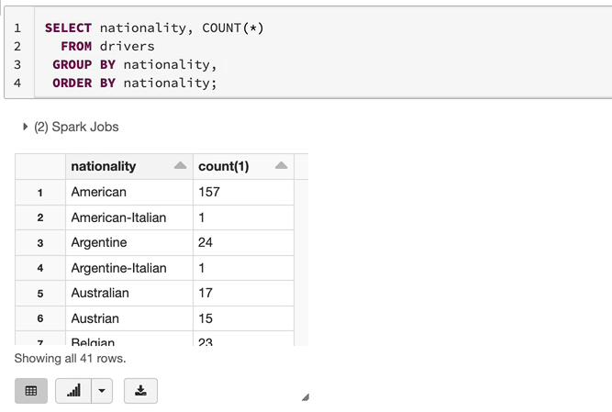

That's going to give you each nationality and the count here. You can use your order by, for example, if you wanted to order by the drivers based on their nationality, you've got the order there as well. And if you wanted to group by multiple fields, you would just keep adding those fields here as well as in the select statement. And then it work for you. If, for example, you wanted to get the country to the countries which have got, say, more than a hundred drivers driven in Formula One, you've got an interesting class called having so you can say the same statement, but you would say having count(*) in this case greater than one, you can use any aggregate function here that you're using here as well. So in this case, we're saying select from the drivers via the count(*) on a day is greater than that 100.

**SELECT** nationality, COUNT(*)

**FROM** drivers

**GROUP** **BY** nationality

**HAVING** COUNT(*) > 100

**ORDER** **BY** nationality;

There might be only a few countries, so that is just American and British drivers.

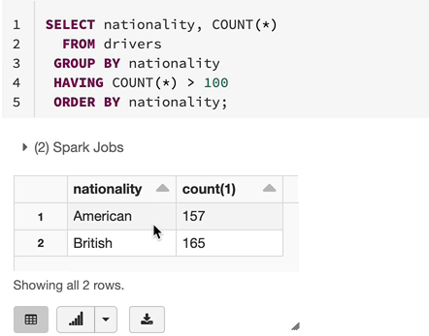

So that's how they group by and having class works in relation to the aggregate functions. So the thing to remember is if you just run an aggregate function like we did before on the account, you're going to get one one record. If I did a max, you're going to get only one record.

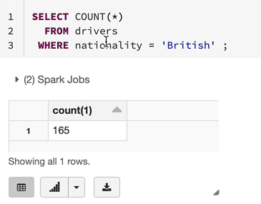

Count is going to give you only one record unless you have a group by plus when you do a group by clause.

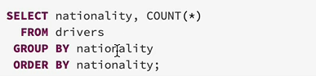

The counts are the allegations are per nationality in this case, but per item from that field is what what's going to happen. And the having clause lets you restrict the data based on the aggregate function.

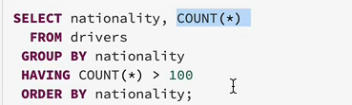

So that's pretty much everything about the aggregate functions, but there are plenty of aggregate functions available in the documentation. And whenever you come up, whenever you need one, just come and have a look here. You can search this documentation as well. But for example, if I wanted to look at the min function, I could just do min. But on when you've got a multiple function. So the standard min function is here and you get help for that as well.

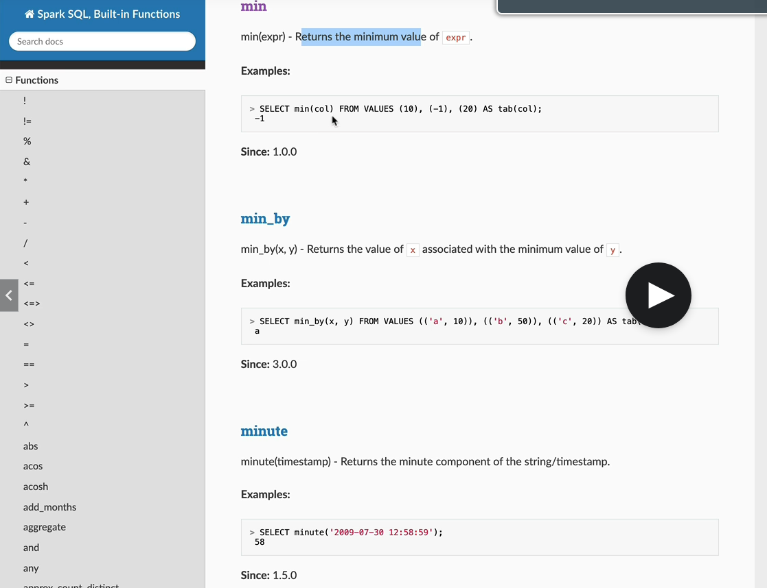

So that returns the minimum value of that expression being sent in. So in this case, it's going to be select minimum of that column value.

Let's next look at window function's window functions work very similar to the window functions that we've seen in park data frames. Let's switch to the documentation first and let's look for rank, because that's the one we saw in data frames. And as you can see here, the window function expects two things which is partitioned by and the order by.

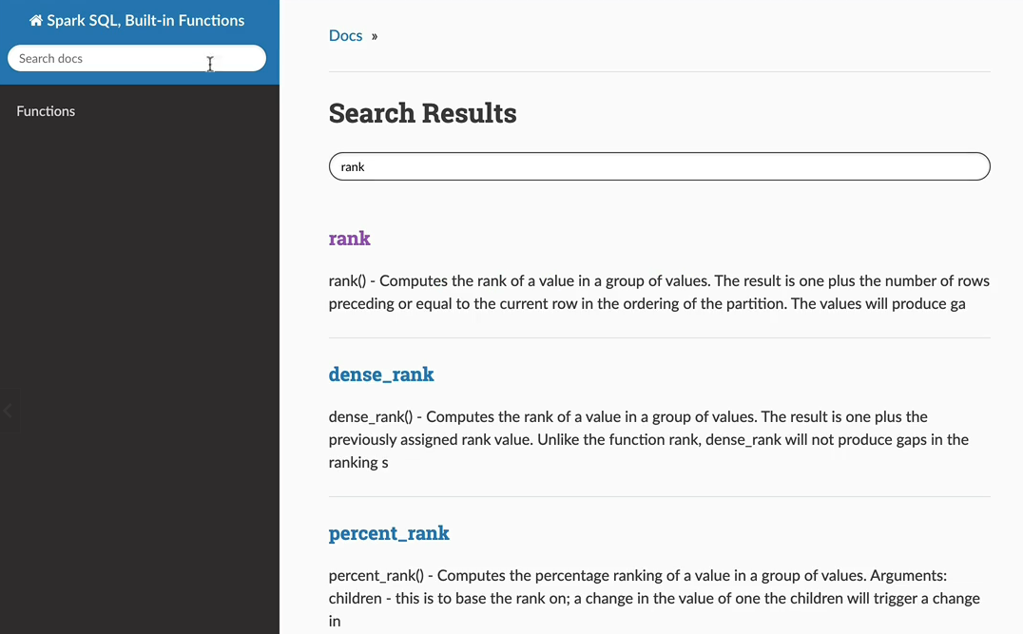

This is the rank function, the using and for the rank function. You want to tell her what to partition the data by and how to order the data.

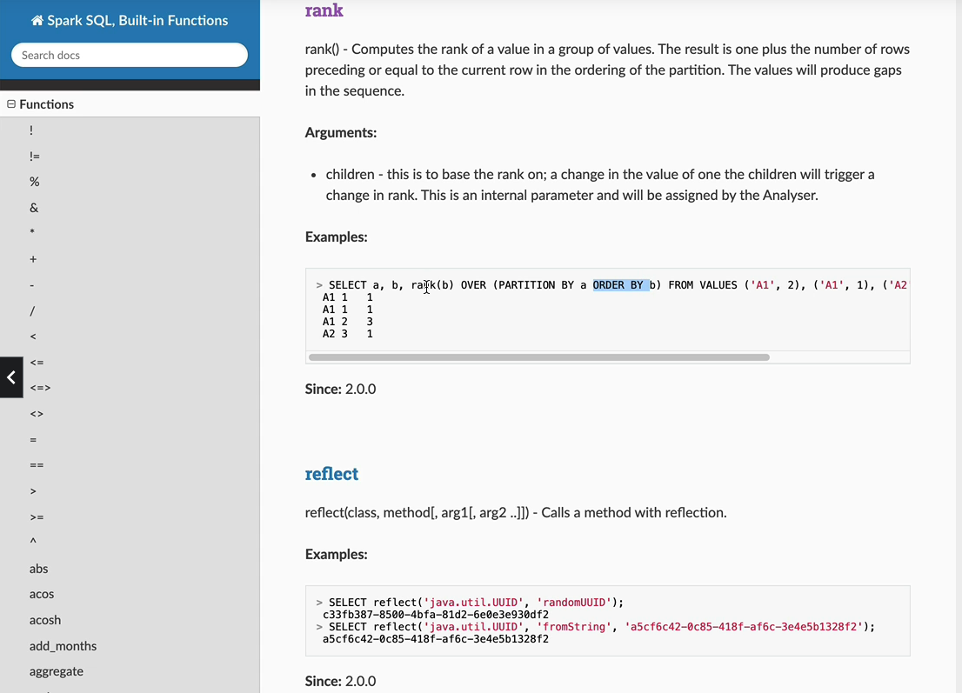

So let's say if we wanted to order by the data, but so we want to rank the drivers on the top. So it runs from number one, for example. And then we want to partition the data by nationality so the rank is applied within the nationality. So if you take this example, the American drivers go from one to one hundred and fifty seven, and then when it goes to British drivers, it starts again from number one. So in order to do that, we need the select statement and the data is going to be read from drivers table because we are doing nationality, let's print the nationality, let's print the name of the driver, and let's get the date of birth of the driver. And then we do the rank. So rank over. And then we want to specify the partition by, as we said, we want to partition the data by nationality because we want the right to reset after every nationality and the rank is within the nationality. And then we want the order by the date of birth. So in this case, we want to do this ending because we want to rank the youngest driver as number one and the older one as the whatever the highest number is coming out in the partition. And let's call this one as a rank.

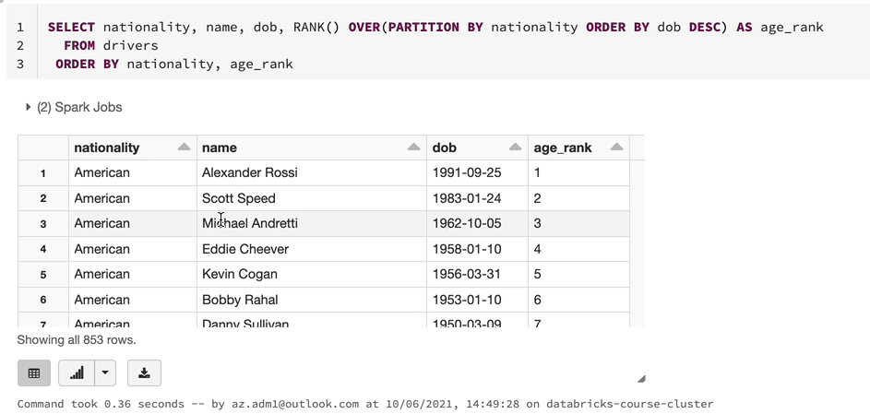

And just so we can see the data properly, let's order by. Nationality, and then let's do the age rank as well. So that means we want to see the data in the order they come and we're going to run this one. Let's see what's coming up. So as you can see, we got the American drivers and he's the nineteen ninety one date of birth and he's ranked number one, 1983, number two and things like that. And then when we come to, for example, Australian, they rank should have said so let me find that one.

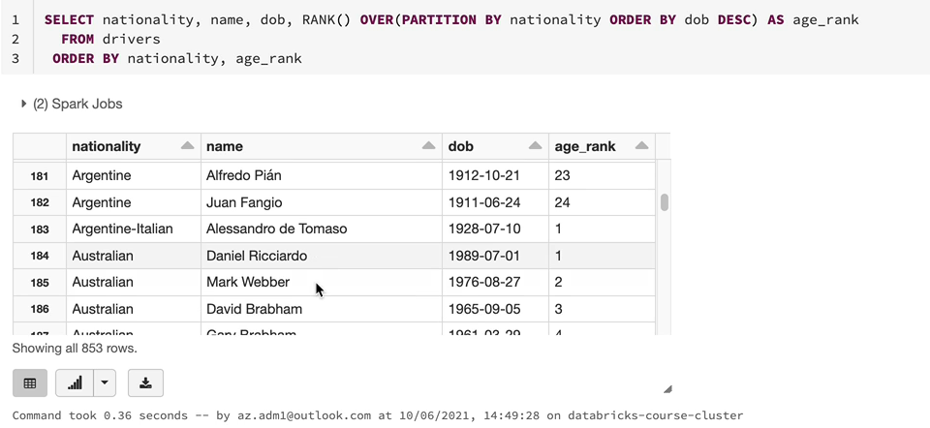

So you've got Danielle. Ricky Ricardo is number one, is born in 1989, and then you've got Mark Webber after that and things like that. So again, it runs and you've got Brazilian drivers and you've got the British ones and the rank should start again from number one and London. All this should be the number one here because he's the youngest driver, so. So that's how you do the rank, but there are a number of functions you can use, so you've got the dense rank, you've got the row number, you've got plenty of window functions you can use within seconds. So it's quite easy to write as well when you come to do it within SQL.

### SQL Joins

In this lesson, we are going to look at Joins in SQL, very similar to what we've seen in dataframe Joins. We get the same types of giants offered within SQL as well. So this page gives you the Joins available within SQL as well.

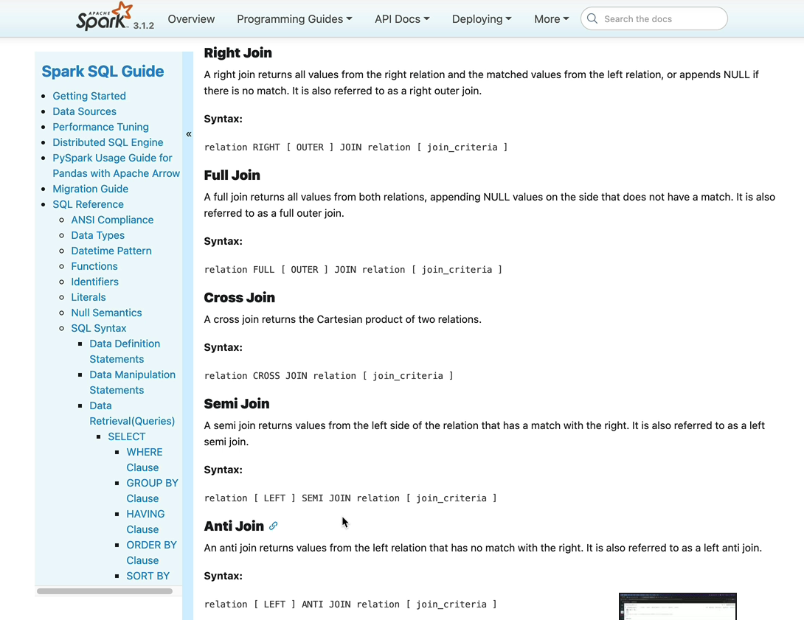

As we have seen in the example of dataframe, we've got the inner join left and right join, full join cross join, semi join and anti joins. And there are examples here as well. But I'm going to walk you through each one of those anyway in this notebook. So in order to get started, I've created a new notebook called the sql_joins_demo. Its then under the demo folder again. And we're going to use the driver standings table, which we created as part of our Spark work, and that is in the f1 presentation database, as you know. And the structure of the table looks like this.

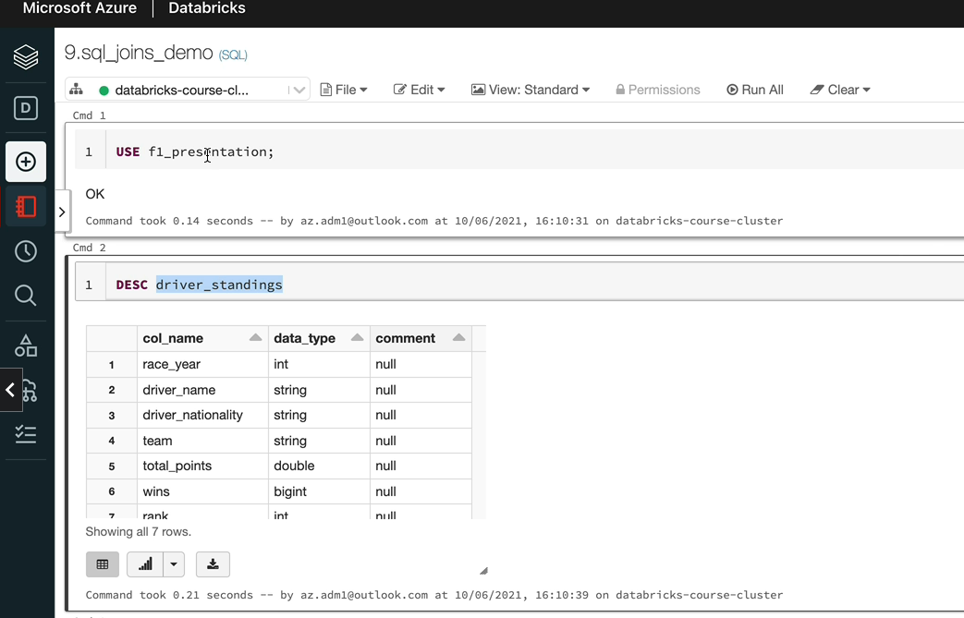

We got the races driver name, nationality team, total points wins and we added a new field called the rank as well. So he's ranked. So every driver exists in this table for each of the year. So for 2018, there'll be one entry for the driver and 2019, another entry and things like that. And we'll have the number of wins and the number of total points and the rank for that year for the driver as well. So what I have done is because in order to do joins, we need more than one table. I have created two views here. They are temporary views as we've seen previously, and that's going to have the same data from the drivers standings for the race year 2018 and one of the views and 2020 in another view.

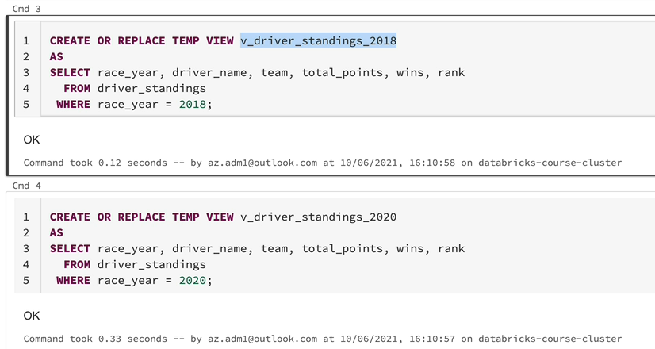

So let's just do a quick select from this table just to see what's in the view so that you know what you're working with. So this view has got 20 records because 20 drivers raised in 2018 and we've got the ranks for each one of them as well.

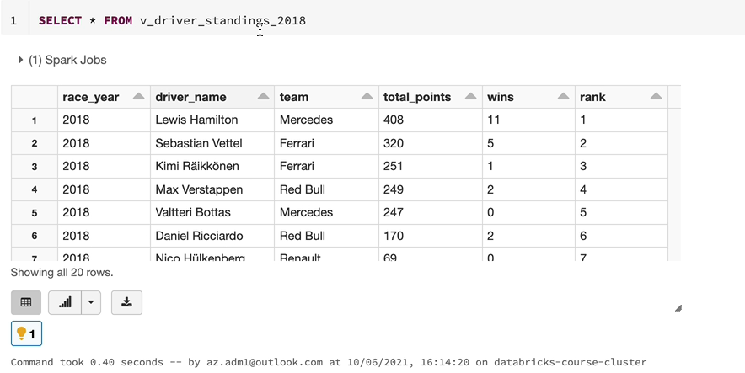

So Lewis Hamilton's number one at total number two and things like that. And similarly, we can do the same for the 2020 and 2020 may have more records because we had more cars, so 24 drivers in 2020 and 20 drivers in 2018. And one thing you may notice is some of the drivers who raced in 2018 didn't race in 2020. Similarly, 2020 had some new drivers. They didn't exist in 2018 as well. So we're going to start with the Inner Join. So let's join the two tables in order to do that, we need them in front of us. I don't want to type in the long table names every time, so I'm going to alias the table. I'm here with these and it's got 20, 18, and I'm going to join that table to 2020. And again, I'm going to alias the table with 2020, and we need On class join on the condition and that is going to be d_2018.driver name and d_2020.driver_name.

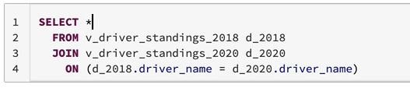

So the joins are done, so now we need to select the data, so let's do that. And we've selected data from both tables, as you can see, the column names are repeated, so the ones on the left are from 2018 and the ones on the right are 2020.

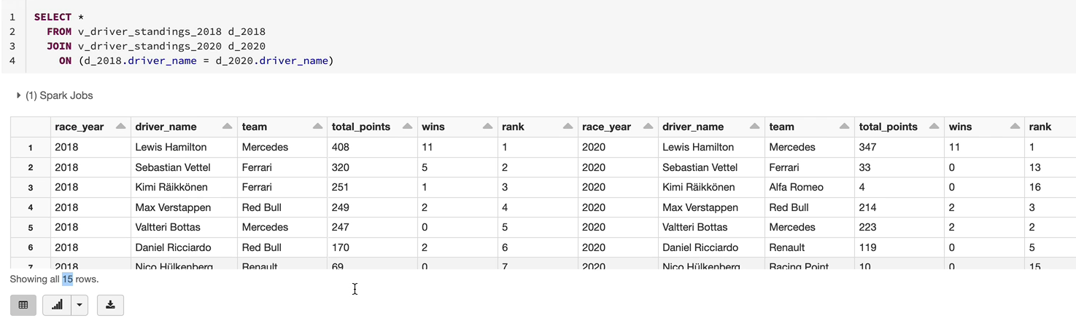

First thing you may have noticed is we only have 15 records, we had 24 for 2020 and 20 for twenty eighteen. As I said, some drivers didn't race on 2018 or 2020 and enjoy and will give you output one when the conditions are satisfied on both tables. So in this case, what you got here is the 15 drivers who raised on both races. So you won't see any nulls anywhere and all of them raised on both of them. So it's an interesting joint here. As you can see, Hamilton's being number one on both, but Vettel dropped from number two to number 13 in 2020 because Ferrari were doing poorly and Richen went from number three ranked to number 16. That's because he switched teams. He went from Ferrari to Alfa Romeo. But they're not doing analysis here. We just want to understand how the joins worked. So this is how it works. And the next thing we want to do is to do the left join. Now, you may be wondering how to get all the drivers from 2018 immaterial of whether they raised in 2020 or not. So we could have nulls for the 2020 field. But we want to see them for 2018 for all of those drivers. That's where the left join comes in. I'm going to copy and paste that one. It's very simple. All you have to do is change the join to left join.

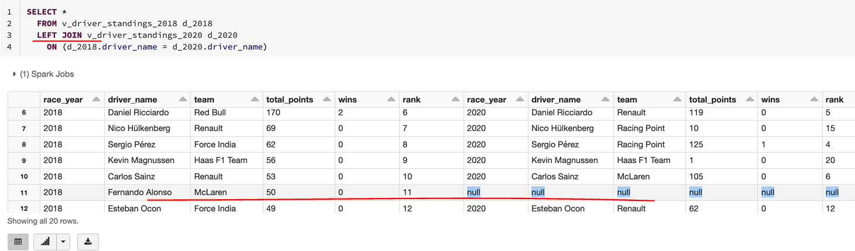

And as you can see, we got 20 Records' because twenty eighteen had 20 records. If you scroll down, you're going to see some of the drivers who wouldn't have any interest in 2020. As you can see, Alonso dropped out of Formula One in 2020 before 2020. So he doesn't have any information for 2020, 2018. He raced for McLaren and there'll be other three drivers as well. So we got one man down, Ericsson and also Hartly, all of them, and also Shiraki. So all of those drivers, they race for 2018, but they didn't race in 2020. So those are the five drivers out of the 2018 who didn't race in 2020. And now the question would be, what if we want to get everyone who raised in 2020 and then we get the information for them in 2018, if they're raised otherwise, we just want to see. So we want to list all the 24 drivers with the data for 2020. But for 2018 we could have nulls. So that's where right outer join comes in. Again, we just need to change the left to right. You can also use right outer join here if you wanted to, but you don't really have to. It's the same thing. And when you do this, you're going to see the 24 records. So you've got the 24 records.

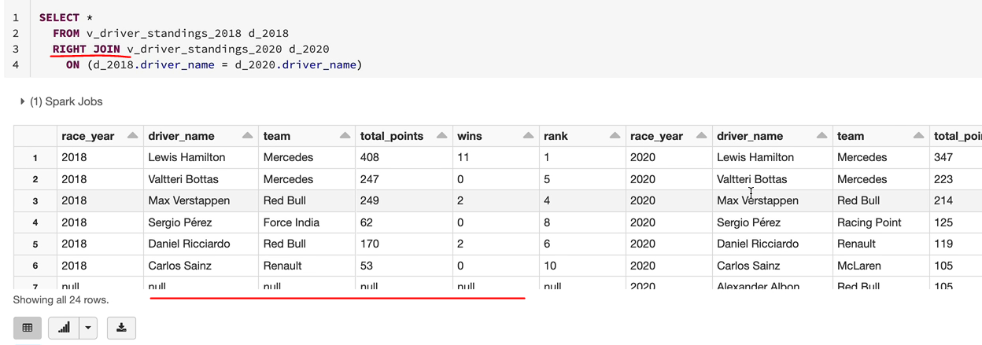

We've had a new driver, Aleksandar Albon, who writes for Red Bull. He was not in Formula One in 2018. And similarly, you're going to see a lot more drivers here. So you've got Danielle Kiviat, Jovanotti, George Russell, all of those drivers. So so that's how the Rialto joint works. But the question now comes, we want to see all drivers who raced either in twenty, eighteen or nineteen, but we want to see their data for 2018 if the race for 2018 with the nulls for 2020 and vice versa. So in that case, we need to use the full out to. So, again, we just have to go for the full join in here, and that's going to give you everybody. So we've got 29 records and that would have everyone who is raised in either one of those races. So the first record itself, Alexander, was born. He raised in 2020, but not not in 2018.

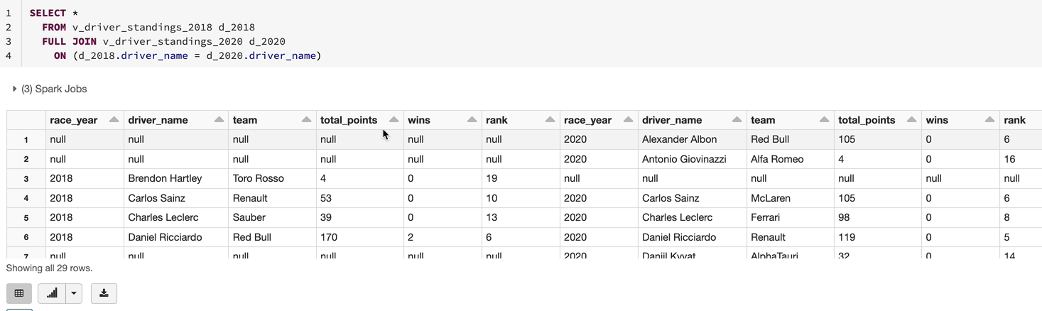

Similarly, you're going to see other drivers who raised into the eighteen, Fernando Alonso. He didn't race in 2020. And all of those. It's a superset of both of them, basically. And now we got a few other joints which are less frequently used, so the first one is the semi join. I said this before, I don't use this often. It's basically an inner join with only the data from the left table. So let me explain what I mean by that. So this is a semi join. If I run this one, I'm only going to get data from the left side of the join, which is this table, so that all the 2018 columns, you're not going to see the 2020 columns. And also you only have the data from the twenty eighteen, which is twenty records with the five drivers who didn't race for the 2020 race has been excluded.

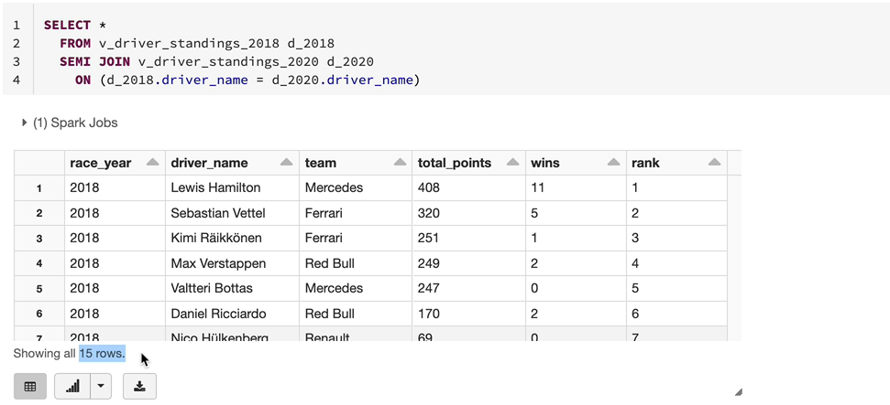

So if you want to visualize it, it is an inner join, but you get the data from one the left table of the joint. So this is 15 records. If we go back to our inner join, you're going to see those 15 records. So you've got the 15 records. But here you've got both table columns being listed.

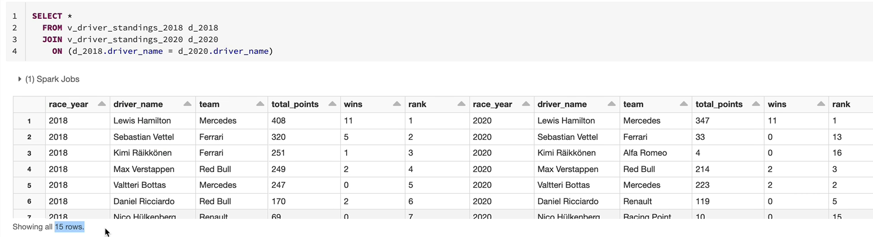

But whereas in the semi joint, they'll only see the left table being joint listed. So the next one we've got here is the anti join. This one is quite useful. Let me show you how that works. So this table gives you the five records which didn't come here, so if you wanted to find out the drivers who raised in 2018 but not in 2020, you're going to see them here. So these are the 2018 drivers, but they didn't have a race in 2020. So this is quite useful when you want to find out the drivers who raised in 2018 but not in 2020 kind of scenarios.

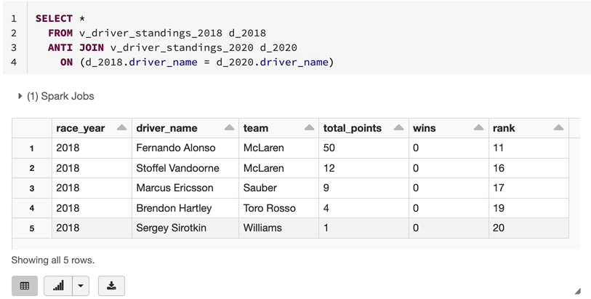

So the last one we want to talk about is the cross join. Again, I don't use this. This is going to give you a Cartesian product. So basically you're going to get every single record from the left giant to the right table of the joint. So if I do a cross join, we don't need the joint condition because we're going to do a joint of the two tables here. And if I run this one, you're going to get 20 times 24, and that is 480 records. So the left had 20 records and the right had twenty four records and joining everything.

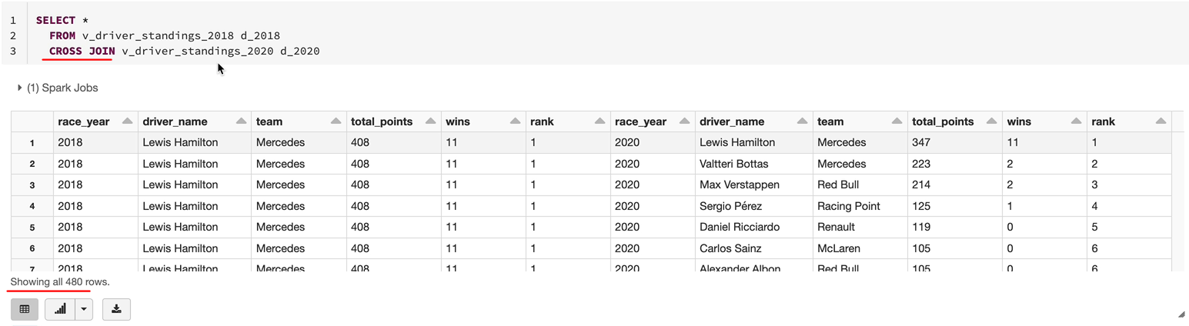

So for example, the first record from their left is Lewis Hamilton. That's going to appear 20 times with everybody else on the other side. This is not quite useful at all really in this scenario. But you may find it useful in scenarios where you want to join a very small dimension with a few records to fact table and multiply the data. But here, having Lewis Hamilton repeated 20 times and joined to everybody else on that side is not really useful for us. So that's all the joint.

So just to recap, we got the inner join, which will join the two tables on the condition and give you only the matching records. A left outer join to the right you'll get everything from the left and the values from the right if they are matched otherwise you get nulls. But in the case of right, it's the other way around to left. You get everything from right and the matching data from left and full outer join is like a superset of both of them. And the semi joint is similar to it in a join, except that the columns are limited, but the records are the same as the inner join. And the Anti joint is where actually you get everything which is in left but not in right. And the cross join is everything from left to join to the right. And you get a Cartesian product of the two. I hope now you've got a good understanding of Joins and also how SQL works in Spark, and as I said before, this is not a SQL, so I've given you enough information, but you will have a lot more to learn by looking at the documentation.

## Spark SQL – Analysis

Now that we have a good understanding about how to use Spark SQL, let's put that into practice. In the next few lessons, we're going to do some interesting analysis on our Formula One data to identify the most dominant drivers and teams of all time, as well as in the last decade, etc.. In order to support our analysis, we'll first create a table with all the data required, the granularity of the data will be race year, driver name and team name. This is so that we can slice the data based on any of these values and do the reporting on the. This will be very similar to the race results table that we created earlier, using PySpark with some small differences. We're not going to be modifying the pyspark file, that's because I want to show you how to achieve these things in Sparks SQL as well so that you've got a full understanding about pyspark as well as the capabilities of sparks SQL too. We will then run some queries to run the dominant drivers and the teams of all time as well as in the last decade, finally will create some visualization of this data and create dashboard from this.

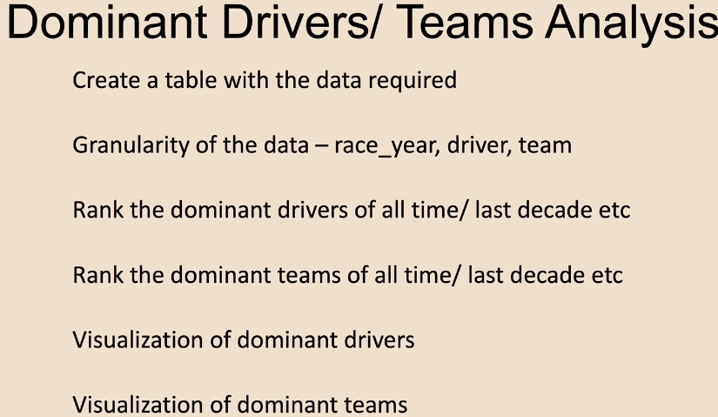

### Create Race Results Table

Let's start by creating a new notebook for our work, and I'm going to create that under our Formula One folder because it's a project work now under trans. And this is going to be very similar to the race results pyspark file that we created previously. As I said, we are going to be joining the driver teams and all of those tables to get a very similar output as this one. But there are going to be minor differences and the differences are going to be in terms of calculating the points. So I'll explain that in a minute.

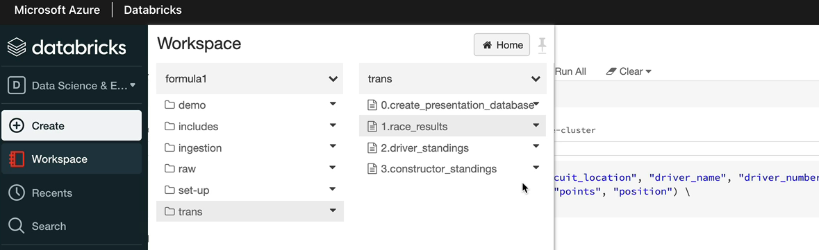

But because it is going to be based on calculating the points, I'm going to call this one as calculated race results. So let's do that.

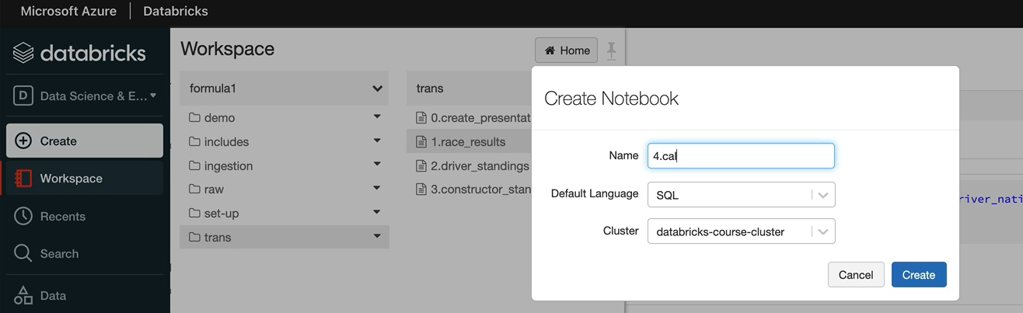

So let's first understand the data that we need in order to clear this table we're talking about, which is the calculated results table. Let's switch back to our data model. So what we need in terms of identifying the most dominant drivers and the teams are the results basically. Right.

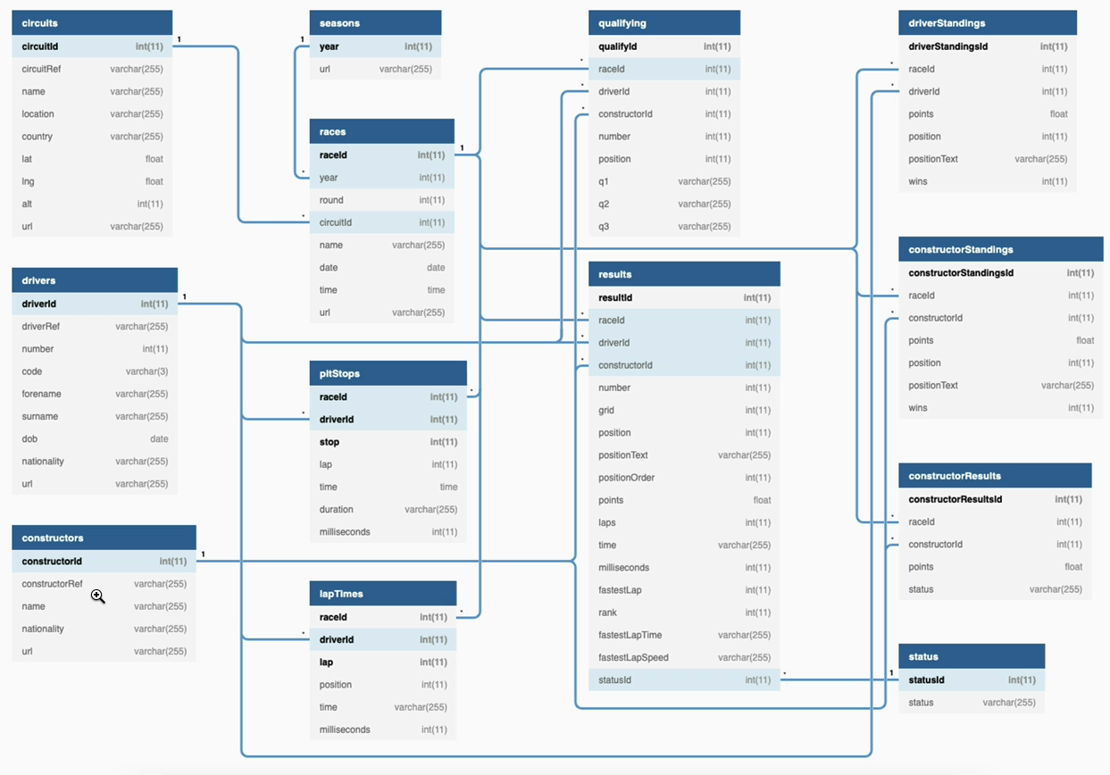

So we would need the points and the positions they completed, the race and things like that. But we also want to slice and dice the data based on the driver name as well as the constructor name. So that means we need to join to the drivers and the constructors table and also in order to get the race to be allowed to join to the races table. So what we'll do is we'll take this table, do an inner join to race drivers and constructors. Let's start doing that. Because we are going to be using all of the data from our f1_processed database. I'm going to use the default of the current database as f1_processed. Let's start with selecting the data that we need. And as we said, the first table we want to select the data from is the results table. And that data, we said, needs to be joined to the drivers table as well as to the constructors table and the races table. So let's do all of those. So the joins are all done now.

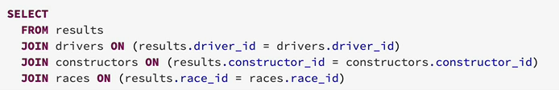

We need to select the columns we're interested in, as we said, we'll start with the races because race here is the one first we said so that'll be a race race as a race here. And then we need the. Team name said that's on the constructor's table. So that's the name, and then we got the drivers table and we need the name from the drivers table as well as we need the position and the points. So they are both on the results table. So the position tells us which position the driver finish the race on and then the points tells us how many points he scored in the race. So these are the information we need. Let's execute this. So that's the output, as we can see, but this is from 1954, finishing first, you get eight points in 1954, but the points never stayed the same.

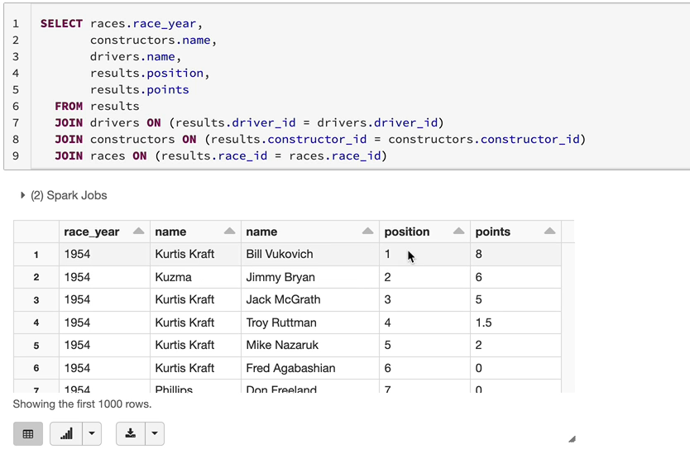

So if we look here for finishing first in 2012, you get twenty five points. But I think we can see more anomalies in the data they're finishing and finishing first in nineteen fifty three. You've got nine points. So the points never stayed the same at some point. Actually you've had about a ten points for finishing first as well. What we can sense from this is if we add up the points and say this is the dominant driver or this is the dominant team, which is not going to be right because for finishing first in 2012, we've got twenty five points. But in 1954 he only had 8 points, which is not right. But in both cases you finish first. So you should be awarded the same points in order to find out who dominated throughout the period. So we're going to calculate the points ourselves. So the way you do that is you can use the position.

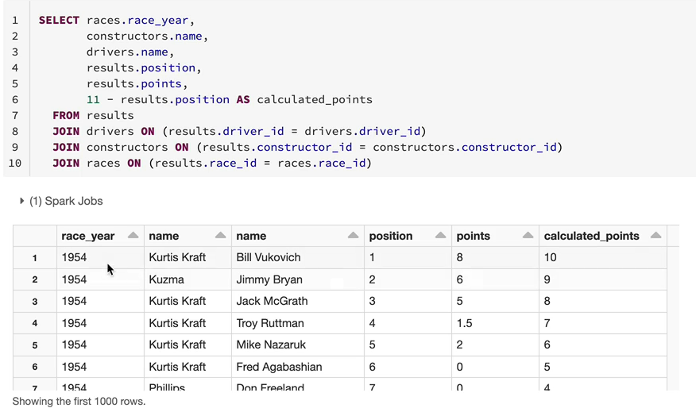

What I'm going to do is if you finish first, I'm going to give 10 points finishing second, you get nine points like that. It goes down up to finishing tenth. You get one point and after that you get no points, basically. So. Well, the way you can do that is using the position, right? So if I did. Number 11 minus the position. So what would happen is you finish first, so 11 minus one, you get 10 points, you finish second, you get 11, minus two, you get nine points. So I'm going to call this one as calculated points because we are calculating this points. And let's execute that and see what comes at. In 1954 for possession one, you've got ten points, and similarly, you're going to have the same number of points. Immaterial, of which you raised the 2012 Bettles, got the 10 points for finishing first, not the twenty five points, but you've seen some nulls as well as negative values, the negative values are coming because you finished outside of top ten. So we're only interested in the top ten. So let's do a filter as well. So I'm going to save. You finished with the top 10, so that's less than or equal to 10, so that means you're not going to see the negative values. You'll only see the top 10 drivers and teams from this, so that's brilliant.

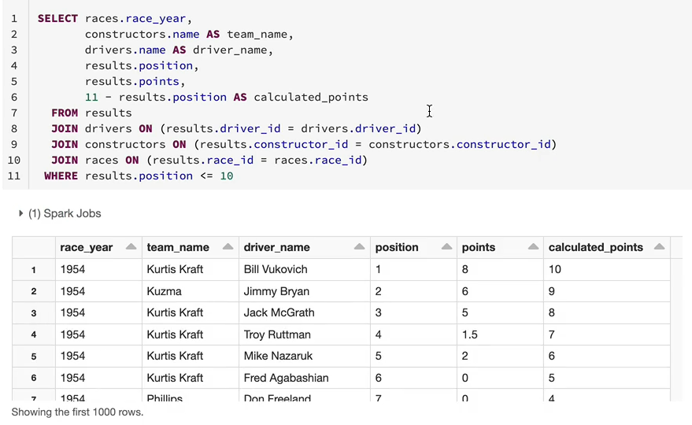

One of the things you may notice is if you created a table from this one, you're going to have two columns called name, which is ambiguous. We don't want that. So we need to give an alias. So I'm going to call the constructor name as team name and I'm going to call the driver name. Driver's name as the driver name. So the aliens would give us unique names for each of the columns. So that table basically gives us the information we need in order to find out whether who is the dominant driver and who is the dominant team. So let's save this in a table, because this table is going to be used multiple times. So instead of doing all the joints and getting the data and having the expensive operations repeated many times, we are going to save this in a table. So it is useful for the analysis purposes. So let's do that. So what you can do is you can do the create table statement, so create table and then they need to give the table name. So let's say we want to call this one as calculated race results. And then we can specify the former I'm going to use PRK nowadays, Daltrey's the default format. We haven't touched upon Delta yet, so I'm going to explicitly specify PRK. So it'll create the Parker files. But when we come to talk about Delta, I'll explain what the Delta format is. And then you say us. But one thing that will happen is because we use the default or the current database as f1_processed, this table will be created and as f1_processed. I don't want that because we are putting all of the data that we're using for presentation purposes under the presentation database, like the race results. So that's how we've segregated our tables. So I want to put it into f1_presentation. So in order to do that, we are going to say we're going to put this table under f1_presentation database.

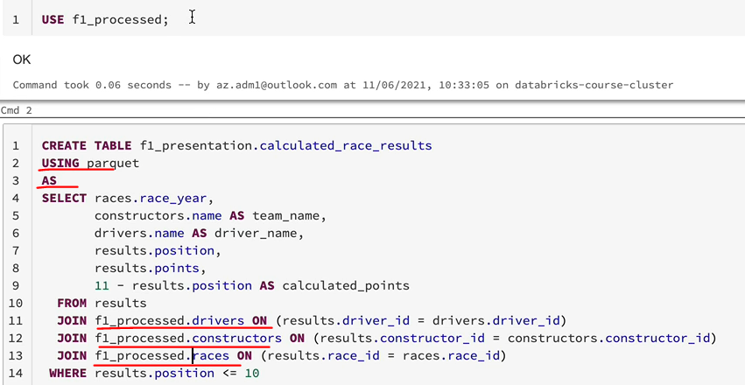

So this is what I meant previously, if you are working with multiple databases, just specifying a current database as one database doesn't really solve that problem. So I normally tend to put the full database name on each of the tables so that when someone comes to look at the query, they'll understand actually where the data is coming from rather than using a default or a current database at the top of the script. But if you are working with only one database within a notebook, that's fine. But this is I think this is best practice, but it will be totally down to you. So let's give this statement now, and we expect a table to be created with the data we need. OK, so the tables now created, let's quickly carry the data to make sure we got what we need. So that will be selected from this table. And as we can see, we got the data. This is for the 1996 race and we've got position one uncalculated point says 10. And all of that looks as we would expect to see.

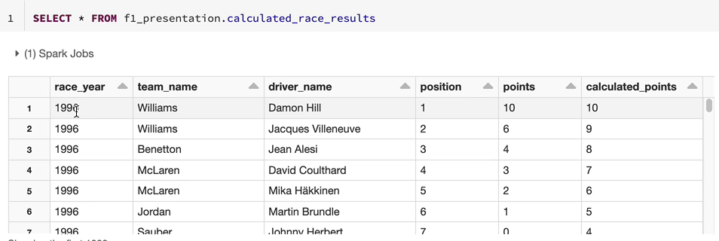

So now that we've got the data we need in the next lesson, we're going to look at the dominant drivers.

### Dominant Drivers – Analysis

Now that we've got the table with the data that we need, let's look at the analysis so we want to find the dominant drivers now. So I'm going to not cloud this folder.

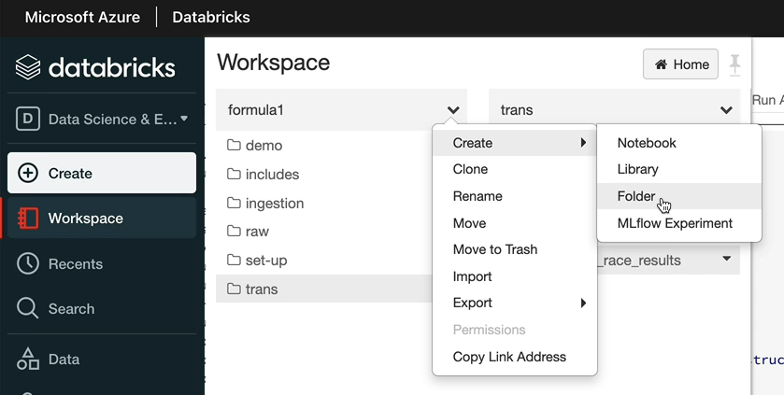

I'm going to create a separate folder for analysis purposes. So that's kept separate. And here, let's create a notebook called Find Dominant Drivers.

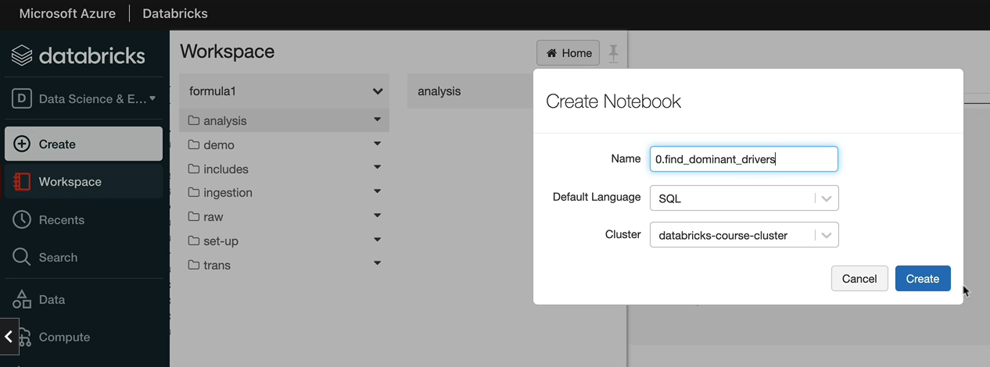

Let's now start analyzing the data. So if I do select * from this table that we created previously, which is to calculate results, we got the driver details and we've got the points he's earned. So we were in on the calculated points because now that is fairly distributed amongst all drivers as opposed to based on the years they've raised and they've got the points. So one of the things we could do is we can calculate the total number of points for each of the drivers and then rank them based on their total number of points. So let's try and do that. So it'll be driver name we want to select and then we want to do the total number of points for the drivers so we can use the aggregate function sum on the calculated points. So I just tagged out there so it'll give you help with the column names. And so I'm going to call this one as total points. And because we are doing the aggregations based on the driver name, as we discussed previously, we need to group by the driver name. So the date is grouped by the driver name. And then for each of the drivers, we got the points being summarized here.

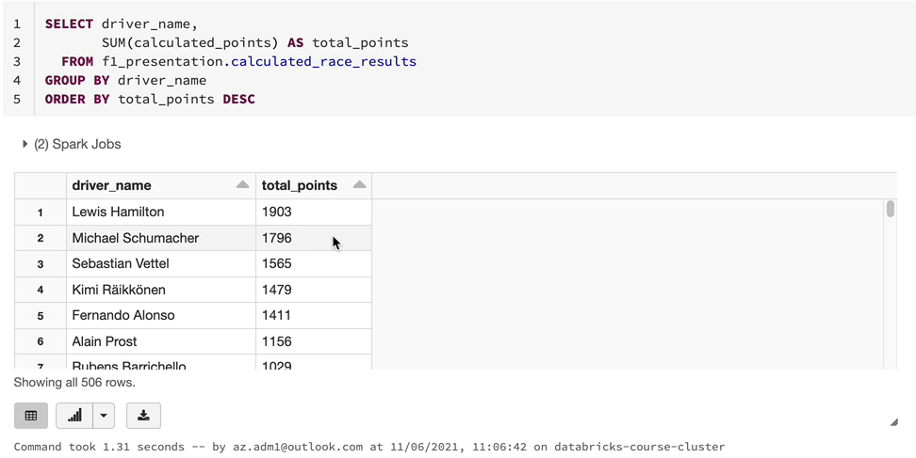

And because we want to see the one with the highest point on the top, let's do an order by as well. And that'll be the order by. We want to see the highest points on the top. So I'm going to do order by descending. Let's now look at the data here. It makes sense, we've got Lewis Hamilton with a lot of points and Michael Schumacher, who dominated the decade before, he ranks number two and then you've got Vettel as well. That looks reasonably OK. But one thing you might think of is the driver who raised the most number of races. He's going to have the most number of points. It really doesn't matter that much how well he did, but we want to know how well he did. So let's prove a point here. I'm going to do a count of the number of records for each of the driver, which tells us number of races he's raced. And we're going to call this one as total races. And let's see how that looks.

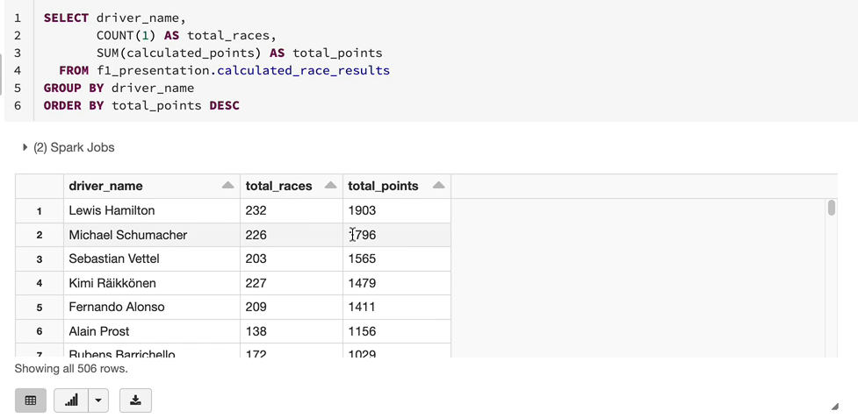

Lewis Hamilton obviously has traced on 232 races with one thousand nine hundred and three points, and similarly, Michael Schumacher has got a similar number of races and points. So it doesn't make a huge difference. But by the first look, it looks like Lewis Hamilton has only raced on six more races, but he's got another one hundred and seven points. So he's probably done slightly better, which is OK. But if you scroll down a bit. So you're saying things like here, SayNow only raised one hundred and four races and got eight hundred and sixty nine points, whereas Rosberg raised 144 races, it is 40 races more and he's only scored another 30 points, which doesn't make sense. And we would think Senna should be higher about compared to Rossbach. So in order to fix that one, instead of looking at the total points, we can look at the average points each driver has scored across races, so that might probably give us a better understanding of the data. So let's see average points now. Again, I just did a tab to get that column list here. That's quite handy. When you come to the ABC, I'm going to call this one ABC and the score points. And let's now order by the average points and see whether that changes the order in any way. Oh, no. That's really messed everything up because we got drivers, we haven't even heard of that match and they are on the top.

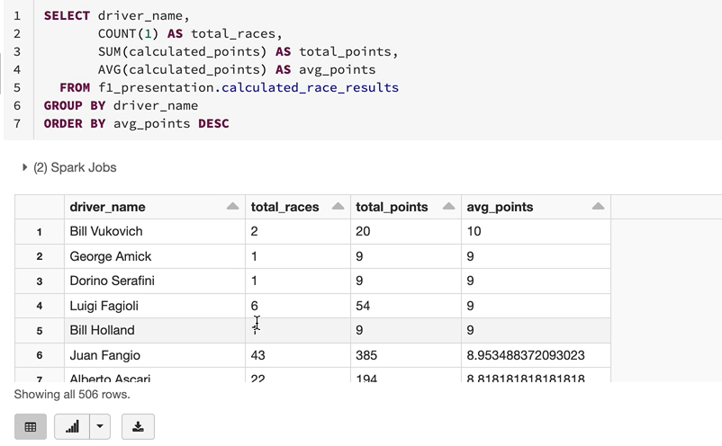

That's because there are people who just raced on one race and got nine points. Obviously, they would be ranked higher compared to the ones who raised on more races but got fewer points as well. So we really need to restrict on the number of races. So we want to probably say that we will only include drivers who've raised on a number of races, at least because that way you've got a bigger sample of data to analyze it rather than just looking at a few. So you might be tempted to say I want to save their total races is. Greater than 50, but if he did have a class here that wouldn't work, the wear would only operate on what you've selected from this table. So let me do that anyway, just to show you. So if I said actually, I want to see one of the drivers who breaks on at least 50 races, this is going to tell me the wire is not OK. I should put that after the from. Let me do it there. And that would even still tell you, actually, you can't really resolve the total racist column here because the table doesn't have the total. So if you had it in The View, the total races interview and then you just select it from there, it would work. But in this case, it won't work.

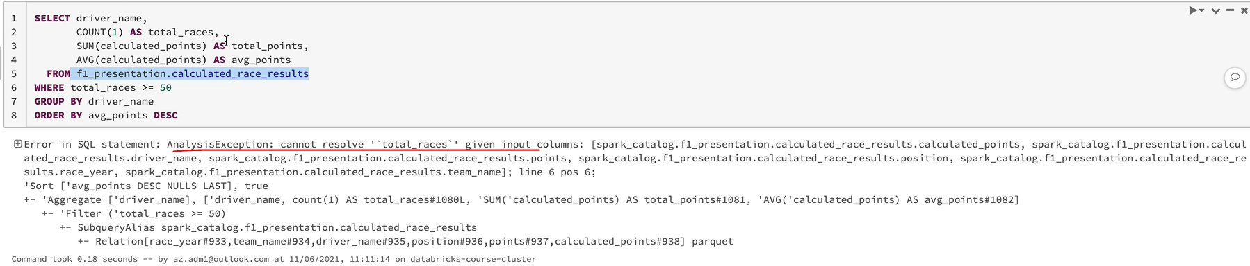

But you can fix it by using the having clause, which we talked about. Having works on aggregated output. So you can say having you cant say total races, but you can say count. So now it's going to only pick the drivers who placed on at least 50 races. So you saying here are reasonable data? So you've got Alan Prost raised 138 races with one hundred one thousand one hundred and fifty six. We didn't even see him in the last select when we did it by his average points is 8.37. So he was scoring 8.37 on an average across all his hundred and thirty eight races, which is pretty good. And so now obviously we looked at previously he was on number 14, I think, and now he's moved up to number two.

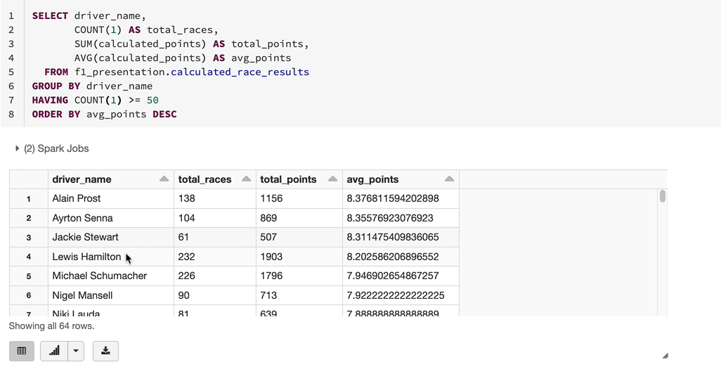

And a lot of people respect him as one of the best drivers Formula One's ever had. And you've got Jackie Stewart and Lewis Hamilton and Michael Schumacher and so Lewis Hamilton and Michael Schumacher, our most recent player drivers. But the others are slightly older. So their sport does think actually these are the drivers who dominated the sport all time. But some of you might be following Formula One in the recent decade, last couple of decades. So let's look at that data and see who dominated in the last decade to start with. And then we can go 20 years as well. That'll give a good rating. So in order to do that, because we've got the race here, which we did include in our table, we can say between 2011 and 2020, say. So now this is going to pull the data between 2011 and 2020 and do exactly the same ranking which we used. And as you can see, most of us do know, Lewis Hamilton dominated the last few years. And before that it was Vattel and Rossbach had a small brief season as well and just happened to be an up and coming as well. So this kind of gives us a good picture. Alonzo had a better decade before that than the 2011 to 2020. So what we can do is we can look at the decade before let's do that. And that would be from 2001 to 2010. Let's look at that one now. And now, as you can see, you've got Schumacher absolutely dominated that area and Lewis Hamilton and Monteil and Alonso as well. So these things give us a better reading of the drivers who dominated in the last decade or the our all time.

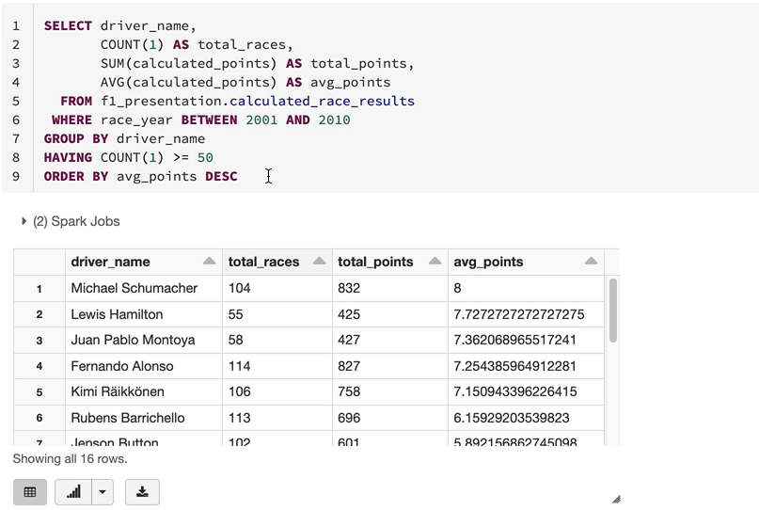

So hope this has been useful in looking at how to use sparks equal to analyze your data, and if you want to save this output, you can save that into table or you can have a view which you can carry later on as well.

### Dominant Teams – Analysis

OK, the next thing we want to do is to find the most dominant teams of all time as well as in the last decade. So what I'm going to do is I'm going to open the five dominant drivers, which we did previously and under the tab. And then I'm going to copy the sequel from there and do the work here. So the difference is, actually, we looked at the driver previously, but we want to look at teams. So I'm going to change the select to use the team name and the group by to do the team name. So normally in Formula One, each team has got two drivers, but because we are grouping by team name and summarizing the points, we are going to pick up both drivers points as the team.

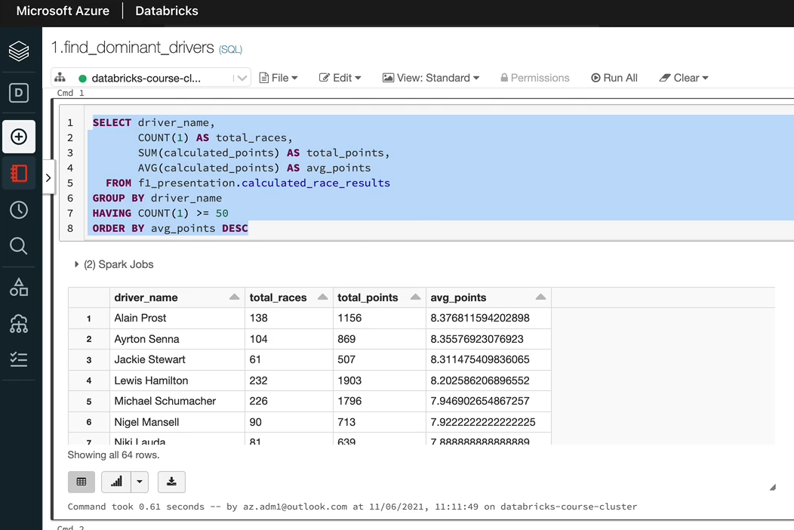

So again, we want to have a count greater than a certain number because there are two drivers in a race, 50 doesn't go that far. So I'm going to go for 100 just to give a similar picture to the drivers points. So let's do that and execute it and see what happens. So this is for all time. For all time, Mercedes has come on top because they've been dominating the recent years and the domination is quite significant compared to others.

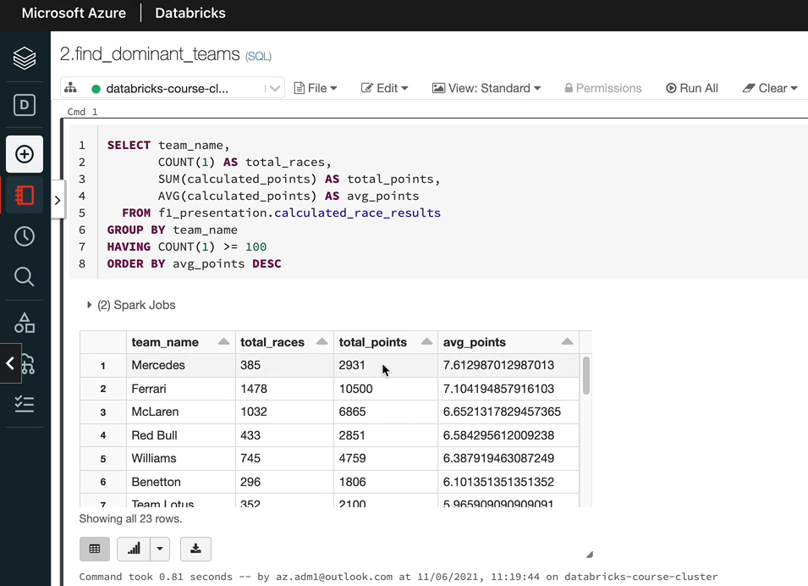

That's why even with the three hundred and eighty five races, they are still way above. So they've got seven point six one points on average per race. And obviously Ferrari follows next. And McLaren had a really good time in the last decade and Red Bull did as well. And Williams has had a really good time previously, but recently they've been doing poorly. That's why they are number five. But if you look at specific periods, Williams might come out on top for those periods. So let's do something like that. Let's look at the last 10 years like we did for the other work.

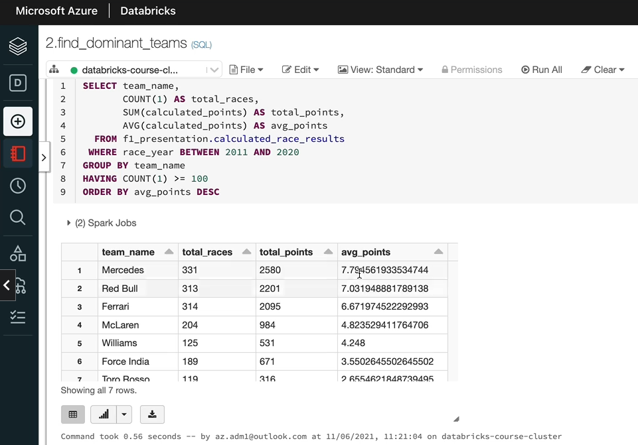

So for the last 10 years, we got Mercedes, obviously they are they have dominated it and you've got Red Bull closely following and Ferrari are on the third. But if we look at the ten years before that, things will be different. So let's have a look at the. So as you can see, Ferrari had a really good time during that time, and they've got McLaren, Red Bull and Renault had a good time as well. Actually, Alonso was driving for a couple of years and he was a champion.

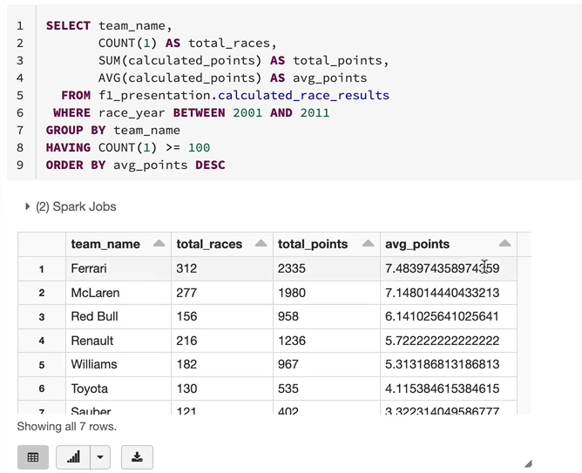

So as you could say, this is quite simple with a SQL just to analyze it. And the analyst normally prefer a SQL as well.

### Dominant Drivers – Visualization

So far, I have been talking you through this data and explaining which driver dominated in which year, that information is not here, but it'll be nice if we can pick the top five or ten drivers and then visualize their data or visualize their performance over the years so that we can talk through. And it makes a bit more sense. So that's what we are going to do in this lesson.

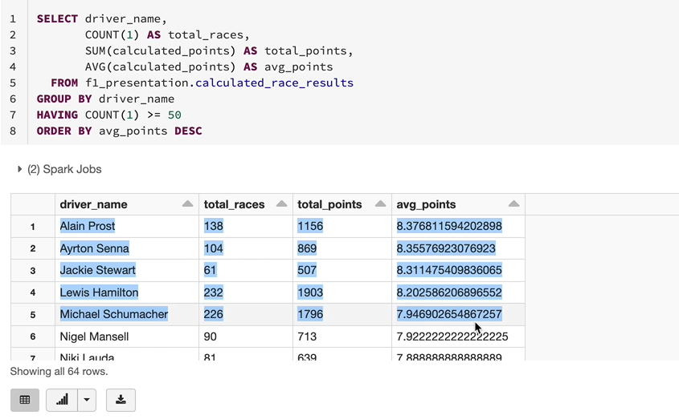

So I'm going to copy this select statement we've got here because we can use it in the next one rather than writing it from scratch. And also what I have done is I have created another notebook and called it with dominant drivers and that's under the same analysis folder. So let me put that statement in here. If I run it, we get the same results we saw, so we got the drivers right here, but the rank itself is not a specific column. We relied on the UI, so we need to use that information later down the road. So I'm going to create a rank as a column within this data. In order to do that, we can use the window function as we've seen previously, so we can use the rank function. So as you know, the rank function takes in two values. One is the partitioned by and the other one is the Order by. So it usually be partitioned by within a window. And then we are to buy something to give it a rank. In this case, we don't really need to partition by anything because we are ranking the whole population of our data. So let's make the partition by but we still need the order by and the order by we want to do is based on the average points. So the average point itself is not a column within this table because that's the column you can use here. But in order to get the average points, we used the average function here. And interestingly, you can use the same aggregate function in your order by as well. And then if you do descending, we are going to get the driver rank. So I'm going to call this one as the driver function. And let's run this statement and we should get a rank which matches the UI itself.

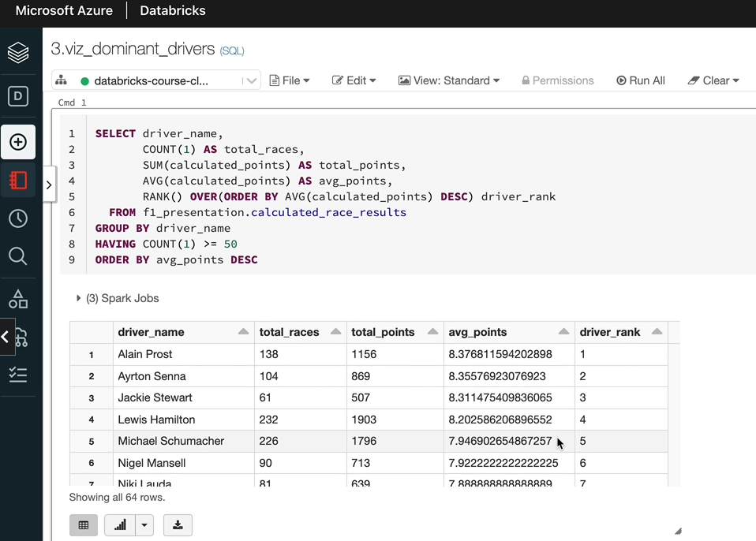

So now that we've got a rank here, we can use that later in our processing. OK, that's pretty good. In the next statement, we are going to get the information for each of the drivers per year so that we can plot it on a chart. So let's copy this select statement. And what we need now is the race here as well, because we want to see their performance over the years and see how well they've performed over the years. So you need the rest here in your select. If you add it to the select, you need to add it to the Gooby as well so that the aggregations are done on the race year. And the driver name. We don't really need the rank because the rank is all time and we don't want to rank them within it within each year as well, like we could do that. But that's not what we are plotting in this case. I'm going to take that out and let me run this query. The query returned no results. That's because we still having the having count one greater than 50, that is within a year. That's what we grouping by. We only have 20 or a maximum of 24 races. So I'm going to take that out altogether. And if we just run it, we're going to get the data. So we got the race here and the driver name and how many races he's raised and the total points and the average points and things like that, which is fine. But let's all the bike race here as well.

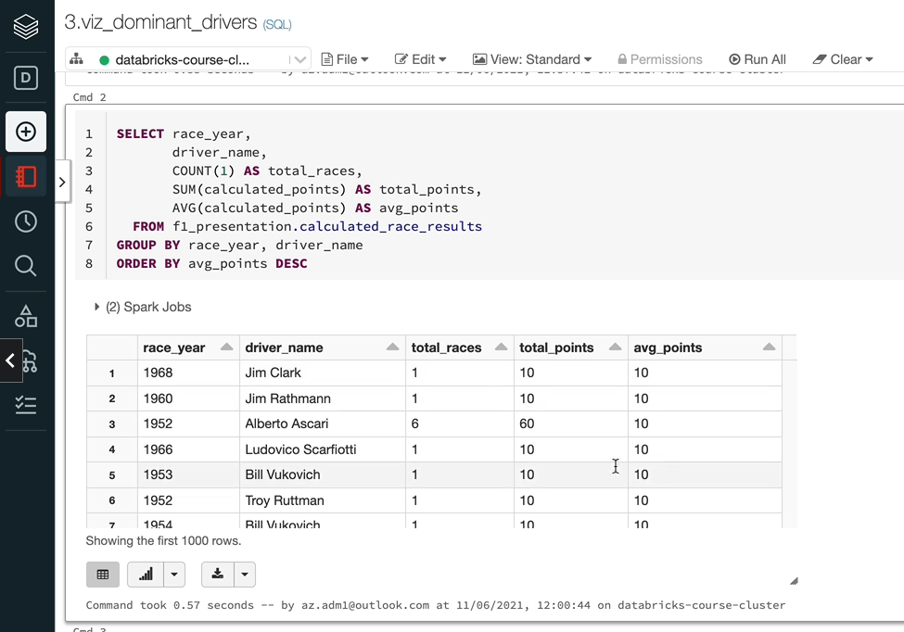

So that's cool, so be saying within in 1950, so we've had Fanshaw had three races and average points is 10 and things like that, but we're not interested in all of these drivers. We're only interested in certain drivers which which are the top five or 10 in this case. So one option is we can have that as a city, which is a common table expression in this country, but that is slightly advanced. But instead we can apply one of the things we've used already, which is create a temporary view. So let's do that.

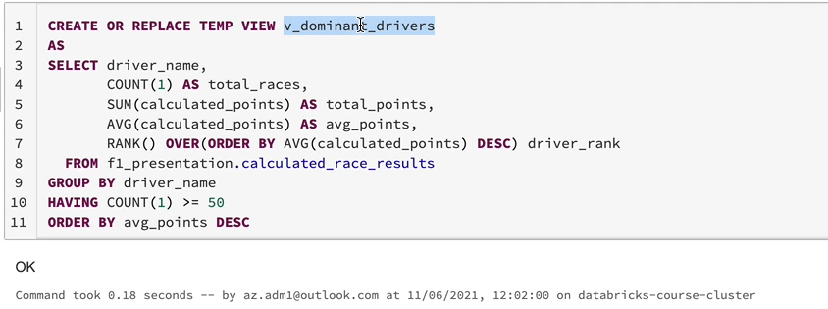

So I have now created a view called dominant drivers v_dominant_drivers and we can join the view here or we can even filter down because it's only a handful of records you can just use in class to filter out. We haven't seen the end yet, but I'll show you how to use that. So all they do is drive a name in. You can give a list of driver names, but I'm going to select it from that view. So that'll be select driver name from that view where driver rank is say less than or equal to 10. So that's going to give you the top ten drivers of all time and their performance over the years, each of the years. So let's run that now.

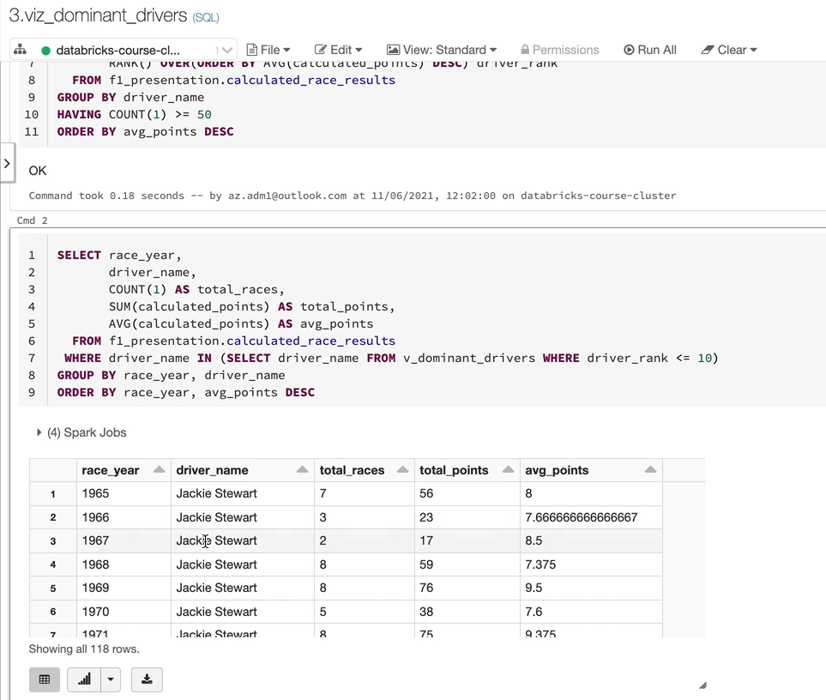

And from now, you can only see, like Jacky's tour dominated the early era and then it went to Nikil out Ouda for a period of time, and you've got Nigel Mansell, Alan Preist, Anna Nicole Aldworth back for a bit as well. So all of that information is here, but we don't want to be looking at this data as it is. We want to create some charts from this one. So let's do that. The first thing I want to try and do is to create a line chart. So in order to do that, you click on this chart button and that gives you by default, the bar chart. Let's change that to our line chart here. So go to plot options and then you can pick pick the type of chart you want, which is a line chart is what I want to get. And you can change everything here.

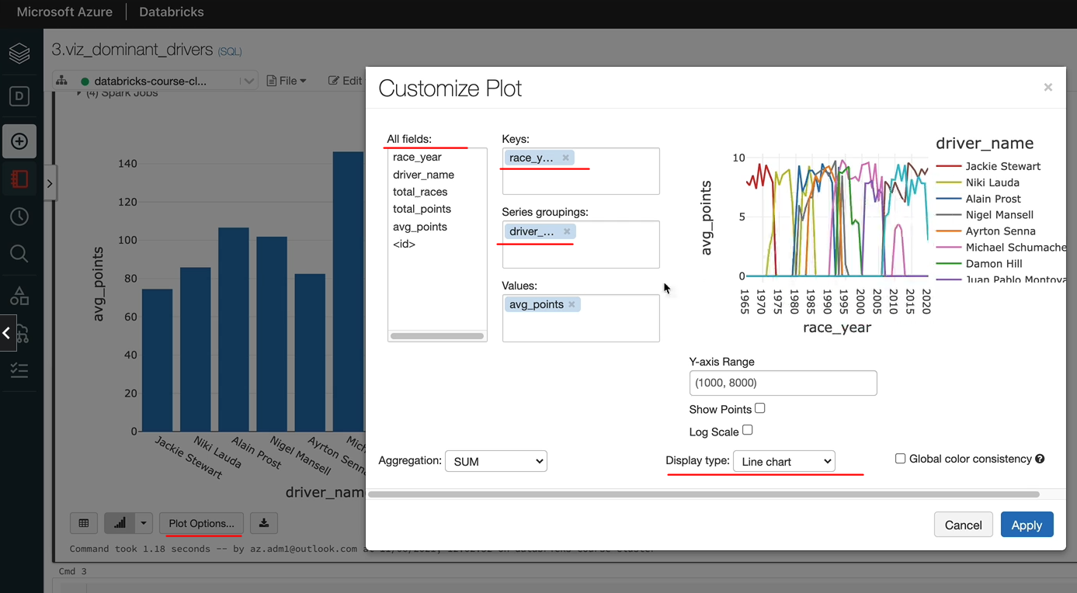

So in my case, I want to use the keys as a ratio because that's what we want to see at the bottom here. So let's put the race here as keys and we want to. Group the data based on the driver, because that's what we're going to display, and then if you put that there, you're going to get what you want. So let's click apply. OK, so this is the chart we wanted. It may look a bit daunting to start with, but you can see the top performers on the top. So you got Jackie Stewart dominated the early era and then you've got Nike louder and you've got Alan Prast for a period of time. But in between, you've had Nicholaus for a period of time as well. He came back and we've got Nigel Mansell for a period of time. You've got Michael Schumacher for a long period of time here. And then Sebastian Vettel with the Red Bull headed for a few years. And now it's Lewis Hamilton for the last few years. So that's that's what the chart tells you. And as we've seen previously, these are the drivers who dominated the sport. So that's a nice chart.

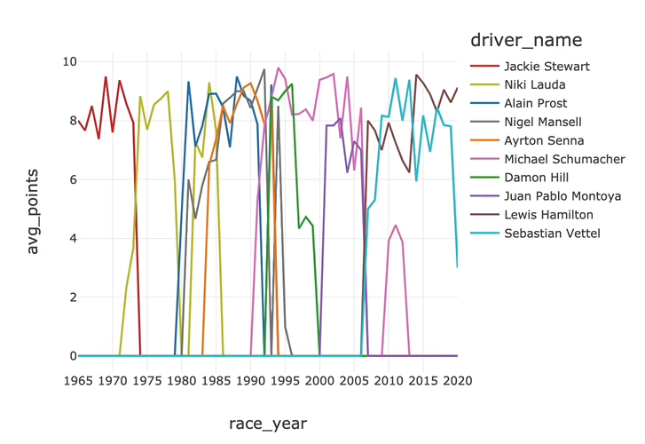

But let's look at a few more charts as well. So we'll do a bar chart and then area chart as well. So I'm going to do a bar chart next. So in this bar chart, it doesn't make a lot of sense just to look at it as it is, but I want to see the total races because we were saying the ones who raised the most had the most points. We can now see how that works. So I'm going to put the driver name as the keys. And then you've got the values as turtle races and turtle points. Let's click apply.

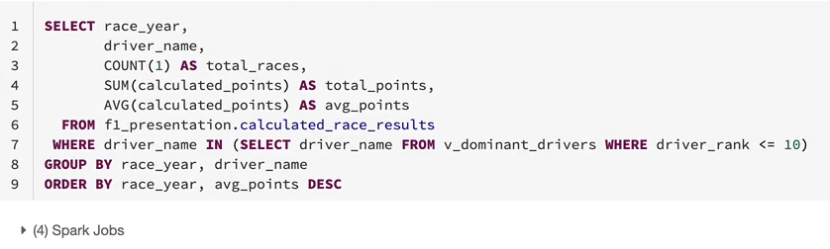

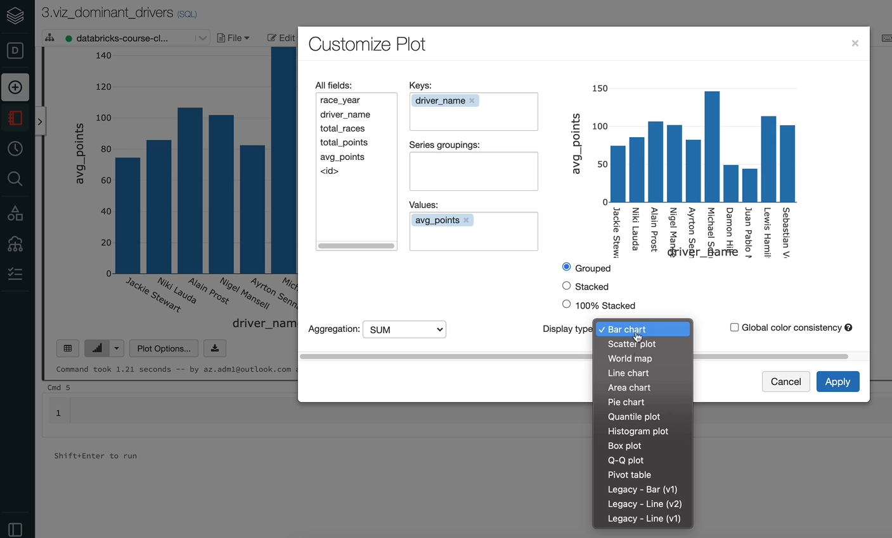

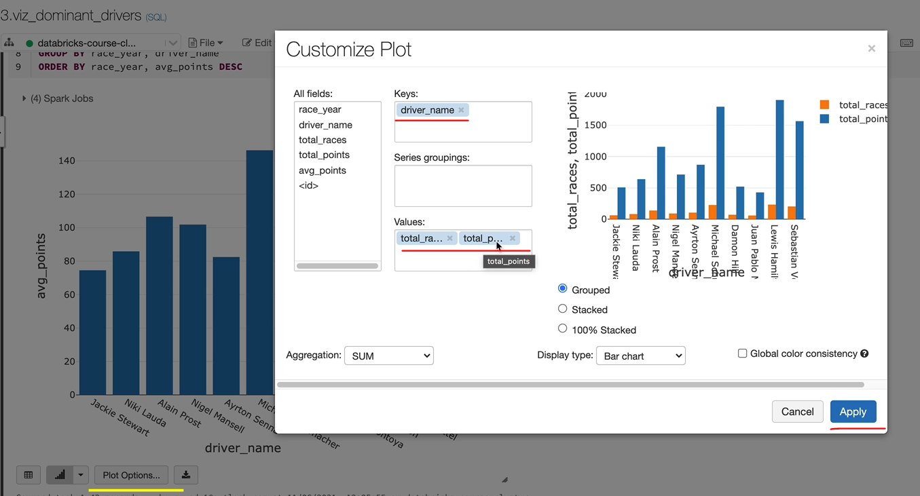

And then you can see these drivers, the later drivers here are having more and more races. The sustainability is quite long nowadays, and that's why they've got more points as well. And the other thing I want to do is the area chart, which will be quite an interesting one to see how they dominated and the periods it'll be. It'll look better than the line chart that we created previously. Let's do that now. Let me run this country first. And then if we go into the plot options again and then look at the area chart and we want to change this because we won the race, here's the key. And we won the tribal name as the groupings and we've got the average points. So, again, let's click apply and then I'll talk you through. So now this makes a bit more sense.

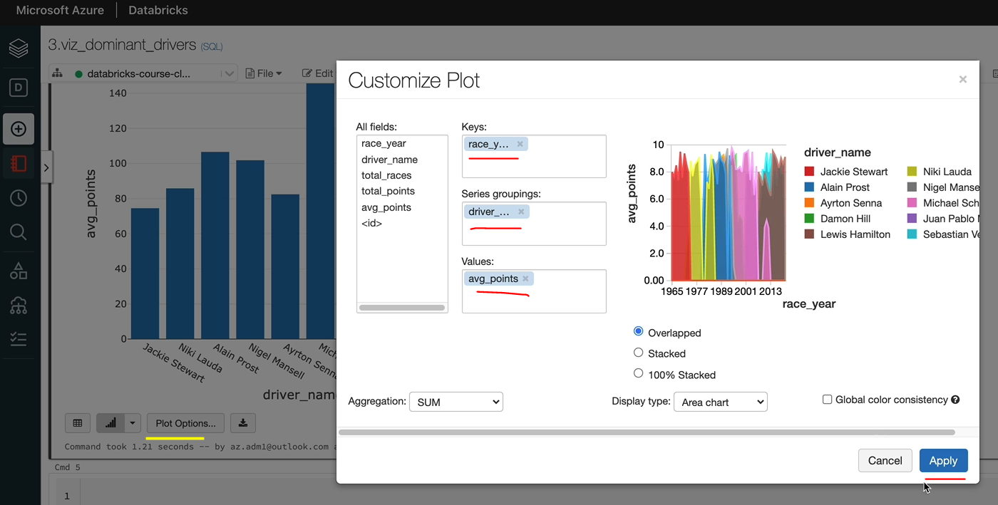

As you can see, that's the Jackie Stewart era where he dominated. And then you've got Niccola there for a period of time here and then back again and you've got Alan Prast for a period of time.

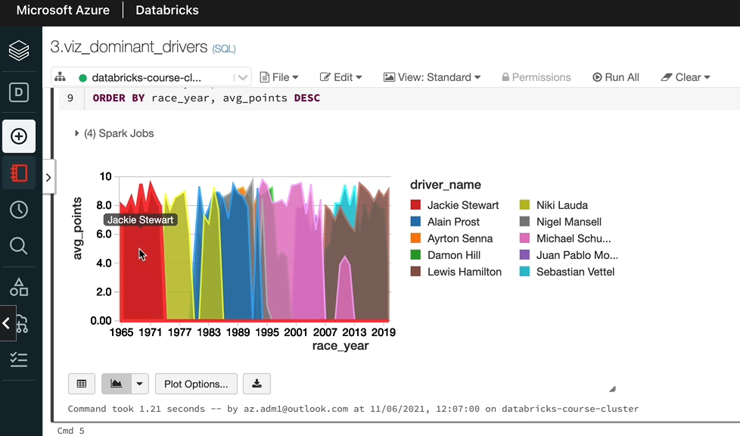

And then we've got and center at the back. But his time was shorter before his death and the race. And after that, you've got Michael Schumacher for a long period of time here. And Vettel had a period of time with the Red Bull here and then now it's Lewis Hamilton for the last few years. So amongst the ones we've looked at, I guess actually this one gives us a better picture of what's happened in Formula One of all time. If you want to look at only the last 10 years, 20 years, you can again change the Currys here and then you can visualize the data if you wanted to.

### Dominant Teams – Visualization

In this lesson, we want to look at the dominant teams. Now that we've done dominant, diverse teams follows a similar pattern, except for the driver details, we would use the team details. To start with, I'm going to clone this notebook because a lot of the code will be very similar on both of them. So I'm going to change this one from drivers to teams. And the number three, I'm going to change that to four and click clone. So that will clone my notebook for me.

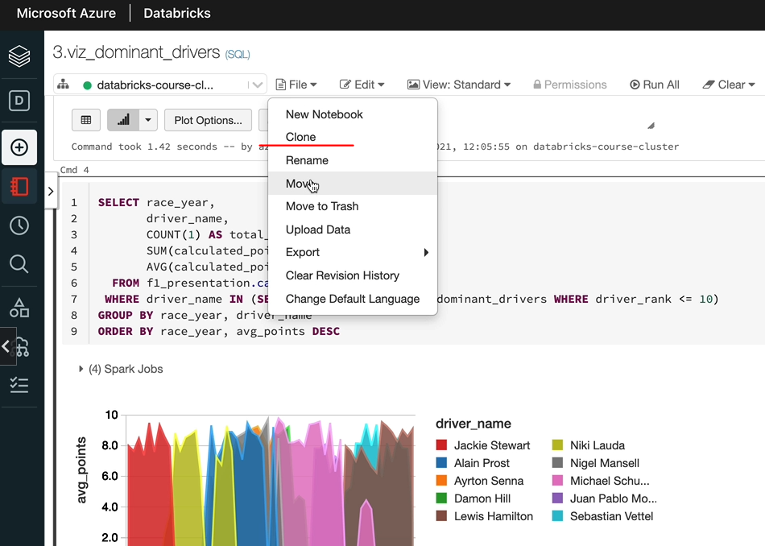

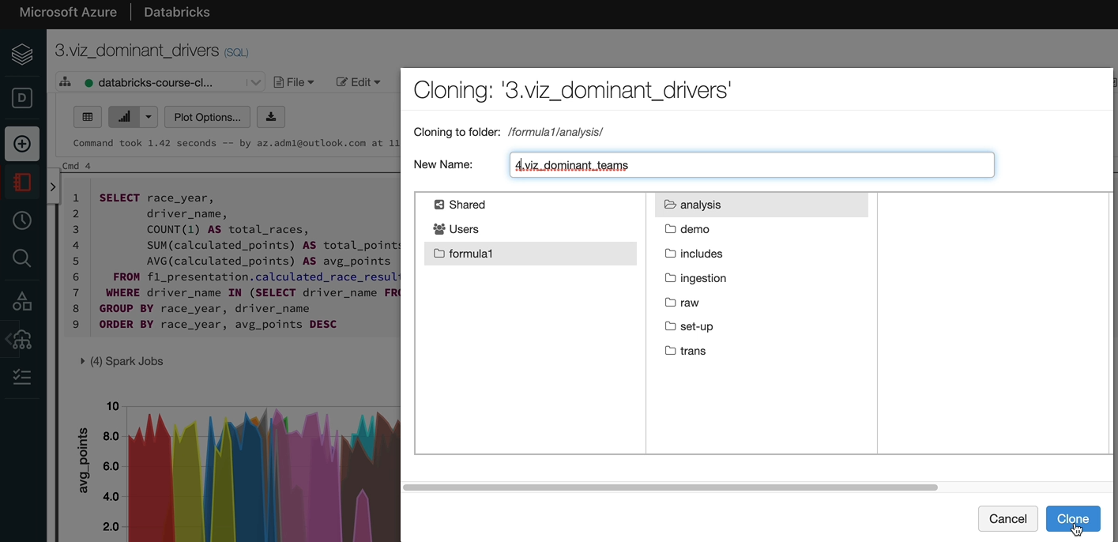

So the view itself, we need to change that to teams now. And instead of the driver name, we're going to have the team name, I'm going to copy that so I can paste it as I go along. And now this will be called the team rank. And also we want a group by the team name. So this will should give us what we need. I need to attach to the cluster, and that's done as well. So let's run it.

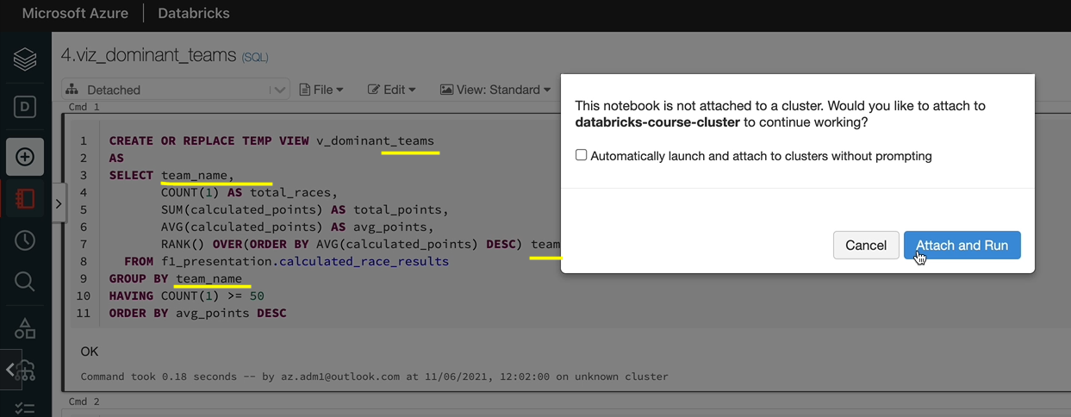

So let's just quickly query the view just to make sure that the data is as we expected, because we made a few changes. Now. That looks good, but one thing we wanted to do is actually we wanted to increase the count to 100 because we got two drivers on each team's normally, so it's better to do it that way.

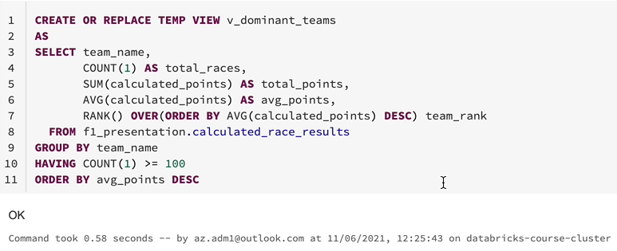

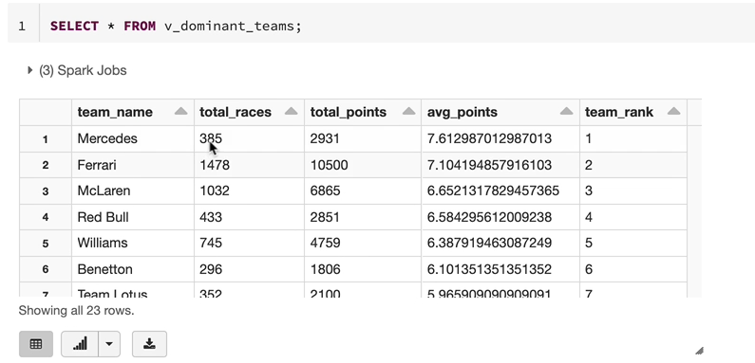

OK, so that looks pretty good and to be expected and now let's make the other changes, I'm again going to replace the driver with the team name here. So the query has returned the results here.

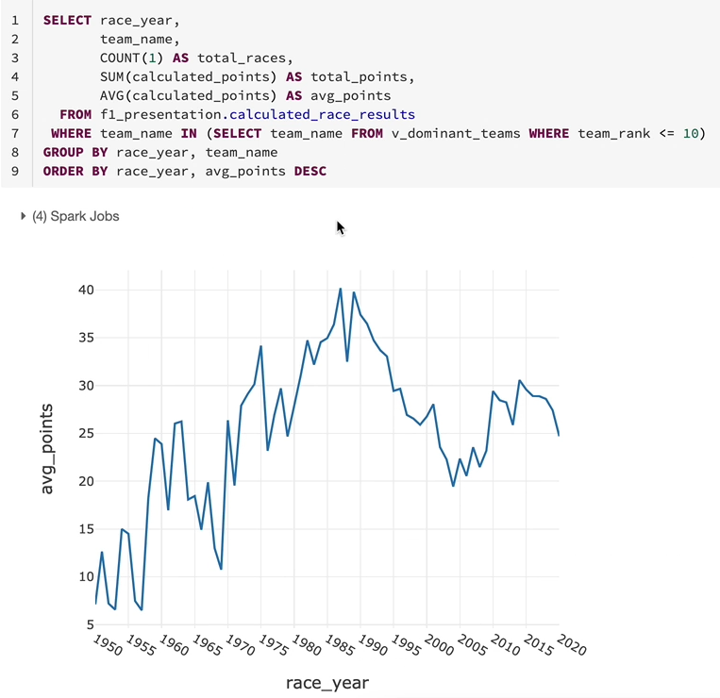

We just need to plot it. So let me go up the plot options and we want the race here as the keys and we want a group by the team name now rather than the driver name. And we want to give the average points and we want to use the line chart instead of the bar chart.

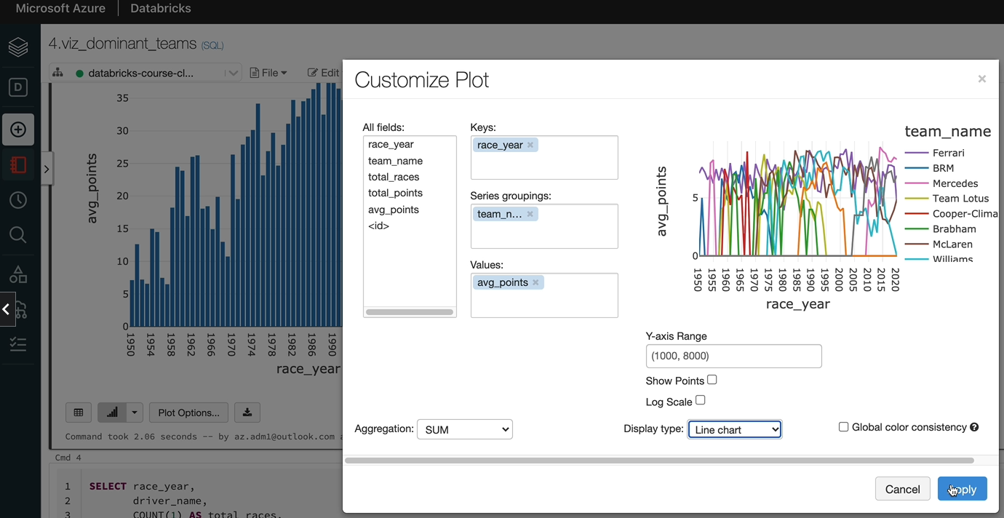

So let's click, OK, and it looks a lot more clouded than the driver one, so I would encourage you to use team rank less than or equal to five so that we can see better visualization.

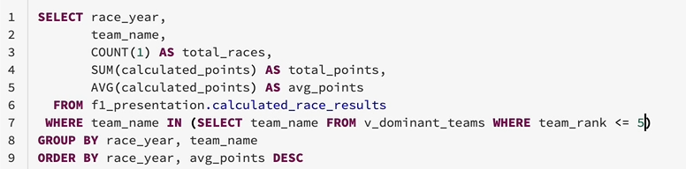

And then let's go to Plott again and go by the team name. And that looks a lot better to be seeing just the top five teams here.

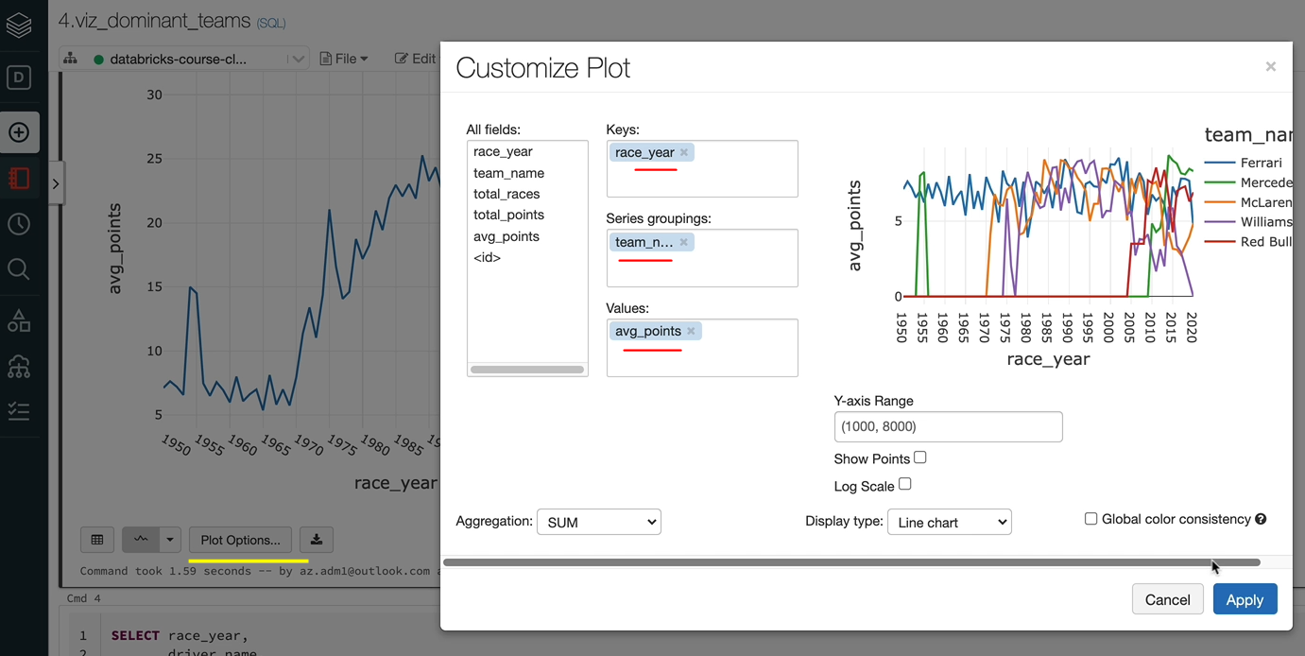

And as you can see, we've had a spike from Mercedes and then they went away from the spot and they came back here and they're dominating again. And Ferrari have been consistent most of the time through, but they've been running behind recently. And Red Bull had a good couple of seasons here with Vettel. And also you've got Williams dominating a period of time as well. They came back from they came from here and then they've dominated that period. And then now they are not doing that well.

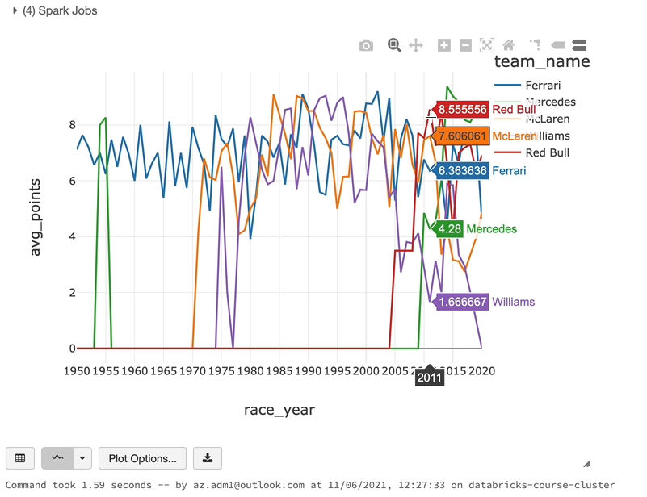

So that kind of makes a lot of sense and let's not worry about this bar chart, because it might not add any value for the teams. Let's close that one and let's do the same thing with the area chart. I'm going to copy this curry and then put it underneath here and run it through. And we cannot use the area chart for this one, so we want the. This here and then we want to buy the team name and we got the average point as well, so let's click apply. And as you can see, Ferrari have been dominant for a very long period of time and we've got others dominating at different periods of time. So Ferrari just dominated most of the way through and we got Mercedes dominating in the last few years.

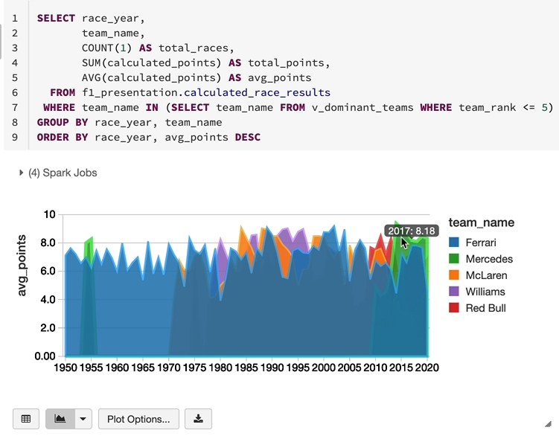

So that kind of explains what happened in Formula One in terms of teams. And that's the end of this lesson. And in the next lesson, I'll show you how to create a dashboard from the specialisations and make them available for someone else either.

### Create Dashboards – Drivers

In the last couple of lessons, we've created some really good visualizations, but it would be nice if we can share those visualizations via dashboard to the rest of the team or someone from outside the team. So that's where data gives you the option to create dashboards. And that's what we are going to do in this lesson. But before we create a dashboard, I'm going to show you one more visualization command call display HTML. So we've seen this place before and the select statement when it runs, it's running a display statement. That's what you've seen here. But there is another function called display HTML. And I'm going to show you how to use that one first. That will help us give a title for our dashboard, for example. So let's try and create a title for our dashboard. I'm going to create a python cell, so I'm going to create a variable python variable called HTML, and I'm going to give it a html string.

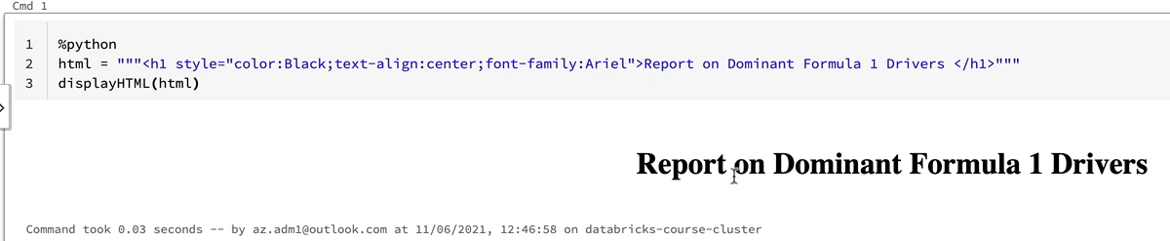

And that's what going to be sent to the display e-mail function to display the e-mail. And once we've done that, we can use that in our visualization as well. So what we're going to do is we're going to define a header for our dashboard here, and I've already prepared that for you. So I'm going to quickly copy and paste it here and I'll explain that it is just a header with the colors black and the text being aligned in the center and the font being Aryal. And that's going to have this text, basically. So let me just run this. OK, I missed the variable being passed in, so I'm going to send that in. And now you're seeing the report on dominant Formula One drivers. So our dashboard is going to have this as the header and then we'll have the other visualizations in the dashboard as well. So let's do that. In order to create a dashboard, you come over to view and then click on new dashboard. So that basically gives you all the visualizations that were available in that notebook. Let's start with naming our dashboard.

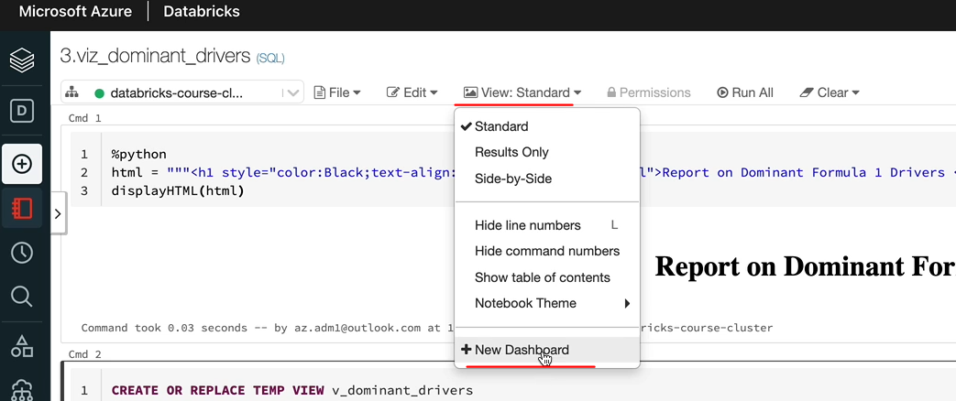

I'm going to call this one as F1 dominant drivers. Within the visualisations here, you can resize them, you can move them around and do everything. So I'm going to resize this because we don't want to have that all the way down. I'm going to make it a slightly smaller and you can delete the visualizations you don't need. For example, if I don't want to have this in my visualization, I can delete this chart.

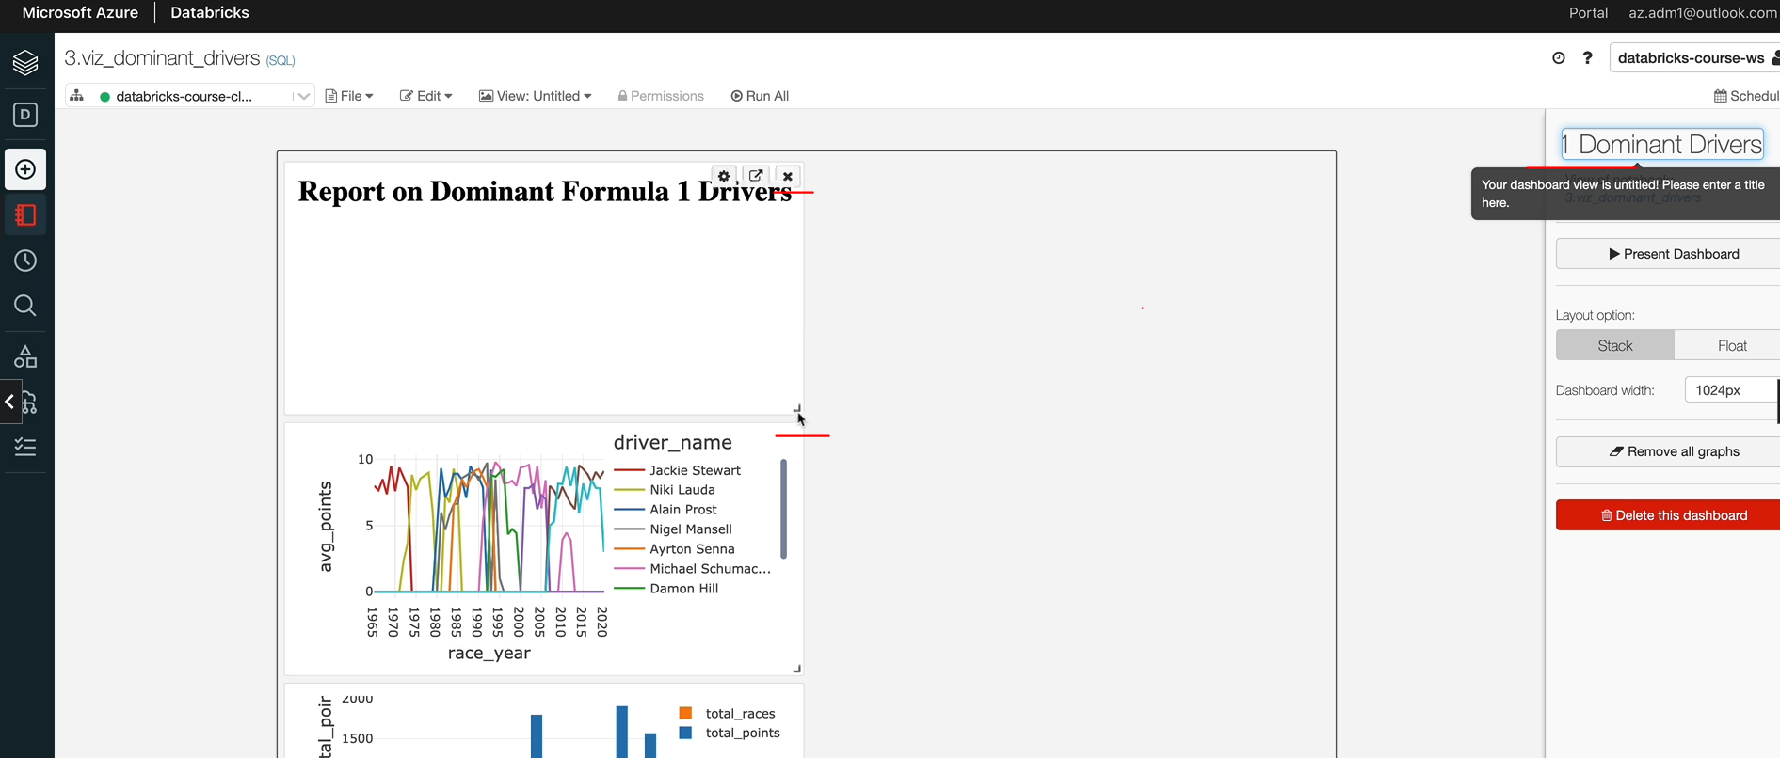

So that's gone and I can move them around. So let me move this to here. And also it'll be good to see a bit more information here. So I'm going to make it slightly bigger.

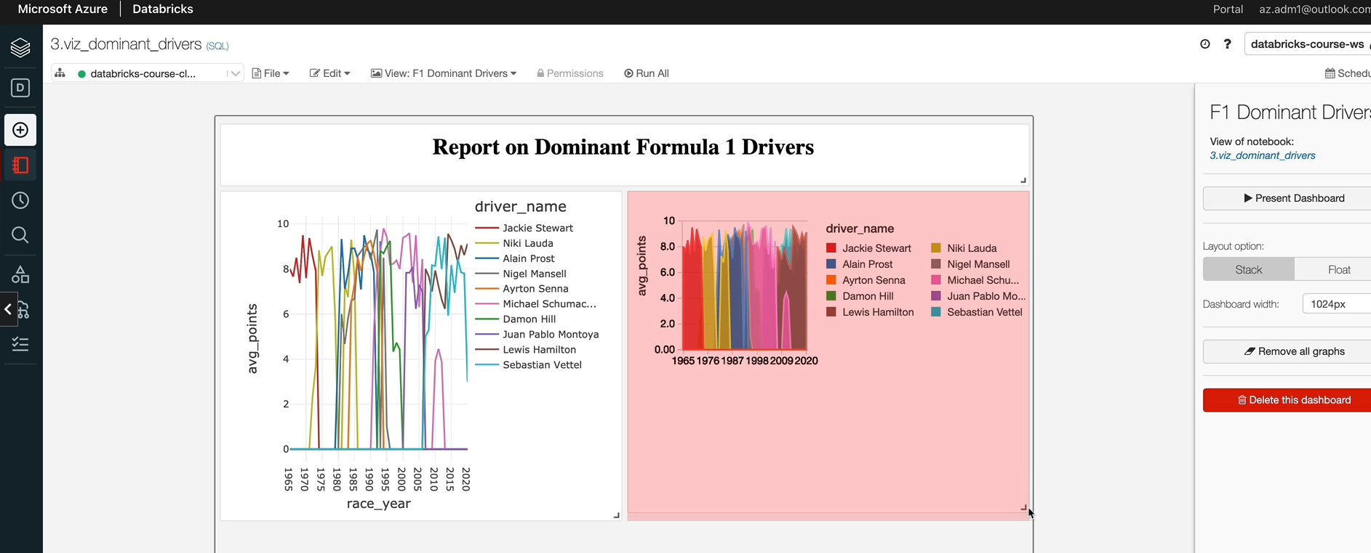

And also, let's make this one slightly bigger, just to match the. And there are other things you can do, so you've got the settings on here, which you can use to give a title for that chart, for example.

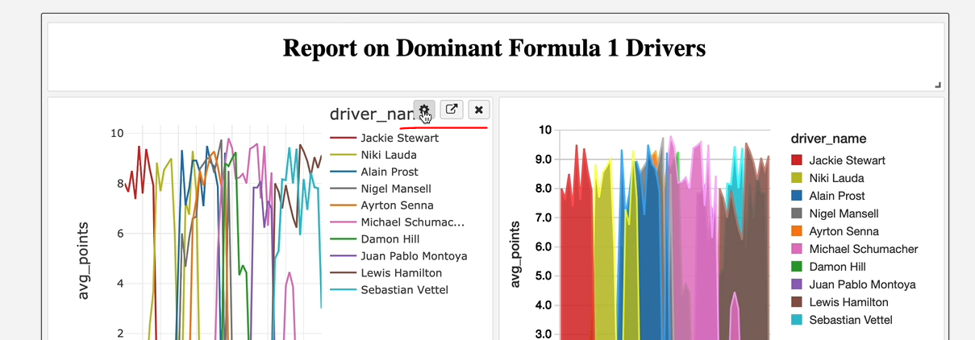

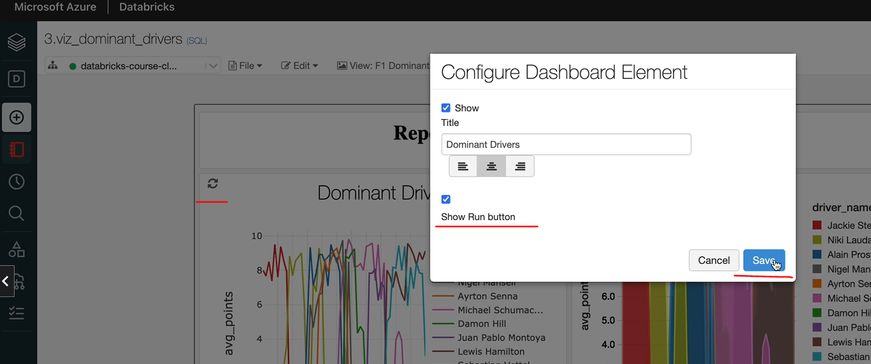

So let me say, uh, dominant drivers and you cannot lie it in the way you want. And if you want to have a separate run button for that, you can do that as well. So let me click save here. So that's got a red button and that's got the header. Come over here as well. Let's do the same thing for these as well. And the separate one band basically lets you run just that query, so that's SQL behind it can be rerun again, so it's running it in parquet now, giving you the result. So if the data has changed, then you'll see the new results here. So that's the beauty of this one. And if you want to click, run all you can run the whole thing. And once you've finished everything, you can make it available by clicking on the dashboard. And that gives you a new aura, which you can share with other people.

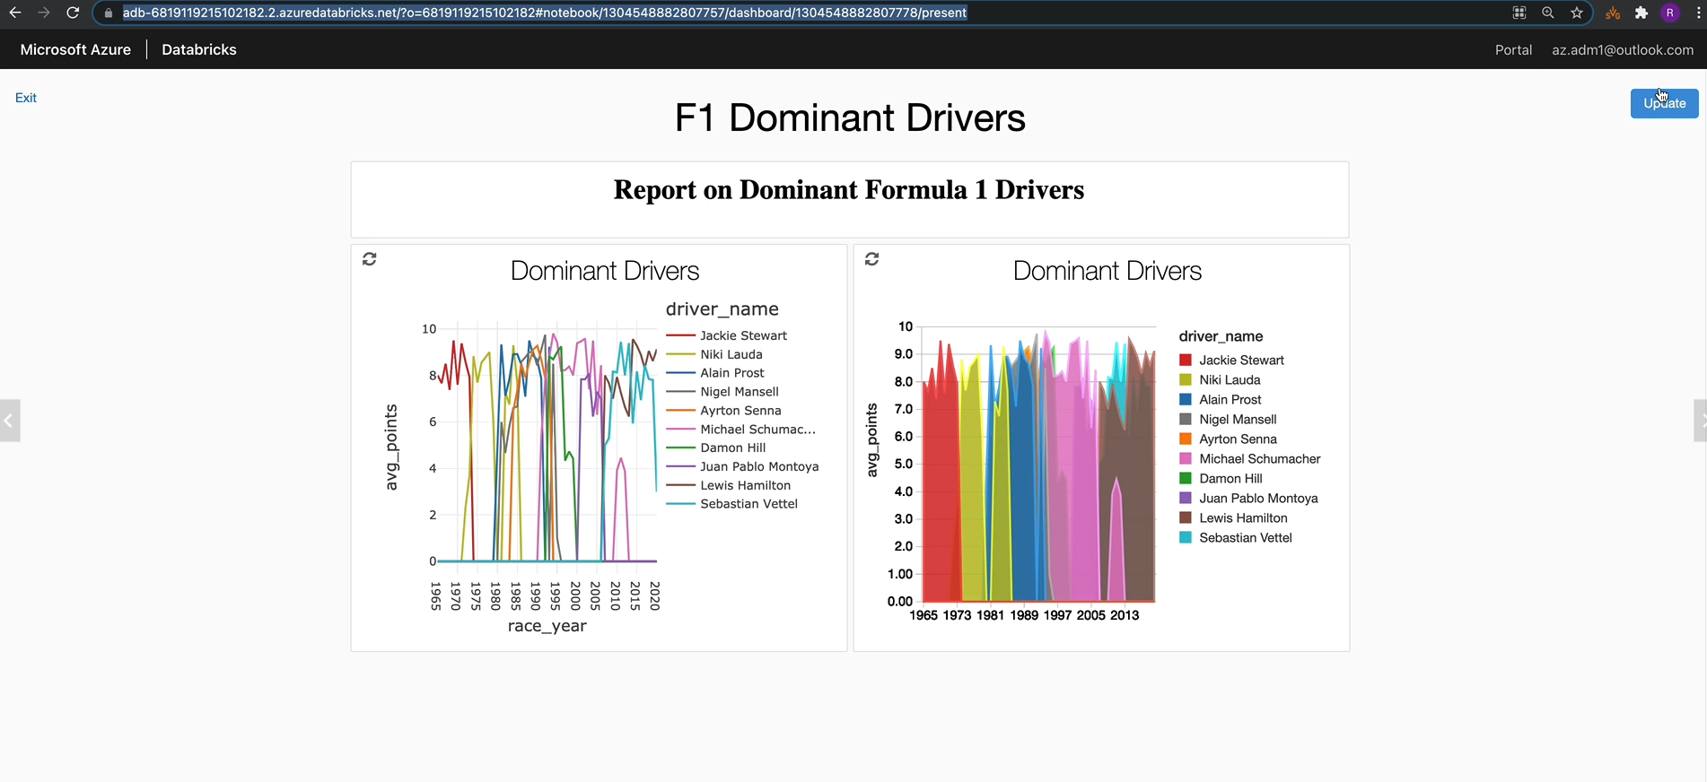

And because we gave a rainbow and we got a separate events for these ones. And if you wanted to update the entire dashboard, you click on the update. It's going to run the entire notebook and reproduce the visualizations for you as well, which is quite nice. So you can just make sure that your your dashboard is up to date when you're looking at it. So that's how you create dashboards within databricks.

### Create Dashboard – Teams

Now that we've created a dashboard for the dominant drivers, we want to create a dashboard for the dominant teams and because it's going to be very similar to what we've done on the drivers. I hope you manage to complete the assignment if you have in place, follow along with me. So this is my dominant teams notebook. I've already put the HTML here, so and I've changed the drivers to teams. If I ever won this one, it's going to produce the report on dominant Formula One team specialization. And the other visualizations are what we've seen previously.

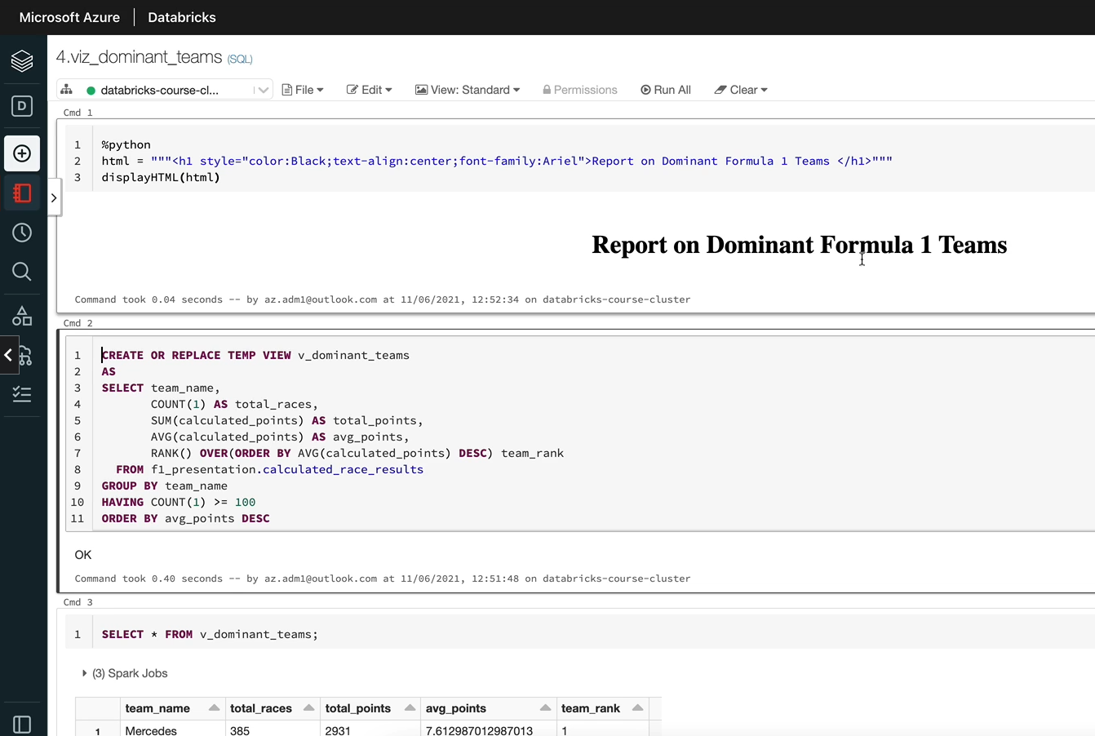

So let's create a notebook, come up with The View and then click on New Notebook and I'm going to call this one as F1 dominant teams.

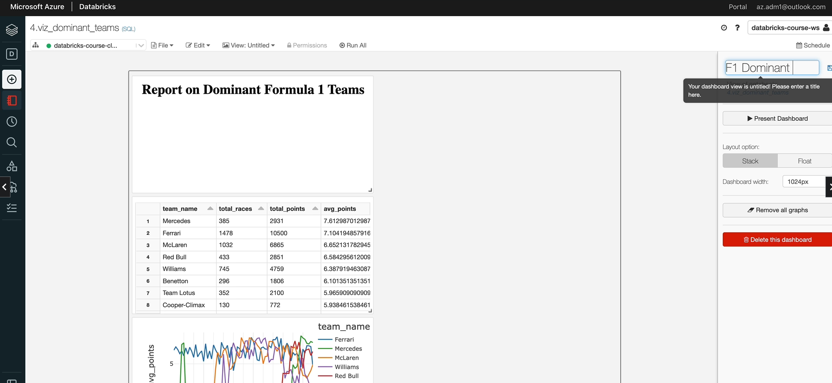

And similar to what we did previously, I'm going to just resize this visualization and then we can ignore this one because we had a statement there so that can be deleted.

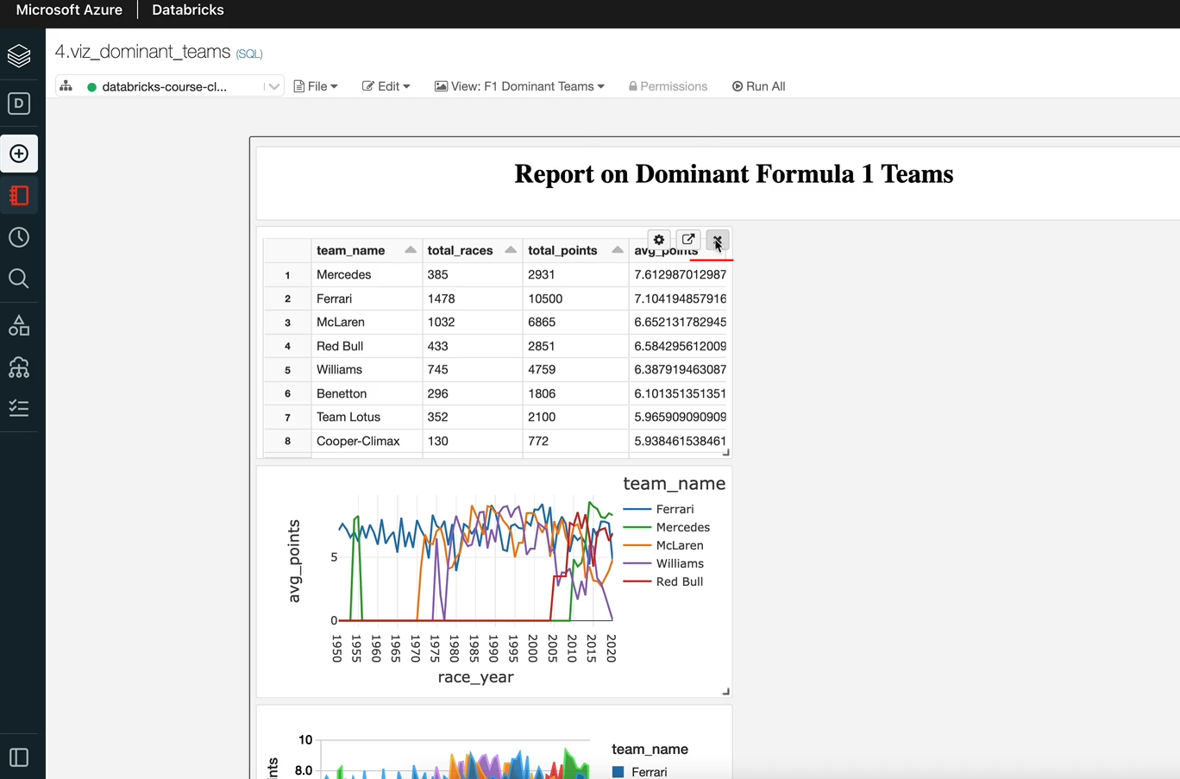

And these are the two visualizations we are interested in. I'm going to just write them over and then make it slightly bigger. And we do exactly the same thing for this. And we could use the settings here to put a title for this one so that be dominant teams and let's copy that so that we can use it for the other one as well.

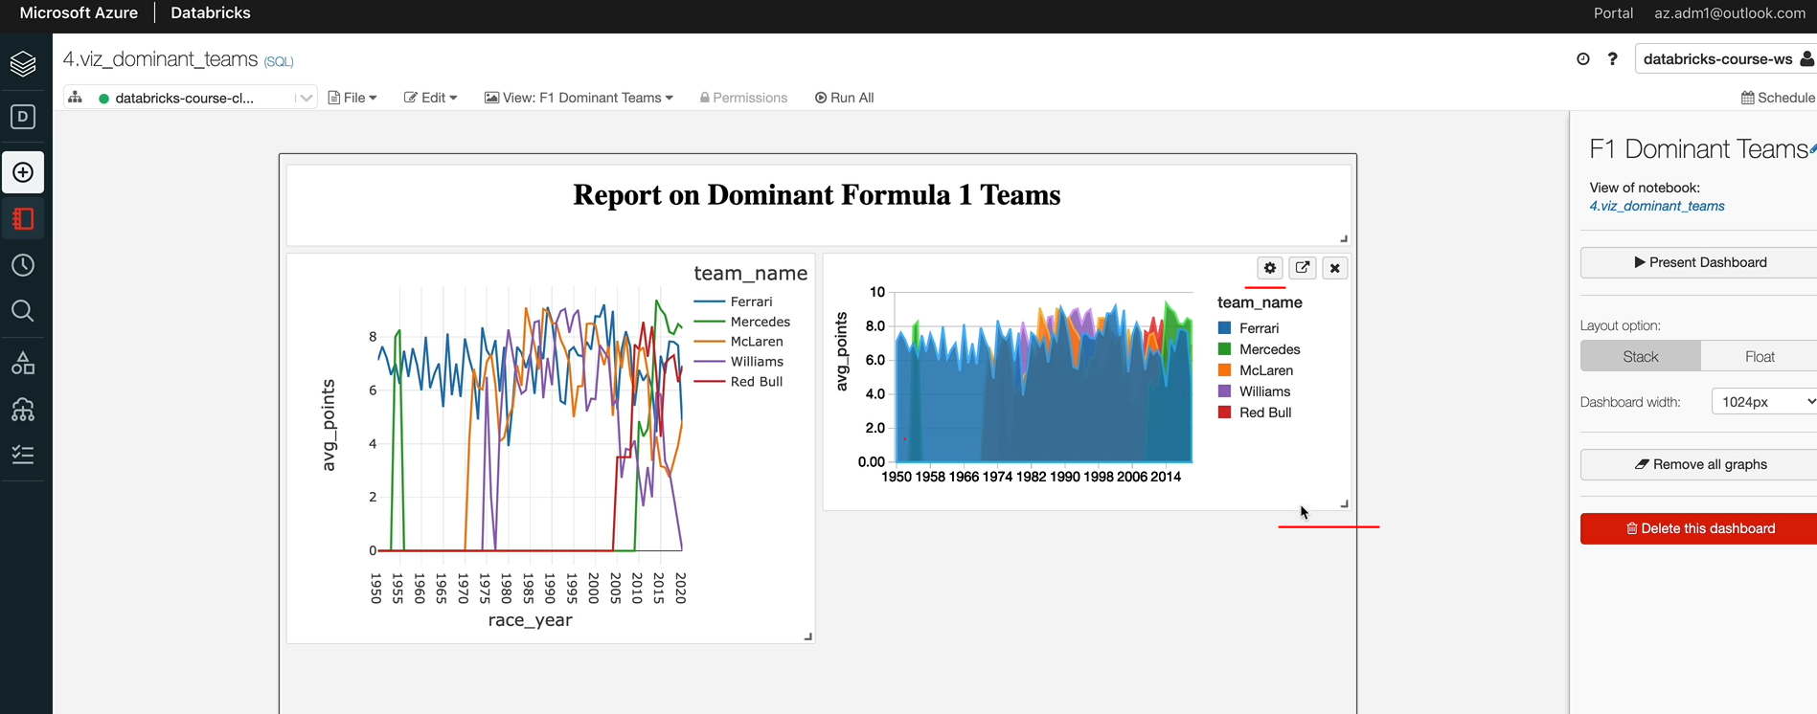

And I'm going to just give that the title as well. And this time we have it enable the run button on this one, which is fine. And then if you click on the person dashboard, so that's the dashboard we've got. And if you want it to update, you can do that as well. So that's the end of this lesson. And we've successfully created the dashboard for dominant drivers as well as teams, which is great.

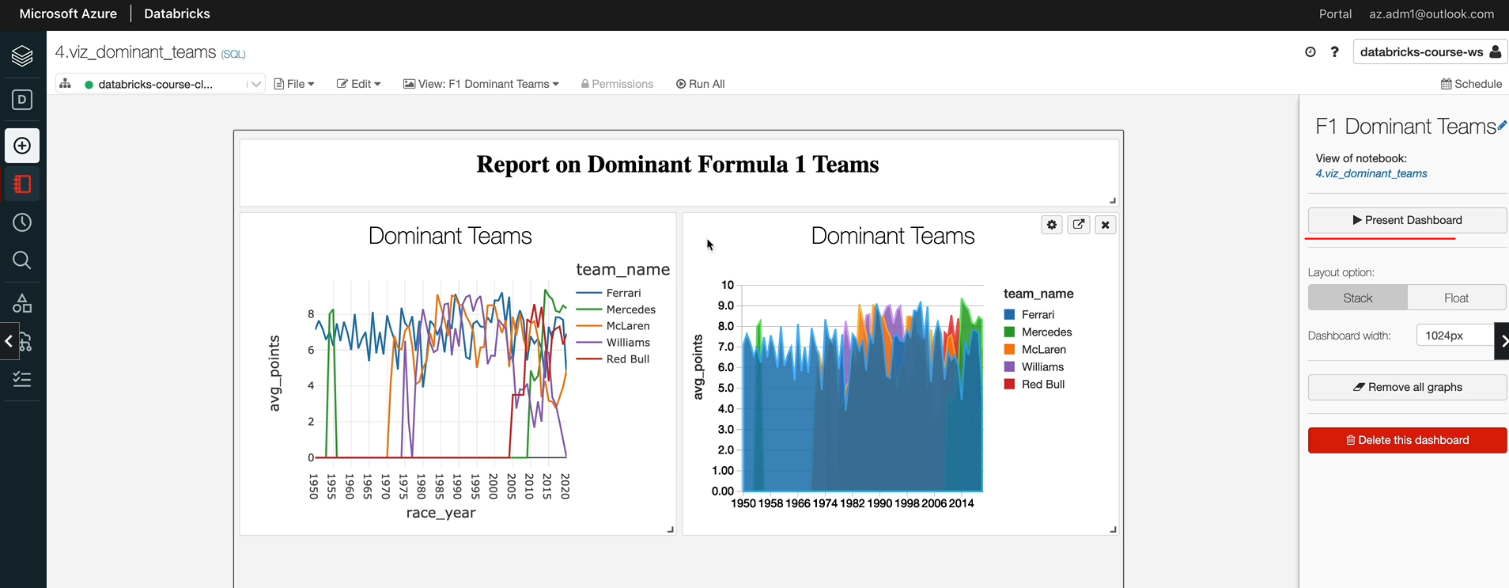

## Incremental Load

So far, we have been building a project to take all of the data and overwrite the entire data on every execution. This is OK for the size of our datasets, but this won't be the case for most projects in the real world. We may have to use other design patterns. In this section we'll discuss various data loading design patents such as full refresh, incremental load and hybrid approache. We will then discuss the approach we want to take for our project, which has been set up to use a hybrid scenario to provide maximum learning. Finally, we will apply these techniques to our project. By the end of this section. I hope you will have a good understanding about the various design patterns being used in the industry for loading data and also how to implement them in projects.



### Data Loading Design Patterns

We're going to learn some harder concepts from here onwards. I'll try to make it as easy as possible, but please do come back and watch this video more than once if you need to. The terminology used here might be different in your organizations, but the concepts will pretty much be the same. So far in our design, we took all the data that we received in the raw container, processed all of the data and replaced everything in our processed and the presentation containers every time. This is a simple architecture and works well when you have small amounts of data, and this is generally called a full load. It won't be suitable for large data pipelines, mainly due to the amount of processing we'll have to perform in order to process all of the data every time those pipelines are generally designed to load and process onely the data that has changed between the current run and the previous run. And this is generally called the incremental load.



Generally, these two types of loads are dictated by how much data we've received from the source system, whether it is all of the data or whether it's only the changes. For example, if we receive all of the data every time, it is a good candidate for a full load. But if we instead receive onely the data that's changed since the last load, then that is a candidate for an incremental load. But this is just a guidance, there are techniques that we can apply to create a full load from an incremental dataset and vice versa, but these things make the processing more complex and we won't go into these in these lessons.

Let's start understanding the full data set in this scenario. The source system provides all of the data since day one for every load. Let's take our Formula One project as an example to understand it better. On day one will receive the data for this one on data will not only receive the data related to race, two will also receive the data from day one, which is the race one data. Similarly on day three will receive data related to race as one, two as well as three and on day four will receive data related to one two three and four. So it goes on like this. So your data grows as the day moves on and it becomes bigger and bigger.

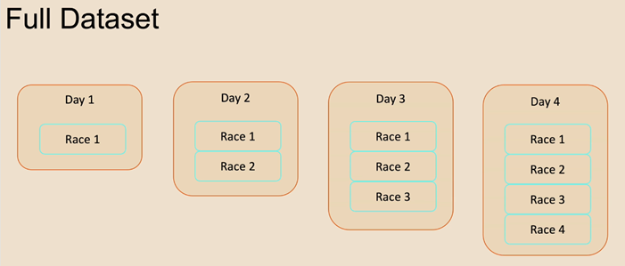

Let's now look at the processing that we need in order to process the full data set.

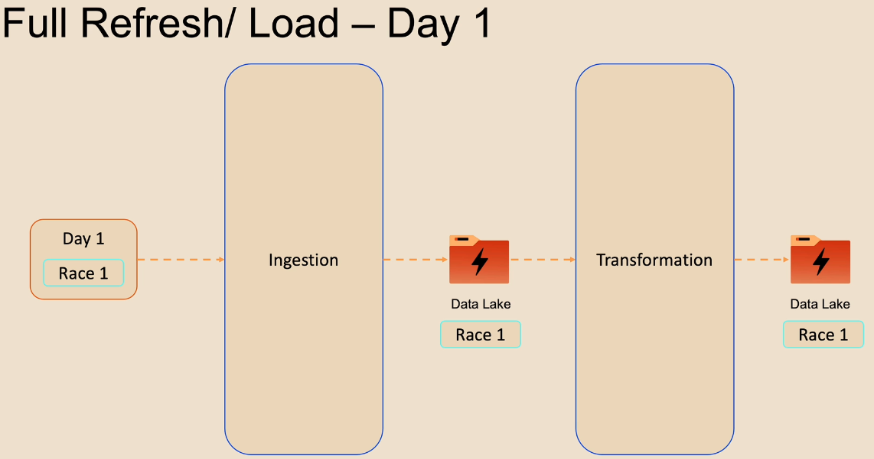

The architecture you're seeing here will be familiar to you because this is what we just implemented for our Formula One project on day one. The data includes one layer race. One information integration process just creates the data in the data link and the process container. And similarly, the transformation creates that data in the data lake under the presentation layer. Those two containers had no data before we started this process and they'll now have the race one data. On day two, the incoming data includes a race as one and two information, if the ingestion process adds this data to the data lake, there'll be duplicates.

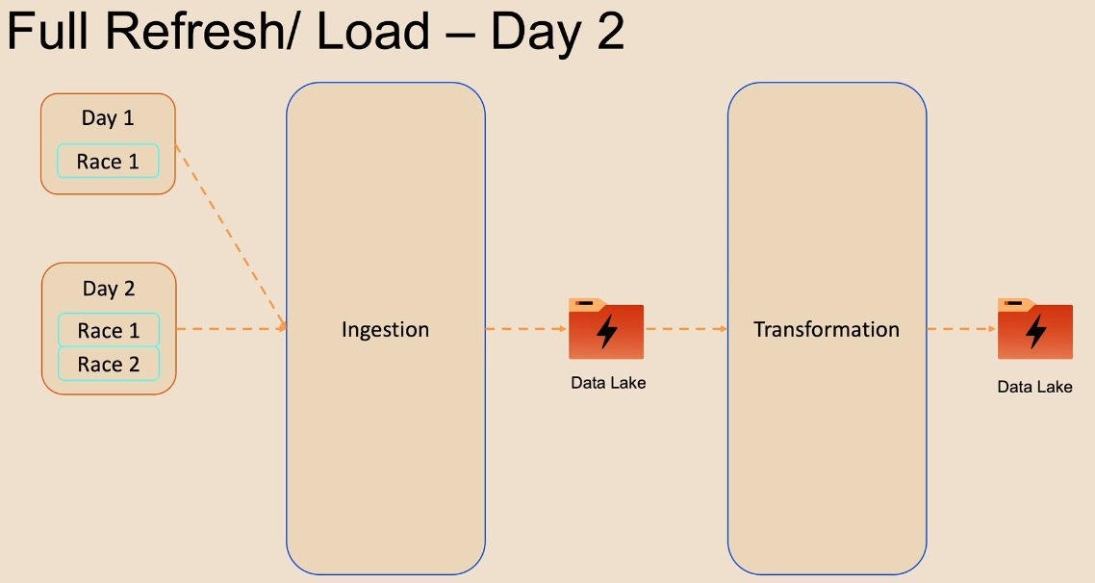

So it does an override that makes the existing data from the previous ones deleted. And the new data is added to the data lake, the transformation process does exactly the same thing. It deletes the race one data which is already there, and then it adds the new data we've received, which is for race one and two.

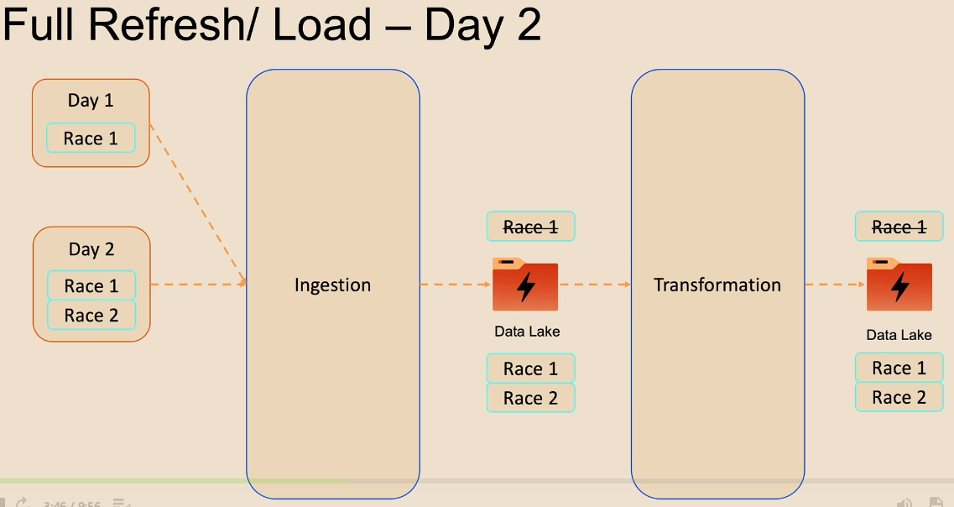

On day three, the same thing happens. The incoming data includes races one, two and three. Injection process deletes the existing data, which is from race one and two from the data, and add the new data as received.

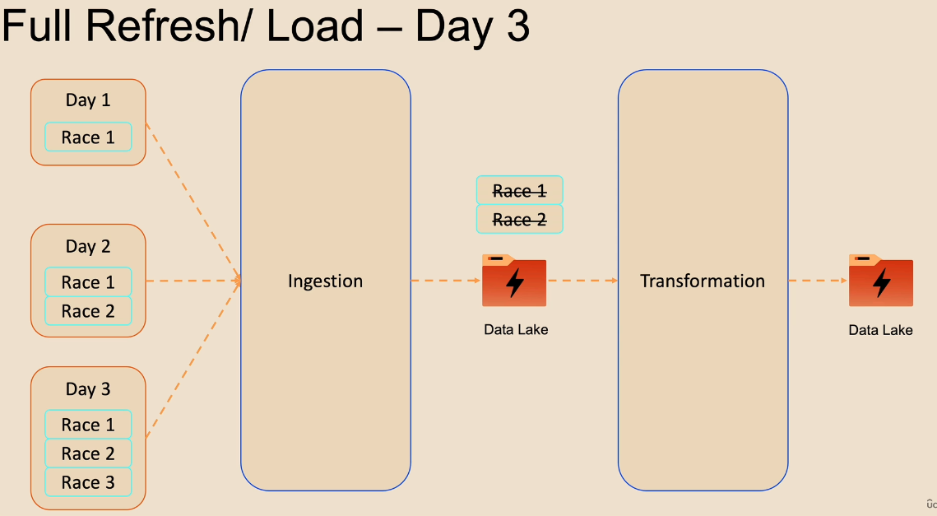

The transformation process does exactly the same thing and it goes on. As you can see, the problem here is that we are processing the data from all races on everyone, even though only the data from the recent day or race, recent race has changed.

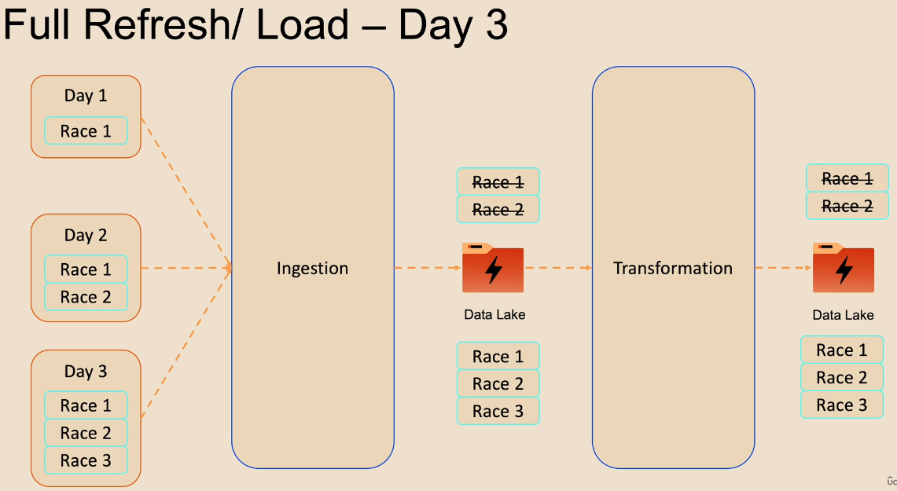

This adds a significant amount of processing required for the ingestion as well as the transformation phases, thus potentially adding latency to the data being consumed and also more processing power to be required and resulting potentially in higher costs for your application as well.

Having said that, it gives the simplest design possible in which we can just overwrite the data without worrying about losing anything, now that we understand the full data set and the full refresh of the full load patterns, let's have a look at the incremental data set. As we said before, incremental data set will only contain the changes since the previous data set we've received.

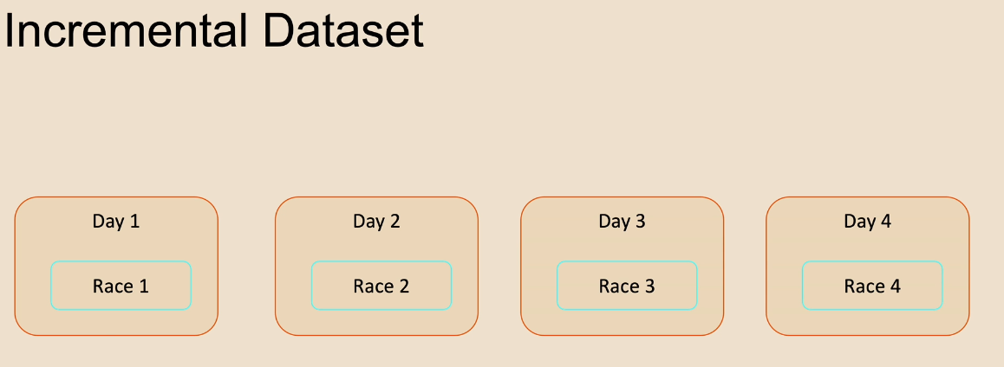

Again, let's take our Formula One data set as an example to understand it better. Similar to the full data set will get the race one data on day one on data, unlike the full data set, will only get the race to data. Day three will include the races data and therefore will include the races data for day 3, etc..

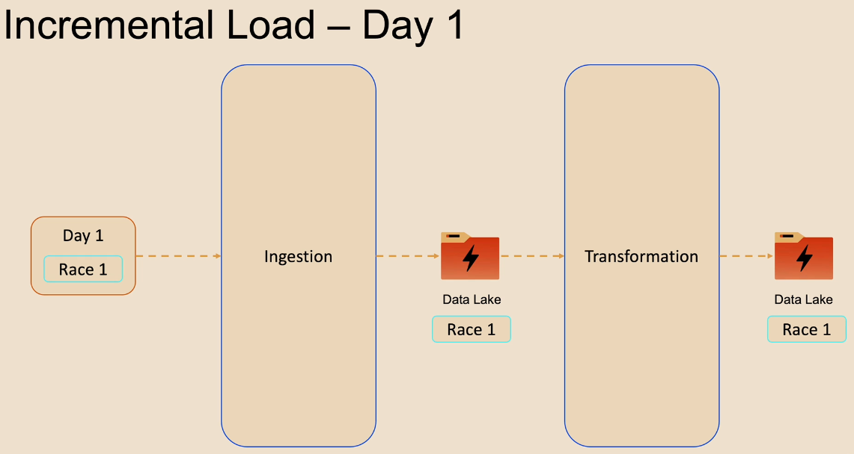

Now let's take a look at how an incremental load would work on day one. There are no changes between a full load and an incremental load. Both the process and the presentation containers are empty to start with, so day one data will be returned to those.

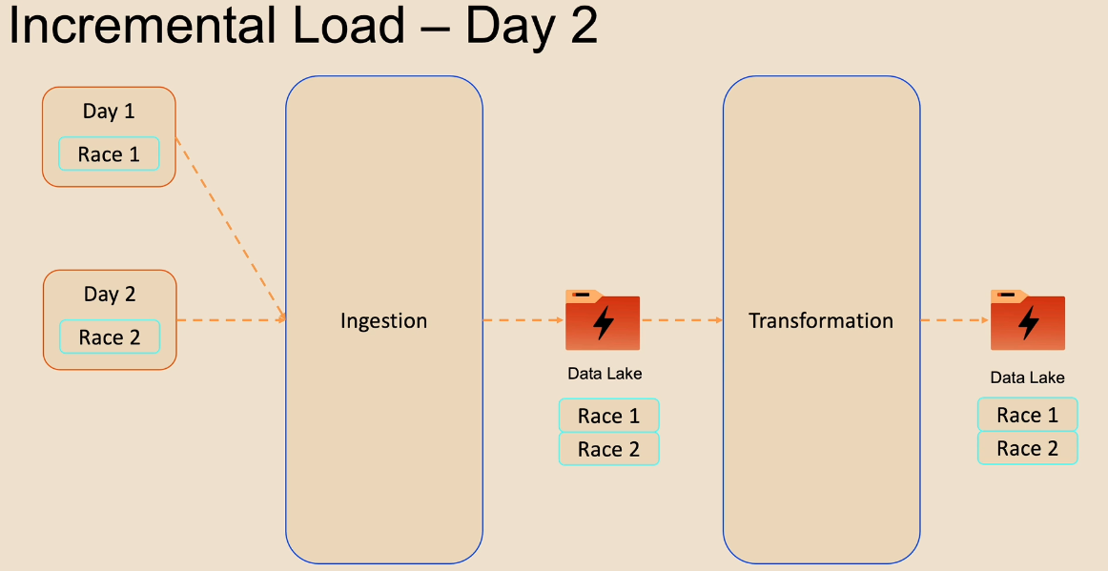

Data is going to be vastly different on data will only receive the data from rates to, as we said before, so the injection process will upend the race to data, to the data like. The transformation process will now need to identify the changes from the ingested data and process, one that and this will result in the data like for the presentation layer to be added with the rest to data alone. You might be thinking this is just an easy thing to do because as we move forward with the days, we just have to add the additional data to the data as we go along. But this is not as simple as that because we will have to consider rerun scenarios where we will have to replace just the data we need to replace rather than just to overwrite. In the end, data like with the new data being received and also in real world scenarios, you will have data missing on the first day, which might end up coming on day two, for example. So we'll have a lot of other scenarios to deal with. So incremental loads are generally complex to implement. So we need to design a clever system that only removes the required data from the data lake and replaces that in cases like rerun scenarios.

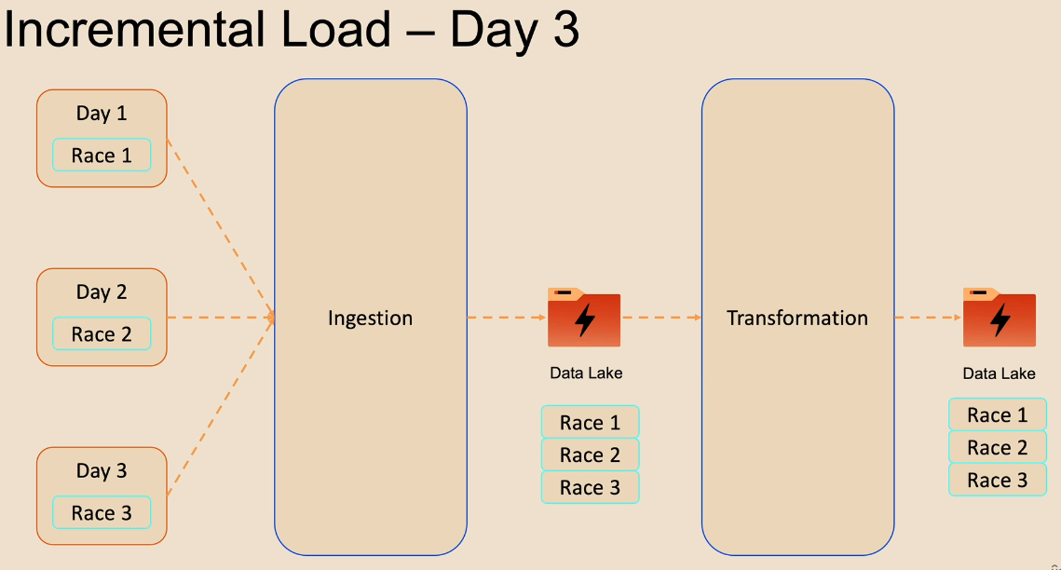

Day three follows a similar pattern today, too, it just happens. The data from race three to the data lake on both the process and the presentation containers. So that is the main to design patterns which are followed and an incremental load apart from these two straightforward scenarios that we discussed. There are a range of hybrid scenarios implemented in real, real world projects. This could be due to the nature of data being received, and it is very complex are the type and the granularity of the transformations that are being done. So let's look at some of these scenarios. They can receive a full dataset, but still choose to process them incrementally. That could be because we want to get some performance gains out of our transformation and the ingestion layers. This would require another process up front to identify the changes. If you take Formula One as an example, again, they one we received this one day today to be received, race 1 and 2 data. Then we come to process data data. We can introduce that new process. We are talking about a friend to exclude all the data related to day one, i.e. race one data and will only take the race 2 data. So we'll end up with the one the race to data and we can incrementally process that and improve the performance of the transformation face. They can receive an incremental dataset, but process that in full. So this is slightly opposite to the number one we discussed. Again, we just need a process up front to combine the data from the two days to create a full dataset and then process that. In some cases, we could receive some files within a day to say as full and some as incremental, and our process will have to deal with those. So when we come to the Formula One data set, you will see this scenario. In some cases, we might receive incremental data and ingested them incrementally, but transformations are done in full. This may happen because the material of the data being received incrementally. Our transformation logic may require all of the data.

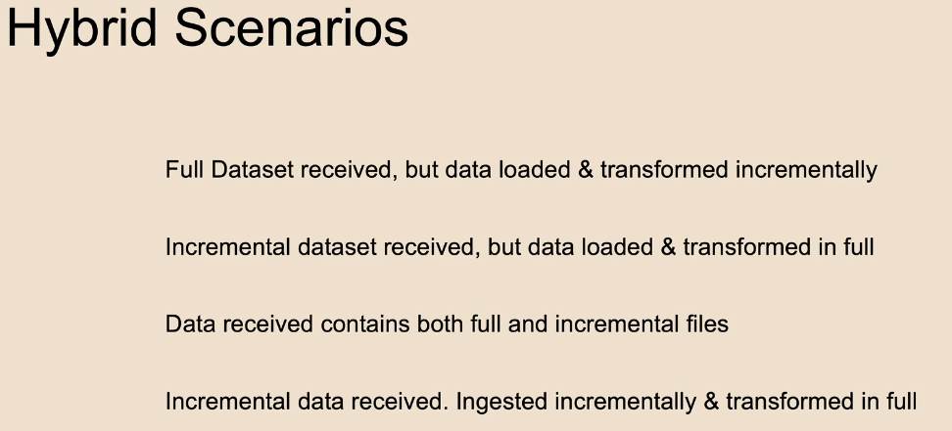

For example, in our Formula One, we may have to aggregate the data across all of the races to find out dominant drivers and dominant teams and things like that with the two primary design patterns of incremental load and the full load, as well as these hybrid scenarios. I hope you now have an understanding about all of the data processing and data loading scenarios. So that's the end of this lesson. In the next lesson, we'll look at a scenario for our project and what we are going to do.

### Formula 1 - Project Scenario

We are going to look at a scenario for our project. This will be slightly complicated, but this is quite a common scenario in the real world, moreover, you've already dealt with a simple full load scenario. So let's take a look at a hybrid scenario to strengthen your understanding about real world scenarios. As you know, the Formula 1 race happens on a Sunday. Also, it doesn't happen on every Sunday. There are usually only 20 to 24 weeks in a year in which the race happens and the other weeks there are no races. So let's assume that on day one, which is one of our sundays days will receive the first file. This file will contain data for not only the data from race 1, it will contain data for all prior races. Let's assume that it contains data for races from race 1 to 1047. This is what you have seen previously. This file gives us all races from 1950 to the end of 2020. This may look like we are again dealing with full load, but that's not the case. Day 2, will contain the data from only the next race that is the first race in twenty. Please don't be confused with the race number of 1052 here, rather than 1048, which you would expect. The races from 1048 to 51 got cancelled due to Covid and there is no data for those. That's why we moved from 1047 straight to 1052. On day 3, which is one of the following Sunday's will receive data for the next race, which is 1053 race id.

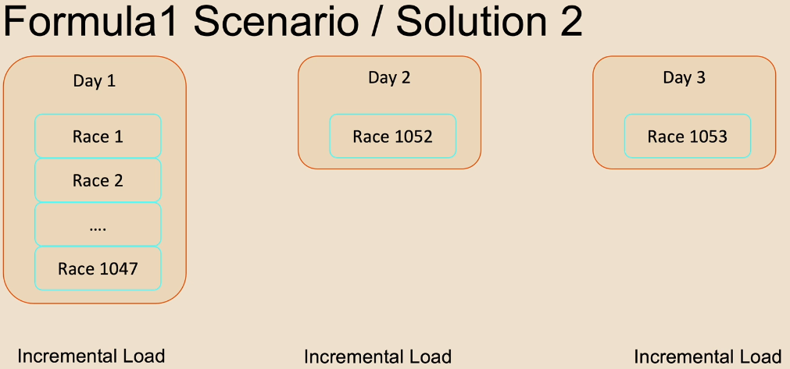

As you can see, we're dealing with incremental load scenario rather than a full load scenario but day 1 contains all the historic races and the future days will only have the races since day 1. As you can see here we are dealing with incremental load scenario rather than a full load scenario, the one exception here is that day 1 contains all historic crisis rather than the future days will only have the racist since. Day 1 file here is commonly known here as the cut-over file or the history file and the subsequent files are known as the delta files. The delta between the previous and the current.

Let's now look at how to implement a solution for this. One solution is to develop two sets of files, one, to develop a full refresh for the cutover file or the day 1 file, and then create incremental loads for day 2 and day 3. This has been done in the past for many projects in the industry, but this is not the best approach I would advise, as this will require two lots of code testing, implementation and quite a lot of cost involved in terms of maintaining two pieces of code. A better solution is to implement an incremental load for all of these files, including the day one file, because in theory, these are all incremental data, just that the first day's data has more than one day's arrays within that one. The only thing to be careful of is we will have an incremental load pattern being implemented for this one, but our incremental load code would be clever enough to understand that one of the days may have more than one race worth of data. This is the solution we are going to implement for our project, and I hope this will give you good experience on how to implement a complex design pattern. On top of these design patterns, we are also going to have different scenarios for our data sets, just to give you a bit more experience in that respect as well. Again, this is very common in the industry. As you can see, there is some data that is not directly related to the race. For example, things like circuits, constructors and drivers are not tied to just one race. Also, the races data is decided upfront at the beginning of the year rather than at each race weekend. And also these files are very small. So we'll get an up to date full file for each one of these every week. So we are not going to have incremental data for these files. We'll have full files every week. We can just replace that data in our data lake with them. Whereas the other files, such as results, pit stops, lap times and qualifying, are going to have new data every week from the race. They're not going to have any historic data and they are bigger files. We will receive and process just the incremental data from the weekend for these files. This makes our process much more performant. So that's our data scenario.

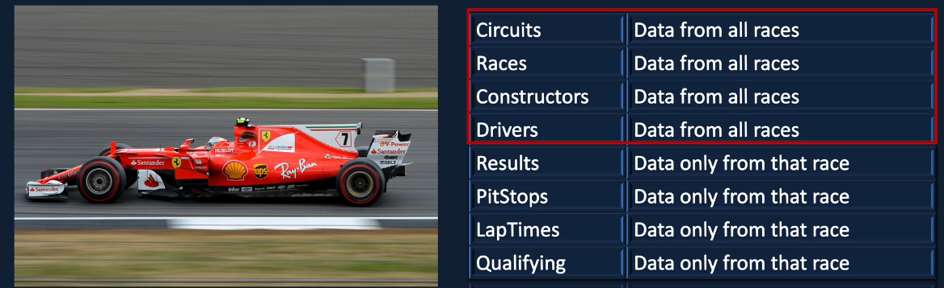

It is slightly complex, but this is a common scenario in the real world. For example, if you're working with a credit card company, you may have a file called customer, another file called merchant, but you will have a transaction file for the credit card transactions. But when you receive that data into your data lake, you might get a full file for a customer and the merchant because they are just dimensions. And you may get incremental data for the credit card transactions because there might be billions of credit card transactions in a day. So you wouldn't want to get every transaction from day one are coming to you every day. So you would only want to have the data from what's changed as opposed to everything. But whereas it doesn't matter so much on things like customers and merchants. So having our files play out in this way I also think gives you a good experience in terms of developing a solution like this. So let's now look at the solution that we are going to implement.

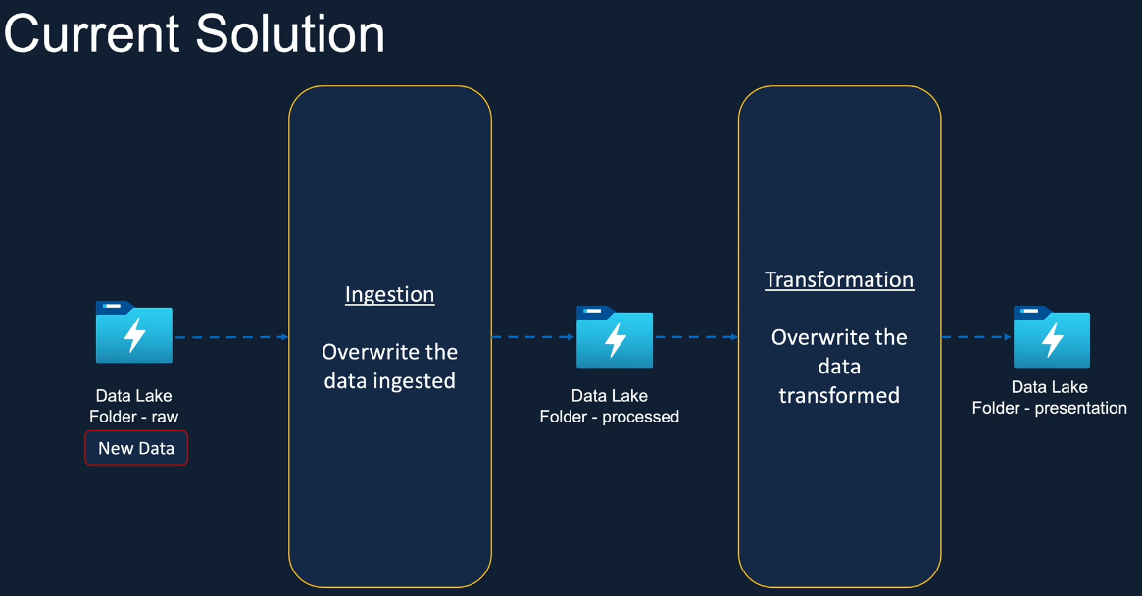

This is our current solution. We received any new data into a real container. We ingest that data into our data like processed container by overwriting what's already there. We then transform that data and we overwrite what's already there in the presentation container. And the new data is now in every container within the data link.

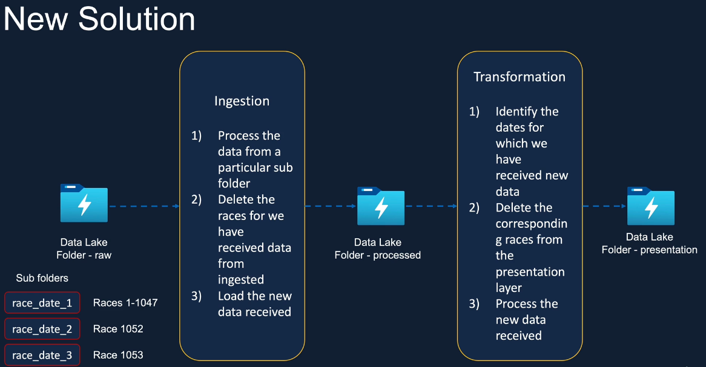

In the new solution, we will receive the data into sub folders within our data lake container so they won't come directly into the raw container. Then there will be sub folders for each of their race dates. Injection process will be cleverer. It will be fed with the race date as the parameter. It gets the list of cities from a particular subfolder, in raw, using the race date supplied. Data for those races are then removed from the process container in our data lake and new data is then loaded. Keeping the subfolder name as race date gives us the ability to process data just from that race, identifying the unique race ids within the file gives us the ability to deal with a cutover file more effectively because that will have more race ids as well. The transformation process does a very similar process. It identifies the right side is to be processed, gets the data from a process container. That's the transformation and updates our data like presentation layer. Hope that gives you an idea of what we are going to try and achieve in our solution. I know it's slightly complicated if you're new to creating data pipelines.

### Formula 1 – Project Data Setup

The first thing we want to do is to set up our environment ready for doing our incremental load. So because of the way we are going to design our pipelines, we are going to have additional columns in our tables in process and presentation. So I'm going to drop the tables first. In order to do that, I use the drop database with cascade, so what that does is actually drop all the tables under this database and then the database itself and then we'll put back the database. So this is the database create statements we've used previously. So I've done that for both process and presentation. So let's run that one first. OK, so that's now completed.

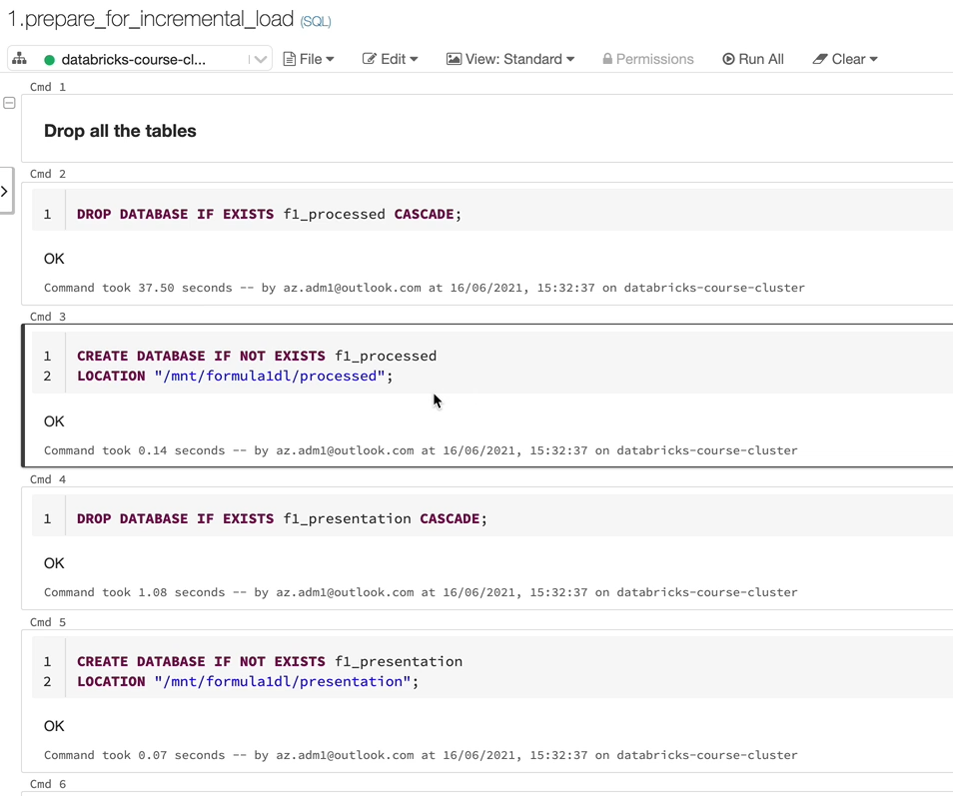

I just want to mention that I put this script under a folder called utils. So in any project I normally tend to keep it utils folder where I have things like clean up scripts and things like that so you can follow the same or it's up to you. But that's what I have done actually, I've created a new notebook here, which is SQL Notebook and that utils, and then I've kept this notebook here safe.

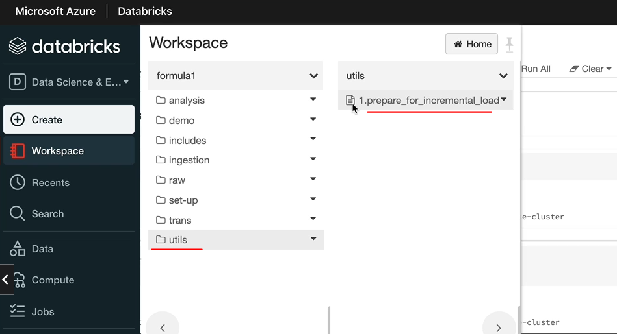

The next thing we want to do is we want to tidy up our storage account as well, so let's have a look at that. So I'm in storage explorer. So the presentation should now be empty because, as you know, they are all managed tables, so when we drop the tables, the data here gets deleted as well, and the processed should be empty as well. The raw would have data in here. What I want to do is to delete all of this data because we are not going to have any data directly in the raw container. We are going to have data folders, as we said. So I'm going to delete this data first. So, there is no data in this container anymore, but we want to bring in new data so the new data would be in separate folders so each of them will relate to a race date.

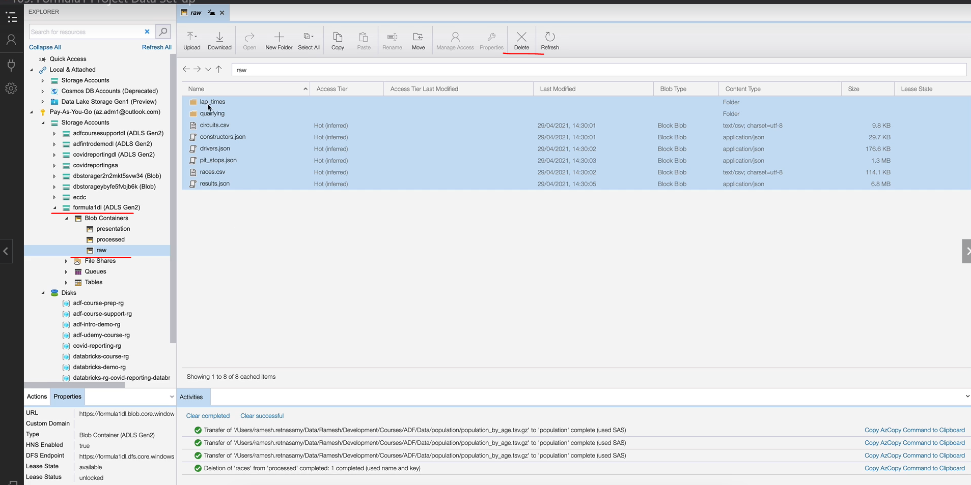

So the first race happened on the 20th of March and the second one in this year happened on the 18th of April. And the cutover itself we will put it a week before the first race, which will be 21st of March. So I have already extracted the data here. I'll make all of this data available in the course material.

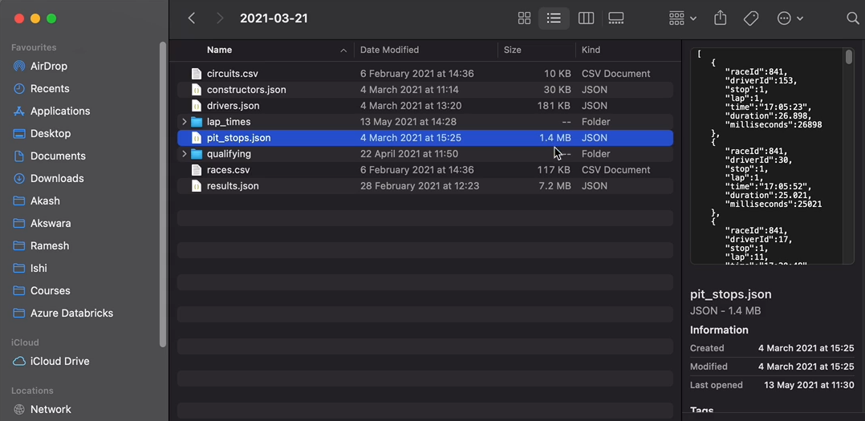

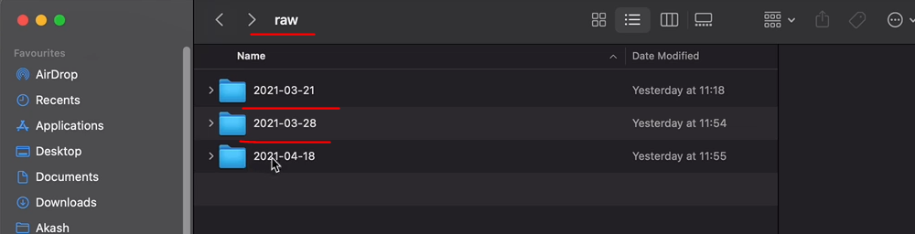

So as you can see, this is going to have the cutover data. So if we open it up, we got big files here. So pit stops, for example, is one point for make. And the twenty eighth of March is the first race. And as you can see, they are tiny files and 18th of April is the second race. And that's tiny files as well because they've just got data for one race and the 21st of March has got data for all races from 99, 1950 to 2020.

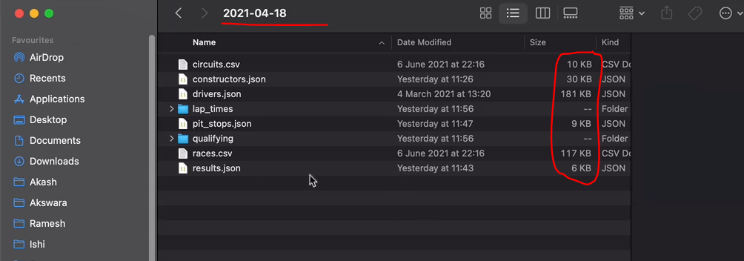

So let's get all of these data into here. So I'm going to just drag and drop into the container.

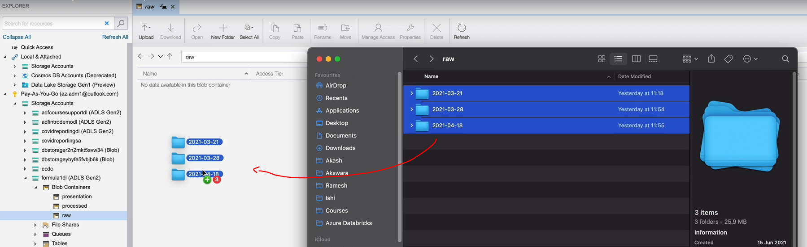

And the data is now being transferred, so let's wait for that to complete. And now we've got the three folders in the real containers, so that's all the setup we needed to do.

### Full Refresh Implementation

So here we are going to look at the full files being highlighted here, which are Circuits, Races, Constructors and Drivers, and we're going to look at the condition of these four files. And as we discussed before, these four files are going to contain all of the data. So, for example, the data received for 2021 would not only have the drivers who are racing in 2021, it would have all drivers who raised from 1950 onwards to today.

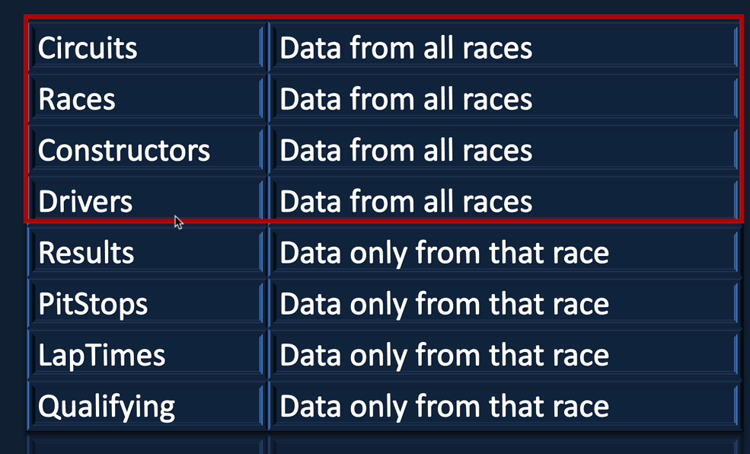

So they are going to be dealt with with the full load scenario, which is a overwrite of the existing data, and then put the new data on data like that's what we would do. Now that we know its full load scenario, you might be wondering whether we still need any changes to our ingestion notebooks. Yes, we do need changes to our ingestion notebook because even though it's going to be over right now, the data is not in the raw container. They are in some folders within the real container with the red state. So we need to make those changes so that the right data is being picked up when the notebook runs. So let's start with making those changes. Now. Let me navigate to the intuition for the circuit file, which is another folder, and it's in just circuits file. As we said before, we need a new parameter for this notebook, and that is the file date. So when I say file data that relates to the data we have here, which is the time, 1st of March, 28th of March and the 18th of April and it goes on.

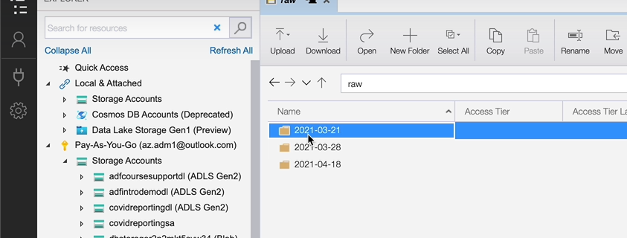

I'm not calling this as a race date, even though it relates to race dates here. The cutover file won't be right if we call it a race day because it contains data related to multiple races. So let's call this one as file date. It is a folder date here, but we are dealing with separate files when we are talking about ingestion here. So I'm going to call that as a full file date. So let me copy this and I'm going to create this new parameter and that's going to be called P and this go file date. And we're going to replace the string here as well as the variable name is going to be different as well.

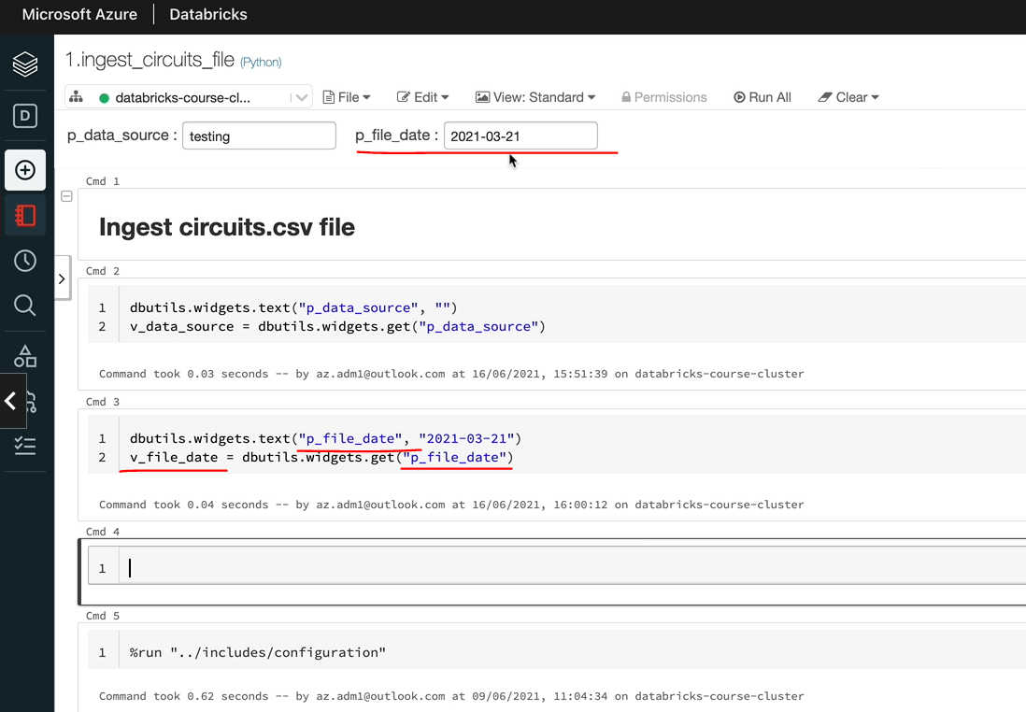

And I'm going to give it a default value to start with. But anything you send in would overwrite that. So if I just ran that, that's the file date here. But in the future, you can change it. So we might be calling it from the data factory and putting in a different value when we come to run it. But that's for a later lesson. So if I print the file date, that's going to contain 21st of March 2021. So that's the one we're going to use. And the first place we want to use that is in the folder path here. So now the folder path doesn't go just up to the raw folder path. It's going to be that folder here, which is the file date. So let's put that in here and that will be the end file date because that's the variable we've used here.

circuits_df = spark.read \

.option("header", True) \

.schema(circuits_schema) \

.csv(f"{raw_folder_path}/{v_file_date}/circuits.csv")

One more thing I would like to do is to add that file date to our data as well, actually, so it might become handy later on. So when you want to debug actually what's happened with your data, you will know which file really to trace the source data back to. I'm going to add it here. We are adding the data source here. So in the similar way, we can just add the file data as well. So we'll do this with column and then I'm going to call this new field as file date. And that came from the underscore file date. If we scroll down, what we're doing here is right in the data, in parquet files and we're in the new table called the and it's called processed and it's going to have a circuit data.

circuits_renamed_df = circuits_selected_df.withColumnRenamed("circuitId", "circuit_id") \

.withColumnRenamed("circuitRef", "circuit_ref") \

.withColumnRenamed("lat", "latitude") \

.withColumnRenamed("lng", "longitude") \

.withColumnRenamed("alt", "altitude") \

.withColumn("data_source", lit(v_data_source)) \

.withColumn("file_date", lit(v_file_date))

There are no changes to that one and believe the displays for now so that we can look at the data once it's processed. So let's do a all. OK, so that's been successfully executed, as you can see, all the data is as we expected. So what's happened is we've taken the file from the folder for the file date being supplied and then loaded that into our secured stable. So I'm going to make the same change to the other three files, which are races, constructors and drivers.

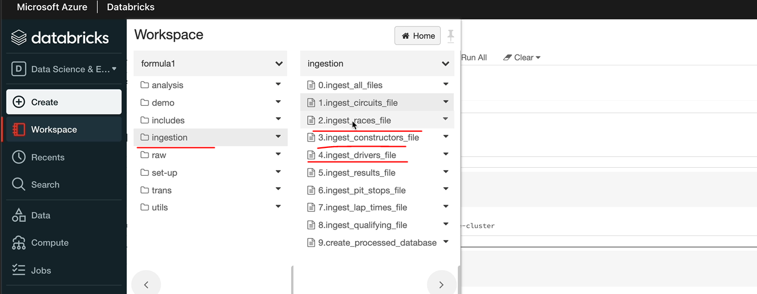

OK, I have done the change to all the other three files as well, and this is the driver file and as you can see, it's got the file date as first of March 20 21. There is no date. So it's because I haven't sent a data source. But when you send it, it'll come through. In the next lesson, we're going to get the other four files.

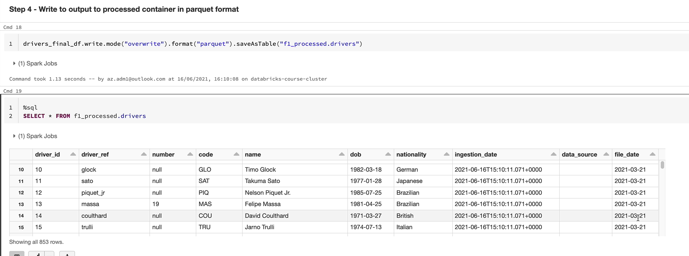

Full Code

**Ingest races.csv file**

dbutils.widgets.text("p_data_source", "")

v_data_source = dbutils.widgets.get("p_data_source")

dbutils.widgets.text("p_file_date", "2021-03-21")

v_file_date = dbutils.widgets.get("p_file_date")

%run "../includes/configuration"

%run "../includes/common_functions"

**Step 1 – Read the CSV file using the spark dataframe reader API**

from pyspark.sql.types import StructType, StructField, IntegerType, StringType, DateType

races_schema = StructType(fields=[StructField("raceId", IntegerType(), False),

StructField("year", IntegerType(), True),

StructField("round", IntegerType(), True),

StructField("circuitId", IntegerType(), True),

StructField("name", StringType(), True),

StructField("date", DateType(), True),

StructField("time", StringType(), True),

StructField("url", StringType(), True)

])

races_df = spark.read \

.option("header", True) \

.schema(races_schema) \

.csv(f"{raw_folder_path}/{v_file_date}/races.csv")

**Step 2 – Add ingestion date and race_timestamp to the dataframe**

from pyspark.sql.functions import to_timestamp, concat, col, lit

races_with_timestamp_df =

races_df.withColumn("race_timestamp", to_timestamp(concat(col('date'), lit(' '), \

col('time')), 'yyyy-MM-dd HH:mm:ss')) \

.withColumn("data_source", lit(v_data_source)) \

.withColumn("file_date", lit(v_file_date))

races_with_ingestion_date_df = add_ingestion_date(races_with_timestamp_df)

**Step 3 – Select only the columns required & rename as required**

races_selected_df = races_with_ingestion_date_df.select(col('raceId').alias('race_id'),

col('year').alias('race_year'), col('round'),

col('circuitId').alias('circuit_id'),col('name'),

col('ingestion_date'), col('race_timestamp'))

**Write the output to processed container in parquet format**

races_selected_df.write.mode("overwrite").partitionBy('race_year').format("parquet").saveAsTable("f1_processed.races")

%sql

SELECT * FROM f1_processed.races;

dbutils.notebook.exit("Success")

**Ingest constructors.json file**

dbutils.widgets.text("p_data_source", "")

v_data_source = dbutils.widgets.get("p_data_source")

dbutils.widgets.text("p_file_date", "2021-03-21")

v_file_date = dbutils.widgets.get("p_file_date")

%run "../includes/configuration"

%run "../includes/common_functions"

**Step 1 - Read the JSON file using the spark dataframe reader**

constructors_schema = "constructorId INT, constructorRef STRING, name STRING, nationality STRING, url STRING"

constructor_df = spark.read \

.schema(constructors_schema) \

.json(f"{raw_folder_path}/{v_file_date}/constructors.json")

**Step 2 - Drop unwanted columns from the dataframe**

**from** pyspark.sql.functions **import** col

constructor_dropped_df = constructor_df.drop(col('url'))

**Step 3 - Rename columns and add ingestion date**

**from** pyspark.sql.functions **import** lit

constructor_renamed_df = constructor_dropped_df.withColumnRenamed("constructorId",

"constructor_id") \

.withColumnRenamed("constructorRef",

"constructor_ref") \

.withColumn("data_source", lit(v_data_source)) \

.withColumn("file_date", lit(v_file_date))

constructor_final_df = add_ingestion_date(constructor_renamed_df)

**Step 4 Write output to parquet file**

constructor_final_df.write.mode("overwrite").format("parquet").saveAsTable("f1_processed.constructors")

%sql

**SELECT** * **FROM** f1_processed.constructors;

dbutils.notebook.exit("Success")

**Ingest drivers.json file**

dbutils.widgets.text("p_data_source", "")

v_data_source = dbutils.widgets.get("p_data_source")

dbutils.widgets.text("p_file_date", "2021-03-21")

v_file_date = dbutils.widgets.get("p_file_date")

%run "../includes/configuration"

%run "../includes/common_functions"

**Step 1 - Read the JSON file using the spark dataframe reader API**

**from** pyspark.sql.types **import** StructType, StructField, IntegerType, StringType, DateType

name_schema = StructType(fields=[StructField("forename", StringType(), **True**),

StructField("surname", StringType(), **True**)

])

drivers_schema = StructType(fields=[StructField("driverId", IntegerType(), **False**),

StructField("driverRef", StringType(), **True**),

StructField("number", IntegerType(), **True**),

StructField("code", StringType(), **True**),

StructField("name", name_schema),

StructField("dob", DateType(), **True**),

StructField("nationality", StringType(), **True**),

StructField("url", StringType(), **True**)

])

drivers_df = spark.read \

.schema(drivers_schema) \

.json(f"{raw_folder_path}/{v_file_date}/drivers.json")

**Step 2 - Rename columns and add new columns**

1. driverId renamed to driver_id
2. driverRef renamed to driver_ref
3. ingestion date added
4. name added with concatenation of forename and surname

**from** pyspark.sql.functions **import** col, concat, lit

drivers_with_ingestion_date_df = add_ingestion_date(drivers_df)

drivers_with_columns_df =

drivers_with_ingestion_date_df.withColumnRenamed("driverId", "driver_id") \

.withColumnRenamed("driverRef", "driver_ref") \

.withColumn("name", concat(col("name.forename"),

lit(" "), col("name.surname"))) \

.withColumn("data_source", lit(v_data_source)) \

.withColumn("file_date", lit(v_file_date))

**Step 3 - Drop the unwanted columns**

1. name.forename
2. name.surname
3. url

drivers_final_df = drivers_with_columns_df.drop(col("url"))

**Step 4 - Write to output to processed container in parquet format**

drivers_final_df.write

.mode("overwrite")

.format("parquet")

.saveAsTable("f1_processed.drivers")

%sql

**SELECT** * **FROM** f1_processed.drivers

dbutils.notebook.exit("Success")

### Incremental Load – Method 1

Now that we've implemented a solution for a full load scenario, we're going to look at the incremental load scenario. So they are the results, pit stops, lap times and qualifying files which contain only the data related to that race in the file being received for that vehicle.

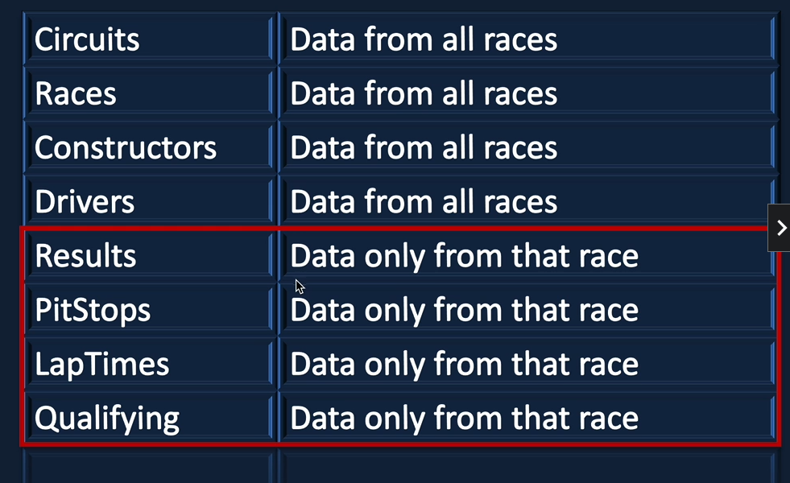

So we wouldn't be able to override the data, which is already in the data lake. By doing that we lose all of the data. And we'll just put today's data, which is current races data. We wouldn't want to do that. We want to append the data to the data lake and in case of failures and we rerun a file, we would want to replace only that files data rather than the entire data. So that's the kind of solution we going to look here. There are a few solutions we can implement. I'm going to take you through a couple which are widely used in the industry. And then if you need to explore further, that will set you up to have the knowledge and go and explore further as well. So let's get started. Before we start writing the code, I want to just quickly take you through the data and then we can analyze the data in the notebook and then we can start the start making the changes for us.

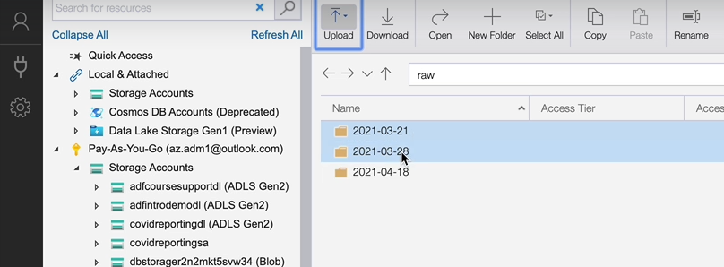

So as we know in the raw container, we got now the data folders, which are the 21st of March, 28th March and 18th of April. So we've got the cut off file here and the results file that's the one we're interested in is the six point eight make file is quite big compared to the others.

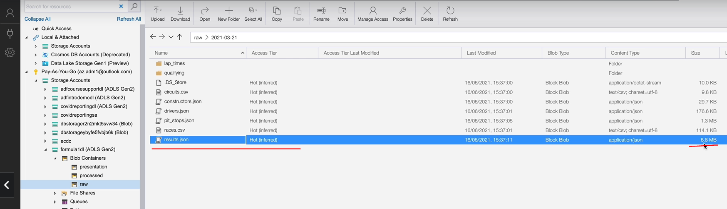

And we got the 28 file, which is got only one recent data, which is a small file, as you can see, five point seven kilobytes and the other one will be similar, 5.7 kilobytes for the next race file.

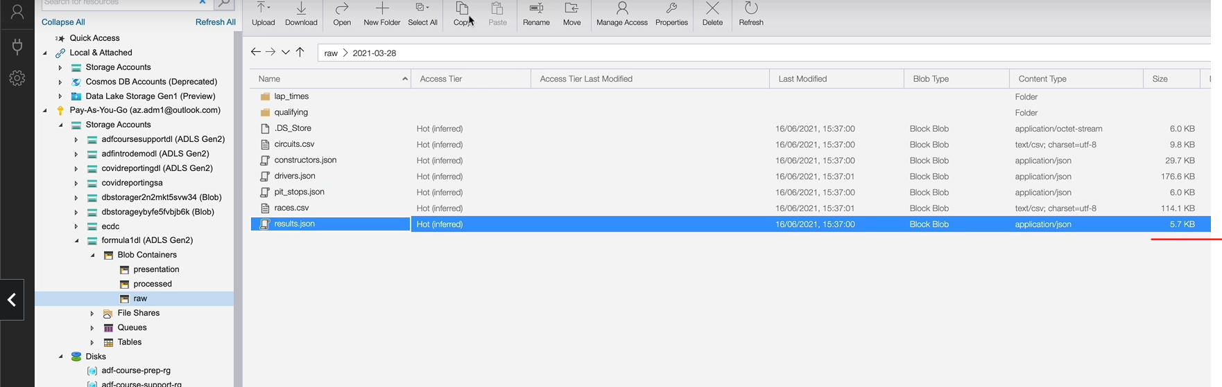

So because the cutover file is quite a big, most of the work, when I take it through, will work with these two files. So we load the 28 March and then we load the 18th of April file and we'll do some reruns as well. So we'll understand all the concepts and then we'll come back and implement the entire solution for the cutover, as well as the two Delta files here.

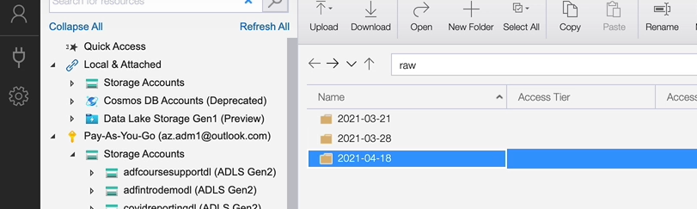

So let's go to the notebook first. So let's look at the data we're talking about. I'm in the industry sales file. I'm going to just write a few queries here just to show you the data in those files. But we'll delete those cells once we've done that work. So let me quickly read the file and show you what the data is in the in those files. So what I have done here is I'm reading the cutover file from the 21st of March 2021 results, and I've just created a view over this. I have created the view just so we can carry the view just to see what's in the file. So let me just quickly do a select to find out the race id in this file.

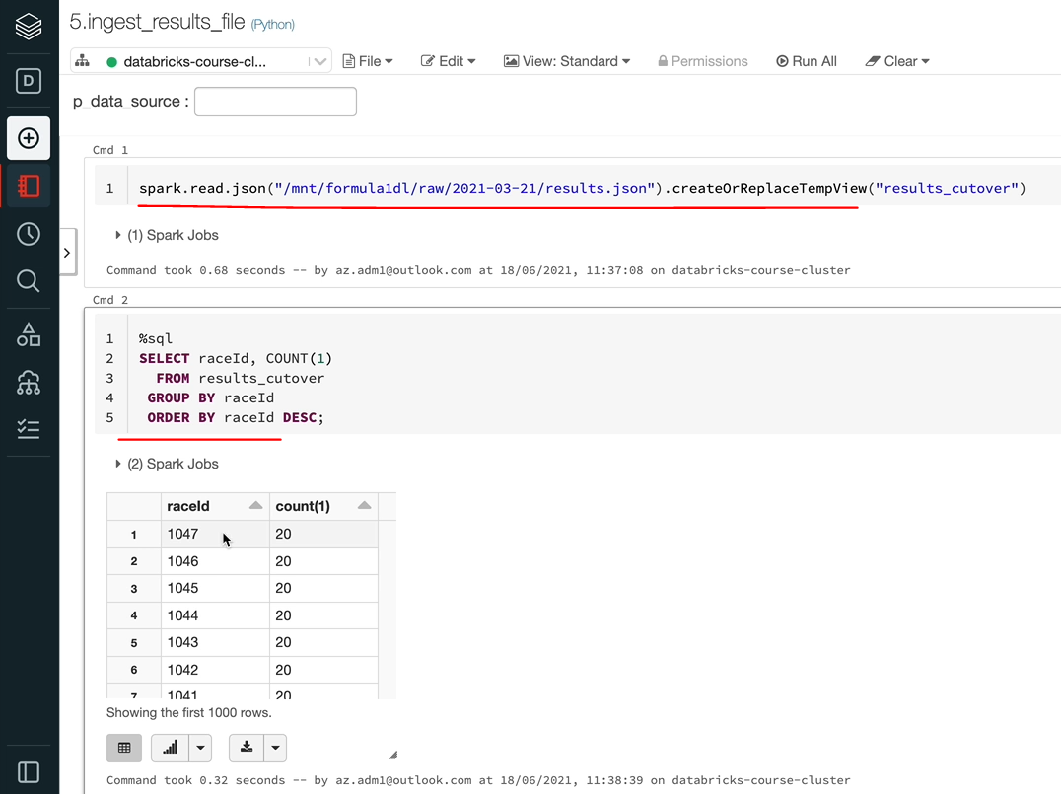

So that be select and then I'm going to do a race id, and a count from the file and then I'll group by race id and order by race id. So as you can see, we've got data from race 1 onwards to raise 1047. So that's the cutover file. Let me quickly show you the other two files as well. So the other one is on the 28. So I'm going to call this one as a result_w1. So one for week one, and then I'm going to just take the same SQL and run that for other one as well, and we should only see one race side here, which is the 1052, I think, yet 1052 has got 20 records.

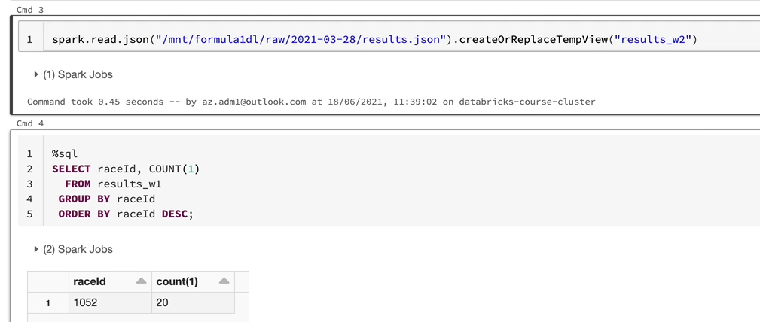

And if I did with two in here, so that would be the April 18th rather than the 28 March. And then I'm going to do a week two. So that should be the 1053 and 20 records as well.

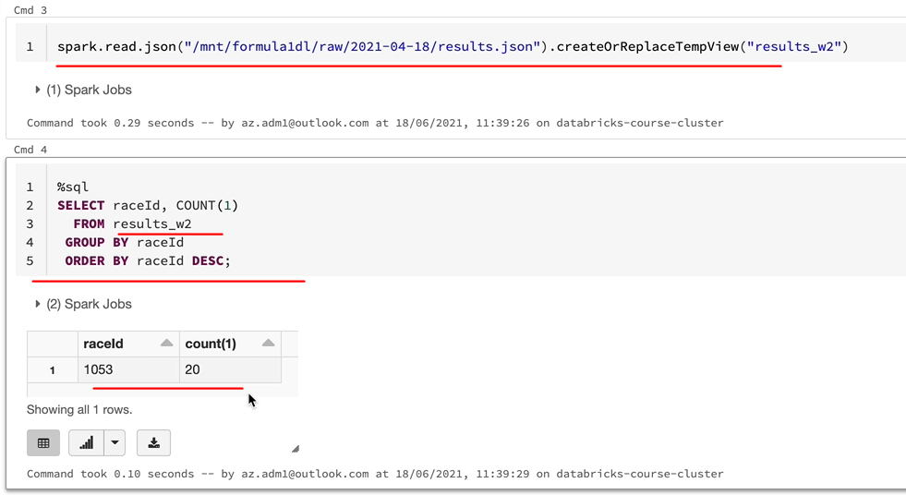

So as I said before, what we're going to do is we're going to ignore the cut over file for now because it will take a long time to process because we are going to be achieving our solution using the partitioning technique. So our data is going to be partitioned by over a thousand partitions because that's going to be based on the race id. And we are we only got a single node cluster. So even though the data is going to be partitioned, we are not going to be able to make the make use of all the partitions. So it only adds to the overhead and it'll be slower. So instead of sitting there waiting for that to finish, I'm going to show you the solution based on the other two files to show how to do an incremental load and then we will implement the solution with the cutover file to test the entire solution.

So first, let's make the changes to use the file date similar to what we did for the full load file, we need to have the file date. So instead of raw folder path, I'm going to go for the twenty eight here to start with.

%md

### Ingest results.json file

dbutils.widgets.text("p_data_source", "")

v_data_source = dbutils.widgets.get("p_data_source")

dbutils.widgets.text("p_file_date", "2021-03-28")

v_file_date = dbutils.widgets.get("p_file_date")

And then as you know, we need to use this in our reads so that we are reading the right file. So instead of the for the path and then json, we are going to use the file date as well in between so that we find the data within that file date.

results_df = spark.read \

.schema(results_schema) \

.json(f"{raw_folder_path}/{v_file_date}/results.json")

And also similar to the other ones, let's add the final day to the data as well, actually, so that is going to go into the data frame and return as well. So that would be the file date. And we're going to use the v_file_date that we got about. So that's all the changes we did to the other files we've done to this as well. But the difference here, as you know, is this is an incremental load rather than a full load. So we can overwrite the table. So by doing this, we are going to go overwrite the table results with the new data every time. So as we saw, 1052 was the race id for the first day and then 1053 is the second day's data. So when we put the race id, 1052 first, and then when you overwrite with 1053, we're going to lose 1052, and there will be only 1053.

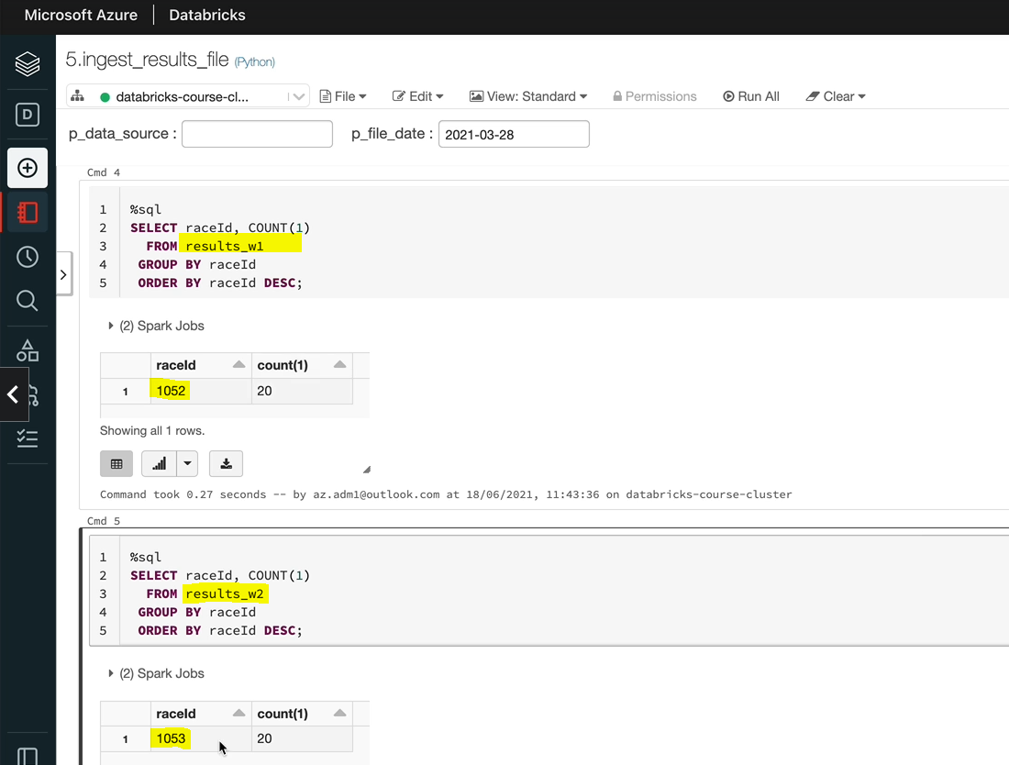

So that needs to be changed to append. So we would think that would normally work.

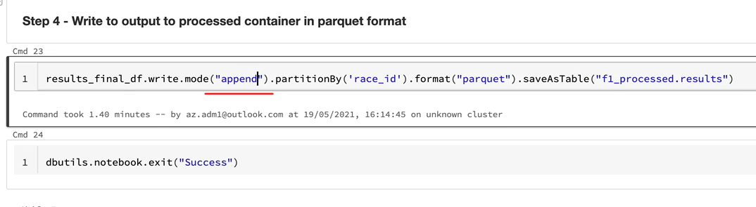

So let's run this. So that's going to run for the 28th March. I'm going to do a run all. So I missed the / here, so I'm going to just put that back in and then run it all again, so that should now go through.

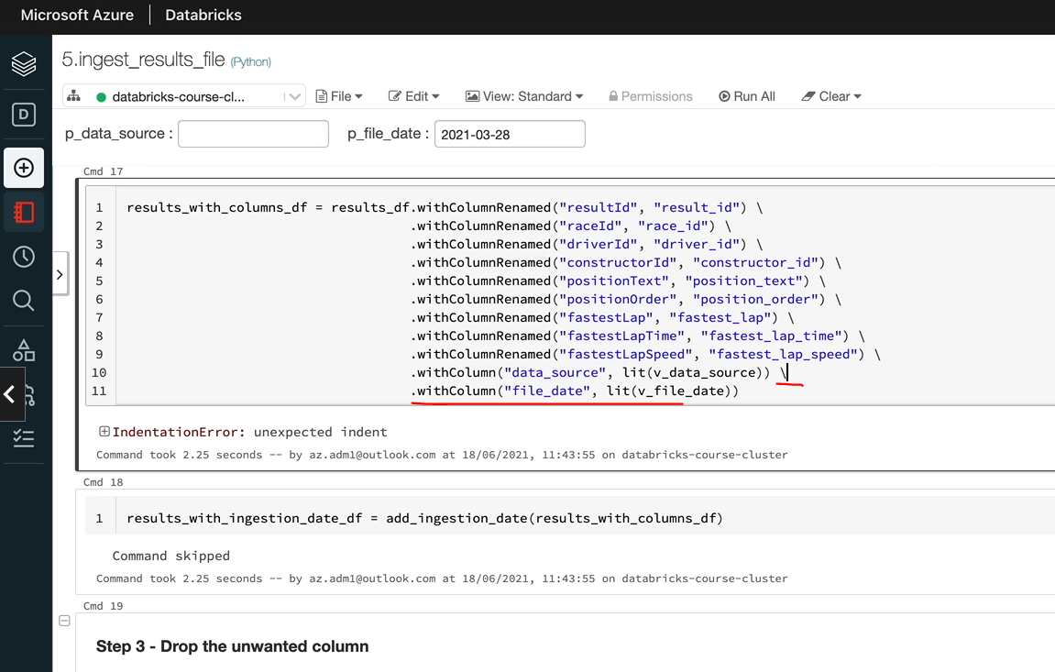

So that's succeeded here. And I'm going to query this table and show you what data is in that.

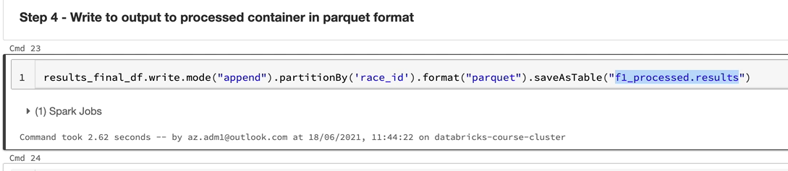

So as you can see, there are 20 records and they related to the race, the 1052. So that's the last column there.

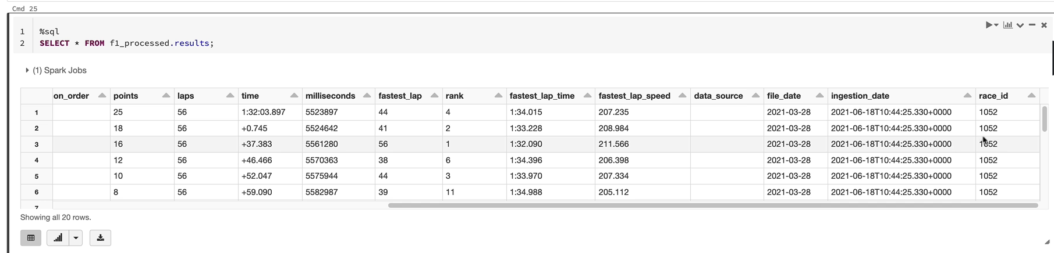

So I'm going to just do a count on race side here. So that's the 10 50 to reside with 20 Reichert's in there. That's what we expected.

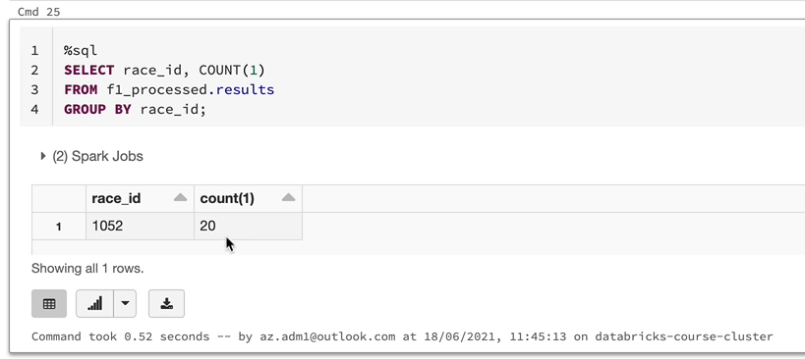

So now we need the next race to be loaded. So we know that it's on the 18th of April. So I put the 18th of April. When you work on this one, make sure you tab out of this.

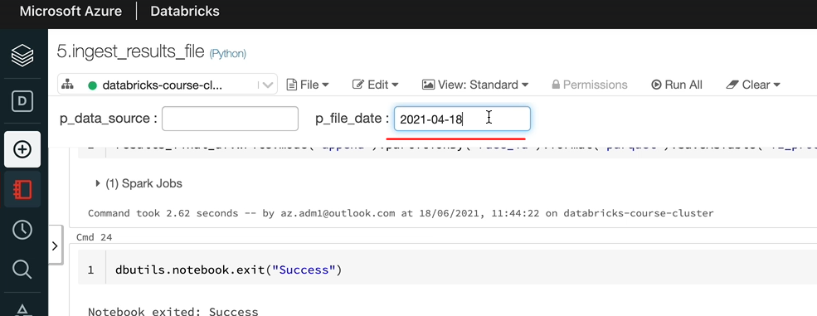

So when you tab out it will execute and it will store that value and then click control and it should take the value from the final date here and then use that for processing. So let's execute this command. It didn't run. It didn't run automatically. That's because I've got exit here. So I just came and ran this one. And as you can see, we got the 1052 race has got 20 records and 1053 has got 20 records.

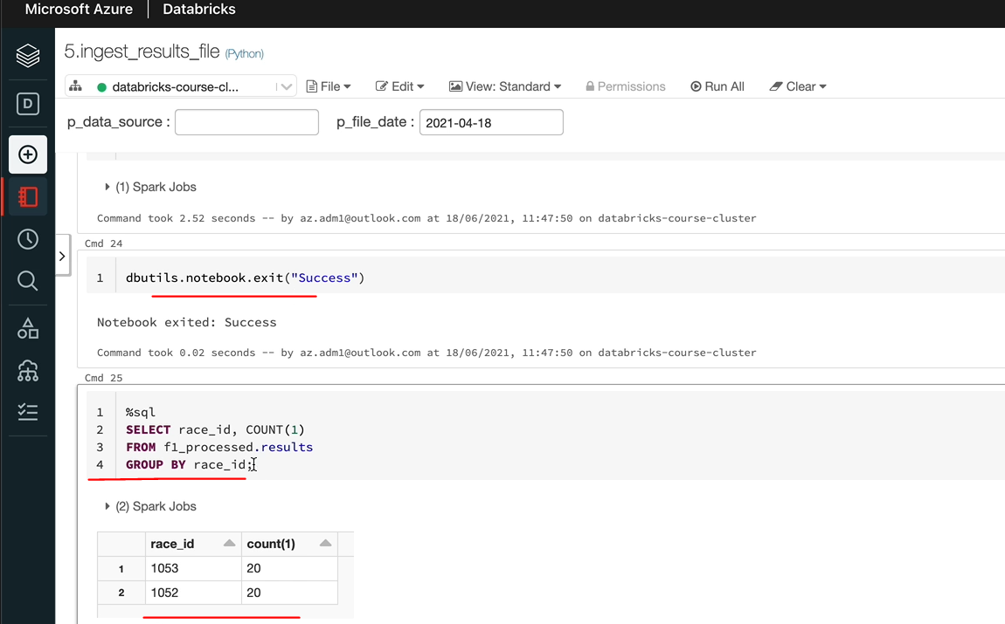

So that's fine on a normal run, it would work OK, so every time when we run it for a week, it's going to just put that data and it just keeps incrementally adding the data. But that's not how normally data projects are, you may have a problem and you would want to run your jobs or notebooks. So when you come to run the notebook, what's going to happen? We need to deal with those scenarios as well. So let's rerun this once. Let's say actually on the 18th of April, we've had an issue with our load. So we want to rerun all of our jobs and this notebook would run as part of that as well. So I'm going to just click on Run All. And let me rerun our select and I can see we got 40 records for 1053. So what's actually happened is we've added 20 more records for 1053, which are just duplicates. You don't want that. So we want to be able to delete the data which is already there if we are processing that side in this load and unload the data afterwards. So that means we would not have duplicates. If you've come from a relational database background like Oracle or SQL server, you would just simply say, I want to delete the data, so just do a delete statement on the table and then you would reload the data or you would say, I want to run a update statement. If it's already there, I'll get an update. Our a merge statement, if it is already there, you do an update, otherwise you'll insert the data. Unfortunately, the data lake architecture in Spark doesn't give you that ability. But we will talk about Delta Lake, which is another open source project which is available within databricks for you. That gives you more capability. But we're not talking about that now. So let's try and solve it with the standard Spark capabilities we've got for the Data Lake.

If I come over to the second syntax, let me show you what the data manipulation statements you've got are. As we said before, you don't have the concept of delete or update so much here. So all you got is insert and load.

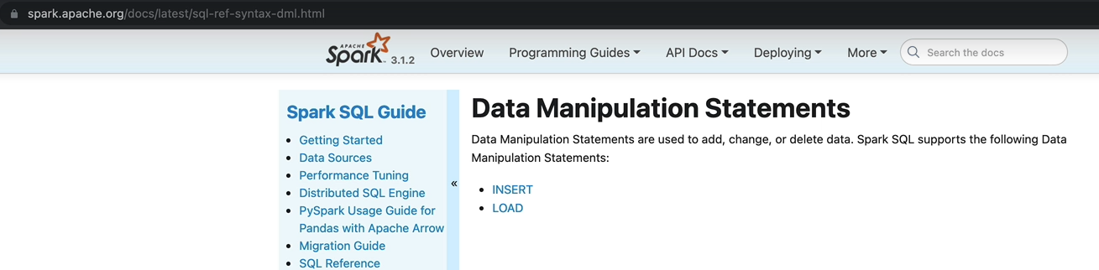

So we need to solve it in a different way, as we know our tables are partitioned by race id. And what we're saying is a weekly file coming through would have data related to that race and it's going to have the entirety of the data. So there are 20 results record for that race and all 20 would be in that file. So what we can do is we can drop the partition. So that means we can delete all of the data for that race id and then we can put the new data back in. So that's what we're going to do. But there are two ways of achieving this, we're going to go with the first method first and then we'll do the next one. So if I come over to data definition language, there is art table statement which lets you drop a partition.

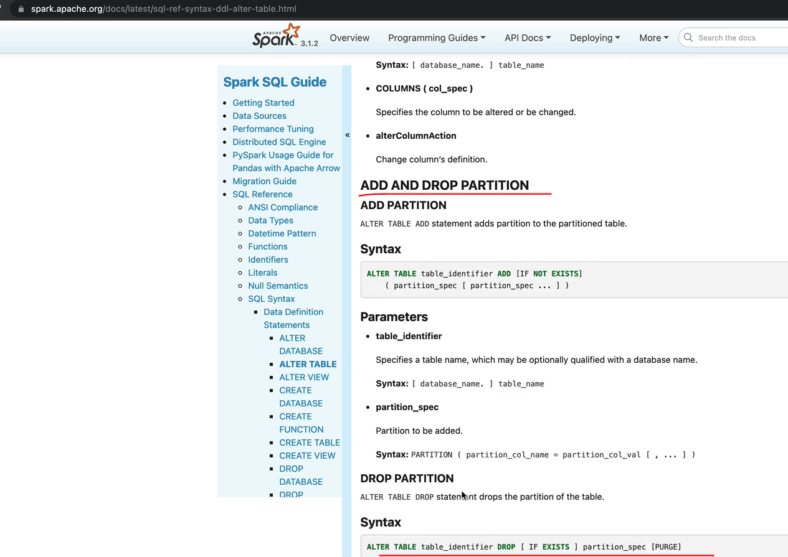

Unfortunately, these are only in SQL syntax, not on the Pyspark syntax. So we'll have to just use these spark.sql to implement that one. So as you can see here, this is alt table add partition. Similarly, you've got a drop partition so you can do alt table and then drop the partition if that exists. Let's switch over to the notebook and then look at doing that one. So we want to drop the partition. But at this point in time, without looking at the data frame, we won't know which partitions to drop. So from the data frame, we can use the select method to get just the race ids, because we're only interested in the race side. And then you can use the distinct method to get the distinct records from this one.

So this would give you the distinct race ids, but we need to loop through this one. So we want to convert this into a list so you can use a collect method and that will give you a list. So this list is a list of rows and rows of the data frame rows and columns we talked about previously. We need to look through this one. But before we carry on, be careful about using collect, because what collect does is collect, takes all the data and put it into the driver notes memory. So we need to make sure that we are only collecting small amount of data. So things like this are typical examples, we've done a distinct we've got only race id, so we're going to have thousand or two thousand records. We're not going to go millions of records to collect into our driver node. So I never do a collect on a normal data frame. Make sure you've already done the aggregations, you've got very little data which you want to collect. That's OK. So what I'm going to do is because it's a list, I'm going to loop through the list and then we'll do the alt table to drop the partition. So I'm going to put it in a loop and I'm going to call I'm going to put this into a race id list.

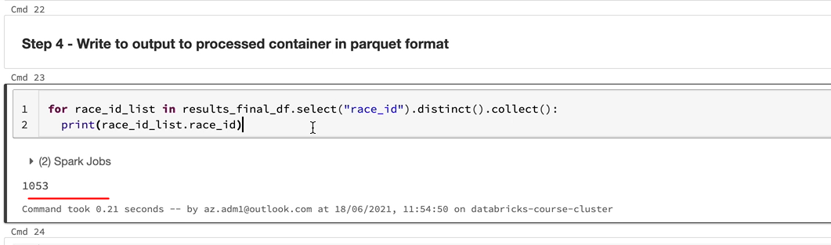

Let me just do a print and show you actually what said saw in this. So as you can see, we got the 1053 in the right side in this case, we've got only one, but in the cutover file, we would have thousands of race ids. That's why we're putting in a for loop and going to implement the solution that they. As I said, we need to use the spark.sql method to use the alt table statement. So the alt table statement goes like this.

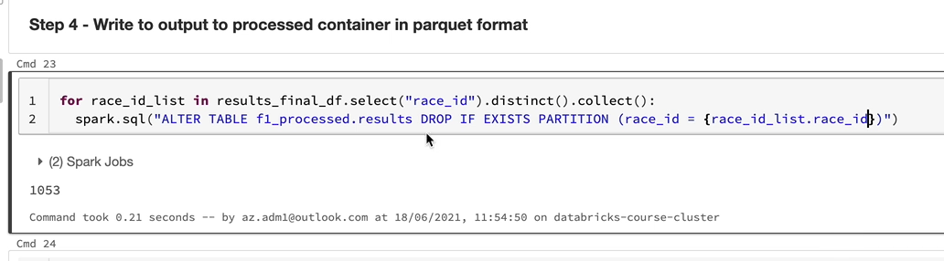

So now we need to drop the partition, so drop the on a normal run. We are not going to have that partition, so we don't want to fail for that one. So we won't only drop it if it exists. And we want to specify that we're dropping a partition and we want to give the partition details here. So the partition specification goes like this. In our case, the partition is right side and we need to give the right side here. So that is in the race_id list dot race_id. So I'm going to just put that in here because we are using a variable here we need to make it as string as well. So this for loop up here is going to go through the list and alter the table to drop the partition first, and then we're going to write all of that data into our table. So let's try and execute that now. As we saw previously, for 1053, we got 40 records. But once we've run it through, we should only see 20 because that 40 should be deleted because we're going to drop that partition and then we should put the 20 records back in. So let's run that and see whether that works.

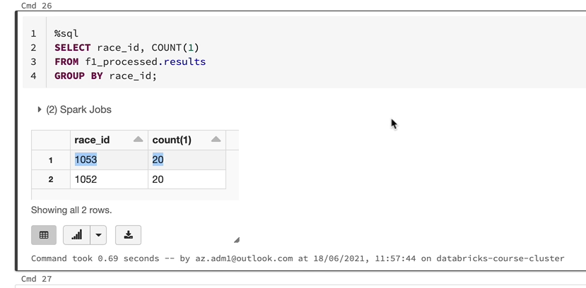

So let's run the sql here, and as you can see, we've only got 20 records so we can run it as many times as we want, the solution is clever enough just to go through and drop the partitions before it loads the data, which is very good. But there is one more thing. So we've got the altar table statement here, but that would fail If the table doesn't exist, it will only execute if the table exists. So for the first run itself, the table is not going to be there. So we need to protect against that.

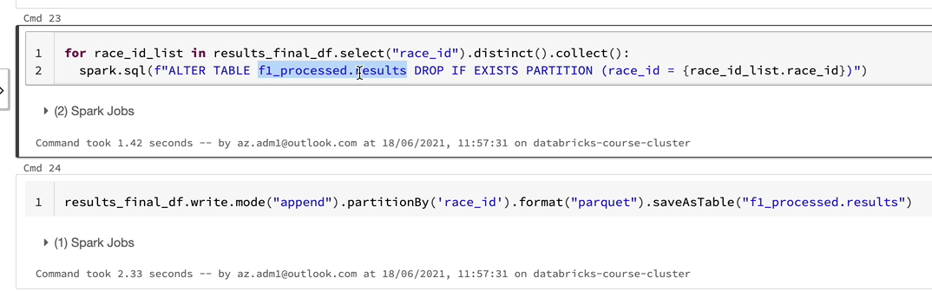

So in order to do that, you can use the Spark catalog function to find out whether the table exists. You can use this function spark.jsparkSession.catalog().tableExists("<tableName>") and then you've got the method called table exist and you give the table name and that one now execute the alter table if the table exists.

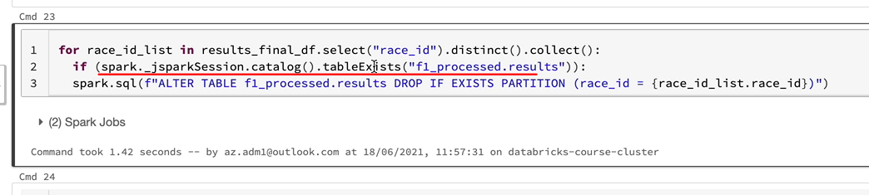

So we are protected against that as well. So let's run this again just to make sure that we've dealt with all the scenarios and it works OK. So let me execute that statement again. And as you can see, we've only got the director still and it's dropped the partition and re-created that as well.

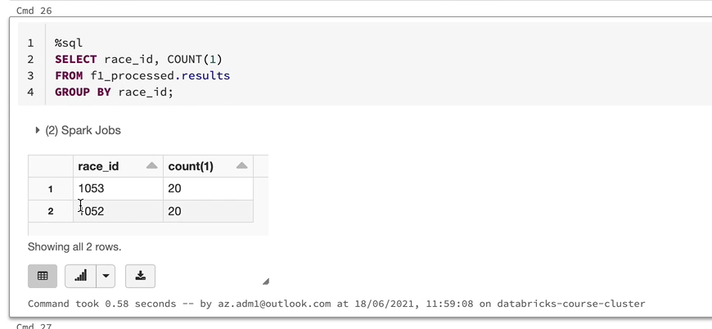

So now that we've got the solution, let's drop the table and I'll run the cutover file first and then the two incremental loads like it would in a production scenario and make sure that our solution works in 10. OK, the table's dropped.

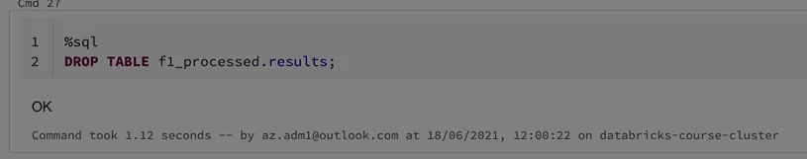

I'm going to load the cutover file, and that is the 21st of March, as I said, a tab out of here so that this cell gets executed.

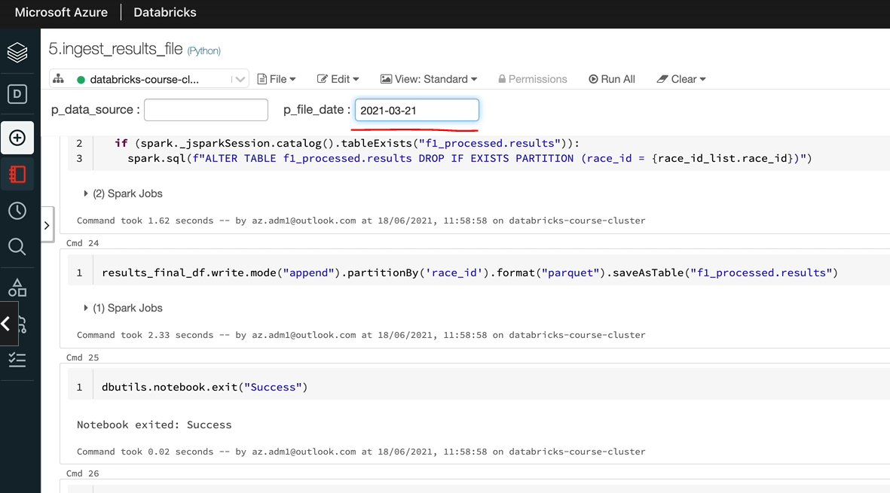

And the p_file_date is 21st of March 2021, if you're ever in doubt, the best thing to do is to check the value of the variable. So let's come over to here. I'll show you how to do that so you can just execute this cell and that's going to set the variable here. So let's just try and bring the variable and make sure we got the right value. So as you can see, that's the twenty first of March.

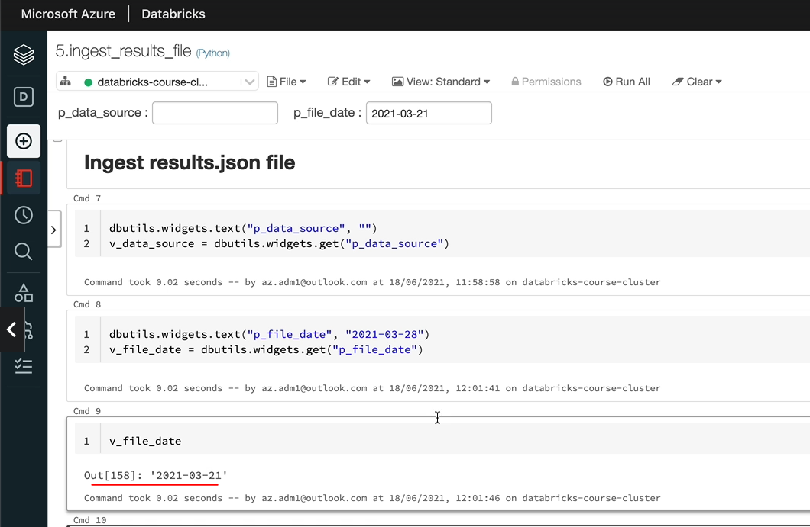

So that cell got executed and we got the values here. So let me delete this one. I'll also tidy up everything we did previously so we don't need any of these statements. I'm going to just delete these cells. OK, so let's do it. It's going to take a while because we got a lot of data in our cutover, fine, but we'll come back to.

**Full Code for this file**

**Ingest results.json file**

dbutils.widgets.text("p_data_source", "")

v_data_source = dbutils.widgets.get("p_data_source")

dbutils.widgets.text("p_file_date", "2021-03-28")

v_file_date = dbutils.widgets.get("p_file_date")

%run "../includes/configuration"

%run "../includes/common_functions"

**Step 1 - Read the JSON file using the spark dataframe reader API**

from pyspark.sql.types import StructType, StructField, IntegerType, StringType, FloatType

results_schema = StructType(fields=[StructField("resultId", IntegerType(), **False**),

StructField("raceId", IntegerType(), **True**),

StructField("driverId", IntegerType(), **True**),

StructField("constructorId", IntegerType(), **True**),

StructField("number", IntegerType(), **True**),

StructField("grid", IntegerType(), **True**),

StructField("position", IntegerType(), **True**),

StructField("positionText", StringType(), **True**),

StructField("positionOrder", IntegerType(), **True**),

StructField("points", FloatType(), **True**),

StructField("laps", IntegerType(), **True**),

StructField("time", StringType(), **True**),

StructField("milliseconds", IntegerType(), **True**),

StructField("fastestLap", IntegerType(), **True**),

StructField("rank", IntegerType(), **True**),

StructField("fastestLapTime", StringType(), **True**),

StructField("fastestLapSpeed", FloatType(), **True**),

StructField("statusId", StringType(), **True**)])

results_df = spark.read \

.schema(results_schema) \

.json(f"{raw_folder_path}/{v_file_date}/results.json")

**Step 2 - Rename columns and add new columns**

from pyspark.sql.functions import lit

results_with_columns_df =

results_df.withColumnRenamed("resultId", "result_id") \

.withColumnRenamed("raceId", "race_id") \

.withColumnRenamed("driverId", "driver_id") \

.withColumnRenamed("constructorId", "constructor_id") \

.withColumnRenamed("positionText", "position_text") \

.withColumnRenamed("positionOrder", "position_order") \

.withColumnRenamed("fastestLap", "fastest_lap") \

.withColumnRenamed("fastestLapTime", "fastest_lap_time") \

.withColumnRenamed("fastestLapSpeed", "fastest_lap_speed") \

.withColumn("data_source", lit(v_data_source)) \

.withColumn("file_date", lit(v_file_date))

results_with_ingestion_date_df = add_ingestion_date(results_with_columns_df)

**Step 3 - Drop the unwanted column**

**from** pyspark.sql.functions **import** col

results_final_df = results_with_ingestion_date_df.drop(col("statusId"))

**Step 4 - Write to output to processed container in parquet format**

for race_id_list in results_final_df.select("race_id").distinct().collect():

if (spark._jsparkSession.catalog().tableExists("f1_processed.results")):

spark.sql(f"ALTER TABLE f1_processed.results DROP IF EXISTS PARTITION (race_id =

{race_id_list.race_id})")

results_final_df.write

.mode("append")

.partitionBy('race_id')

.format("parquet")

.saveAsTable("f1_processed.results")

So that's finished. As you can see, it took 3 minutes to write the data to our file system. So let me run this select statement. As you can see, thousands of race ids are listed there. Let's do the order by to find out the most recent race id. So we should see 1047, I think, as the latest race id on the top, and that's brilliant. We've got the race eighty 1047 on the top.

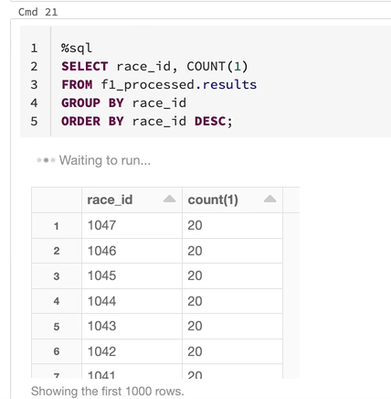

So let me now run the other two files. So that is for the twenty eight.

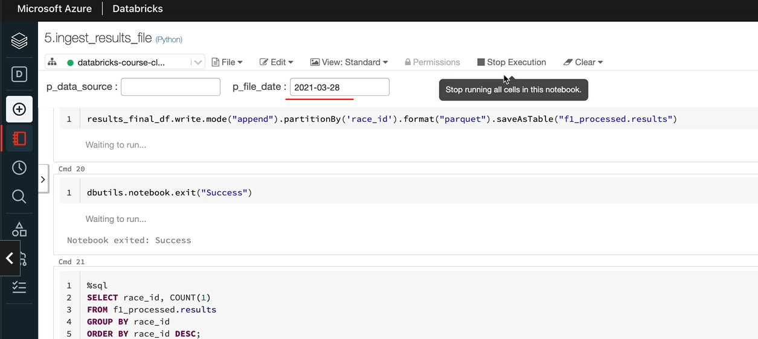

I'll start with that first. And let me run the 18th of April as well.

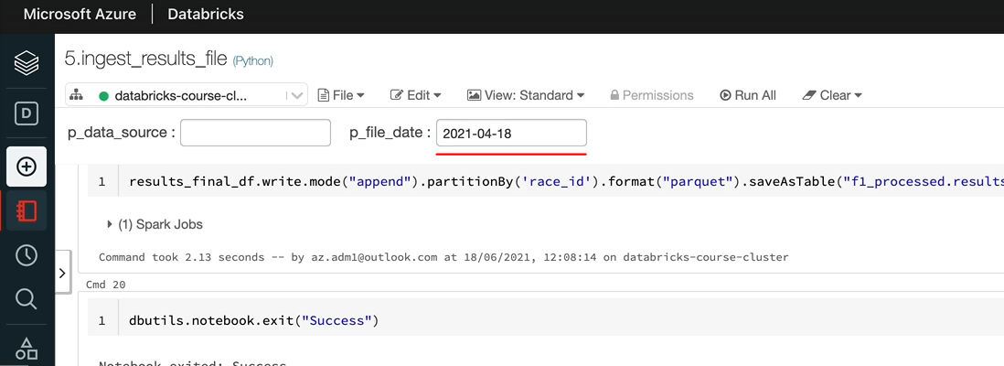

And let me look at the select again, just to see what the data is in the tables, that should see 1053 and 1052 on the top as well. OK, so as you can see, we got the 1053 and 1052 with 20, Records and 1047 with 20 as well, you can rerun any of these just to see whether everything works.

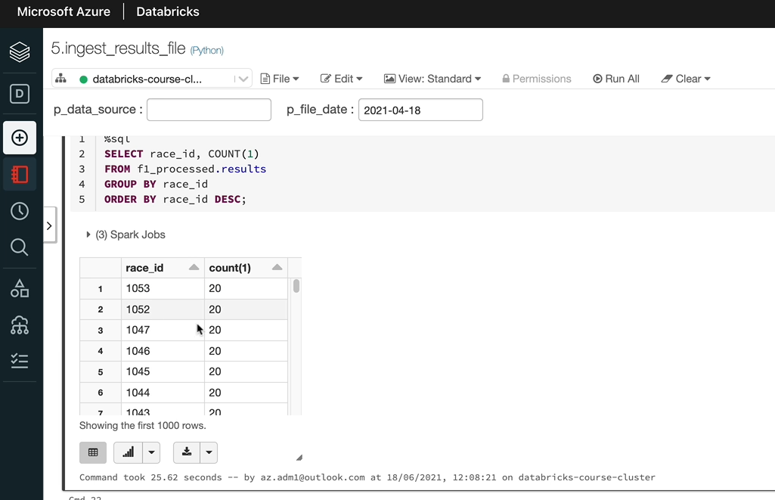

OK, but one thing you may notice is if you try to rerun the cutover, fail again, it'll work eventually, but it'll take a long time. So it will take about 15 minutes to delete all the partitions and reload the data because we are going through each of the partitions in a for loop and then dropping them. It takes a while to do that. So, as I said, this is one solution. In the next lesson, I'm going to show you another one where actually, instead of dropping the partitions and then appending the data, we will use an override functionality given by spark. Even that's not straightforward. So there are a few things we have to do. So I'll cover that in the next lesson.

### Incremental Load – Method 2

We're going to look at another way to solve this problem, so I'm going to comment out all of this, the two two cells here, and then we'll start with the next one. So you can use a shortcut to command this, so if you're in windows, it's control and then a / or if you're in Mac is command and /, it's a backslash that should work. So let me just do that.

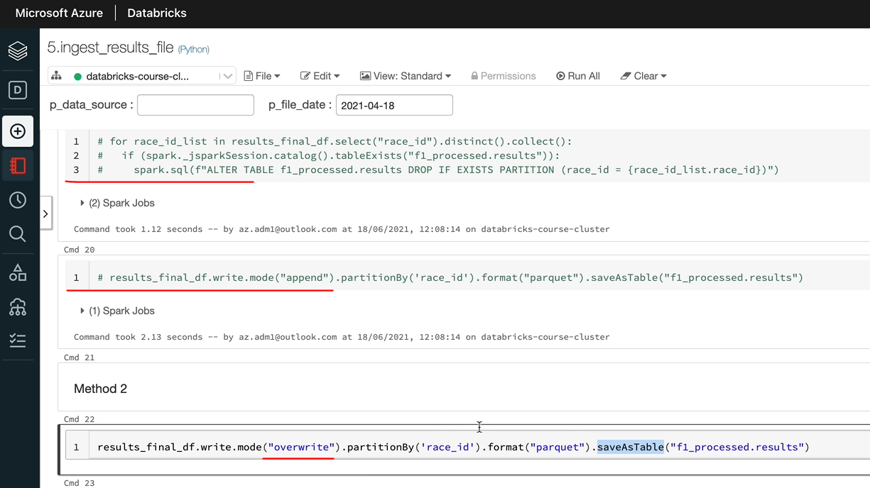

So that's been commented out. In this one, we're going to use an override, so instead of doing an append here, we are going to do a override, but as we know, override overrides the entire table, because when you do a service table, that's what happens.

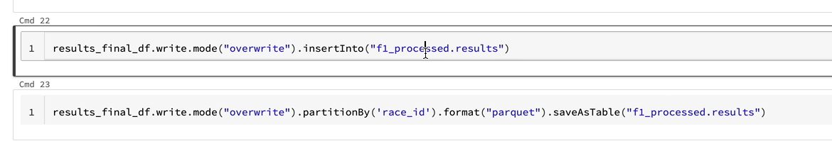

Even though you partition the data by side, it's going to override the entire table. Instead, we have another method called insert into that you can use. So it looks something like this. So we got the results finally and then they go right. More similar to this one. And instead of all of this, we would say insert into this table. So the data frame is going to be inserted into this table. Unfortunately, there is no way to specify the order of columns being inserted here, but spark expects the last column in the list to be the partitioned column when you're doing it. So we can use this statement here to write the data first time. And then once the tables created, we can use this one to add any new data. So any new partitions coming along. So in our example, cutover would be done by this ( Cmd 22) and this ( Cmd 23 ) would do the subsequent files coming through.

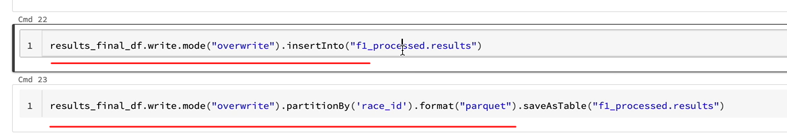

A couple of things we need to do based on what we just discussed. The first thing is we need that if statement. So similar to what we did on the previous statement, we need to find out whether the table exists. So let's put that in. So if the table exists, that means the statement here has already run and it's created the data for us. So we only want to add any new data going forward so we can do that here. If that's not the case, this is the first execution of it. We can do our normal query and overwrite the data. So I'm repeating it again. This here ( Line 4 below ) creates the table up front for you when it runs for the first time, when a notebook runs for the first time. And this ( Line 2 below ) is just going to append the data going forward for every every subsequent month.

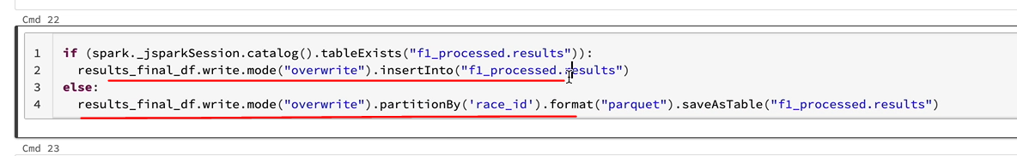

We also said something which is we need the race id to be the last column. If you can look here race id is not the last column race is the second column here, so we need to change the order in our data frame.

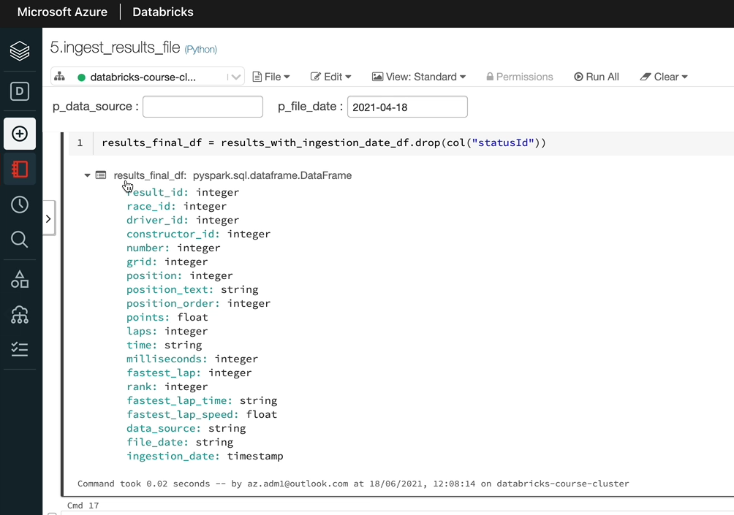

So I've already prepared the statement for that one. So as we know, we can use the select method to select the columns. So I'm going to just paste that here. I'm doing a select, but as you can see here, race_id is now the last column, so that means this insert statement would quite happily work.

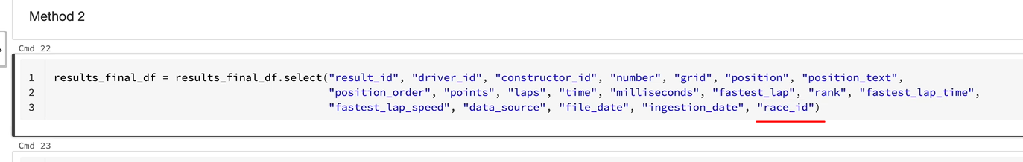

One more thing we need to do for this to work on partitions is we need to tell Spark that our partition override mode is dynamic, if we leave it as default. It's called static in case a static, this statement here is also going to overwrite all of our data, which we don't want.

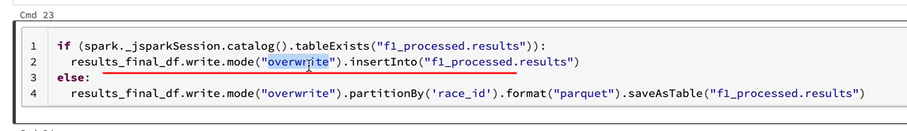

So let's use the configuration parameter. So this statement here would set the partition over more to dynamic. What that means is when the insert into runs, it's going to find the partitions and we only replace those partitions with the new data received. It's not going to overwrite the entire table.

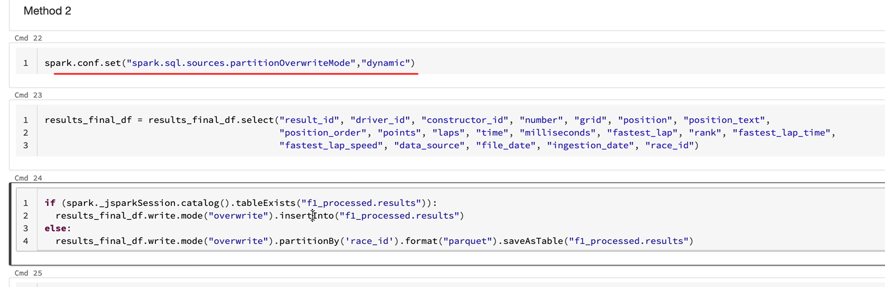

So that's what we want. This looks slightly more complicated compared to the first one we talked about. But the difference between the two is that this will be slightly more efficient because as opposed to going around and dropping all the partitions manually we are letting spark to find the partition and overwrite it while it's trying to insert the data. So I find that to be slightly more performant. So we need to test this one now. But before we test it, let's drop the table. And because it's a managed table, it's going to drop all the data behind it as well.

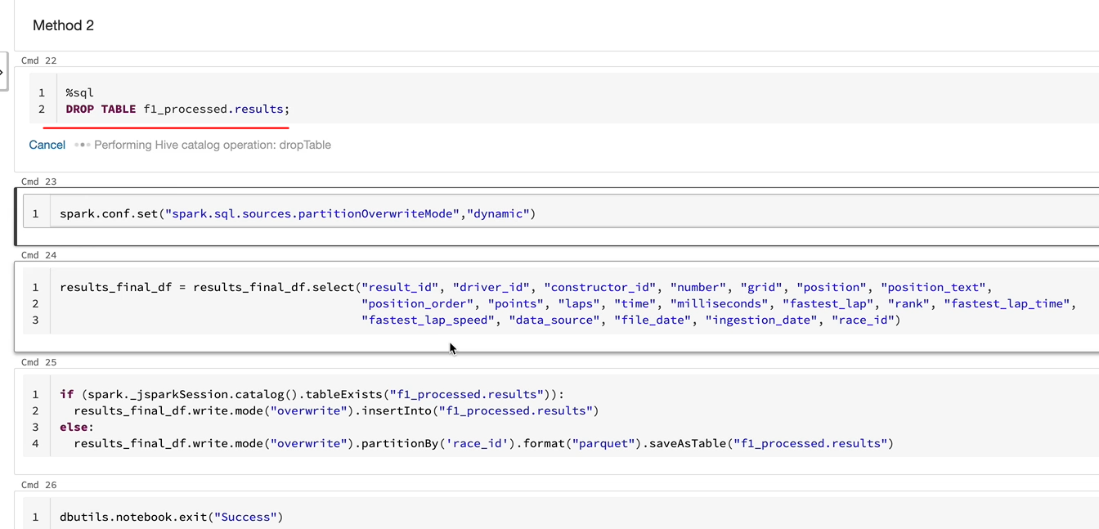

So I'm going to drop the table. The table is now dropped. So let's come in this out. So in sequel, comment is a double hyphen there as opposed to the hash in Python. So if you are in SQL commenting anything out, use the double double hyphens.

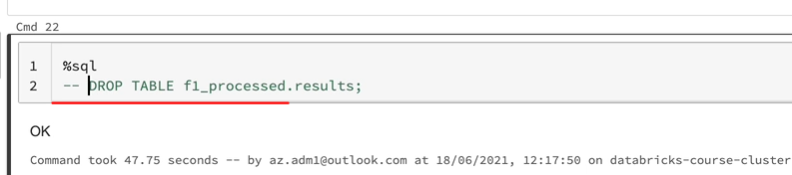

So let's run this for the 18th of April just to make sure it runs OK before we do the cutover load.

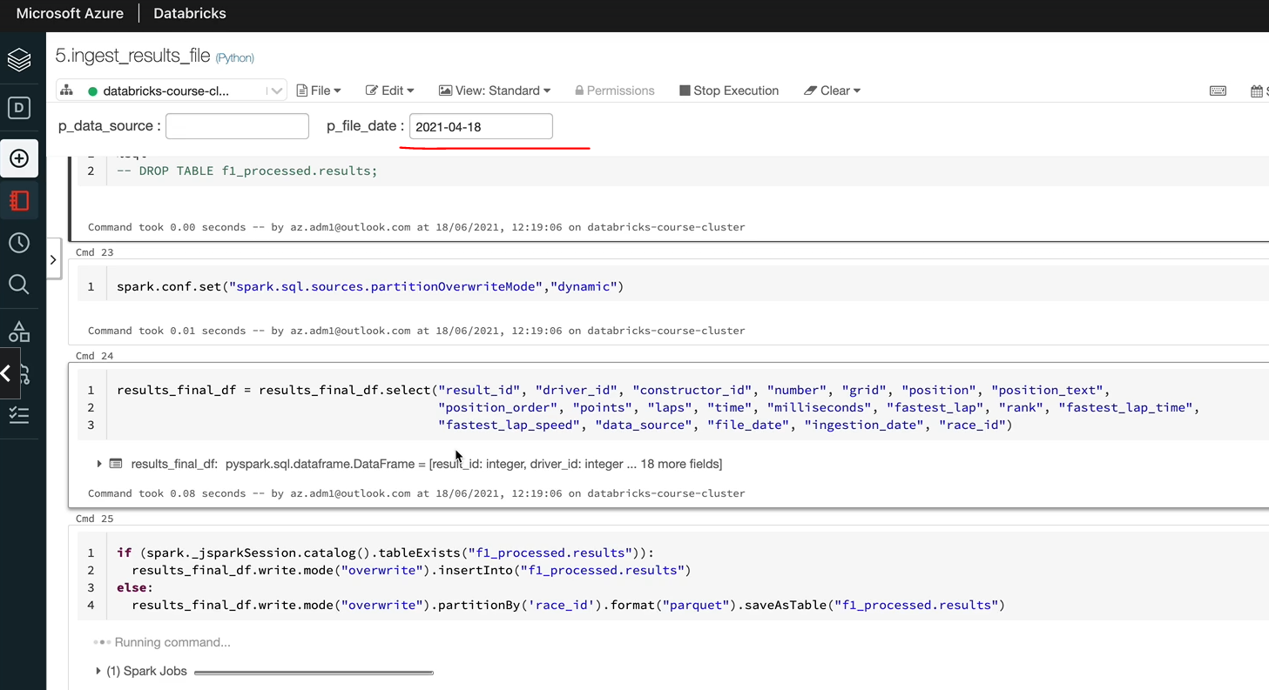

OK, let me execute the select statement and yeah, that's 20 records in there, so that looks brilliant.

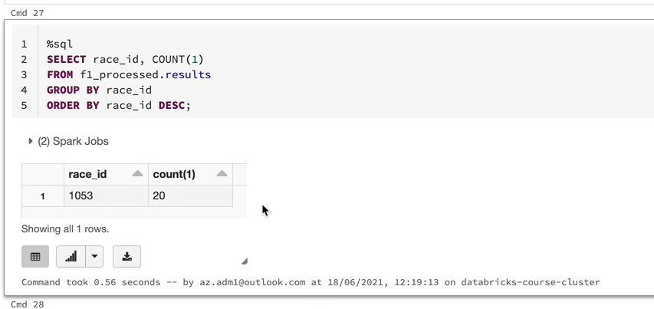

I'm going to drop the table again and then start from the cutover for us. And let's come back again, and then this is for the 21st of March.

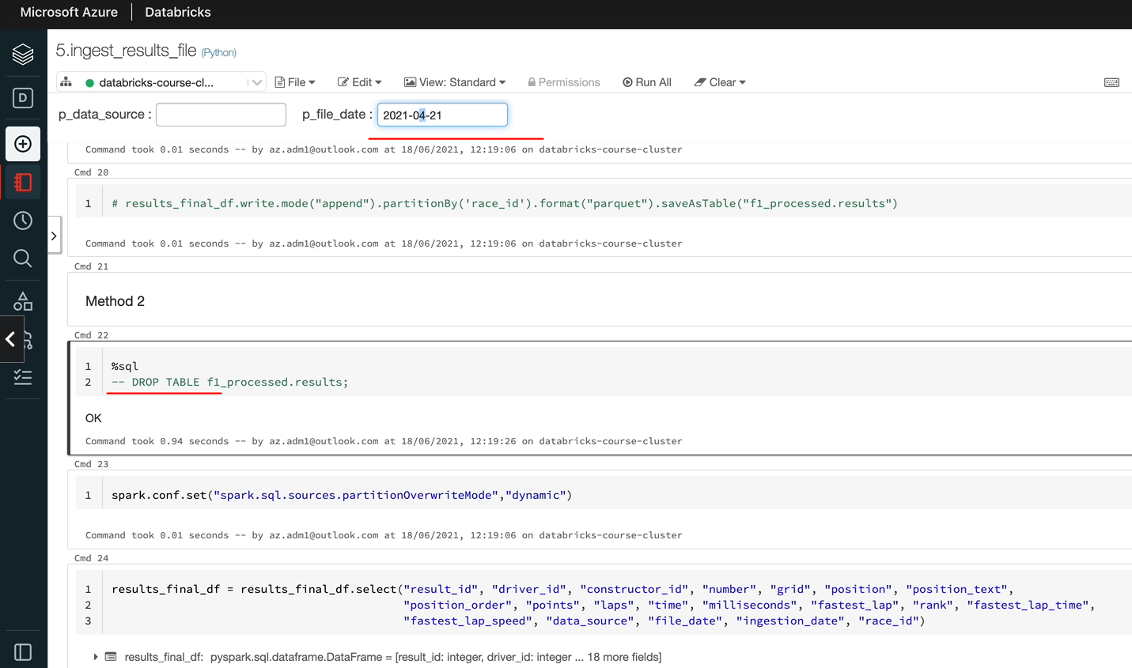

OK, that's completed, so let's just quickly run the selectors well. And that looks brilliant

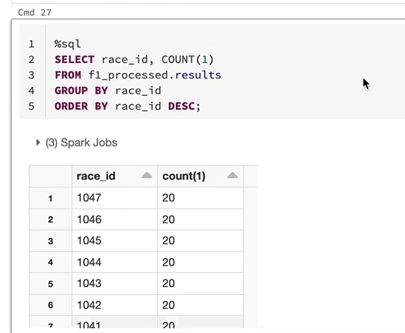

So I'm going to quickly go ahead and run the other two days as well, which is the 28 March as well as the 18th of April.

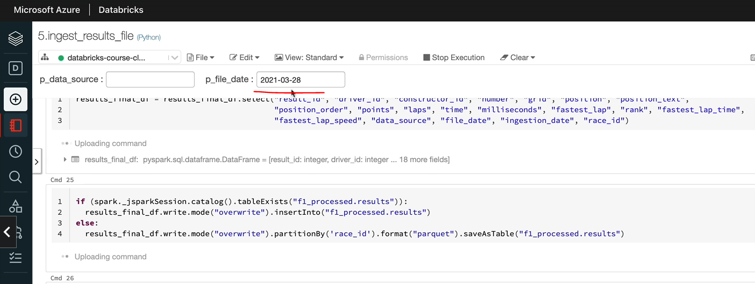

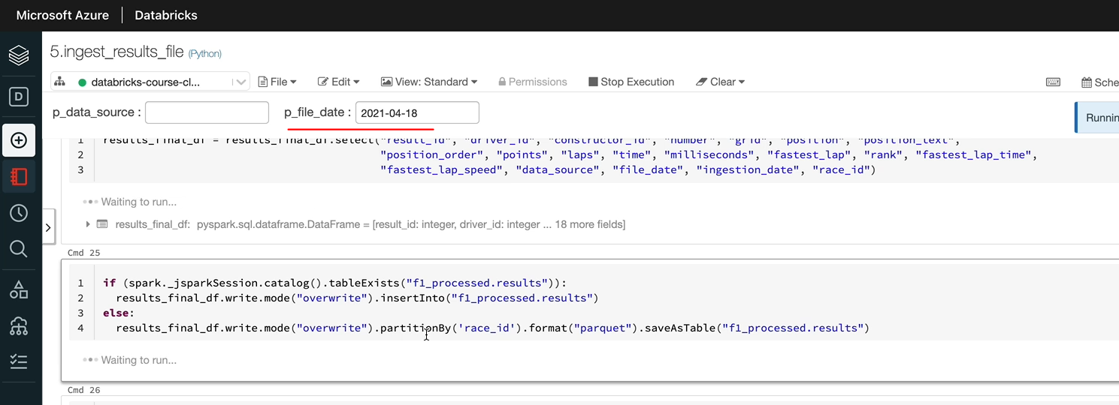

And let's try and 18th of April one more time, just to see whether our code still works and there are no duplicates in the data. I'm going to just do the select and I should still see only 20 records for the race id 1053. OK, that looks brilliant.

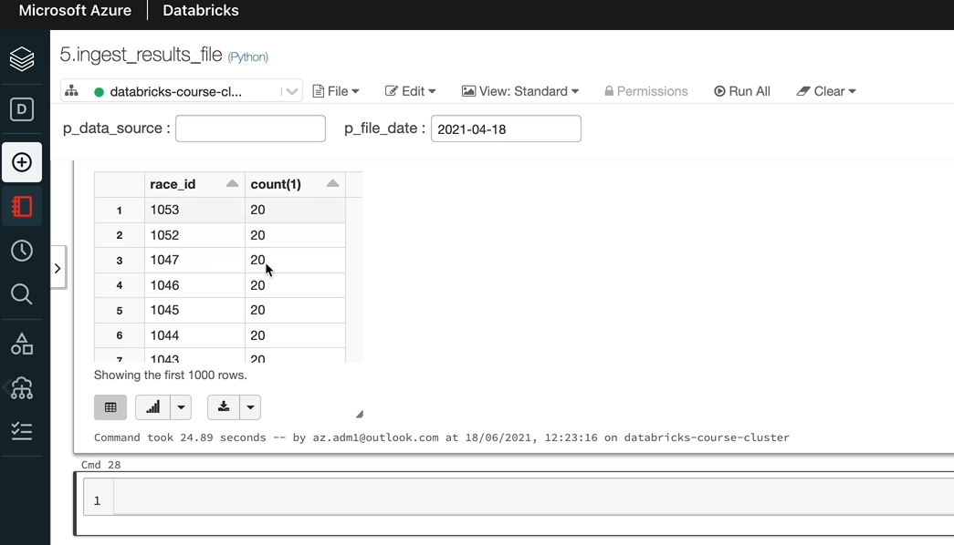

We've got 20, correct, for 1053 and the other races as well. So as I said, these are only 2 of the many options available. So you might come across other options to deal with incremental loads within Spark. But I just wanted to give you a couple of examples and the idea of how to achieve these things. And also, this is how the data lakes were built, up until Delta came along. Delta Lake is something which gives you the ability to do deletes, merge and things like that, which we will look into in the next section of the course. But for now, this is our solution.

**Full Code**

**Ingest results.json file**

dbutils.widgets.text("p_data_source", "")

v_data_source = dbutils.widgets.get("p_data_source")

dbutils.widgets.text("p_file_date", "2021-03-28")

v_file_date = dbutils.widgets.get("p_file_date")

%run "../includes/configuration"

%run "../includes/common_functions"

**Step 1 - Read the JSON file using the spark dataframe reader API**

from pyspark.sql.types import StructType, StructField, IntegerType, StringType, FloatType

results_schema = StructType(fields=[StructField("resultId", IntegerType(), False),

StructField("raceId", IntegerType(), True),

StructField("driverId", IntegerType(), True),

StructField("constructorId", IntegerType(), True),

StructField("number", IntegerType(), True),

StructField("grid", IntegerType(), True),

StructField("position", IntegerType(), True),

StructField("positionText", StringType(), True),

StructField("positionOrder", IntegerType(), True),

StructField("points", FloatType(), True),

StructField("laps", IntegerType(), True),

StructField("time", StringType(), True),

StructField("milliseconds", IntegerType(), True),

StructField("fastestLap", IntegerType(), True),

StructField("rank", IntegerType(), True),

StructField("fastestLapTime", StringType(), True),

StructField("fastestLapSpeed", FloatType(), True),

StructField("statusId", StringType(), True)])

results_df = spark.read \

.schema(results_schema) \

.json(f"{raw_folder_path}/{v_file_date}/results.json")

**Step 2 - Rename columns and add new columns**

from pyspark.sql.functions import lit

results_with_columns_df =

results_df.withColumnRenamed("resultId", "result_id") \

.withColumnRenamed("raceId", "race_id") \

.withColumnRenamed("driverId", "driver_id") \

.withColumnRenamed("constructorId", "constructor_id") \

.withColumnRenamed("positionText", "position_text") \

.withColumnRenamed("positionOrder", "position_order") \

.withColumnRenamed("fastestLap", "fastest_lap") \

.withColumnRenamed("fastestLapTime", "fastest_lap_time") \

.withColumnRenamed("fastestLapSpeed", "fastest_lap_speed") \

.withColumn("data_source", lit(v_data_source)) \

.withColumn("file_date", lit(v_file_date))

results_with_ingestion_date_df = add_ingestion_date(results_with_columns_df)

**Step 3 – Drop the unwanted column**

from pyspark.sql.functions import col

results_final_df = results_with_ingestion_date_df.drop(col(“statusId”))

**Step 4 – Write to output to processed container in parquet format**

**Method 1**

# for race_id_list in results_final_df.select("race_id").distinct().collect():

# if (spark._jsparkSession.catalog().tableExists("f1_processed.results")):

# spark.sql(f"ALTER TABLE f1_processed.results DROP IF EXISTS PARTITION (race_id =

# {race_id_list.race_id})")

#

results_final_df.write.mode("append")

.partitionBy('race_id')

.format("parquet")

.saveAsTable("f1_processed.results")

**Method 2**

overwrite_partition(results_final_df, 'f1_processed', 'results', 'race_id')

dbutils.notebook.exit("Success")

%sql

SELECT race_id, COUNT(1)

FROM f1_processed.results

GROUP BY race_id

ORDER BY race_id DESC;

### Incremental Load Improvements – Assignment

Now that we have successfully processed one of our incremental data sets results, we should look at doing the other three, which are pit stops, lap times and qualifying.

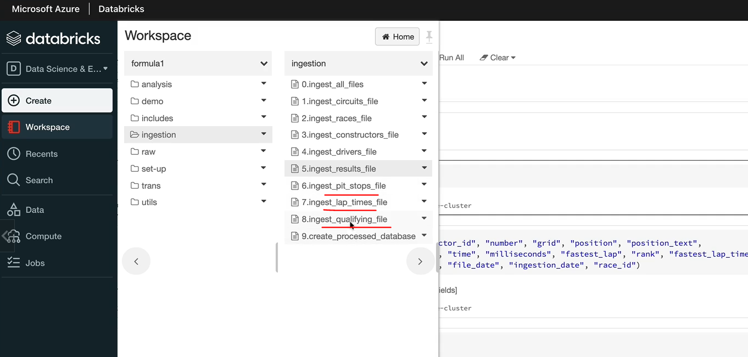

One option could be copy this code, put it into the other three notebooks and make the corresponding changes as we need. But that will mean that we have got a lot of duplicated code in our four files and also some of this functionality could be used elsewhere as well. So the best design would be put this into a function so that we can do unique test and things like that. And also we can just call that function in our notebooks. So that's what we want to do here. Having said that, we've done functions before and we've done the code for the incremental load here. So one of the things you can do is you can dynamically generate this column list rather than hard coding it every time and end up making mistakes.

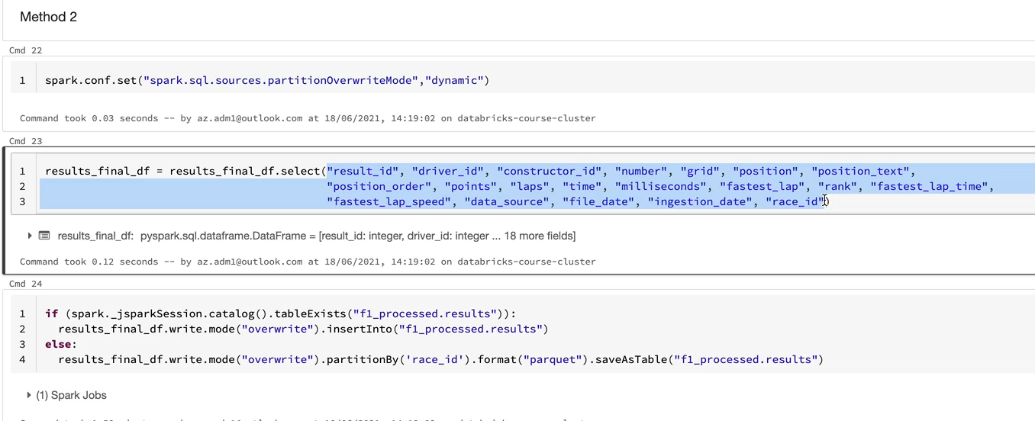

So in order to get the list of column names from a data frame, you can use a method called schema.names, and that should give you the list of column names in that data frame. And then you can look through the column list and move the column that you want to towards the end.

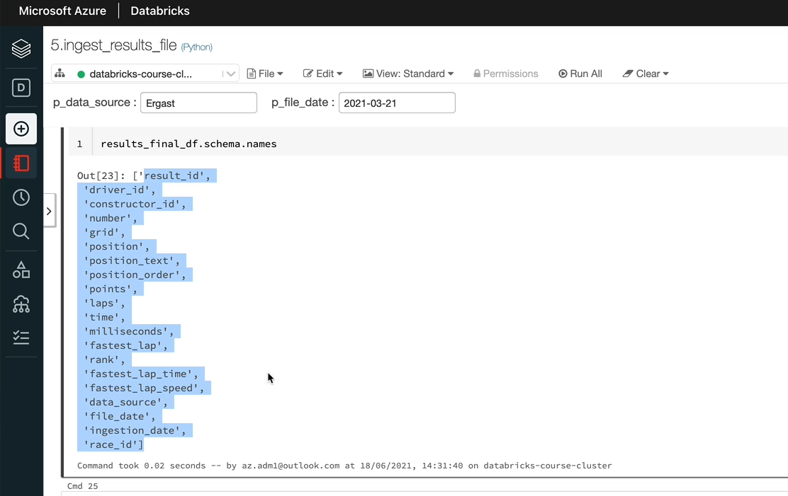

So which will be a partitioned column, for example. This could all sit in one function, which will take in a data frame and the partitioned by column, and it gives you a dataframe with a partitioned by column at the end. The other function you can do is to have the spark configuration here as well as the statements here. And that could take in a data frame, the database name and the table name, as well as the partitioned by column and then maybe just incrementally write the data to our tables as we want. And within the second function, you can call the first function as well, and we can move them into our includes common functions and then we could use them here.

So that means there'll be one statement just to incrementally load the data in all of our other notebooks. And you can write a unit test as well on those functions. We won't go into unit test in this lesson, but you can do that as well. I would like you to now go away and have a go at clear in the function as well as making changes to the other three notebooks as well.

Solution:

We can use the method schema.names to get the list of column names. So we would want to look around that one just to get the individual column names. So I'm going to put that into a variable called column names. And we want to look through the column names and find out the column name, which is our partition column. Let's have a variable called partition column and I'm going to hard code that to race_id for now. And also, once we look through this list of column names, we want to put that into a list. So I'm going to clear an empty list called column_list. And now here I'm going to test for the column name here. So I'm going to call this one a column name rather than column names. And if column name equals the partition_column name, that's what we want to check for, then we don't want to write that into our output. So we want a not equal condition here. We want to only process the not equals. So if the column name is not equal to the partition column name, let's add that to our colum list so that the column lists append and then I can put the column name there. And once we've gone through the for loop, all of the columns are that we want to add the partition_column to the end. So I'm going to do that here. And that would be the partition column. And that should give us a full list of columns.

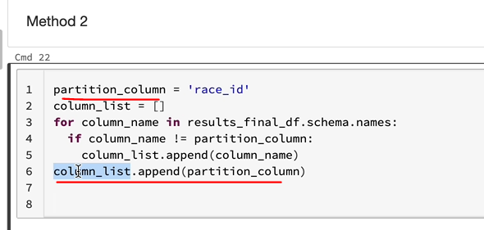

That they need, which is a new column list, so let's print the column list as well so that we can test it and I'm going to re execute this statement here. The last_results_final_df, and I'll show you, as we can see, the resides the second column. So I'm going to execute the statements we've just written. And as you can see, the column, the race_id, has gone from second column to the last column.

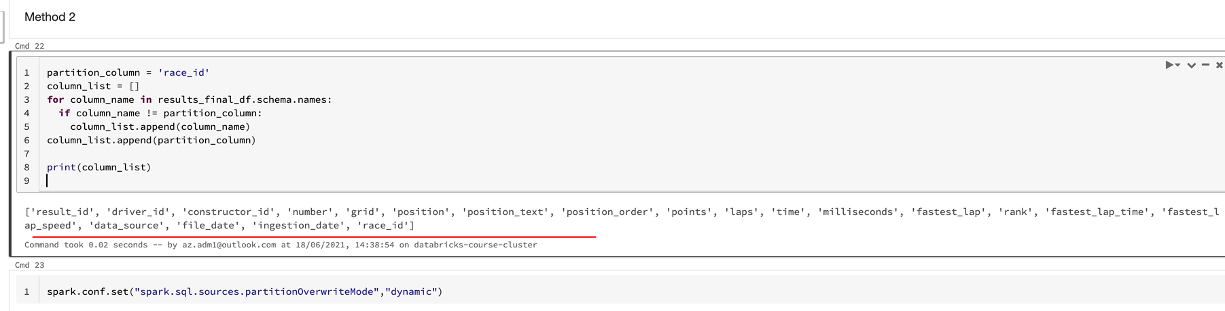

So that's our column list. So we've got that one. And the next thing we want to do is to change our date frame. So I'm going to call this one as output_df. So our input data frame is the result_final_df and all we need to do is select the columns with the column list. So the new data frame is going to have the column list in the order we need. So if we look at that one, as you can see, the race_id is the last column. So that's pretty much the code we need for our first function. I'm going to turn that into a function, call this as re_arrange_partition_column and as we said, this, this function needs a data frame. I'm going to call that as input_df and also it needs partitioned columns so it can be send any data frame and any partition column. It will just rearrange the data frame with the partition column as the last column. So that's what we're doing here. And we don't need the partition column field anymore because that's coming in a separate matter. And I'm going to tab this one out just to align it. And also the input data frame is what we are going to send. So that could be replaced here as well as here. And once we've done everything we want to print the story, we want to return the output data frame. And once you do it like this, you can do a unit test and test the code in isolation and make sure everything is OK. So that's our first function.

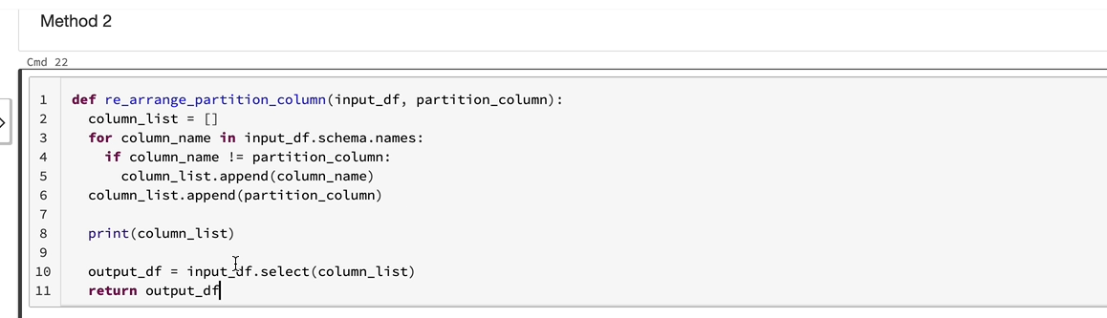

Let's quickly test the function just to make sure that works, OK? Again, I'm going to go back and rerun this statement so that the columns are in the right order, so that our results final date frame, which has got the very ideas, the second column. So we'll send that in. So I'm going to get a new data frame, call it output_df by calling the rearrange partition column data frame. And that's going to have the result_final_df as the input. And we want to send in the partition column which is race_id, and if I run this, I can see the race id is the last column and the function works as expected. So the second function we need is to overwrite our partition. I'm going to create the function. I'm going to call this one as overridePartition, because that's what it does. And that could take in the input data frame. So it needs a data frame to work on and then it's got the database name and the table names we need, so I'm going to call this as db_name and table_name and also we need the partition by column. So I'm going to call it as partition_column. So these are the inputs for this function and the first thing it needs to do is to create an output data frame with the rearranged column names, and for that one, we're going to send the input data frame. So it takes an input data frame and the partition column. So we could replace the hardcoded partition column name and it gives us back the data frame in the column order we need. So that's done. The second thing we want to do is to run this statement because we need this in order for the override to work. And then the last thing we want is the statements here. Let's take those as well. And here we want to replace the f1 process with the db_name. So let's do it here as well and here and also we want to replace the results with the table_name variable. And because we are now replacing the variables, let's make them make the F strings. And the partition by column is now being sent in, so we don't need to hard code that anymore. And the input data frame needs to be used everywhere. So we've already used it here and this is the input data frame.write. So this is now a truly generic function. So let's try and execute that one. Let's try to execute this.

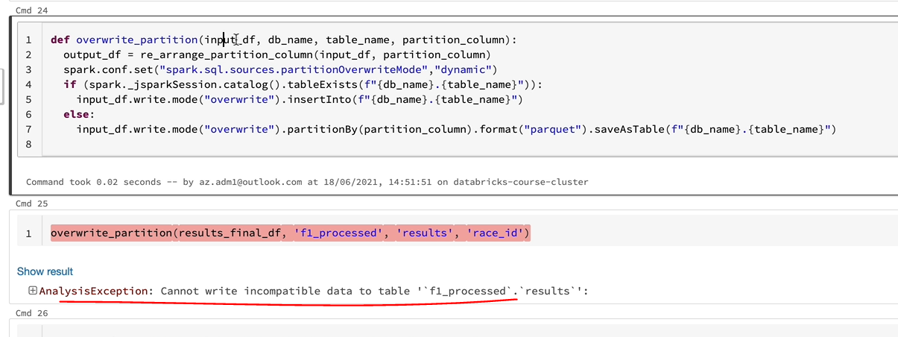

And as you know, we need to send in input data plan, which is our results final D.F. in this case, and it takes a database name. So that one was EF1 processed. And also it takes in a table name, which is results in this case. And also it takes in the partition column, which is reside. So let's execute this and see what happens this error is because we got a mistake in our function. As you can see, we pass in the input_df and then we assign it to the output data frame. And that's the one we should be writing. But we instead write in the input data frame, so I just change those two and compile the function and then rerun this again. And that should now go through.

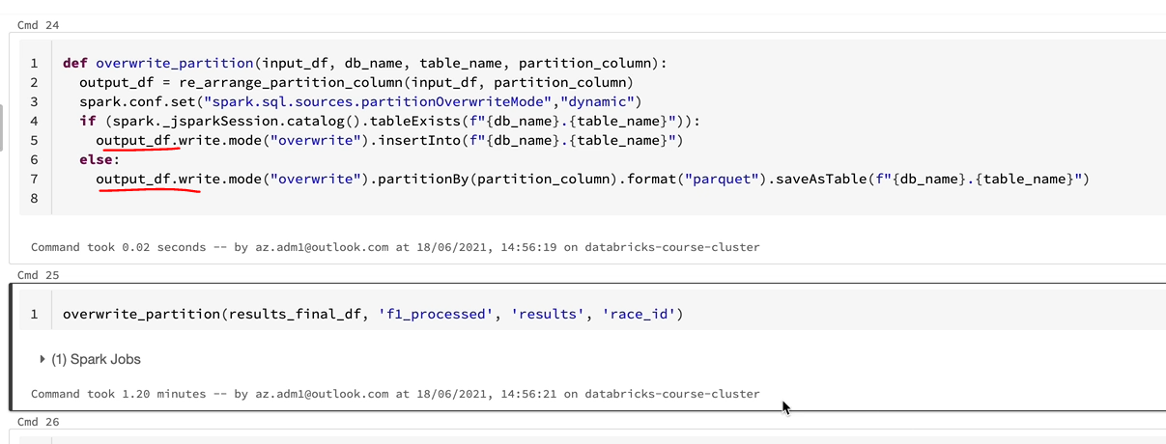

OK, that's gone through successfully. Let's have a look at the data in our table. And that looks as we expect to see. OK, so that's brilliant.

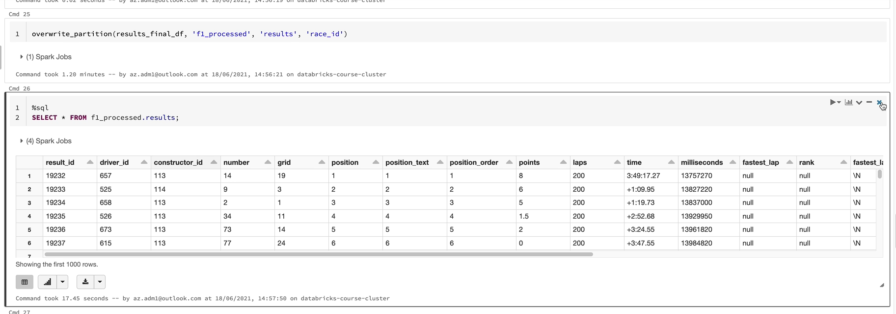

So now let's tidy up this. We need to, first of all, copy those two functions. So let's first copy these functions into our includes folder.

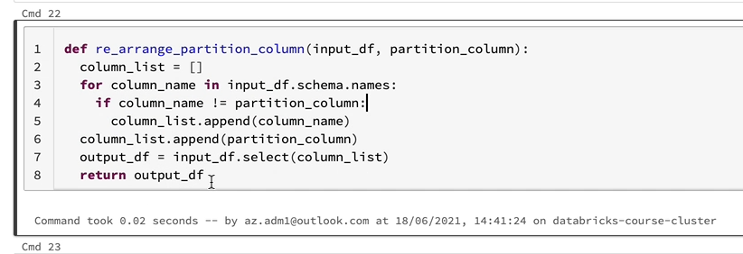

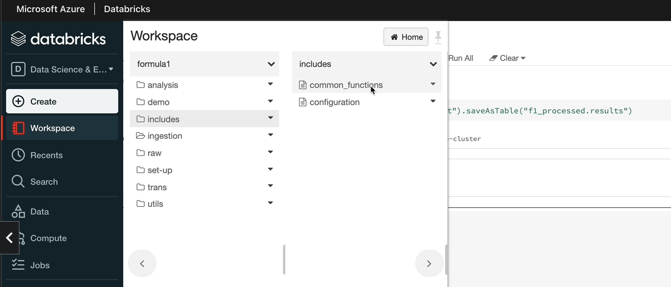

So I'm going to copy this function and then I'm going to go to include and just control click on common functions that'll open up in another tab and then I'm going to put it in there so that I rearrange a partition column. I also want to get the other function, which is this one here, which is the override partition.

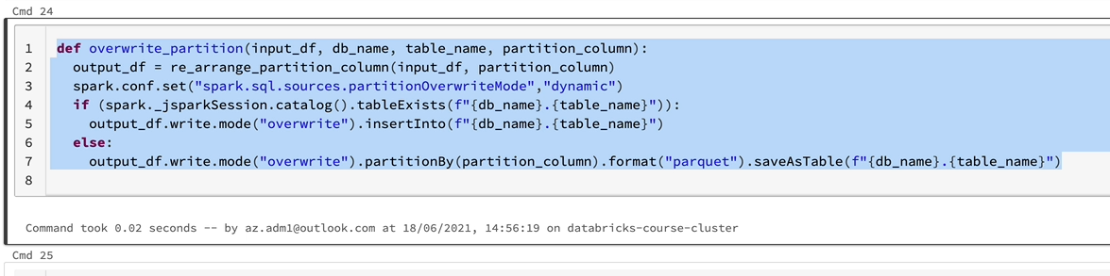

I'm going to put that in here as well. So those two functions are there and we can tidy up this now so we don't need this.

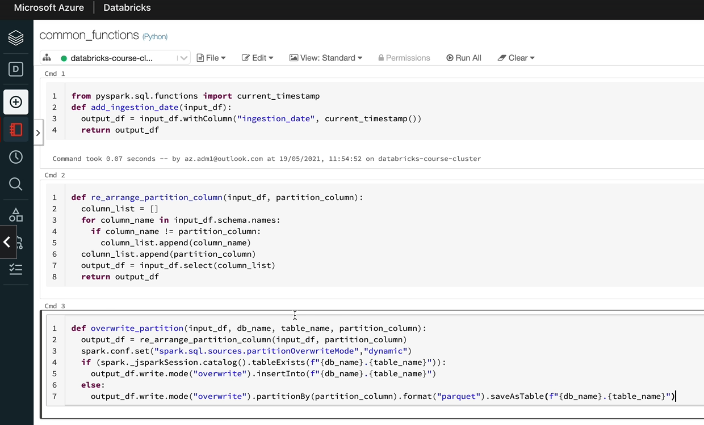

Let's get rid of that. Let's delay everything, all we need is just a call to those function functions or the main function. So that's the statement. We need it, but we can delay everything else. So that's quite concise, so we just have to put this into our other notebooks, but before that, let's just test it with the next next week's with files.

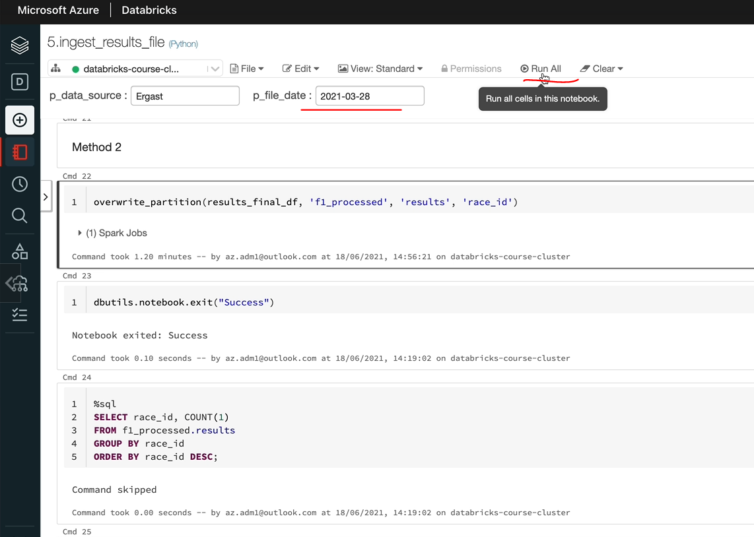

So that's the 2021 03 28. I'm going to just do a run all just to see whether that works and that's succeeded. So let me run the SQL just to make sure that the data is looking OK as well. So we should see the 1052 right side on top.

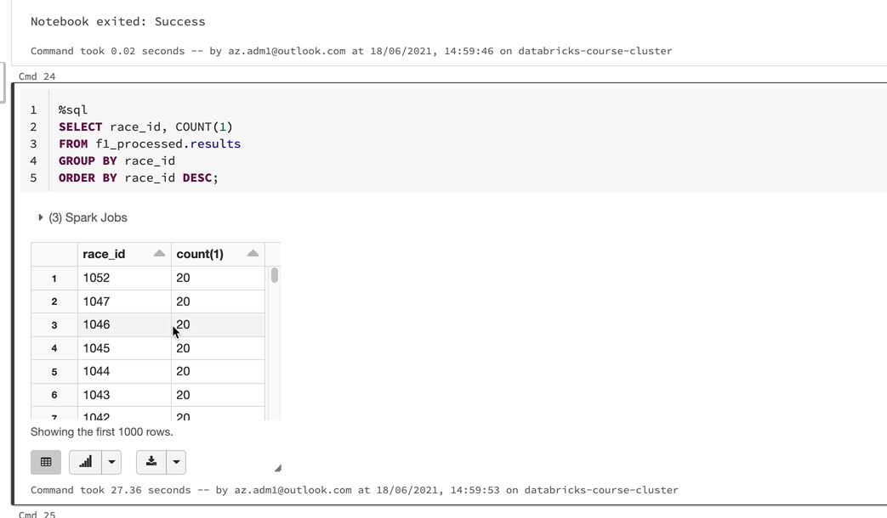

Yeah, that that's on the top, and then we got the ten forty seven and everything else, which is from the historic or the cutover file, so that works perfectly fine. So we just have to copy this statement and put it into the other notebooks.

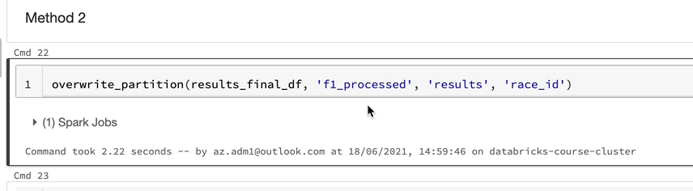

So I let you finish the assignment, but I'll give you the copies of these notebooks if you want to look at the changes I've made.

### Full Code for the files

#### common_functions (Python)

from pyspark.sql.functions import current_timestamp

def add_ingestion_date(input_df):

output_df = input_df.withColumn("ingestion_date", current_timestamp())

return output_df_

def re_arrange_partition_column(input_df, partition_column):

column_list = []

for column_name in input_df.schema.names:

if column_name != partition_column:

column_list.append(column_name)

column_list.append(partition_column)

output_df = input_df.select(column_list)

return output_df

def overwrite_partition(input_df, db_name, table_name, partition_column):

output_df = re_arrange_partition_column(input_df, partition_column)

spark.conf.set("spark.sql.sources.partitionOverwriteMode","dynamic")

if (spark._jsparkSession.catalog().tableExists(f"{db_name}.{table_name}")):

output_df.write.mode("overwrite").insertInto(f"{db_name}.{table_name}")

else:

output_df.write.mode("overwrite")

.partitionBy(partition_column)

.format("parquet")

.saveAsTable(f"{db_name}.{table_name}")

def df_column_to_list(input_df, column_name):

df_row_list = input_df.select(column_name) \

.distinct() \

.collect()

column_value_list = [row[column_name] for row in df_row_list]

return column_value_list

#### Ingest results.json file

dbutils.widgets.text("p_data_source", "")

v_data_source = dbutils.widgets.get("p_data_source")

dbutils.widgets.text("p_file_date", "2021-03-28")

v_file_date = dbutils.widgets.get("p_file_date")

%run "../includes/configuration"

%run "../includes/common_functions"

**Step 1 - Read the JSON file using the spark dataframe reader API**

**from** pyspark.sql.types **import** StructType, StructField, IntegerType, StringType, FloatType

results_schema = StructType(fields=[StructField("resultId", IntegerType(), **False**),

StructField("raceId", IntegerType(), **True**),

StructField("driverId", IntegerType(), **True**),

StructField("constructorId", IntegerType(), **True**),

StructField("number", IntegerType(), **True**),

StructField("grid", IntegerType(), **True**),

StructField("position", IntegerType(), **True**),

StructField("positionText", StringType(), **True**),

StructField("positionOrder", IntegerType(), **True**),

StructField("points", FloatType(), **True**),

StructField("laps", IntegerType(), **True**),

StructField("time", StringType(), **True**),

StructField("milliseconds", IntegerType(), **True**),

StructField("fastestLap", IntegerType(), **True**),

StructField("rank", IntegerType(), **True**),

StructField("fastestLapTime", StringType(), **True**),

StructField("fastestLapSpeed", FloatType(), **True**),

StructField("statusId", StringType(), **True**)])

results_df = spark.read \

.schema(results_schema) \

.json(f"{raw_folder_path}/{v_file_date}/results.json")

**Step 2 - Rename columns and add new columns**

from pyspark.sql.functions import lit

results_with_columns_df = results_df.withColumnRenamed("resultId", "result_id") \

.withColumnRenamed("raceId", "race_id") \

.withColumnRenamed("driverId", "driver_id") \

.withColumnRenamed("constructorId", "constructor_id") \

.withColumnRenamed("positionText", "position_text") \

.withColumnRenamed("positionOrder", "position_order") \

.withColumnRenamed("fastestLap", "fastest_lap") \

.withColumnRenamed("fastestLapTime", "fastest_lap_time") \

.withColumnRenamed("fastestLapSpeed", "fastest_lap_speed") \

.withColumn("data_source", lit(v_data_source)) \

.withColumn("file_date", lit(v_file_date))

results_with_ingestion_date_df = add_ingestion_date(results_with_columns_df)

**Step 3 - Drop the unwanted column**

from pyspark.sql.functions import col

results_final_df = results_with_ingestion_date_df.drop(col("statusId"))

**Step 4 - Write to output to processed container in parquet format**

**Method 1**

# for race_id_list in results_final_df.select("race_id").distinct().collect():

# if (spark._jsparkSession.catalog().tableExists("f1_processed.results")):

# spark.sql(f"ALTER TABLE f1_processed.results DROP IF EXISTS PARTITION (race_id = {race_id_list.race_id})")

# results_final_df.write.mode("append").partitionBy('race_id').format("parquet").saveAsTable("f1_processed.results")

**Method 2**

overwrite_partition(results_final_df, 'f1_processed', 'results', 'race_id')

dbutils.notebook.exit("Success")

%sql

SELECT race_id, COUNT(1)

FROM f1_processed.results

GROUP BY race_id

ORDER BY race_id DESC;

#### Ingest pit_stops.json file

dbutils.widgets.text("p_data_source", "")

v_data_source = dbutils.widgets.get("p_data_source")

dbutils.widgets.text("p_file_date", "2021-03-28")

v_file_date = dbutils.widgets.get("p_file_date")

%run "../includes/configuration"

%run "../includes/common_functions"

**Step 1 - Read the JSON file using the spark dataframe reader API**

**from** pyspark.sql.types **import** StructType, StructField, IntegerType, StringType

pit_stops_schema = StructType(fields=[StructField("raceId", IntegerType(), **False**),

StructField("driverId", IntegerType(), **True**),

StructField("stop", StringType(), **True**),

StructField("lap", IntegerType(), **True**),

StructField("time", StringType(), **True**),

StructField("duration", StringType(), **True**),

StructField("milliseconds", IntegerType(), **True**)

])

pit_stops_df = spark.read \

.schema(pit_stops_schema) \

.option("multiLine", **True**) \

.json(f"{raw_folder_path}/{v_file_date}/pit_stops.json")

**Step 2 - Rename columns and add new columns**

**Rename driverId and raceId**

**Add ingestion_date with current timestamp**

pit_stops_with_ingestion_date_df = add_ingestion_date(pit_stops_df)

from pyspark.sql.functions import lit

final_df = pit_stops_with_ingestion_date_df.withColumnRenamed("driverId", "driver_id") \

.withColumnRenamed("raceId", "race_id") \

.withColumn("ingestion_date", current_timestamp()) \

.withColumn("data_source", lit(v_data_source)) \

.withColumn("file_date", lit(v_file_date))

**Step 3 - Write to output to processed container in parquet format**

overwrite_partition(final_df, 'f1_processed', 'pit_stops', 'race_id')

dbutils.notebook.exit("Success")

#### Ingest lap_times folder

dbutils.widgets.text("p_data_source", "")

v_data_source = dbutils.widgets.get("p_data_source")

dbutils.widgets.text("p_file_date", "2021-03-21")

v_file_date = dbutils.widgets.get("p_file_date")

%run "../includes/configuration"

%run "../includes/common_functions"

**Step 1 – Read the CSV file using the spark dataframe reader API**

from pyspark.sql.types import StructType, StructField, IntegerType, StringType

lap_times_schema = StructType(fields=[StructField("raceId", IntegerType(), False),

StructField("driverId", IntegerType(), True),

StructField("lap", IntegerType(), True),

StructField("position", IntegerType(), True),

StructField("time", StringType(), True),

StructField("milliseconds", IntegerType(), True)

])

lap_times_df = spark.read \

.schema(lap_times_schema) \

.csv(f"{raw_folder_path}/{v_file_date}/lap_times")

**Step 2 - Rename columns and add new columns**

1. Rename driverId and raceId
2. Add ingestion_date with current timestamp

lap_times_with_ingestion_date_df = add_ingestion_date(lap_times_df)

from pyspark.sql.functions import lit

final_df = lap_times_with_ingestion_date_df.withColumnRenamed("driverId", "driver_id") \

.withColumnRenamed("raceId", "race_id") \

.withColumn("ingestion_date", current_timestamp()) \

.withColumn("data_source", lit(v_data_source)) \

.withColumn("file_date", lit(v_file_date))

**Step 3 - Write to output to processed container in parquet format**

overwrite_partition(final_df, 'f1_processed', 'lap_times', 'race_id')

dbutils.notebook.exit("Success")

#### Ingest qualifying json files

dbutils.widgets.text("p_data_source", "")

v_data_source = dbutils.widgets.get("p_data_source")

dbutils.widgets.text("p_file_date", "2021-03-21")

v_file_date = dbutils.widgets.get("p_file_date")

%run "../includes/configuration"

%run "../includes/common_functions"

**Step 1 - Read the JSON file using the spark dataframe reader API**

from pyspark.sql.types import StructType, StructField, IntegerType, StringType

qualifying_schema = StructType(fields=[StructField("qualifyId", IntegerType(), False),

StructField("raceId", IntegerType(), True),

StructField("driverId", IntegerType(), True),

StructField("constructorId", IntegerType(), True),

StructField("number", IntegerType(), True),

StructField("position", IntegerType(), True),

StructField("q1", StringType(), True),

StructField("q2", StringType(), True),

StructField("q3", StringType(), True),

])

qualifying_df = spark.read \

.schema(qualifying_schema) \

.option("multiLine", True) \

.json(f"{raw_folder_path}/{v_file_date}/qualifying")

**Step 2 - Rename columns and add new columns**

1. Rename qualifyingId, driverId, constructorId and raceId
2. Add ingestion_date with current timestamp

qualifying_with_ingestion_date_df = add_ingestion_date(qualifying_df)

**from** pyspark.sql.functions **import** lit

final_df = qualifying_with_ingestion_date_df.withColumnRenamed("qualifyId", "qualify_id") \

.withColumnRenamed("driverId", "driver_id") \

.withColumnRenamed("raceId", "race_id") \

.withColumnRenamed("constructorId", "constructor_id") \

.withColumn("ingestion_date", current_timestamp()) \

.withColumn("data_source", lit(v_data_source)) \

.withColumn("file_date", lit(v_file_date))

**Step 3 - Write to output to processed container in parquet format**

overwrite_partition(final_df, 'f1_processed', 'qualifying', 'race_id')

dbutils.notebook.exit("Success")